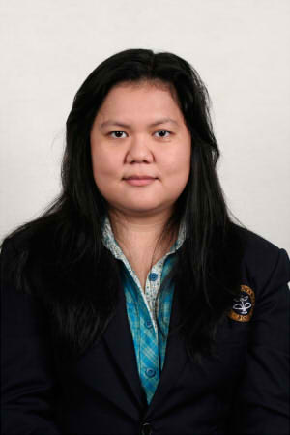

Office Software, Basic knowledge of Adobe Software and Windows OS, Administrative and Secretarial Tasks, High Endurance in Outdoor Survey, Event Budgeting, Proof Reading, Highly Detail Oriented, Creative-Point of View.

**Technical**

**Skills**

2015 – Asuransi Central Asia (Head Office) / Claim Officer / 6 months

2016 – Vista Education / Admission Consultant / June 2016 - now

**Language**

**Work Expirience**

English – limited working proficiency

Japanese – elementary proficiency

**silvyasherly@gmail.com/082123606000**

2010 – Secretarial Member, Himpunan Mahasiswa Hasil Hutan

(HIMASILTAN) IPB

2011 – Leader and Chief Editor, HIMASILTAN Information Center IPB

2011 – Organizating Comitee, ITTO Project Steering Comitee Meeting

cooperating with Ministry of Forestry : Utilization of Small

Diameter Logs from Sustainable Source for Bio-Composite

Products, Bogor

**Organizational Expirience**

2012 – Supporting Staff on Production Section, PT. Pindo Deli Pulp and

Paper Products, Karawang, West Java

Bachelor degree in Forestry with focus on Forest Product. Young yet expirienced in administrative tasks and highly adaptive in new environment. Used to work outdoor and enable to do multi-tasking job. Not only an independent individual, but also a dynamic team member. Eagerly to find new expirience in new environment work place.

2015 – Japanese Language Course Shokyu 3, LBI UI

2015 – Mandarin Language Course 1A, IPB

2013 – TOEFL Preparation Course, English First Bogor

2012 – Bussiness English Intermediate Level Course , English First Bogor

2012 – Real English Upper Intermediate Level Course, English First Bogor

**Internship**

**Expirience**

**Training**

2014 – Bachelor Degree of Forestry, Bogor Agriculture Institute

GPA : 2,78/4,00

**Profile**

**Education**

**Silvya Sherly**

Perumahan Cikaret Hijau blok B no 11 RT 02 RW 11 Bogor