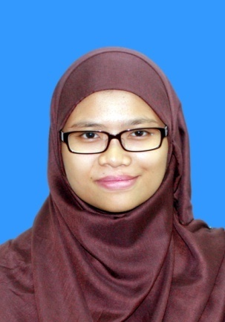

SITI ZUBAIDAH BT IBRHIM

Contact information

Home Adress : No. 15 , Lorong Kanan Satu ,

Kampung Pandan Dalam ,

55100 , Kuala Lumpur

H/P Number : 017 6807349

E-mail Adress : [zubaidah91@gmail.com](mailto:zubaidah91@gmail.com)

Personal Particulars

I/C Number : 910303-14-5198

Age : 24 Years old

Gender : Female

Date of Birth : 3 March 1991

Place of Birth : Kuala Lumpur

Nationality : Malaysian

Religion : Islam

Marital Status : Single

18th August 2014 – 28th November 2014

Educational Background

Internship at Radio Televisyen Malaysia at Corporate Communication Department

6th April 2015 - Current

Global Solution Resources Sdn Bhd

1. Finance Assistant
2. Human Resources & Administration

2011 – ( 2015 Graduated )

**Universiti Selangor (UNISEL)**

**Shah Alam Campus , Selangor**

Bachelor of Communication (Hons) (Corporate Communication)

Faculty of Communication & Media

GPA 4.00 CGPA 2.79

2009 – 2010

Sekolah Menengah Kebangsaan Aminuddin Baki , Kuala Lumpur

Sijil Tinggi Pelajaran Malaysia ( 2010)

2003 – 2008

Sekolah Menengah Kebangsaan Taman Maluri , Kuala Lumpur

Sijil Pelajaran Malaysia ( 2008 )

Extracurricular Activities

**18th August 2014 – 28th November 2014 (Internship)**

12th November 2014

Involved and on duty for Town Hall Session with Ketua Audit Negara at Angkasapuri

30th October 2014

Involved and on duty for MSC Malaysia APICTA AWARDS 2014

28th October 2014

Attending GST Talk at Auditorium P.Ramlee, Angkasapuri

27th September 2014

On duty for Pertandingan Akhir Bintang Klasik 2014 at Auditorium Perdana , Angkasapuri

15th September 2014

On duty for Konsert Tribute P.Ramlee 2014 at Auditorium Perdana Angkasapuri

9th – 10th September 2014

On duty for World Summit on Media for Children 2014 (WSMC 2014) at Royal Chulan Hotel , Kuala Lumpur

On duty for An Evening with Romanian Radio Orchestra at Dewan Filharmonik Petronas

Sept 2014 – November 2014

Attending Monthly Assembly at Angkasapuri organized by Ministry of Communication and Multimedia Malaysia

2014

Involved in Faculty magazine, IMPACT for Feature Writing subject

Completed thesis with title “The Effectiveness of Online Advertising as Perceived by Consumer in Kuala Lumpur.

2013

Organized and joined charity event , “ Cyling for Syria “ to help Syrian refugees

2013

Attending Corporate Communication Camp ( CCC ) 2013 at Impian Hotel Morib , Banting Selangor

2013

A committee member for Young Executive Night dinner

2013

CSR event at Rumah Anak Yatim at Sabak Bernam , Selangor

2013

Class trips at Sarawak for Intercultural Communication subject

Personal strength

Personal strength

* Friendly
* Able to work in group
* Can accept critisim if its good for myself
* Interested to learn a new thing