CURRICULUM VITAE

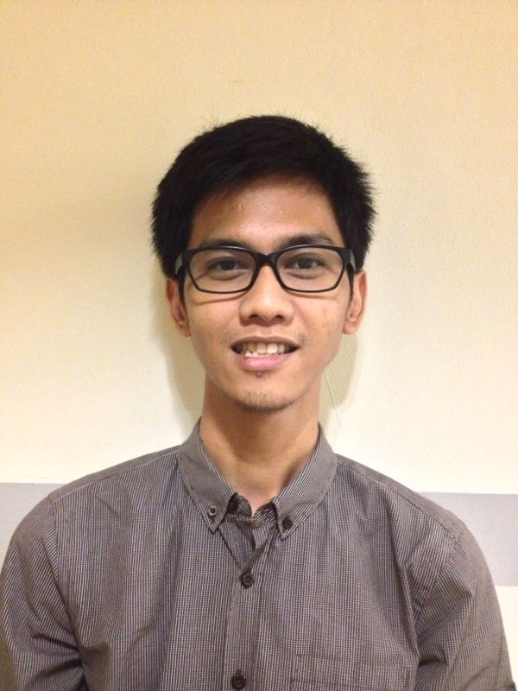

PROFILE

Self motivated, hard working achiever and responsible, knowledgeable, adaptable and capable of working in varied settings with people from various background, team oriented and optimistic in doing any job, fast learner and open minded thinking, an extrovert person with wide ranged connections, and good sense of humor.

P e r s o n a l D e t a i l s
Full Name | : | Aldy Bagus Prabowo
Nick Name | : | Aldy
Religion | : | Moslem
Place and Date of Birth | : | Sukoharjo, January 17th 1991
Sex | : | Male
Marital Status | : | Single
Nationality | : | Indonesian
Address | : | Pura Melati Indah blok B no 3,Pondok Gede  East Jakarta – 17414
Mobile Number | : | 082164219262
E-mail : aldyprabowoo@yahoo.com

F o r m a l E d u c a t I o n a l B a c k g r o u n d
School |  | Place |  | Year
Elementary School | : | SD Tarakanita 2 |  | 1997-2003
Junior High School | : | SMP Tarakanita 1 |  | 2003-2006
Senior High School | : | SMA PSKD 4 |  | 2006-2009
College | : | Atma Jaya Catholic University,  Management |  | 2009 -2013
W o r k E x p e r i e n c e
Specification |  |  | Year
PT. Realtime Futures as a Marketing |  |  | January 2011 – Desember 2011
PT. Kurongkor Medica as a Marketing |  |  | January 2012 – Desember 2012
PT. Diantara Kode Digital Better – b as a Account Executive |  |  | April 2013 – Agustus 2013
PT. Regeneresis as a Marketing |  |  | Oktober 2013 – Present

O r g a n i z a t i o n a l a n d C o u r s e E x p e r i e n c e
Specification | Year
Finalis Abang None Jakarta Kepulauan Seribu | 2013
Lurah Finalis Abang None Jakarta Kepulauan Seribu | 2013
Wallstreet Institute School of English | 2012-present
Viatama Dynamic Selling Skill Training | 2012
OSIS SMA PSKD 4 Ketua Seksi Olah Raga | 2007-2009
Ketua Panitia Prom Night PSKD 4 | 2009
Anggota Panitia Pangudi Luhur Fair Seksi Transportasi | 2008
Anggota Panitia Tarakanita 1 Cup Seksi Keamanan | 2005
Anggota OSIS SLTP Tarakanita 1 Seksi Olah Raga | 2004 - 2005

F o r e i g n L a n g u a g e A b i l i t y
Specification | Description
English (Both spoken and written) | Good

R E F E R E N C E S
Name | Mobile Number
Mrs. Emmy Noviawaty , Director of PT. Kurongkor Medica | +6281318900700

I, the undersigned, certify that, to the best of my knowledge and belief, these Curriculum Vitae correctly describes me, qualifications, and experiences.

Best Regards,

Aldy Bagus Prabowo

