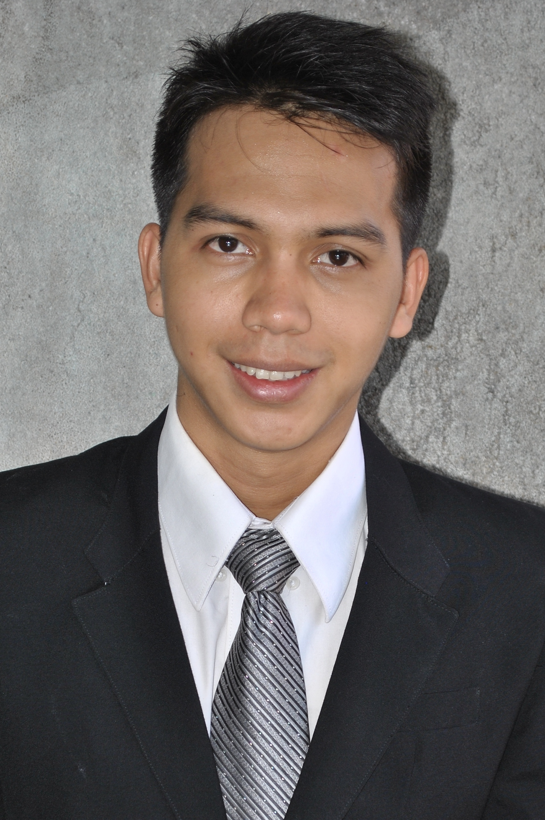

Dear Sir or Madam,

I am Hardi Rezali and I am 23 years old. I graduated from SMA Muhammadiyah 1 Senior High School. I was studying at Pamulang University Marketing Management fifth semester. I would like to join in your company as Account Executive and work together to make a difference to people's everyday lives.
I am submitting my resume and other supporting document for your review and consideration. From this information, you will see that I am an active, highly motivated, able to work under pressure, capable to work in a team, and hard-working person. Now, I am working as a customer services staff at Bank Permata Cabang Tempo Scan since January 2013. I feel I have the necessary qualifications to fill the vacancy you offer.
I hope you would consider me according to my qualification. Thank you for your consideration. I look forward to hearing from you soon.

Respectfully yours,

Hardi Rezali

CURICULUM VITAE
- PERSONAL DATA
NAME : HARDI REZALI
PLACE / DATE OF BIRTH : BHIPIH, 12 December 1989
SEX : MALE
PHYSICAL CONDITION : EXCELLENT
HEIGHT / WEIGHT : 172cm/63kg
NATIONALITY : INDONESIAN
RELIGION : ISLAM
MARITAL STATUS : SINGLE
PRESENT ADDRESS : JL.GALUR SELATAN RT/RW 003/002 JAKPUS
MOBILE NUMBER : 0813-18474340
EMAIL : hardirezali@yahoo.com

- EDUCATION

JUNE 1995 – 2001 : SDN 11 ELEMENTARY SCHOOL
JUNE 2001 – 2004 : SMPN 156 JUNIOR HIGH SCHOOL
JUNE 2004 - 2007 : SMA MUHAMMADIYAH 1 JUNIOR HIGH SCHOOL
PRESENT EDUCATION : PAMULANG UNIVERSITY

- JOB HIGHLIGHTS
IN 2007 : CUSTOMER SERVICE AT CAREFOUR

2007 – 2009 : CRO AT BLITZMEGAPLEX

2009 – 2012 : PT.BANK DKI AS CUSTOMER SERVICE

2012 – PRESENT : PT.BANK PERMATA AS CSR

