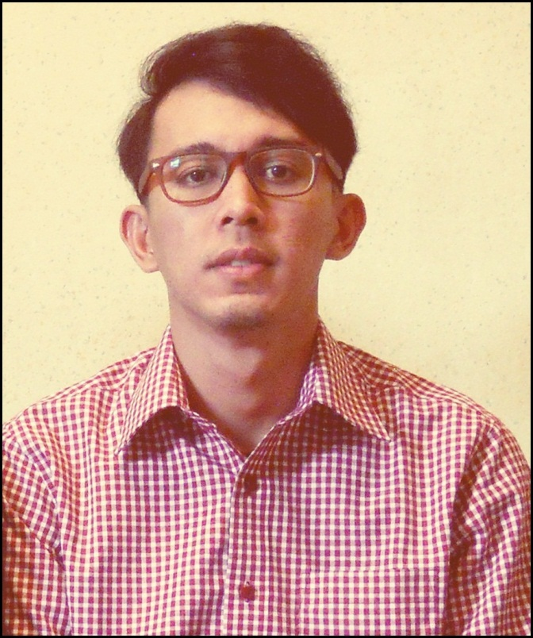
Nama : Rommy Arrahman Kawang
Jenis kelamin : laki-laki
Tempat,tgl lahiR : Jakarta, 9 oktober 1988
Alamat : Jl.wadas raya ujung no.16a rt005/rw03,jaticempaka pondok gede
Bekasi 14711
hp : 0813-1575-9001
Email : tothebang_yeah@yahoo.com / sundayfolks@gmail.com
Agama : ISLAM
Status : Belum menikah
EXPERIENCE
2007-2008 : ( PROJECT OFFICER ) EVENT ORGANIZER -ROOM ON FAMILLY-
2008-2009 : ( PROMOTION ) CV.KAWANG PUTRA
2009- 2010 : ( PROJECT OFFICER ) CV.KAWANG PUTRA
2009-2010 : ( PERSONAL ASSITANT ) PT.TELKOMSEL
2010-2011 : ( COSTUMER SERVICE ) PT.TELKOMSEL
2011-2012 : ( TEAM LEADER,MARKET SHARE ) PT.TELKOMSEL
2012-2013 : ( PRODUCER ) 99ERS RADIO JAKARTA
2013 – day : ( Station Manager / Senior Producer ) DREAMERSRADIO.COM / PT.Mediaworks indonesia
EDUCATION formal
- 2000 – SMP 117
- 2003 - SMA YADIKA 04
- 2006 – UNIVERSITAS ISLAM JAKARTA ( manajemen ekonomi )
Non FORMAL
- INTERNASIONAL LANGUAGE PROGRAM ( ILP)
- GANESHA OPERATION
- English First ( EF )
interest:
- Management
- Music
- Travelling
- Planning Program
- Development
- Fashion
Motivation :
- Memajukan perusahaan dan loyal
- Dapat bekerja sama dengan baik
- Mudah bersosialisasi dengan orang baru
- suka belajar sesuatu hal yang baru
MY quotes
Focus on good thoughts and good things will happen. Stay positive. Think positive. Do positive

( Rommy arrahman kawang )

