CURRICULUM VITAE



PERSONAL DATA

* Name : Bagus Alit
* Place and date of birth : Pekalongan, June 16th, 1991
* Sex : Male
* Religion : Moslem
* Education : S1 Design Communication Visual

FORMAL EDDUCATION

* SD : SD Negeri 3 Kalinegoro, Magelang, Jawa Tengah
* SMP : SMP Negeri 11 Magelang, Jawa Tengah
* SMA : SMA Negeri 36 Rawamangun, Jakarta Timur
* S1 : Universitas Trisakti, Jakarta ( *gpa, 3.02/4.00 )*

JOB EXPERIENCE

* Fresh graduated
* Free lancer for web design

SKILL

* Adobe Dreamweaver
* Adobe Photoshop
* Adobe Illustrator
* Adobe Fireworks
* Microsoft Word
* Corel Painter
* Traditional Drawing
* Computer Hardware and Maintenance

CONTACT

* Address : Jl. Ekor Kuning 3/19, Rawamangun, Jakarta Timur
* Email : [bagus.alit@hotmail.com](mailto:bagus.alit@hotmail.com)
* HP : +62-877-8838-7942

ATTACHMENT DOCUMENT

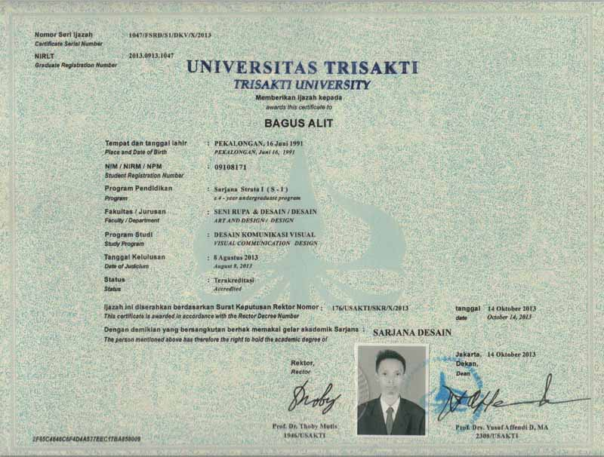

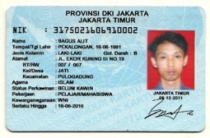

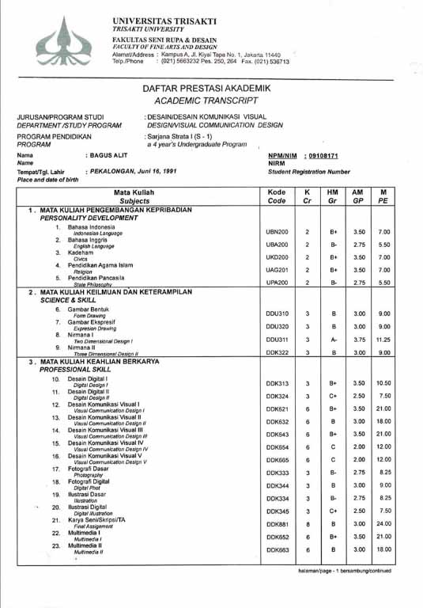

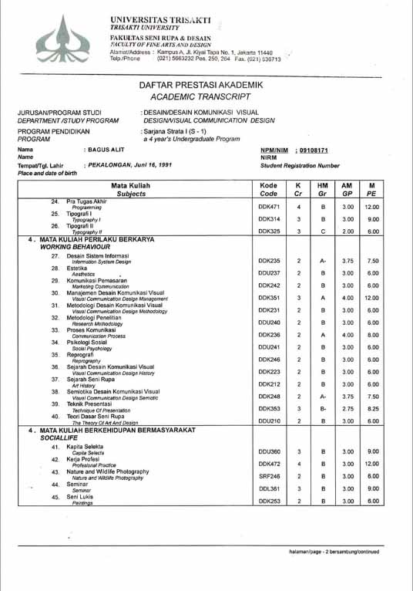

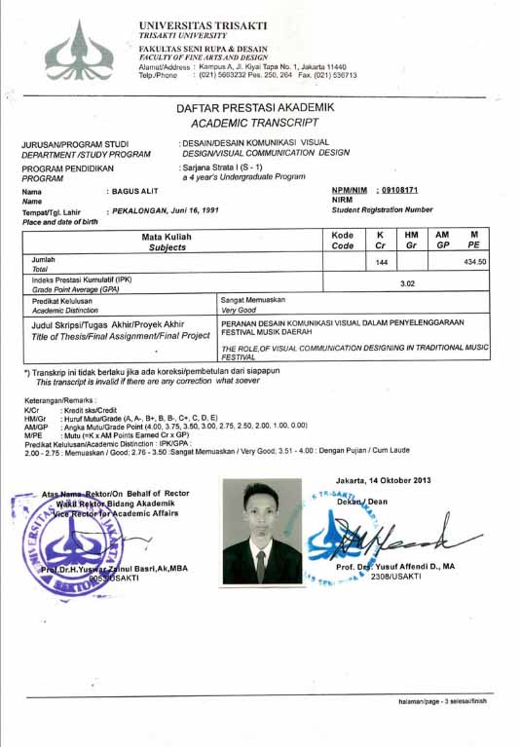

PORTFOLIO

Illustration

POSTER

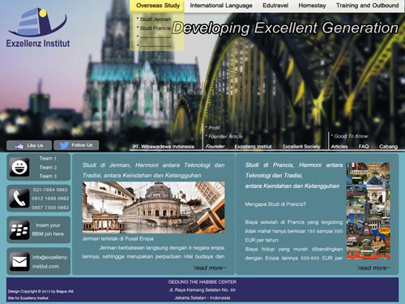WEB DESIGN

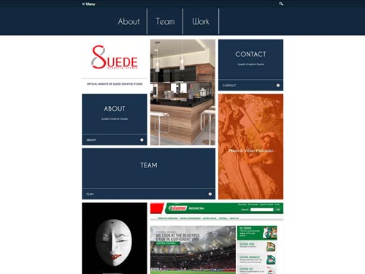

LAYOUT

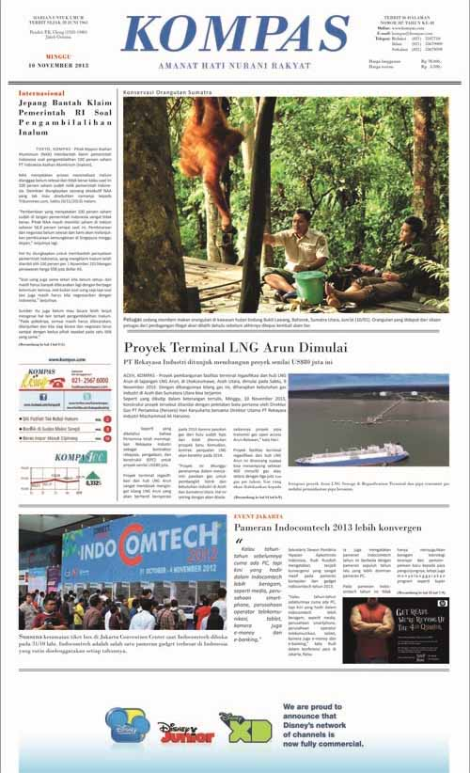 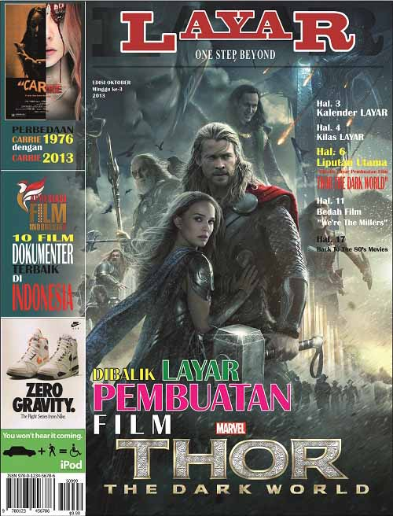

*Sincerely yours,*

*Bagus Alit*