**Tuban, 28 March 2014**

**TO:**

**DIRECTOR**

**PT KANA CIPTA MEDIA**

**JAKARTA**

Dear Sir/Madam,

Related to PT KANA CIPTA MEDIA has been develop factories in Jakarta. Herewith I would like to apply.

Please find attached my Curriculum Vitae for your review, and other detail information will be given to you during an interview, if any.

I was graduated in October 2013 Diploma I majoring in Product Design department as Graphic Design in Institut Teknologi Sepuluh Nopember Surabaya.

I will be very happy if I can contribute my skills and abilities for PT. KANA CIPTA MEDIA in JAKARTA. I am sure that I am the one of the talented people who are you seeking because I am an active and hard worker who has good discipline and honesty.

I am looking forward to hear from you soon and hopefully there is still one best opportunity for me to join with your company.

Thank you very much for your kind attention.

Very truly yours,

**Ubaidillah Elmuddin**

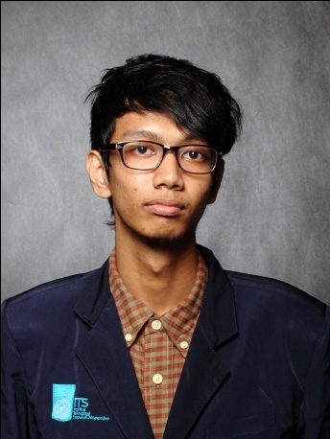**CURRICULUM VITAE**

|  |  |  |  |
| --- | --- | --- | --- |
| N a m e | : | Ubaidillah Elmuddin |  |
| Place / Date of birth | : | Tuban, December 23, 1993 |
| Address | : | Jl. AKBP Suroko 15-H Tuban |
| Phone number | : | HP : 08983291070 |
| Religion / Citizenship | : | Moslem / Indonesia |

##### E d u c a t i o n a n d T r a i n i n g s

1. Formal: October 2013, Graduated from Diploma I Institut Teknologi Sepuluh Nopember, Majoring in Product Design as Graphic Design.
2. Non Formal: Course / Training.

|  |  |  |
| --- | --- | --- |
|  | February 2011 | Training – Program Pendidikan Sistem Ganda (PSG) at Asih Digital Printing Tuban. |
|  | September 2013 | Course – Studied English and Hotel & Cruise ship Program, Sekolah Kapal Pesiar (SKP) Pare. |
|  | October 2013 | Training – Hospitality as waiters, Purnama Hotel Kota Batu. |

##### Working Experiences in Adil Computer :

Company line of business: Computer course.

1. August 2012 – September 2012,

Position: Teacher.

Duties Resume: Responsible to teaching the student until understandable about Microsoft Office and Adobe Photoshop.

***Qualification:***

1. Able to Microsoft Office, Corel Draw, Adobe Photoshop, Adobe Premier, 3D Max, Format Factory, Movie Maker, Adobe Flash, Photoscape and Auto CAD.
2. Understand and able to make documentary a picture photo, audio and video.

*I declare that my curriculum vitae are correct and hoping it can be a consideration for you.*

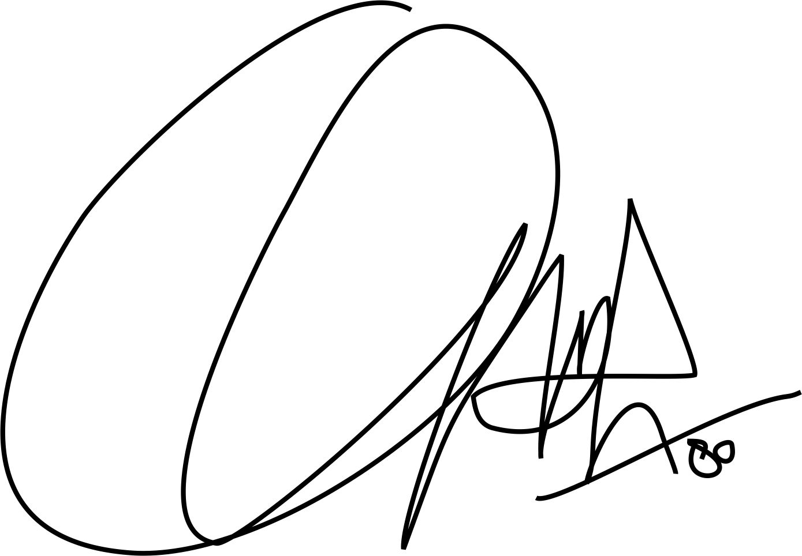

**Ubaidillah Elmuddin**