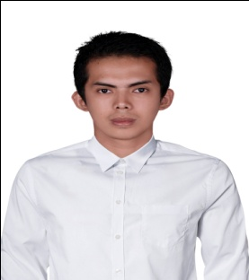

CAREER OBJECTIVE

To build career in a growing organization, where I can get opportunitiest to prove my abilities by accepting challenges, fulfilling the organizational goal and climb career ladder through continuous learning and commitment

PERSONAL DETAILS

Name : Rahmad Fajriyan

Nickname : Riyan

Gender : Male

Place & Date of Birth : Bukittinggi, 25 December 1988

Nationality : Indonesia

Address : Jl. Gambir Anom no. 27, Jalaprang - Bandung

Phone Number : 085222466550

Religion : Islam

E-mail : rahmad.fajriyan@gmail.com

Marital Status : Single

EDUCATIONAL DETAILS

1. 2009 – 2014 : Widyatama Univ Bandung ( unfinished );
2. 2004 – 2007 : SMUN 4 Bukittinggi;
3. 2002 – 2004 : SMPN 8 Bukittinggi;
4. 1996 – 2002 : SDI Masyithah Bukittinggi.

PERSONALITY

Good attitude, kind, tolerant, honest, diligent and responsible

SKILLS

|  |  |
| --- | --- |
| 1. Good communication skill and speak English fluently both oral and written. 2. Internet, email, blog 3. Computers Hardware and Software |  |
| 1. Microsoft Office (word, excel, power point) 2. Html & Css 3. Javascript |  |
| INTEREST AND HOBBIES |  |
|  |  |

Computer, Web Design, music, football, reading and traveling