**DOCUMENTATION OF NATURAL TOURISM APP**

**By Hilmi Ardiansyah**

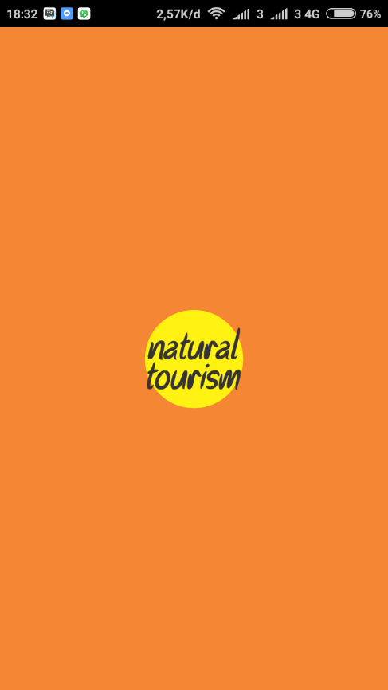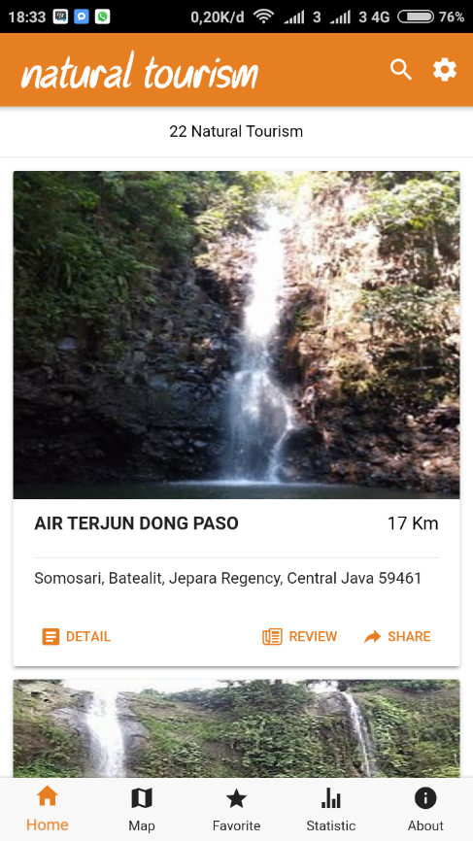

**INTRODUCTION**

Natural Tourism App is an application that helps users in finding natural tourist locations. The application is location-based so that users can easily find the location of the destination you want to go. This application uses Ionic Framework and Firebase as database because it can change location data in realtime without need to build application.

**FIREBASE FOR REALTIME CHANGE**

Firebase is a DbaaS (Database as a Service) service with realtime concepts. Firebase is a cloud service provider with a backend as a service based in San Francisco, California. Firebase consists of complementary features that can be mixed and match according to your needs. Firebase gives you the tools and infrastructure to build a better application and increase your business success.

The main product of Firebase is a database that provides an API to allow developers to store and synchronize data across multiple clients.

**FEATURES**

* **USER AUTH WITH EMAIL ADDRESS**

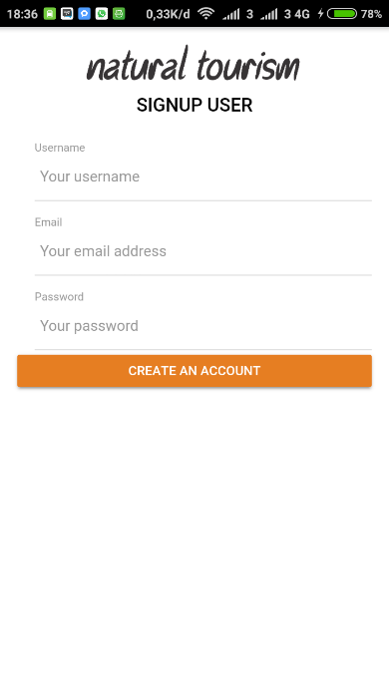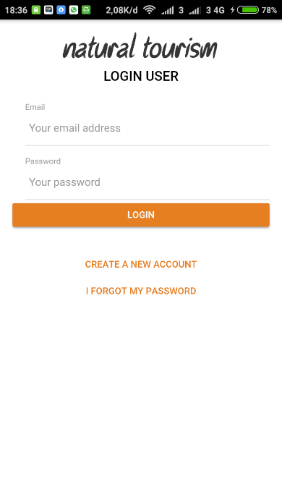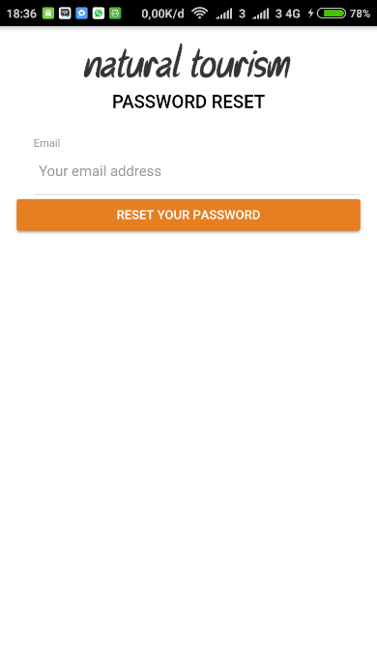

* **MAP AND GEOLOCATION**

You can see your position in the map between natural tourist sites so you know how far and how close the location you want to go.

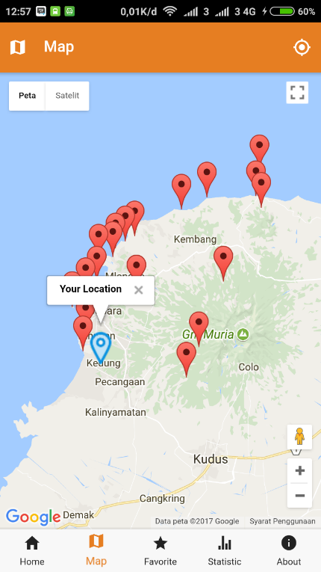

* **REVIEW LOCATION**

You can do a review of natural tourist sites. You are also entitled to edit and delete your review.

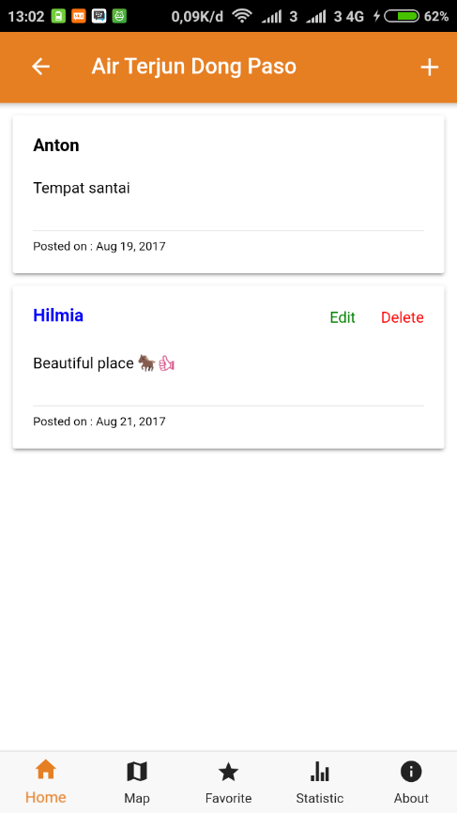

* **DISTANCE LOCATION**

You can see the distance from your position to the tourist location.

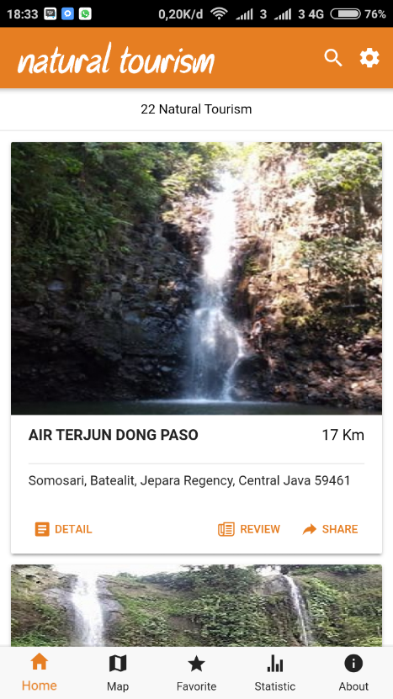

* **FAVORITE LOCATION**

You can add your location to your favorite page so you do not need to search the location of the main page.

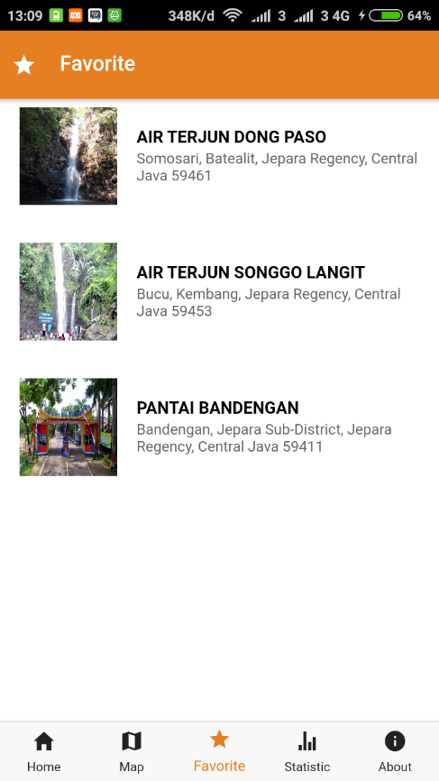

* **REALTIME STATISTIC DATA**

You can display statistical data from all tourist locations and the data can be changed in realtime.

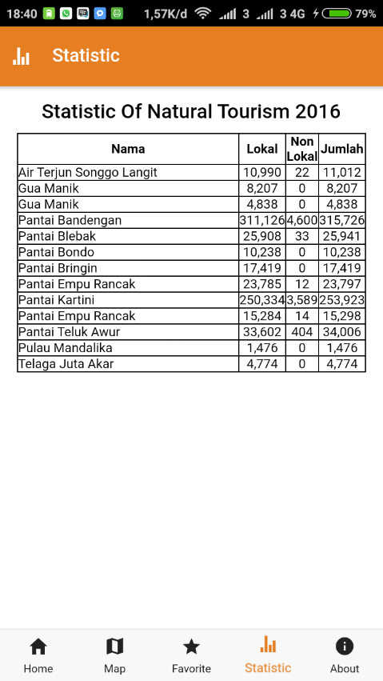

* **SHARE LOCATION**

You can share the tourist location you want.

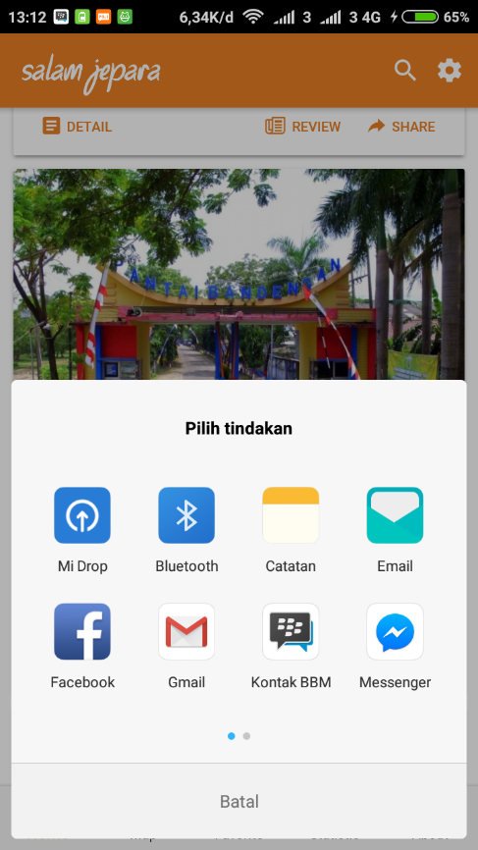

* **SORT BY NAME OR DISTANCE**

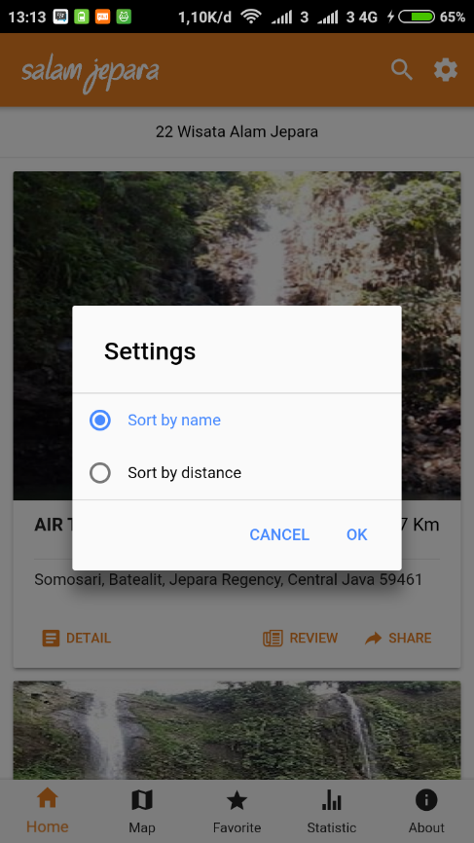

* **SEARCH LOCATION**

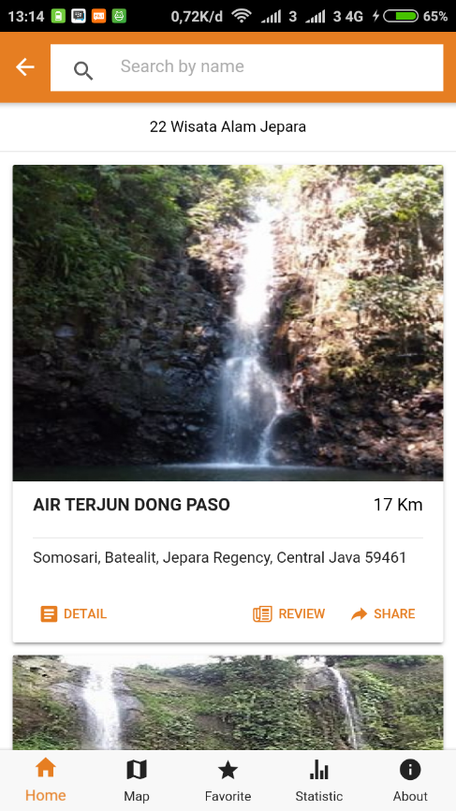

* **GO TO LOCATION (INTEGRATED WITH GOOGLE MAPS APP)**

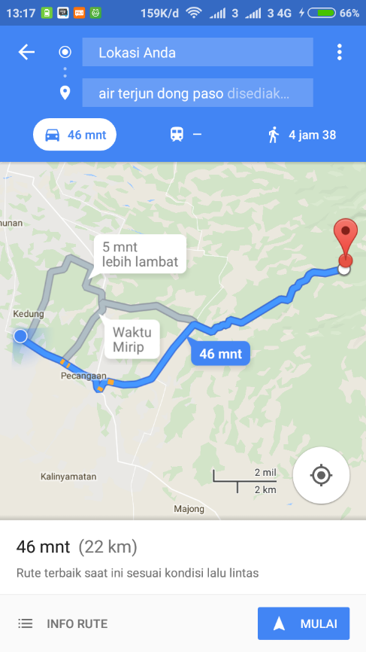

**DATABASE EXPLANATION**

* **CHANGE FIREBASE CONFIG**

To change firebase config, copy your firebase config and paste to **src -> app -> app.modules.ts**

* **STRUCTURE OF DATABASE**

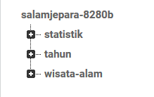

* + **Statistik**

Contains location visit statistics data.

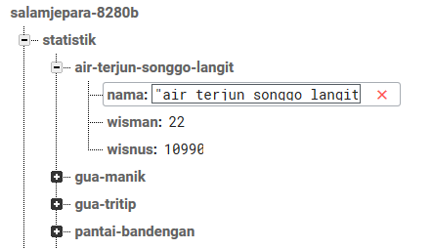

Information :

Nama = Contains the name of a natural tourist location.

Wisman = Data of foreign tourists.

Wisnus = Data of Local tourists.

* + **Tahun**

Year statistical data visit.

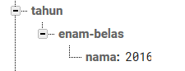

* + **Wisata-alam**

Contains all natural tourist data.

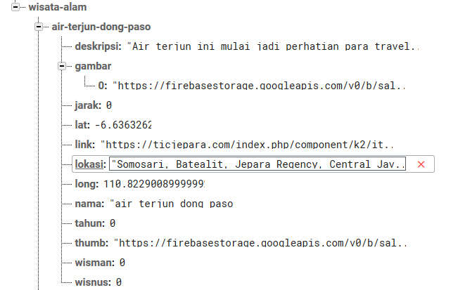

Information :

Deskripsi = Location description.

Gambar = Location image slider (can be more than one)

Jarak = Location distance (must be zero)

Lat = Location latitude.

Link = Nature tour website.

Long = Location longitude.

Nama = Name of location.

Tahun = Years of statistical data.

Thumb = thumbnail of location.

Wisman = data of foreign tourists.

Wisnus = data of local tourists.

If you have any question please email to [doyonsaja@gmail.com](mailto:doyonsaja@gmail.com)