PRAKTEK MANDIRI#2
ANDROID LAYOUT

Creating Layout
To create UI layout for your activity you can do in two ways.
- Creating view object from code programatically
  - Write these code in your MainActivity.java
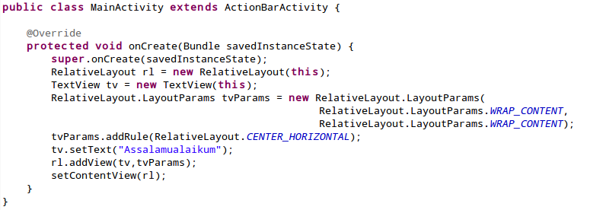
  - Run and see the result
- Creating with xml
  - Write these code in activity_main.xml
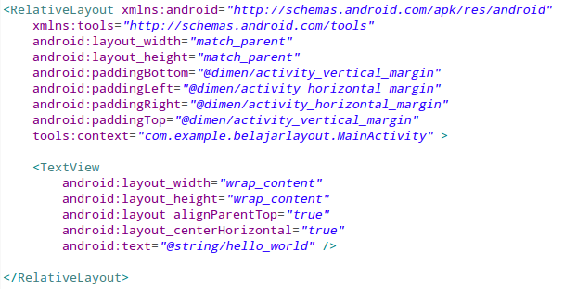
  - Write these code in your MainActivity.java
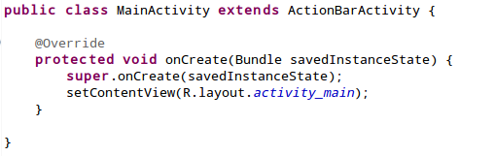

  - Run and see the result

Linear Layout
- Layout Horizontal
  - Create new android project, name it with “Linear Layout Demo”.
  - Create layout_horizontal.xml under res/layout/ folder
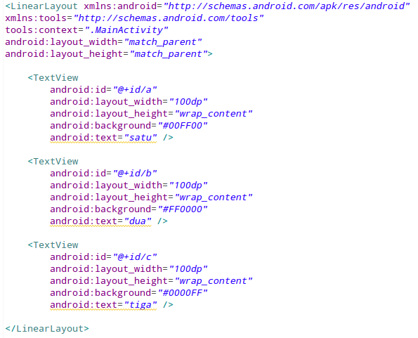

  - Use layout_horizontal.xml as layout for MainActivity
  - Run and see the result
- Layout Horizontal
  - Copy layout_horizontal.xml to layout_vertical.xml, modify these following codes:
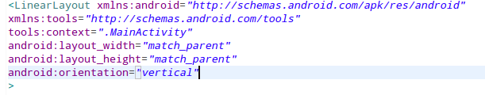
  - Use layout_vertical.xml as layout for MainActivity
  - Run and see the result
- Modify Height
  - Create form_layout.xml
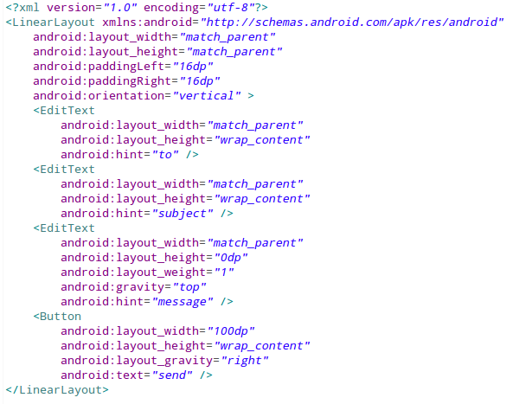
  - Use form_layout.xml as layout for MainActivity
  - Run and see the result

Relative Layout
- Create new android project, name it with “Relative Layout Demo”.
- Create relative_layout.xml and write these code
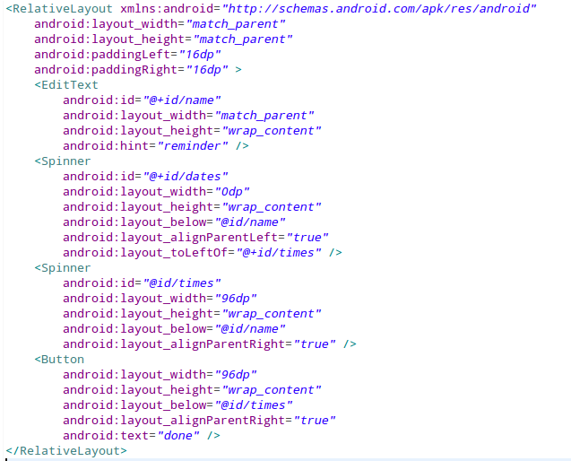
- Use relative_layout.xml as layout for MainActivity
- Run and see the result

List View
- Static ListView item from xml
  - Create new android project, name it with “List View Demo”.
  - Create listview_layout.xml and write these code
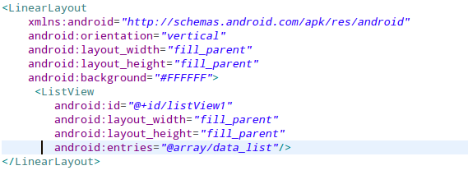
  - Add string array at res/values/strings.xml
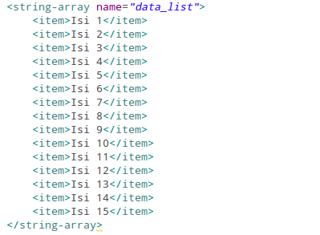
  - Use listview_layout.xml as layout for MainActivity
  - Run and see the result

- Static ListView using array adapter
  - Create new activity ListArrayActivity.java, set as main activity, modify onCreate() method
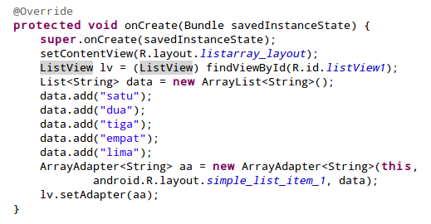
  - Use layout listarray_layout.xml

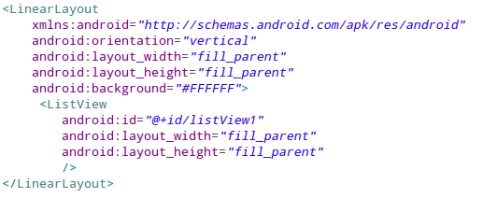
  - Run and see the result

Grid View
- Modify activity_main.xml
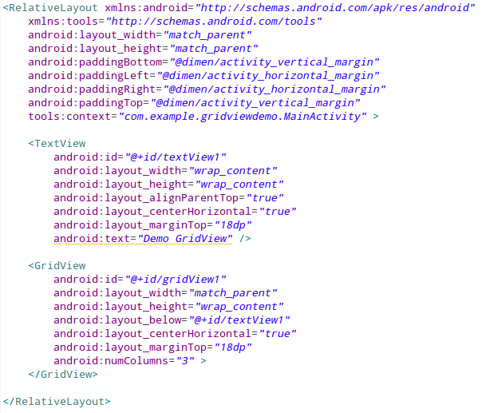
- Add image to drawwable folder (example:andro1.png,andro2.png,andro3.png, ...)
- Create class ImageAdapter.java
- Set adapter at MainActivity.java, change onCreate() method to:
