实验室LOGO 电力系统大型发电设备安全控制和仿真国家重点实验室

—能源互联网与能源战略

The State Key Lab of Power System

研究方向名称（中英文）

能源互联网/多能互补规划及运行系统

Energy Internet/Multi-energy Planning and Operation System

主要研究内容简介（中英文）

能源互联网/多能互补规划及运行系统，提出了层级化能源互联网规划思路与方法，形成了多能源耦合系统规划建模基础理论和规划评估方法，开发了能源互联网规划云平台，提供能源互联网的设备选型配置、网络分析、能效评估等功能，率先推动国内能源互联网示范项目的前期规划和可行性研究。基于能源互联网多维信息以多源协同与有源快切为手段，态势感知主动分析运行风险，利用分布式可调资源辅助解决配电网运行问题，提升了能源互联网的安全性、可靠性与经济性。

The Energy Internet/Multi-energy Planning and Operation System, includes the ideas and methods of hierarchical energy internet planning, which compose the basic theory of planning modeling and planning evaluation method assessment method for multi-energy system. An energy internet planning cloud platform was built to provide equipment selection and configuration, network analysis, efficiency evaluation. This system has taken the lead in promoting the preliminary planning and feasibility study of energy Internet demonstration projects in China. Based on the multi-dimensional information of energy internet, multi-energy collaboration and active fast cutting are used as means to analyze operation risks actively with situational awareness, adjust distributed tunable resources to solve operation problems. And this system thus enhances the security, reliability, and economy of the energy Internet.

图片，数据表格等可视化表征

能源互联网规划平台

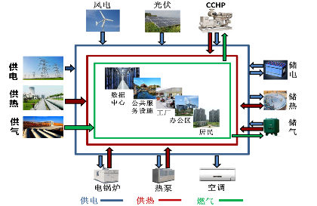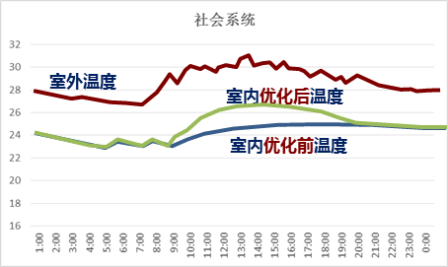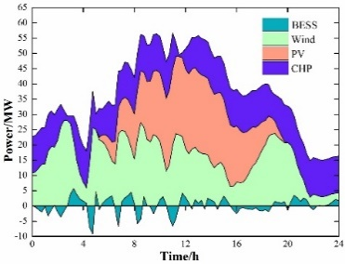

**多种能源生产-传输-存储-消费环节**

**能源生产的优化配置**

**柔性负荷调节**

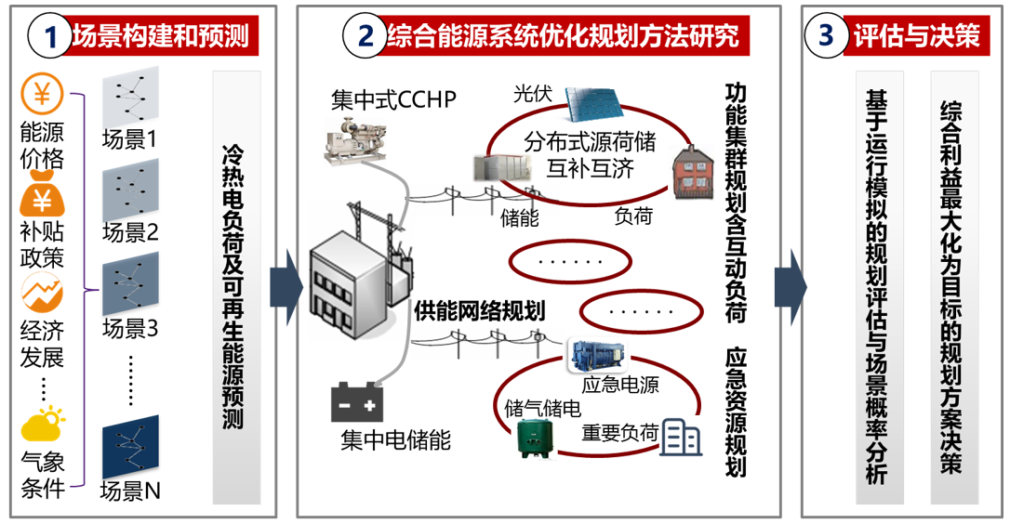

多能互补规划及运行系统

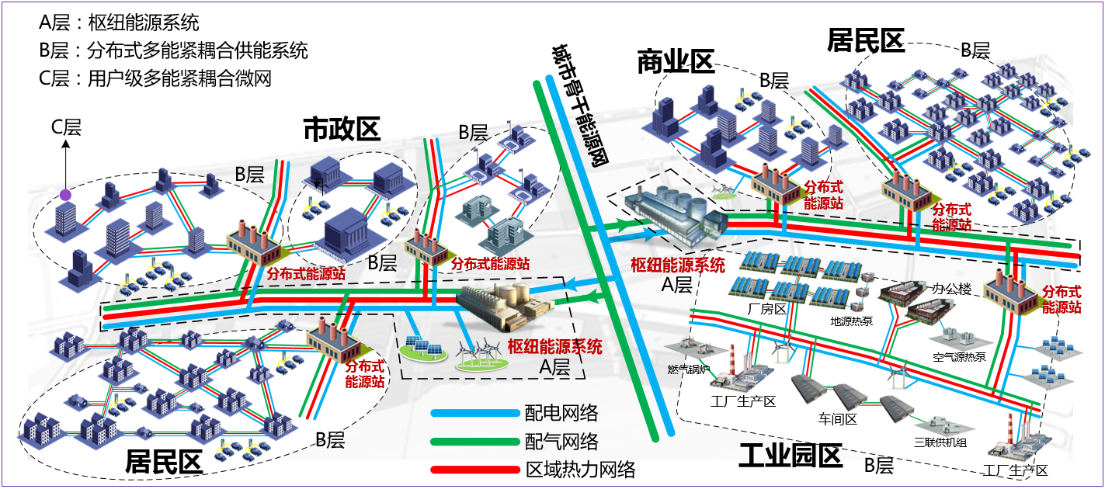

配用电系统全业务统一信息平台

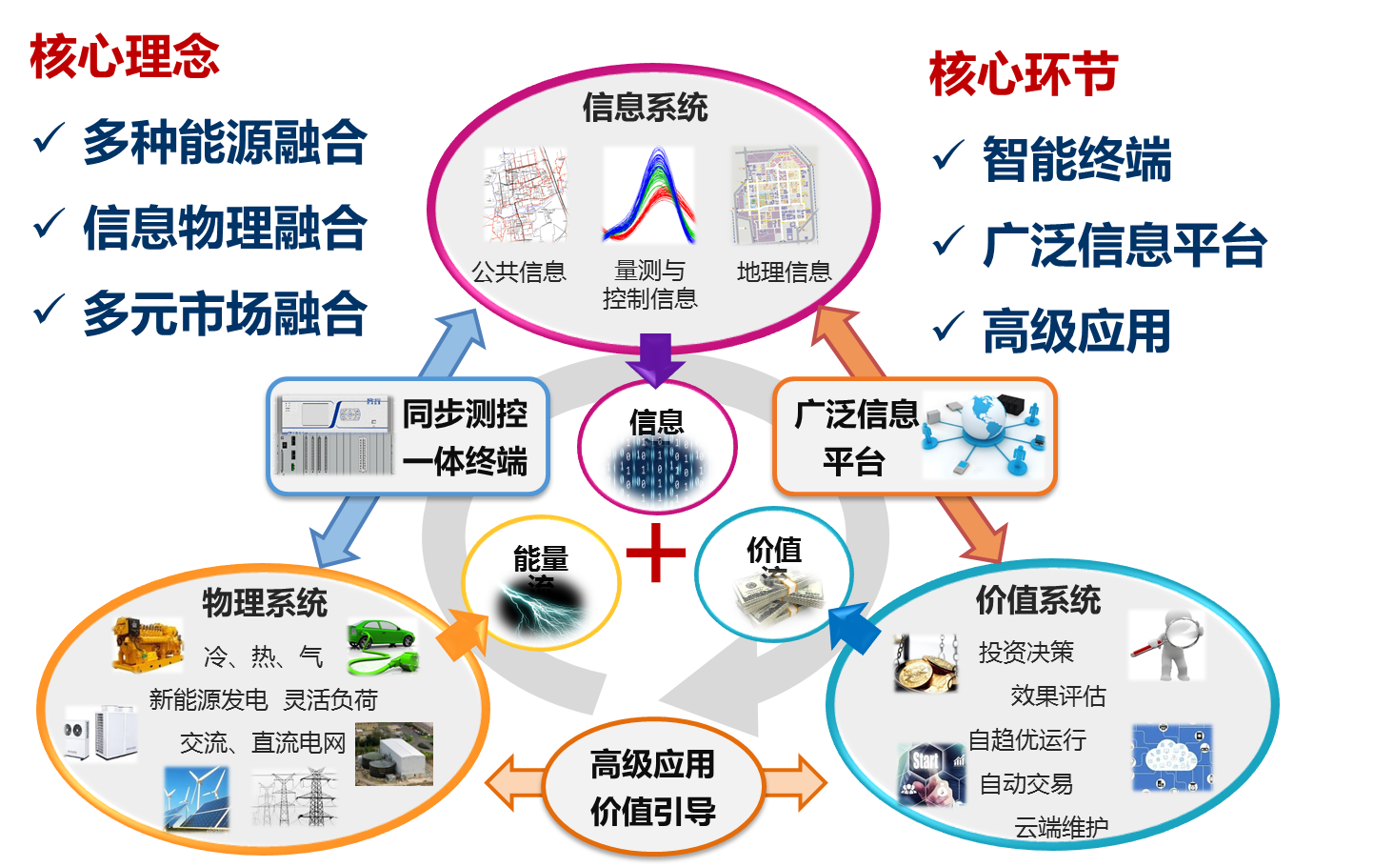

电力系统可靠性与运行可靠性评估，考虑电气设备及电力系统受设备自身健康状况、外部环境条件和系统运行状态变化的影响，首次提出了电力系统运行可靠性概念，建立了条件相依的元件时变可靠性模型，提出了短期可靠性评估算法和运行可靠性快速评估算法，并结合电力系统监测数据，开展了连锁故障机理及阻断策略研究；开发了大电网可靠性风险评估平台，包含全电压等级序列电网规划评估、电网运行可靠性评估、连锁故障风险评估等功能模块，可实现对5000节点以上大电网快速、准确的可靠性评估。

Power system reliability and the operational reliability analysis, considering the impact of aging, environment and system operation condition on the reliability of the electrical equipment and the power system, the idea and theory of the operational reliability was established for the first time. On this basis, the time varying and conditional dependent reliability model was put forward, the short term power system reliability assessment algorithm and the fast operational reliability evaluation method was proposed. Based on the power system measured data, the cascading outage theory and prevention strategy was further studied. A power system reliability and risk evaluation platform was developed at last, including the over-all power system reliability assessment for the power system planning, the power system operational evaluation, the cascading outage risk analysis and other functional modules, the fast and accurate reliability evaluation for a power system with over 5000 nodes is realized.

可靠性评估云平台

