Opportunity Tracking Agent
Terms, Workflow, and Build Requirements
Field | Detail
Purpose | Explain the business terms, current POC behavior, and required additions for the hosted autonomous platform.
Source basis | TrackF workbook, Step 1 DN answers, Step 3 POC code, and Step 4 scale-up plan.
Version | Working reference guide - August 2026

1. Key Terms
Term | Meaning
EAU | Estimated Annual Usage. In this workbook it is shown as Kpcs, meaning thousand pieces per year.
Kpcs | Thousand pieces. 1,000 Kpcs means 1,000,000 units.
Unit/Set | Number of units used in one final product or vehicle set. Example: 1,000,000 units / 5 units per set = 200,000 sets.
Distributor ASP | Distributor average selling price per unit. This is the price currently used in the POC revenue math.
Resale ASP | Customer-facing or resale price. It is captured in the data, but the current POC does not use it for the main revenue calculation.
Sales Revenue | Unweighted revenue. Formula: EAU Kpcs x Distributor ASP. The result is in $K because EAU is already in thousands.
Confidence Level | Probability that the opportunity will convert. 0.30 means 30 percent, 1.00 means 100 percent.
Adjusted Revenue | Risk-weighted revenue. Formula: Sales Revenue x Confidence Level.
Design Status | Commercial/design progress label such as Promotion, Sample, Evaluation, Design In, Design Win, Mass Production, or Lost.
Stage | Engineering validation stage: Concept, EVT, DVT, PVT, or MP.
EVT | Engineering Validation Test. Early validation stage.
DVT | Design Validation Test. More mature validation stage.
PVT | Production Validation Test. Late validation stage close to production.
MP | Mass Production. Product has moved into production.
M/P Date | Expected mass-production date.
Competitor Part | A named competing part being evaluated for the same opportunity. This is a risk signal.
Loss Reason Code | Required reason when an opportunity is marked Design Lost, such as price, technical fit, competitor, timing, or cancellation.
Audit Log | Permanent record of what the agent recommended, what changed, why it changed, and who approved or overrode it.

2. ProjectTrack Columns, Options, and Meanings
The ProjectTrack table is the main opportunity-tracking view. Each row represents one opportunity or project. The columns below show the values currently present in the sample data and how the agent should interpret them.
Column | Options seen | Meaning
Region | Korea, EU, Taiwan, North America, Japan | Sales/geographic region where the opportunity belongs.
Customer | SLM, Flextron, ODE, Foxc, blank | Direct customer/account being sold to. Blank means customer data is missing.
End Customer | GM, Ford, BMWi, Forde, blank | Final OEM/end buyer that will use the product.
Project Name | Hercules, Aphrodite, Hermes, Poseidon, Apollo, Hugo, Dresden, Yellowstone, Montana, blank | Internal opportunity/project name.
Application | ADAS, Powertrain, Lamp, blank | End-use application area for the part.
Product Line | SerDes, IGD, LED Lighting, blank | Product family/category being sold.
Part# | AX01, AX10, AX20, blank | Internal part number proposed for the opportunity.
Design Status | Design Win, Design In, Sample, Promotion, Evaluation | Commercial/design progress status.
Stage | PVT, DVT, EVT, Concept, blank | Engineering/project validation stage.
M/P | Sep'26, Feb'27, May'28, June'27, Jan'27, Oct'26, Dec'26, Mar'27 | Expected mass-production date.
EAU [Kpcs] | 100 to 10,000 | Estimated Annual Usage in thousand pieces.
Unit/Set | 5, 10, 15, 20 | Number of units used per final set/product/vehicle.
Disty Cost (ASP) | $2.00, $3.00, $4.00, blank | Distributor Average Selling Price per unit. Used in the current revenue formula.
Resale (ASP) | $2.10, $3.20, $4.3000, blank | Customer-facing or resale Average Selling Price.
Sales Revenue | $0 to $40,000K | Unweighted revenue. Formula: EAU Kpcs x Disty Cost ASP.
Competitor Part# | blank | Competing part being evaluated. Blank means no competitor is listed.
Confidence Level | 0.00, 0.10, 0.30, 0.50, 0.80, 1.00 | Probability that the opportunity will convert.
Adjusted Revenue | 0.00 to 12,000.00K | Risk-weighted revenue. Formula: Sales Revenue x Confidence Level.
Comments | blank | Notes about the opportunity.

Full Forms Used In The Table
Short form | Full form | Meaning
ADAS | Advanced Driver Assistance Systems | Automotive safety and driver-assist systems.
SerDes | Serializer/Deserializer | High-speed data transmission product category.
IGD | Likely Integrated Gate Driver | Power electronics product category. This should be confirmed internally.
LED | Light Emitting Diode | Lighting technology/product category.
EVT | Engineering Validation Test | Early technical validation stage.
DVT | Design Validation Test | More mature design validation stage.
PVT | Production Validation Test | Late validation before mass production.
MP / M/P | Mass Production | Production stage or expected production date.
EAU | Estimated Annual Usage | Expected annual unit demand.
Kpcs | Thousand pieces | 1,000 Kpcs means 1,000,000 pieces.
ASP | Average Selling Price | Price per unit.
Disty | Distributor | Distributor/channel pricing context.
GM | General Motors | End customer/OEM.
EU | Europe | Geographic region.

Design Status Options
Design Status | Meaning
Promotion | Very early opportunity. Sales is promoting the part to the customer.
Sample | Customer has received or is testing samples.
Evaluation | Customer is evaluating the part technically or commercially.
Design In | Customer is actively designing the part into the product, but it is not fully won yet.
Design Win | The part has been selected or won for the project.
Mass Production | Project has moved into production.
Lost | Opportunity was lost.

Design Status Values Seen In ProjectTrack
Value in sheet | How the agent should understand it
Design Win | The opportunity is considered won or selected. In the DN rules, this should normally appear only at PVT or MP.
Design In | The part is being designed into the customer project, but the opportunity is not fully locked yet. In the DN rules, this fits DVT to PVT.
Sample | The customer has samples or is testing the part. This fits early validation such as Concept or EVT.
Promotion | The part is being promoted to the customer. This is the earliest commercial stage and usually belongs with Concept or EVT.
Evaluation | The customer is evaluating the part technically or commercially. This usually belongs with Concept or EVT.

Confidence Options
Confidence | Meaning
0.00 | No confidence, incomplete record, or non-revenue record.
0.10 | 10 percent confidence. Very early/low likelihood.
0.30 | 30 percent confidence. Early opportunity.
0.50 | 50 percent confidence. Medium likelihood.
0.80 | 80 percent confidence. Strong opportunity, often Design In.
1.00 | 100 percent confidence. Usually Design Win, but still check for dual sourcing or cancellation risk.

3. How The Agent Works Presently
The current project is a proof of concept. It proves the calculation-plus-judgment pattern, but it is not yet a hosted platform and it does not directly read the Excel workbook.
File | Current role
sample_pipeline.json | Sample opportunity data copied into JSON from the workbook-style pipeline.
calc_engine.py | Calculates Sales Revenue, Adjusted Revenue, and rollups by region and stage. This part uses deterministic math only.
judgment.py | Applies mock or live judgment logic to confidence. In mock mode it uses fixed rules such as early-stage optimism and stage/status mismatch.
run_poc.py | Runs the end-to-end demo and prints before/after forecast numbers.
test_calc_engine.py | Confirms the calculation engine matches the spreadsheet numbers for the sample projects.

Current Calculation Logic
Calculation | Formula | Example
Sales Revenue | EAU Kpcs x Distributor ASP | 1,000 Kpcs x $3 = $3,000K
Adjusted Revenue | Sales Revenue x Confidence | $3,000K x 80 percent = $2,400K

4. Business Rules Confirmed By The DN Document
Decision Area | Confirmed Direction
Agent scope | One combined Opportunity Tracking Agent should handle the tracking workflow.
Forecast ownership | Finance should own the formal revenue forecast. This agent should feed and cross-check that process.
Data ownership | Regional sales owners update the tracking data.
Confidence | The agent should auto-enter confidence and perform qualitative analysis.
Lifecycle movement | The agent should auto-move projects to Mass Production or Design Lost when status resolves.
Design Lost | A loss reason code should be required.
Refresh cadence | Monthly refresh is adequate, with additional refresh when customer stage/status changes.
ROI Agent | Keep the ROI Agent separate, but add cross-validation between the two agents.

Valid Design Status And Stage Combinations
Design Status | Valid Stage | Agent behavior
Design Win | PVT or MP | Allow. Still check for dual sourcing or cancellation risk.
Design In | DVT to PVT | Allow. Confidence should generally be medium to high depending on risk.
Sample / Evaluation / Promotion | Concept or EVT | Allow. Confidence should generally be lower because the project is early.
Lost | Design Lost workflow | Move to Design Lost and require a loss reason code.
Mass Production | MP | Move to Mass Production and keep production metadata.

5. Agent Flow Diagram
The diagram below shows the target platform flow. The current POC covers the calculation engine, basic confidence scoring, and before/after forecast output. The remaining blocks are required for a production platform.
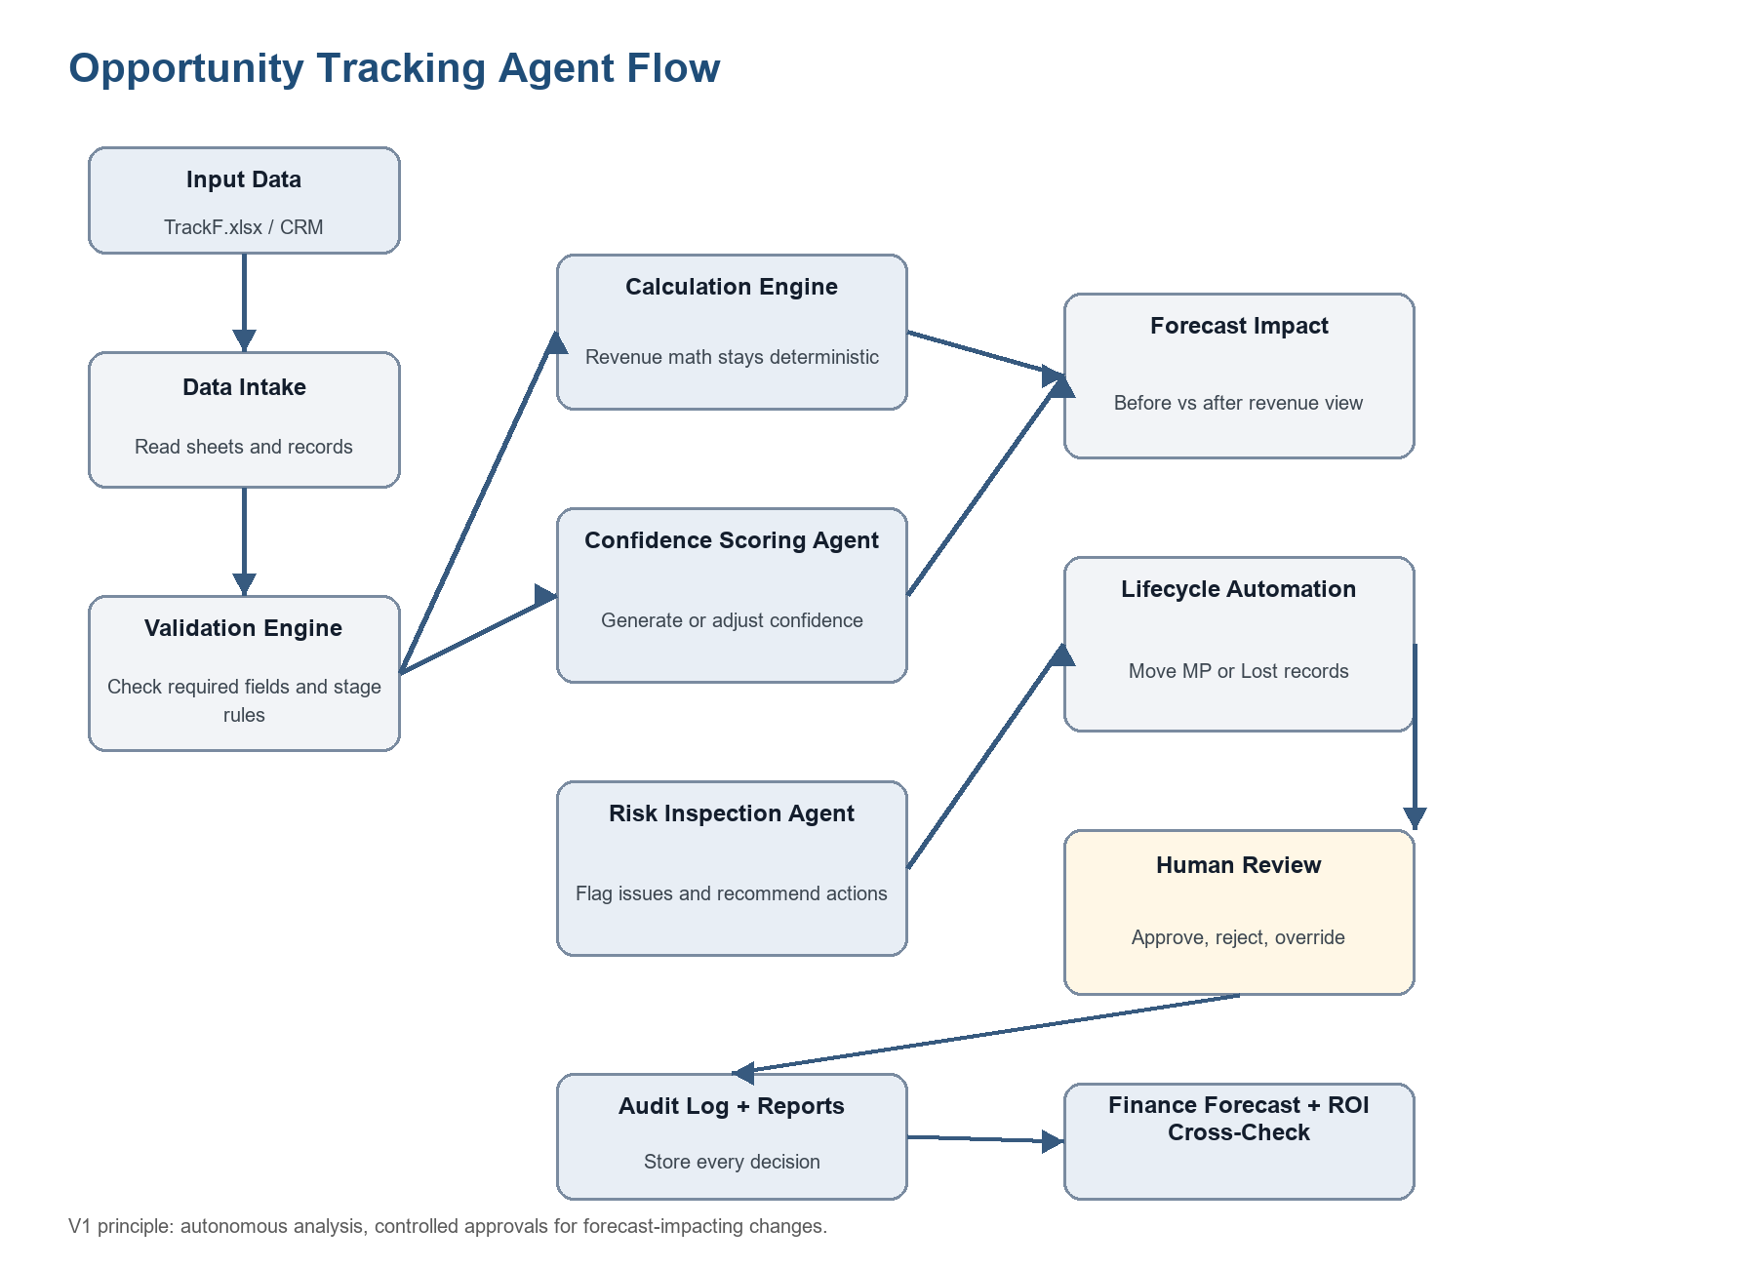

6. Target Workflow Point By Point
Step | Action | Meaning
1 | Import data | Read TrackF.xlsx or future CRM data sources.
2 | Parse sheets | Identify Funnel, ProjectTrack, Mass Production, and Design Lost records.
3 | Validate fields | Check required fields, confidence range, dates, duplicates, and status/stage rules.
4 | Calculate revenue | Use deterministic formulas for Sales Revenue and Adjusted Revenue.
5 | Generate confidence | Use stage, status, risk signals, and business rules to auto-create or adjust confidence.
6 | Inspect risk | Flag competitor risk, early-stage optimism, dual sourcing, cancellation risk, stale stage, and missing loss reasons.
7 | Show forecast impact | Compare original forecast against agent-adjusted forecast by project, region, stage, and quarter.
8 | Move lifecycle records | Auto-move Mass Production and Design Lost records based on status rules.
9 | Human review | Allow approve, reject, override, and needs-follow-up decisions.
10 | Audit and report | Log every recommendation and generate manager reports.
11 | Cross-check | Feed finance forecast and compare assumptions with the ROI Agent.
12 | Learn | Use won/lost outcomes to improve future confidence scoring.

7. What Must Be Added To Make It Work Properly
Required Addition | Why It Is Needed
Excel intake | The platform must read TrackF.xlsx directly instead of relying on sample JSON.
Database | Store opportunities, stages, confidence, decisions, reports, and audit history.
Validation engine | Implement the DN document's status/stage rules and required-field checks.
Auto confidence generator | Move from simple confidence adjustment to agent-generated confidence.
Risk engine | Add dual sourcing, cancellation risk, competitor risk, stale-stage risk, and missing-data risk.
Lifecycle automation | Move records to Mass Production or Design Lost when business rules are met.
Loss reason capture | Require reason code for every Design Lost record.
Approval workflow | Track suggested, approved, rejected, overridden, auto-applied, and needs-review states.
Reports | Create manager-ready dashboards and exports.
Hosting | Build as a web platform with frontend, backend, database, scheduled jobs, and authentication.

8. Platform Recommendation
For the first hosted version, use a practical web platform architecture: React or Next.js for the dashboard, Python FastAPI for the backend, PostgreSQL for persistent data, and a hosted LLM API for the judgment layer. The first release should be autonomous in analysis but controlled in official updates.
Layer | Recommended V1 Choice
Frontend | React or Next.js dashboard
Backend | Python FastAPI
Database | PostgreSQL
Agent runtime | Existing Python POC modules upgraded into backend services
LLM | Hosted API first; local model later if required
Hosting | Vercel for frontend, Render/Railway/Azure/AWS for backend, managed PostgreSQL

