EV-Go Documentation

By Vaughan Hilts, Giovanni Romano, Brandon Smith

**Description**

EV-Go is a web application for electric car drivers. It allows them to plan trips with their electric car, creating a route that passes through charging stations. It takes into account the properties of their car, such as its range on a full charge and its compatibility with different types of charging stations.

**Features**

* can choose car by model and specific spec
* displays map with route through necessary stops
* can export route to Google maps
* auto complete for search boxes using Google Maps API
* works on mobile devices
* server is multithreaded

**Architecture**

* Node.js (API server)
  + zeroMQ/zeroRPC (message queue)
  + Restify (API framework)
  + MySQL (database engine)
  + Mocha (unit tests)
* Python
  + Google Maps API
  + Open Charge Map API (data source)
  + A zeroRPC server

**Architecture Diagram**

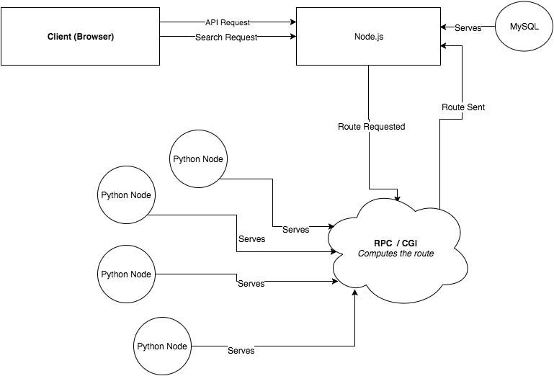

Usage Instructions

1. Enter a starting location in the start text field.

2. Enter a destination in the destination text field.

3. Select a car from the Car dropdown box.

4. Select an associated spec from the Car Model dropdown box.

5. Click the search button and wait for the results.

Examples

Navigating a mountain range in California:

