# Getting Started

To get started, import the provided SQL dump into a MySQL instance of your choice. By default, the provided SQL script will dump into a schema called ‘mydb’. You can adjust this in the script if this will cause conflicts or issues. Otherwise, proceed to dump the schema into the application and continue on with the process.

If you haven’t already, ensure the source files are decompressed somewhere on your hard disk.

After the schema is imported, things are ready to go on the MySQL section. To configure the application, browse to the **Repository** class and change:

self._conn = mysql.connector.connect(user='root', password='',

host='127.0.0.1',

database='mydb')

to reflect any credential changes or database changes you might have applied. The **Repository** class has been moved to the top of the file so it is easy to find. Simply change your string there.

After this is changed, the application is ready to go and run. The next sections show how to use the application.

# Running The Application

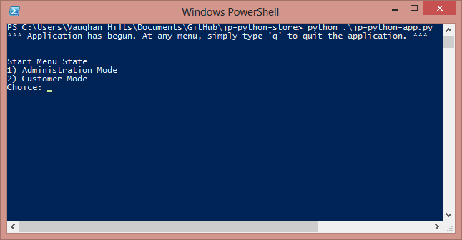

Figure demonstrating how to run jp-store

Invoke the main.py script from the main directory by changing the directory on a command line client that supports python, and run it with the following command.

**PS C:\Users\Vaughan Hilts\Documents\GitHub\jp-python-store> python .\jp-python-app.py**

To run on your own system move to wherever the client directory is on your computer and run **python jp-python-app.py**

Alternatively, you can simply double click the python script to run it as a single script and the IDLE interpreter should kick in and serve your application up as is.

That’s it! A diagram is included above to show how the directory structure will look and how execution will look if everything is done correctly.

# Navigating The Application

The application works by navigating a set of states and utilizing their menu options. This particular implementation of the application only has 3 distinct states: Home, Customer Menu, and Administrator Menu. In particular, they allow numeric input to execute and navigate. Consider the following menu from initial run:

*** Application has begun. At any menu, simply type 'q' to quit the application. ***

Start Menu State

1) Administration Mode

2) Customer Mode

Choice:

From this, you can simply select a numeric option to begin your choices. As indicated, simply press ‘q’ at any time to quit. We’ll **very briefly** go over the menus and their options

## Administration Mode

Admin Menu

1) Back to main

2) Add a new product

3) Update stock for product

4) Increment stock for product

5) Edit Supplier

6) Edit A Product

7) Edit Publisher

* **Back to main.** Provides a way to return to the start menu, mostly so one can select the customer menu.
* **Add a new product.** Promptsthe administrator for some values and allows them to enter some new product information into the database.
* **Update stock for product / increment stock for product.** This allows an administrator to edit the stock of their product either via increments or an absolute value.
* **Edit Supplier.** Allows editing of supplier information
* **Edit a product.** Allows editing of a product and the various attributes
* **Edit publisher.** Allows editing of various publisher attributes (primarily, name)

## Customer Menu

Customer Menu

1) Back to main

2) View my Orders

3) Update my Account

4) Check Stock

5) Purchase Items

6) Search

7) Add to Cart

8) See Cart

9) Clear Cart

10) See full product details

* **Back to main.** Provides a way back to the main start menu, similar to admin mode. It can also be used to change customer accounts by re-entering customer mode.
* **View my orders.** Allows a particular customer who is logged in to view their orders.
* **Update my account.** Allows the currently logged in customer to change stuff, such as their name and address.
* **Check stock.** Allows a customer to check the stock of a particular product.
* **Purchase items.** Allows the customer to purchase everything inside their cart, it will also clear their cart.
* **Search.** Allows the customer to search for products to buy
* **Add to cart.** Allows the customer to add some products to their cart
* **See cart.** Allows the customer to look at what is currently inside their cart
* **Clear cart.** Allows the customer to abandon their and remove everything