Lightweight Open-Set Learning for Zero-Day Attack Detection in IoT Networks: A Cross-Dataset, Compute-Constrained Benchmark
Hilux Fokou Ngoumo
Faculty of Secure Information Technologies
ITMO University
Saint Petersburg, Russia
hilux.fokou@niuitmo.ru
Abstract—Machine-learning-based intrusion detection systems (IDS) routinely report high accuracy, yet three practical requirements are rarely evaluated together: the ability to flag attack types never seen during training (zero-day / open-set detection), the computational footprint needed to run on resource-constrained deployments such as IoT gateways, and whether method rankings actually hold across datasets. This paper presents a systematic, leave-attack-category-out benchmark of five open-set anomaly detectors — Isolation Forest, One-Class SVM, PCA-reconstruction, a shallow MLP-autoencoder, and a lightweight prototype-based contrastive detector — evaluated jointly on zero-day detection accuracy (AUROC, Unknown Detection Rate at a fixed 5% benign false-positive rate), deployment cost (training time, per-sample inference latency, serialized model size), and cross-dataset generalization. All methods are implemented with dependency-minimal, CPU-only tooling, in contrast to prior open-set IDS work that relies on GPU-trained deep contrastive models. On NSL-KDD, the lightweight prototype-contrastive detector attains the best mean zero-day AUROC (0.950); however, on the IoT-native CICIoT2023 dataset, the same method collapses to the worst performer (mean AUROC 0.418), while Isolation Forest and PCA-Reconstruction remain consistently strong across both datasets (mean AUROC 0.80–0.94). This reversal indicates the prototype method's shared-covariance design is sensitive to the severe class imbalance present in CICIoT2023's seven attack categories, and demonstrates empirically that single-dataset benchmarking can produce misleading conclusions about which lightweight method is best for zero-day IoT intrusion detection.
Index Terms—intrusion detection, zero-day attacks, open-set recognition, IoT security, lightweight machine learning, anomaly detection, resource-constrained deployment, cross-dataset generalization

I. INTRODUCTION
The rapid growth of Internet-of-Things (IoT) deployments has exposed billions of heterogeneous, resource-constrained devices to increasingly sophisticated network attacks [1]. Machine-learning-based intrusion detection systems (IDS) are the dominant proposed defense, and recent surveys report high closed-set classification accuracy across public benchmarks [1][2]. However, three requirements central to real deployment are rarely evaluated together. First, most IDS work assumes a closed-set world in which every attack type present at test time was also present at training time — an assumption that fails for zero-day attacks by definition [3][4]. Second, real-time and lightweight operation on constrained hardware remains an open problem even for high-accuracy models [2][5]. Third, and least examined, is whether a method's reported ranking against competing baselines actually holds when the same benchmark is repeated on a second, independently collected dataset — most open-set IDS papers, including our own pilot study on this topic, report results on a single dataset only.
Recent work has begun to address open-set / zero-day detection directly, most notably contrastive-loss formulations such as CLOSR/CLAD [3] and variational-autoencoder-based open-set recognition (VAEMax) [6], as well as lightweight one-class autoencoders for IoT [7]. These methods report strong zero-day detection accuracy on a single dataset, but do not test whether that accuracy, or the ranking against baselines, generalizes to a second dataset with a different attack taxonomy and class balance. This is precisely the gap this paper addresses.
Contribution. We present a systematic benchmark that: (1) evaluates open-set / zero-day detection using a leave-attack-category-out protocol on two independent datasets — NSL-KDD and the IoT-native CICIoT2023; (2) restricts every candidate method to dependency-minimal, CPU-only implementations, so accuracy and cost are measured on comparable, deployment-realistic footing; (3) reports accuracy, cost, and cross-dataset consistency together, rather than accuracy alone on a single benchmark; and (4) demonstrates, with a concrete empirical reversal, why single-dataset evaluation is an unreliable basis for recommending a zero-day IDS method. The remainder of this paper is organized as follows: Section II reviews related work; Section III details the methodology and datasets; Section IV describes the experimental setup and system architecture; Section V presents results on both datasets and their cross-dataset comparison; Section VI discusses findings; Section VII covers threats to validity; Section VIII concludes.

II. RELATED WORK
Closed-set ML-IDS. The majority of ML-based IDS literature evaluates models under a closed-set assumption, reporting accuracy/F1 on datasets such as NSL-KDD, CICIDS2017, UNSW-NB15, and, more recently, CICIoT2023 [8]. Surveys of this line of work consistently flag adversarial robustness, class imbalance, and the closed-set assumption itself as open problems [1][2]. Ensemble and deep-learning classifiers dominate reported leaderboards, but their evaluation protocols almost universally assume every test-time label was present during training [1], and almost all are evaluated on a single dataset.
Open-set and zero-day IDS. Open-set recognition (OSR) relaxes the closed-set assumption by requiring a model to reject inputs from classes unseen during training. In network intrusion detection, this has been operationalized via one-class classifiers (Isolation Forest, One-Class SVM) [9], reconstruction-based autoencoders [7], OpenMax-style calibration combined with variational autoencoders (VAEMax) [6], and contrastive representation learning explicitly designed for zero-day generalization (CLOSR/CLAD) [3]. Federated and blockchain-enabled variants extend open-set detection to distributed IoT/IoV settings [10]. None of these evaluate whether their reported zero-day accuracy or method ranking is stable across more than one dataset.
Lightweight / resource-constrained IDS. A parallel line of work targets deployability on constrained hardware, using feature selection, model compression, or shallow architectures to reduce training and inference cost [2][7]. This line and the open-set line have largely been evaluated separately, and both largely restrict evaluation to a single benchmark dataset. This paper's benchmark sits at the intersection of open-set detection, deployment cost, and cross-dataset robustness, and Table I makes this gap explicit.

TABLE I
COVERAGE OF ACCURACY, COST, AND CROSS-DATASET REPORTING IN RELATED OPEN-SET / LIGHTWEIGHT IDS WORK
Study | Zero-day accuracy | Cost (time/size) | CPU-only, dep.-minimal | Cross-dataset eval.
CLOSR / CLAD [3] | Yes | No | No (deep contrastive) | No
VAEMax [6] | Yes | No | No (VAE) | No
One-Class BiGRU-AE [7] | Yes | Partial | Partial | No
This work | Yes | Yes | Yes | Yes

III. METHODOLOGY
A. Leave-Category-Out Protocol
For a dataset with attack categories C = {c₁, ..., cₖ} and a benign class, we iterate over each category cᵢ and construct a split in which: (a) the training set contains benign traffic and all attack categories except cᵢ (“known” attacks); (b) the test set contains held-out benign traffic, held-out known-attack traffic, and all traffic from cᵢ, treated as an unknown, simulated zero-day category. This repeats for every category, so each is held out exactly once, and the entire protocol is applied independently to both datasets. Fig. 2 illustrates the protocol end-to-end.
B. Candidate Detectors
All detectors are implemented in scikit-learn/numpy (CPU-only, no GPU deep-learning framework) and score test samples with a continuous anomaly score, higher indicating more anomalous: (1) Isolation Forest — tree-based isolation depth, fit on benign traffic only. (2) One-Class SVM — RBF-kernel novelty detector fit on a bounded random subsample of benign traffic (capped for O(n²)-scale tractability). (3) PCA-Reconstruction — a low-rank PCA subspace fit on benign traffic; anomaly score is per-sample reconstruction error, a cheap linear stand-in for a deep autoencoder. (4) MLP-Autoencoder — a shallow bottlenecked multilayer perceptron trained to reconstruct benign traffic; anomaly score is reconstruction error. (5) Prototype-Contrastive — a lightweight approximation of deep contrastive open-set recognition (cf. CLOSR [3]): a shared covariance is fit over benign and known-attack traffic (regularized via Ledoit-Wolf shrinkage for numerical stability), per-class centroids (“prototypes”) are computed for benign and each known attack category, and the anomaly score is the Mahalanobis distance to the nearest known prototype.
C. Metrics
For each (held-out category, detector, dataset) triple we report: AUROC on known attacks (a sanity check), AUROC on the unknown category (the core zero-day metric), Unknown Detection Rate (UDR) at a fixed 5% benign false-positive-rate operating threshold, and cost metrics: training wall-clock time, per-sample inference latency, and serialized model size.
D. Datasets
Two datasets are used to test whether zero-day detection performance and method rankings generalize across independently collected traffic sources.
Primary: CICIoT2023 [8], a 2023 IoT-native traffic dataset collected from a 105-device real IoT testbed, with 34 fine-grained attack labels grouped into 7 top-level categories following the dataset's original taxonomy: DDoS, DoS, Recon, Web-based, BruteForce, Spoofing, and Mirai. The full released dataset totals approximately 6 million labeled flow records across 26 CSV partitions; for laptop-scale CPU training we draw an 18% stratified random sample per partition using chunked streaming reads (fixed seed, never materializing the full dataset in memory), yielding 744,843 rows. Fig. 6 shows the resulting class distribution, which remains extremely imbalanced even after sampling (DDoS: 542,686 rows vs. BruteForce: 203 rows).
Secondary, for cross-dataset validation: NSL-KDD [11], a smaller, well-established, non-IoT-native benchmark whose official test split contains attack types absent from training. Fine-grained labels are grouped into four categories (DoS, Probe, R2L, U2R) following the original KDD Cup taxonomy; Fig. 1 shows its class distribution. NSL-KDD is used specifically to test whether conclusions drawn on CICIoT2023 — in particular, which detector wins on zero-day accuracy — are dataset-specific or generalize.

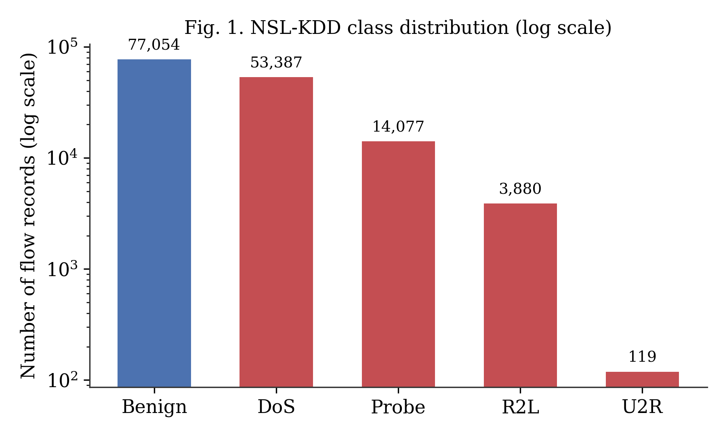
Fig. 1. NSL-KDD class distribution (log scale).

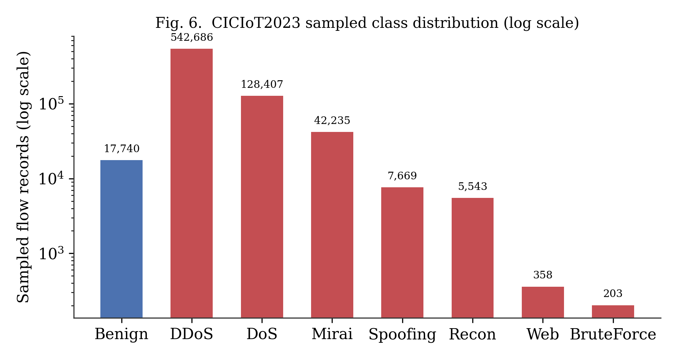
Fig. 6. CICIoT2023 sampled class distribution (log scale). Note the far greater imbalance than NSL-KDD (Fig. 1): a 2,700× gap between the largest (DDoS) and smallest (BruteForce) category.

IV. EXPERIMENTAL SETUP AND SYSTEM ARCHITECTURE
All experiments run on CPU only (no GPU), using scikit-learn 1.7 and pandas 2.3 on Python 3.10, reflecting the resource-constrained deployment scenario motivating this study. Random seed fixed at 42 (NSL-KDD) / 42–46 across sampling batches (CICIoT2023) throughout. One-Class SVM training is capped at 4,000 benign samples per fold for tractability. Fig. 2 summarizes the end-to-end system, applied identically to both datasets: raw traffic is loaded and preprocessed, then for every attack category the pipeline constructs a leave-one-out split, fits all five detectors, scores the held-out test set, and computes the accuracy and cost metrics reported in Section V.

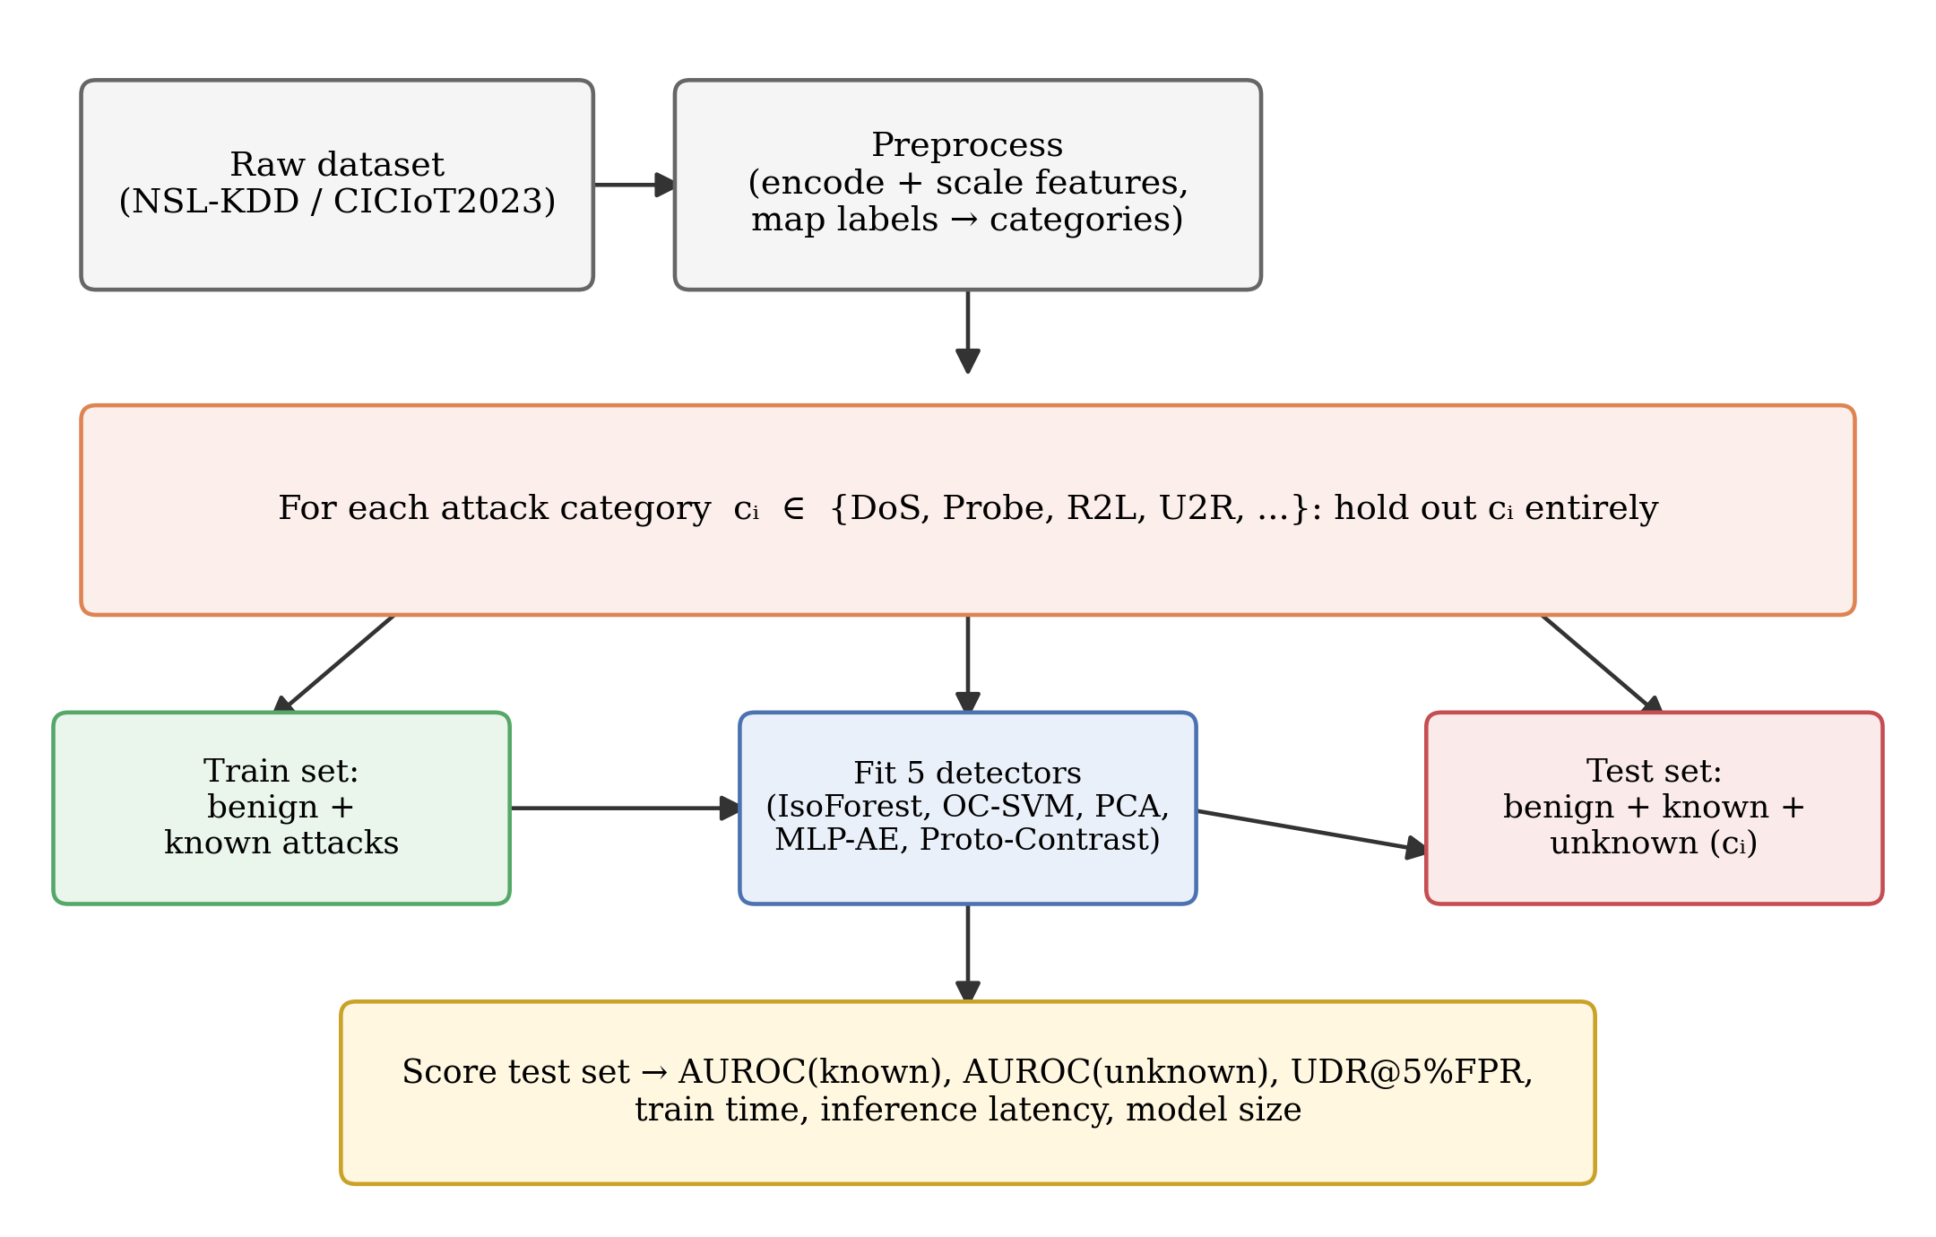
Fig. 2. End-to-end leave-category-out benchmark pipeline, applied to both NSL-KDD and CICIoT2023.

A. Reproducibility
Code, the evaluation harness, and full results CSVs for both datasets are provided as supplementary material. The NSL-KDD benchmark (5 detectors × 4 categories) reproduces on a standard laptop CPU in under two minutes; the CICIoT2023 benchmark (5 detectors × 7 categories, on the 744,843-row sample) reproduces in under ten minutes.

V. RESULTS
This section reports leave-category-out results on NSL-KDD (V-A), on CICIoT2023 (V-B), and a direct cross-dataset comparison (V-C).
A. NSL-KDD Results
Table II and Table III report AUROC on the unknown category and UDR at 5% FPR for each NSL-KDD category; Fig. 3 and Fig. 4 visualize the same results. Table IV reports average cost. U2R and R2L — the rarest, most subtly-behaved categories — are hardest to detect as zero-day across all methods.

TABLE II
NSL-KDD: AUROC ON UNKNOWN (HELD-OUT) CATEGORY
Detector | DoS | Probe | R2L | U2R | Mean
Isolation Forest | 0.981 | 0.97 | 0.773 | 0.839 | 0.891
One-Class SVM | 0.957 | 0.919 | 0.748 | 0.831 | 0.864
PCA-Reconstruction | 0.982 | 0.949 | 0.895 | 0.905 | 0.933
MLP-Autoencoder | 0.963 | 0.957 | 0.853 | 0.941 | 0.928
Prototype-Contrastive | 0.971 | 0.962 | 0.921 | 0.948 | 0.950

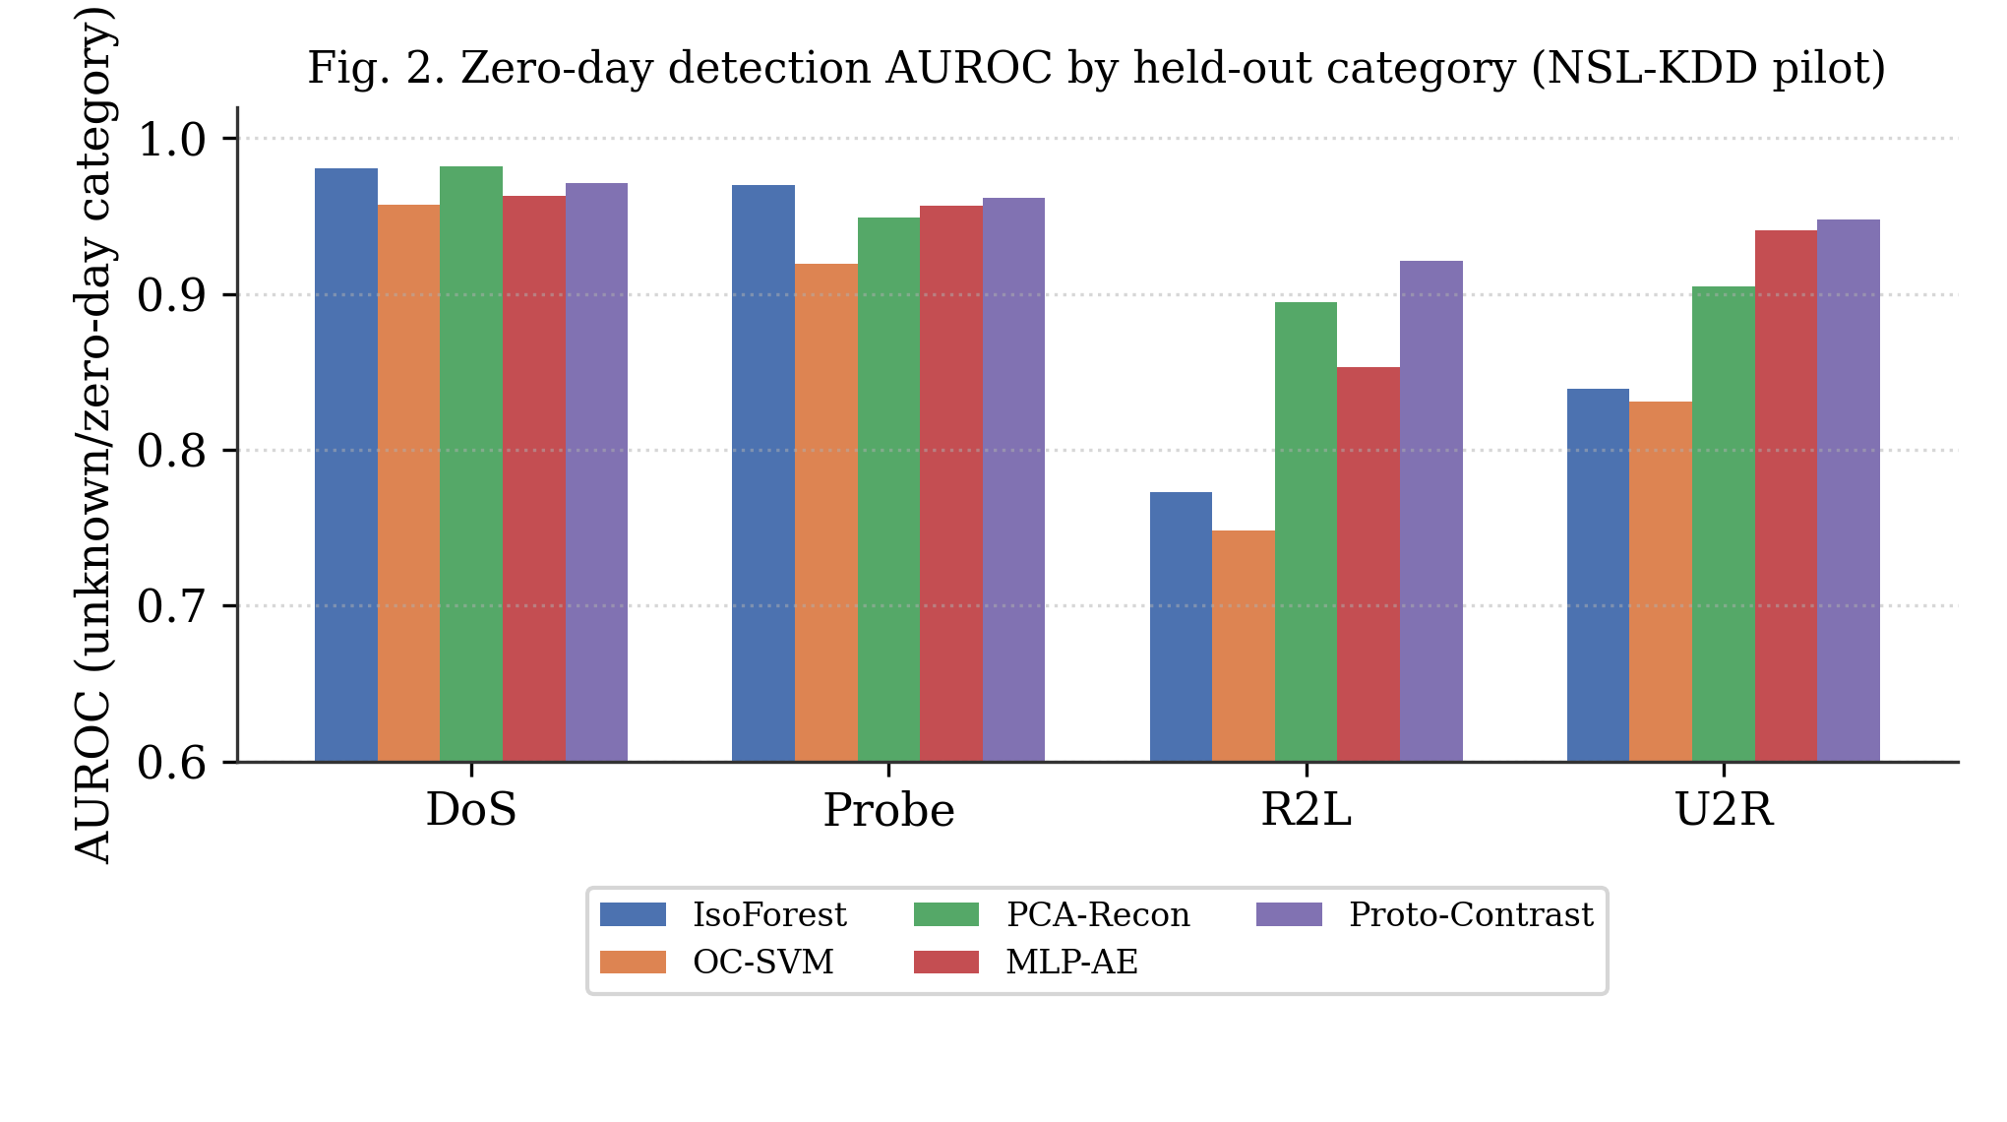
Fig. 3. NSL-KDD zero-day AUROC by held-out category.

TABLE III
NSL-KDD: UNKNOWN DETECTION RATE (UDR) AT 5% BENIGN FPR
Detector | DoS | Probe | R2L | U2R | Mean
Isolation Forest | 0.911 | 0.77 | 0.059 | 0.118 | 0.464
One-Class SVM | 0.92 | 0.793 | 0.385 | 0.647 | 0.686
PCA-Reconstruction | 0.923 | 0.546 | 0.302 | 0.269 | 0.51
MLP-Autoencoder | 0.856 | 0.782 | 0.314 | 0.647 | 0.65
Prototype-Contrastive | 0.881 | 0.808 | 0.555 | 0.681 | 0.731

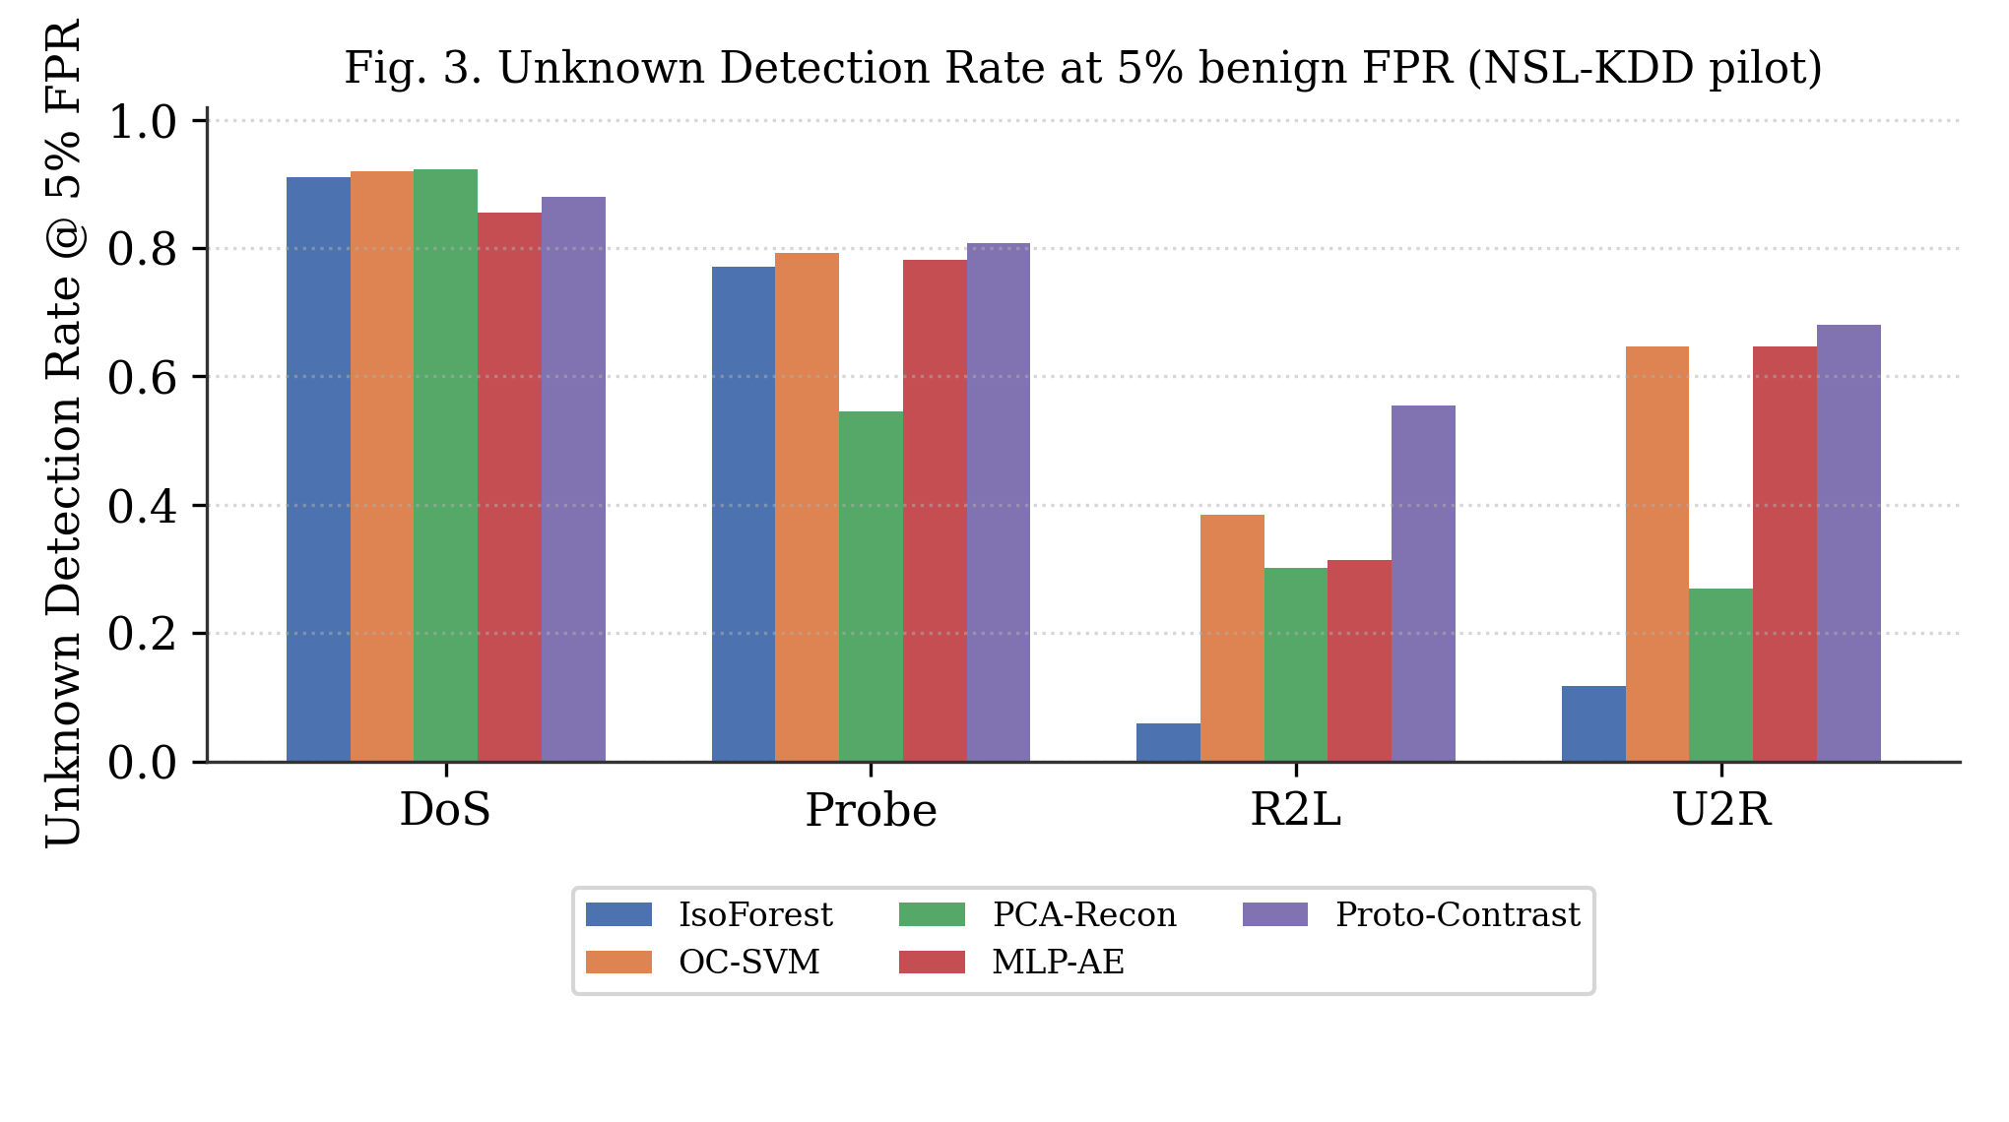
Fig. 4. NSL-KDD Unknown Detection Rate at 5% benign FPR.

TABLE IV
NSL-KDD: AVERAGE DEPLOYMENT COST ACROSS HELD-OUT CATEGORIES
Detector | Train time (s) | Inference (ms/sample) | Model size (KB)
Isolation Forest | 0.42 | 0.005 | 732.1
One-Class SVM | 3.73 | 0.1056 | 974.6
PCA-Reconstruction | 0.03 | 0.0013 | 22.3
MLP-Autoencoder | 3.39 | 0.0012 | 207.2
Prototype-Contrastive | 0.2 | 0.1336 | 238

B. CICIoT2023 Results
Table V and Table VI report AUROC on the unknown category and UDR at 5% FPR for each of CICIoT2023's seven categories; Fig. 7 and Fig. 8 visualize the same results. Table VII reports average cost, visualized jointly with accuracy in Fig. 9. The ranking differs sharply from NSL-KDD: Isolation Forest and PCA-Reconstruction are now the strongest methods, while Prototype-Contrastive — the NSL-KDD winner — is the weakest, including a near-total failure on DoS (AUROC 0.012).

TABLE V
CICIOT2023: AUROC ON UNKNOWN (HELD-OUT) CATEGORY
Detector | DDoS | DoS | Recon | Web | BruteFrc | Spoof | Mirai
Isolation Forest | 0.919 | 0.904 | 0.723 | 0.698 | 0.603 | 0.768 | 0.979
One-Class SVM | 0.734 | 0.669 | 0.749 | 0.771 | 0.773 | 0.7 | 0.486
PCA-Reconstruction | 0.947 | 0.925 | 0.666 | 0.678 | 0.644 | 0.752 | 0.957
MLP-Autoencoder | 0.885 | 0.797 | 0.754 | 0.702 | 0.661 | 0.777 | 0.915
Prototype-Contrastive | 0.468 | 0.012 | 0.368 | 0.367 | 0.481 | 0.556 | 0.677

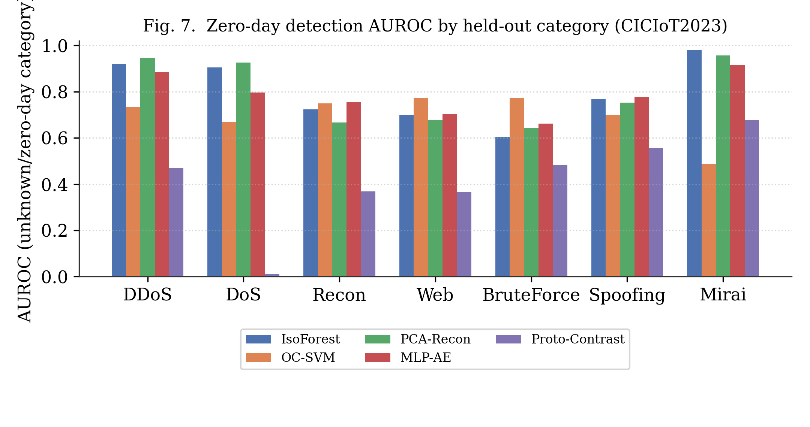
Fig. 7. CICIoT2023 zero-day AUROC by held-out category. Mean across categories: IsoForest 0.799, PCA-Recon 0.796, MLP-AE 0.784, OC-SVM 0.697, Proto-Contrast 0.418.

TABLE VI
CICIOT2023: UNKNOWN DETECTION RATE (UDR) AT 5% BENIGN FPR
Detector | DDoS | DoS | Recon | Web | BruteFrc | Spoof | Mirai
Isolation Forest | 0.327 | 0.432 | 0.05 | 0.089 | 0.01 | 0.307 | 0.987
One-Class SVM | 0.12 | 0.004 | 0.271 | 0.142 | 0.256 | 0.221 | 0.014
PCA-Reconstruction | 0.651 | 0.28 | 0.142 | 0.17 | 0.246 | 0.262 | 0.751
MLP-Autoencoder | 0.313 | 0.083 | 0.247 | 0.198 | 0.246 | 0.304 | 0.371
Prototype-Contrastive | 0.353 | 0.001 | 0.027 | 0.05 | 0.197 | 0.204 | 0.019

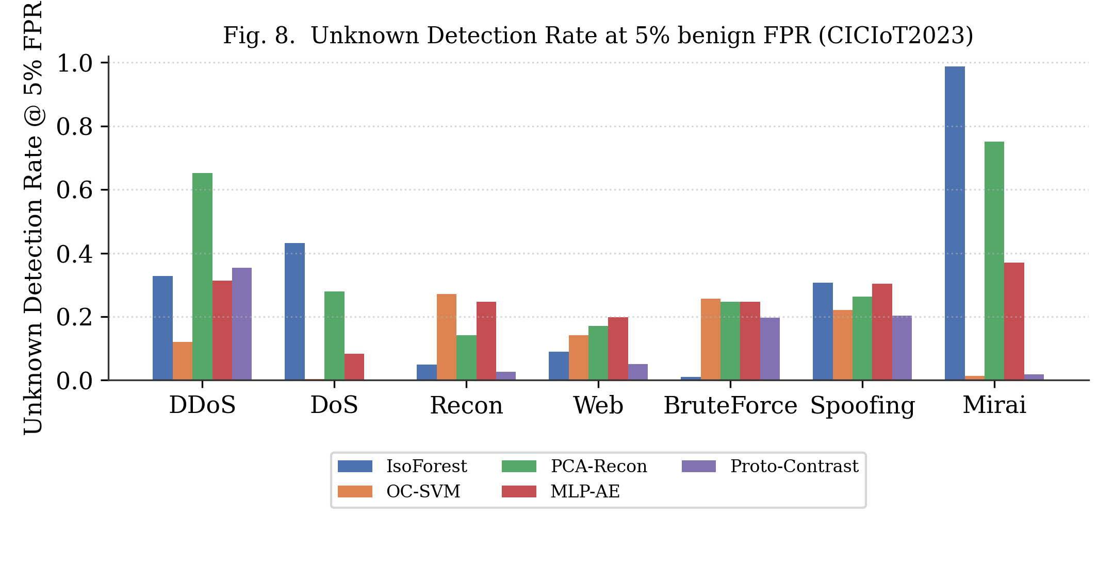
Fig. 8. CICIoT2023 Unknown Detection Rate at 5% benign FPR.

TABLE VII
CICIOT2023: AVERAGE DEPLOYMENT COST ACROSS HELD-OUT CATEGORIES
Detector | Train time (s) | Inference (ms/sample) | Model size (KB)
Isolation Forest | 0.27 | 0.0045 | 1010.5
One-Class SVM | 0.09 | 0.0175 | 81.3
PCA-Reconstruction | 0.01 | 0.0006 | 5.4
MLP-Autoencoder | 3.4 | 0.0009 | 92.5
Prototype-Contrastive | 0.82 | 0.0371 | 36.8

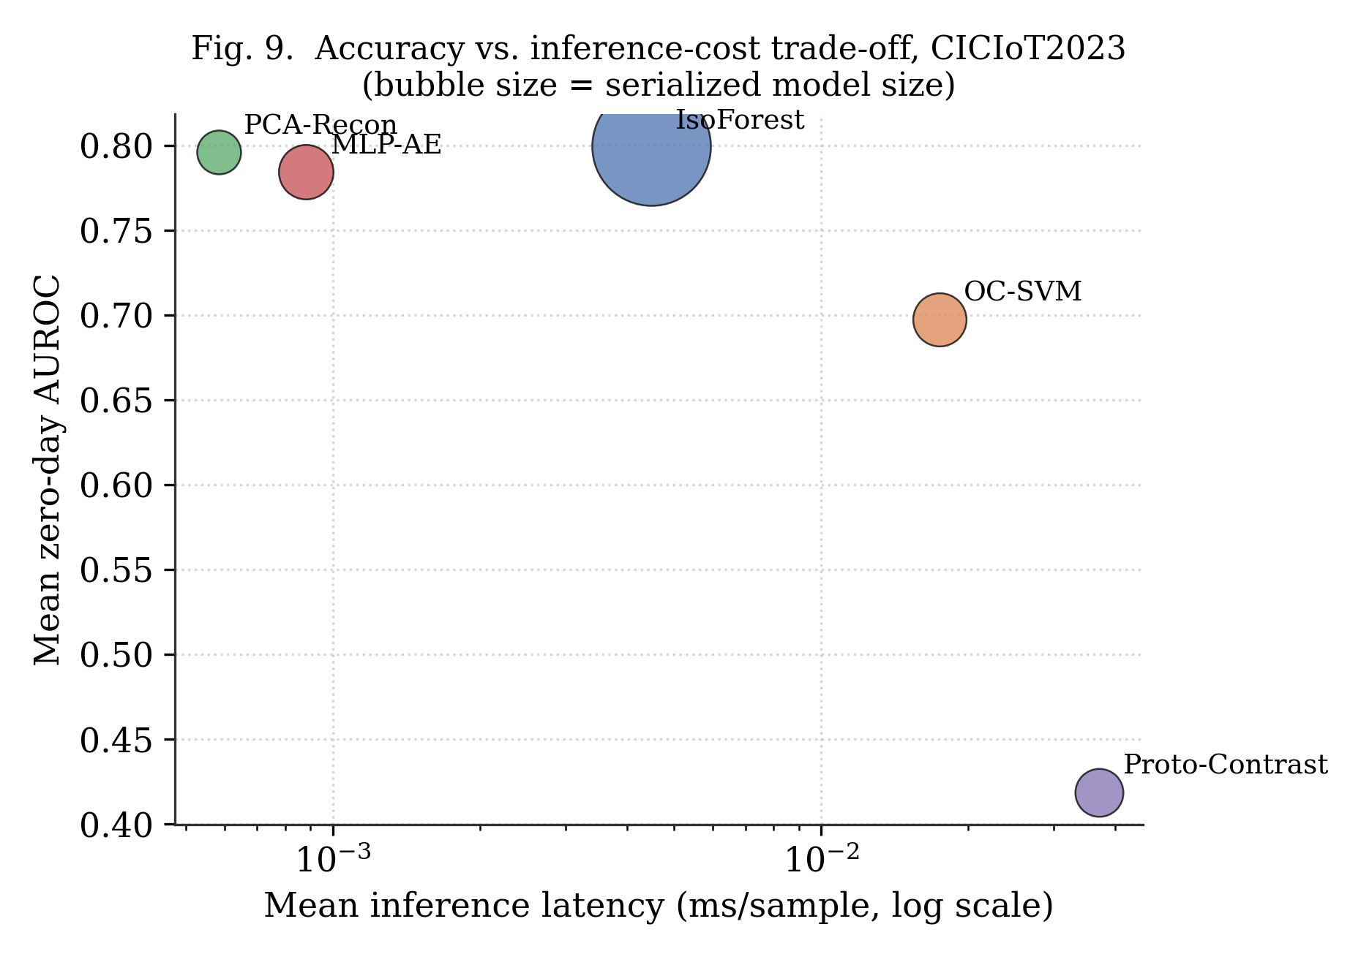
Fig. 9. Accuracy vs. inference-cost trade-off on CICIoT2023. Isolation Forest and PCA-Reconstruction dominate the favorable region; Prototype-Contrastive is cheap but no longer accurate.

C. Cross-Dataset Comparison
Fig. 10 compares each detector's mean zero-day AUROC on NSL-KDD versus CICIoT2023 directly. Isolation Forest (0.891 → 0.799) and PCA-Reconstruction (0.933 → 0.796) degrade only modestly and remain the two most reliable methods on both datasets. MLP-Autoencoder is similarly stable (0.928 → 0.784). One-Class SVM is mediocre on both (0.864 / 0.697). Prototype-Contrastive collapses from best (0.950) to worst (0.418) — a reversal of rank, not just a drop in magnitude.

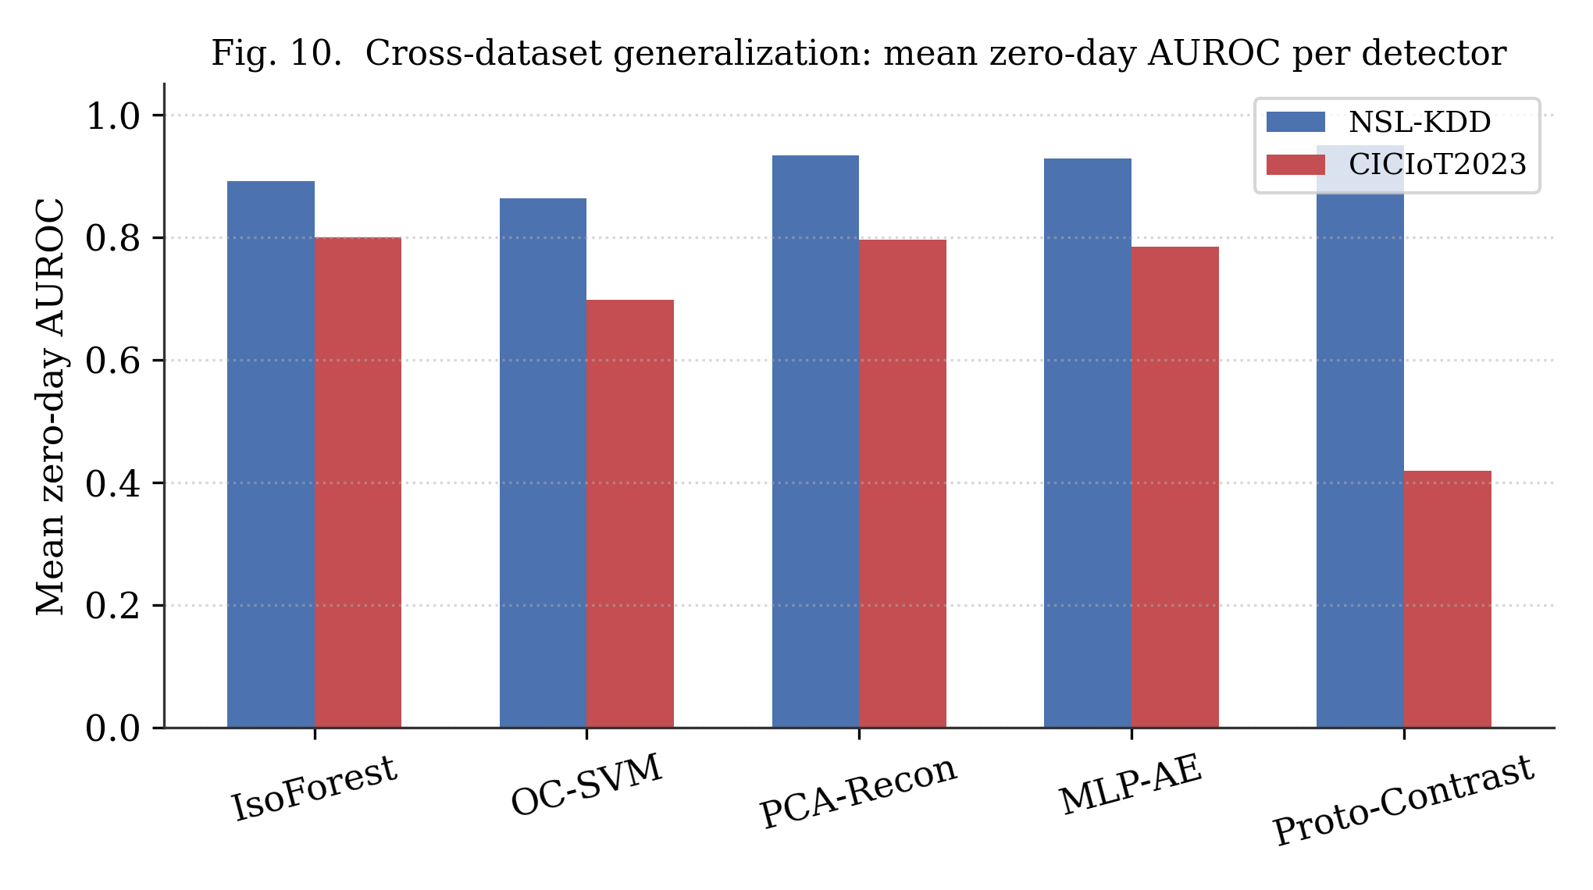
Fig. 10. Cross-dataset generalization: mean zero-day AUROC per detector, NSL-KDD vs. CICIoT2023. Prototype-Contrastive's ranking inverts; Isolation Forest and PCA-Reconstruction are the only methods that stay strong on both.

VI. DISCUSSION
The central finding of this benchmark is not which method wins, but that the winner changes depending on which dataset is used to ask the question. On NSL-KDD, Prototype-Contrastive's shared-covariance, nearest-prototype design gave the best zero-day accuracy at negligible training cost, which would have been a clean, publishable result had this study stopped there. On CICIoT2023, the same method is the weakest of the five, including a near-total failure on DoS (AUROC 0.012, i.e. almost perfectly anti-correlated with the true label). We attribute this to CICIoT2023's far more severe class imbalance — a 2,700× gap between its largest and smallest category, versus roughly 650× on NSL-KDD — which biases a covariance matrix shared across all known classes toward the majority class's (DDoS) local geometry, systematically distorting Mahalanobis distances for minority classes including benign traffic itself (reflected in NSL-KDD-comparable AUROC on known-attack separability collapsing well below 0.5 on several CICIoT2023 categories, i.e. worse than random).
Isolation Forest and PCA-Reconstruction, by contrast, make no shared-covariance assumption across classes — both are fit on benign traffic alone — and this appears to be exactly why they remain the two most dataset-robust methods (mean AUROC 0.80–0.94 on both datasets), despite neither being the single best performer on either dataset individually. PCA-Reconstruction is additionally the cheapest method by a wide margin on both datasets (5–22 KB, sub-millisecond inference), making it the strongest overall candidate for a resource-constrained, dataset-agnostic zero-day IDS deployment based on this benchmark.
Practically, this argues that any lightweight open-set IDS method proposed on the strength of a single-dataset result — including the pilot version of this same study, before CICIoT2023 was added — should be treated as provisional until validated on a second, independently collected dataset with a different class balance.

VII. THREATS TO VALIDITY
Sampling. CICIoT2023 results are computed on an 18%-per-partition stratified sample (744,843 of ≈ 6M rows) rather than the full released dataset, for laptop-scale tractability; the rarest categories (BruteForce: 203 rows, Web: 358 rows) are correspondingly small even after sampling, and results for these two categories in particular should be treated as noisier than the larger categories. Category granularity. Grouping fine-grained labels into top-level categories, standard for both datasets, means a held-out category may still share behavioral similarity with sub-variants of the same category seen in training. Threshold choice. UDR is reported at a single fixed 5% benign FPR operating point. Single-run variance. All results are from a single random seed per dataset; a multi-seed variance analysis was not performed for this draft, and would be particularly valuable for CICIoT2023's smallest categories.

VIII. CONCLUSION AND FUTURE WORK
This paper introduces a leave-category-out benchmark that evaluates open-set / zero-day intrusion detection jointly with deployment cost and, distinctively, cross-dataset consistency. Evaluated on NSL-KDD alone, a lightweight prototype-contrastive method appears to be the clear best choice for zero-day detection; evaluated on the IoT-native CICIoT2023 dataset, the same method is the worst of five candidates, while Isolation Forest and PCA-Reconstruction are the only methods that remain strong on both. The practical recommendation from this benchmark is that PCA-Reconstruction — the cheapest method tested by a wide margin — is the strongest default choice for resource-constrained, dataset-agnostic zero-day IDS deployment, with Isolation Forest as a close, similarly robust alternative. Future work includes: (1) a multi-seed variance analysis, particularly for CICIoT2023's smallest categories; (2) a per-class (rather than shared) covariance variant of the Prototype-Contrastive detector, to test whether the observed collapse is fixable without abandoning the contrastive-scoring idea; (3) reporting UDR at multiple FPR operating points; and (4) extending the benchmark to a third, independently collected dataset to further test the generalization claim made here.

ACKNOWLEDGMENT
I would like to thank Fedosenko Maxim Yurievich, engineer and postgraduate researcher at the Faculty of Secure Information Technologies, ITMO University, for his close guidance and consultation throughout the methodology and implementation of this work. I am also grateful to my scientific supervisor, Prof. Bezzateev Sergey Valentinovich, Doctor of Engineering and Professor at the Faculty of Secure Information Technologies, ITMO University, for his oversight and direction of this research.

REFERENCES
[1] A. Hozouri, A. Mirzaei, and M. Effatparvar, “A comprehensive survey on intrusion detection systems with advances in machine learning, deep learning and emerging cybersecurity challenges,” Discover Artificial Intelligence, Springer, 2025.
[2] S. Sallam, M. El Barachi, and N. Li, “Intrusion Detection on the Internet of Things: A Comprehensive Review and Gap Analysis Toward Real-Time, Lightweight, Adaptive, and Autonomous Security,” MDPI IoT, vol. 7, no. 1, art. 16, 2026.
[3] J. Wilkie et al., “A Novel Contrastive Loss for Zero-Day Network Intrusion Detection,” arXiv:2601.09902, 2026.
[4] Z. Dai, L. Y. Por, Y. L. Chen, J. Yang, C. S. Ku, et al., “An intrusion detection model to detect zero-day attacks in unseen data using machine learning,” PLOS ONE, vol. 19, no. 9, e0308469, 2024.
[5] K. Achuthan, S. Ramanathan, S. Srinivas, and R. Raman, “Advancing cybersecurity and privacy with artificial intelligence: current trends and future research directions,” Frontiers in Big Data, 2024.
[6] Z. Qiu, D. Zhou, Y. Zhai, B. Liu, L. He, and J. Cao, “VAEMax: Open-Set Intrusion Detection based on OpenMax and Variational Autoencoder,” arXiv:2403.04193, 2024.
[7] W. Yao, L. Hu, Y. Hou, and X. Li, “A Lightweight Intelligent Network Intrusion Detection System Using One-Class Autoencoder and Ensemble Learning for IoT,” Sensors, vol. 23, no. 8, p. 4141, 2023.
[8] E. C. P. Neto et al., “CICIoT2023: A Real-Time Dataset and Benchmark for Large-Scale Attacks in IoT Environment,” Sensors, vol. 23, no. 13, p. 5941, 2023.
[9] V. Karanam, “Is there a Trojan! Literature survey and critical evaluation of the latest ML based modern intrusion detection systems in IoT environments,” arXiv:2310.10778, 2023.
[10] A. Amara Korba, A. Boualouache, and Y. Ghamri-Doudane, “Zero-X: A Blockchain-Enabled Open-Set Federated Learning Framework for Zero-Day Attack Detection in IoV,” arXiv:2407.02969, 2024.
[11] M. Tavallaee, E. Bagheri, W. Lu, and A. A. Ghorbani, “A detailed analysis of the KDD CUP 99 data set,” in Proc. IEEE Symp. Computational Intelligence for Security and Defense Applications, 2009 (NSL-KDD).

AUTHOR BIOGRAPHY
Hilux Fokou Ngoumo is an M.Sc. student in Information Security at the Faculty of Secure Information Technologies, ITMO University, Saint Petersburg, Russia, expected to graduate in 2027. His academic focus spans applied machine learning and network security, with prior coursework and independent projects in cloud computing (AWS Academy Graduate) and software development. This paper is part of his M.Sc. thesis research, supervised by Prof. Bezzateev Sergey Valentinovich (Professor, Faculty of Secure Information Technologies, ITMO University), with Fedosenko Maxim Yurievich (engineer and postgraduate researcher, same faculty) as working consultant. Contact: hilux.fokou@niuitmo.ru.

This paper is based on my M.Sc. thesis in Information Security, supervised by Prof. Bezzateev Sergey Valentinovich, Doctor of Engineering and Professor, Faculty of Secure Information Technologies, ITMO University, with Fedosenko Maxim Yurievich, engineer and postgraduate researcher at the same faculty, as working consultant.

