**Composition induced changes in optical response of Ti1-xSixO2 from first principles calculations**

*Pavel Ondračkaa,b, David Holecc, Eva Kedroňováa,b, Marek Eliáša,b, Stéphane Elisabethd, Antoine Goulletd, Lenka Zajíčkováa,b*

*a Faculty of Science, Masaryk University, Kotlářská 2, 611 37 Brno, Czech Republic*

*b CEITEC - Central European Institute of Technology, Masaryk University, Kotlářská 2, 611 37 Brno, Czech Republic*

*c Department of Physical Metallurgy and Materials Testing, Montanuniversität Leoben, Franz-Josef-Straße 18, Leoben A-8700, Austria*

*d Institut des Matériaux Jean Rouxel (IMN), Université de Nantes, UMR CNRS 6502, 2 rue de la Houssinière, BP 32229, 44322 Nantes Cedex 3, France*

email address of the presenting author: [pavel.ondracka@gmail.com](mailto:pavel.ondracka@gmail.com)

Mixed TixSiyO2 materials offer great potential for compositionally induced variation of their optical properties, due to the high difference of their refractive indices (TiO2: ~2.5, SiO2: ~1.5) and band gaps (TiO2: ~3.2 eV, SiO2: ~8.5 eV). This opens new possibilities for designing optical devices.

In the present work, the variation of Ti1-xSixO2 optical constants caused by changed Si concentration is studied by employing Density Functional Theory. Special Quasi-random Structures method is used to generate structural models of Ti1-xSixO2 disordered solid solutions based on various TiO2 and SiO2 phases. These initial supercells are fully structurally optimized (i.e., optimized with respect to the cell shape, size, and atomic positions) using the Vienna Ab initio Simulation Package. Ab initio Molecular Dynamics approach (“simulated annealing”) is used to generate structural models of the amorphous phase. Optical constants of the resulting structures are calculated using the linearized augmented plane wave method as implemented in the all-electron Wien2k code together with the modified Becke-Johnson exchange-correlation potential allowing for an accurate prediction of electronic structures and band gaps [1].

The calculated dielectric function and band gaps are compared with experimental data obtained by fitting the optical measurements (ellipsometry, spectrophotometry) carried out on Ti1-xSixO2 films prepared by plasma enhanced chemical vapor deposition and atomic layer deposition.

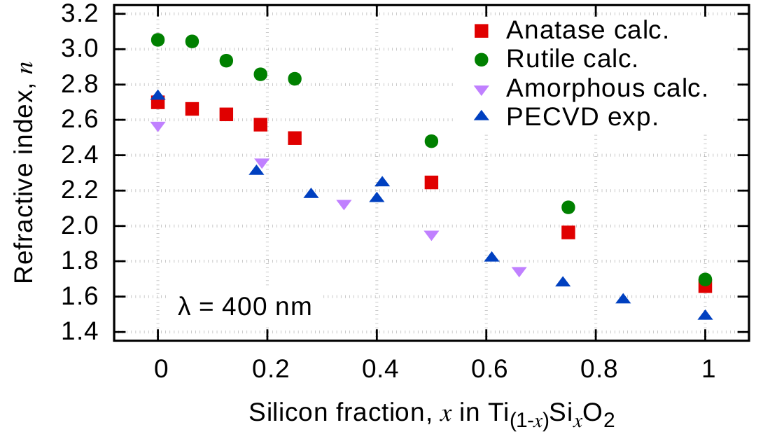

Figure 1: Predicted and measured evolution of refractive index of Ti1–xSixO2

[1] F. Tran, P. Blaha, Phys. Rev. Lett. 102 (2009) 226401.