Project Synopsis

on

**TERRAIN PREDICTION**

Submitted as a part of course curriculum for

**Bachelor of Technology**

in

**Computer Science**



**Submitted by**

Himanshu Singh (2200290120083)

Krishna Kant Gupta (2200290120090)

Sanidhya Singh (2200290120148)

**Under the Supervision of**

PROF VIVEK KUMAR SHARMA

**KIET Group of Institutions, Ghaziabad**

**Department of Computer Science**

**Dr. A.P.J. Abdul Kalam Technical University**

**2024-2025**

**ACKNOWLEDGEMENT**

It gives us a great sense of pleasure to present the synopsis of the B.Tech Mini Project undertaken during B.Tech. Third Year. We owe a special debt of gratitude to PROF VIVEK KUMAR SHARMA(Project Guide), Department of Computer Science, KIET Group of Institutions, Delhi- NCR, Ghaziabad, for his constant support and guidance throughout the course of our work. His sincerity, thoroughness and perseverance have been a constant source of inspiration for us. It is only his/her cognizant efforts that our endeavours have seen the light of the day.

We also take the opportunity to acknowledge the contribution of Dr. Ajay Kumar Shrivastava, Head of the Department of Computer Science, KIET Group of Institutions, Delhi- NCR, Ghaziabad, for his full support and assistance during the development of the project. We also do not like to miss the opportunity to acknowledge the contribution of all the faculty members of the department for their kind assistance and cooperation during the development of our project.

Last but not the least, we acknowledge our friends for their contribution to the completion of the project.

Signature: Guide Name & Signature

Student’s Name:

Roll No: Signature

Project coordinator

**ABSTRACT**

This project explores the application of Convolutional Neural Networks (CNNs) for terrain prediction, a critical task in fields such as environmental monitoring, urban planning, and autonomous navigation. The objective is to develop a CNN-based model capable of accurately predicting and classifying terrain types from high-resolution satellite or aerial imagery.

The project encompasses several key stages. Initially, it involves acquiring and preprocessing a substantial dataset of terrain images, including tasks such as normalization, augmentation, and segmentation to enhance the quality and variety of training data. A custom CNN architecture is then designed, featuring multiple convolutional and pooling layers to capture spatial hierarchies and patterns in the imagery.

The model is trained using a supervised learning approach, with rigorous hyperparameter tuning and cross-validation to optimize performance. Evaluation metrics such as accuracy, precision, and recall are used to assess model effectiveness. Additionally, the project includes visualizations of the predicted terrain classifications, providing a clear demonstration of the model’s capabilities.

In conclusion, this project successfully applies deep learning techniques to improve terrain prediction, offering valuable insights for both academic research and practical applications in terrain analysis.

**CHAPTER 1 INTRODUCTION**

**1.1 Introduction**

Terrain prediction is an essential task in various fields, such as autonomous vehicle navigation, military operations, environmental monitoring, and disaster management. Understanding and predicting terrain features can aid in safe and efficient navigation, resource planning, and environmental protection. Traditional methods of terrain analysis rely heavily on human expertise and manually interpreted data, which can be time-consuming and error-prone. With advancements in deep learning, specifically Convolutional Neural Networks (CNN), terrain prediction can now be automated, providing accurate and real-time results. CNNs are particularly suited for this task because of their ability to detect patterns and features in spatial data like images.

* 1. **Problem Statement**

Current methods for terrain prediction often involve manual analysis, which is labor-intensive and subject to human error. These methods are not scalable for large-scale or real-time applications, such as autonomous navigation or rapid disaster response. The need for an automated system that can predict terrain features from satellite or aerial imagery with high accuracy is critical. This project aims to address this problem by leveraging CNN-based models for efficient and accurate terrain classification and prediction.

* 1. **Objective**

The primary objective of this project is to develop a terrain prediction system using Convolutional Neural Networks (CNN). The system should be able to:

* Classify different terrain types (e.g., mountains, forests, rivers, deserts) based on satellite or aerial images.
* Achieve high accuracy and robustness in the predictions across varying image resolutions and conditions.
* Provide a scalable solution that can be applied to real-time applications like autonomous vehicle navigation and disaster management.
  1. **Scope**

This project will focus on the following areas:

* Data collection and preprocessing: Gathering satellite or aerial imagery for training and testing the CNN model.
* Model design and training: Developing and fine-tuning a CNN model for terrain classification.
* Evaluation and testing: Validating the model's accuracy, efficiency, and generalization to unseen data.
* Application areas: The project will consider use cases in autonomous vehicle navigation, military operations, and environmental monitoring.

**CHAPTER 2 LITERATURE REVIEW**

**Terrain Prediction and Classification**

Terrain prediction is a critical task in areas such as geospatial analysis, environmental monitoring, and autonomous navigation. Traditionally, terrain classification methods involved manual interpretation of satellite and aerial imagery, which was labor-intensive and prone to human error, particularly with large datasets. Early machine learning techniques, such as Support Vector Machines (SVMs) and Random Forests, introduced automation but still required extensive feature engineering, which limited their scalability and effectiveness in handling complex terrain data. For example, SVMs were used to classify hyperspectral remote sensing data, but these models required careful design of input features, making them inefficient for large-scale terrain classification tasks.

The development of Convolutional Neural Networks (CNNs) has revolutionized terrain prediction and classification by eliminating the need for manual feature extraction. CNNs are capable of learning hierarchical features directly from raw pixel data, making them highly effective in terrain classification tasks. Cheng et al. (2016) demonstrated that CNNs could achieve state-of-the-art performance in classifying remote sensing images, particularly in land-use classification, by learning rotation-invariant features. Zhang et al. (2018) also used CNNs to classify high-resolution satellite images, showing that CNNs outperform traditional methods in distinguishing urban and rural landscapes by handling high spatial variability in the data. These studies showcase the effectiveness of CNNs in improving the accuracy and efficiency of terrain classification.

**CNNs in Terrain Classification**

CNNs have become the dominant approach for terrain classification due to their ability to automatically learn spatial features from large datasets. Xu et al. (2019) extended the application of CNNs to multi-scale terrain classification, demonstrating that deep learning models, especially CNNs, significantly outperformed traditional machine learning algorithms in large and complex datasets. Their research used both optical and hyperspectral images, underscoring CNNs' dominance in terrain prediction. Li et al. (2020) proposed a multi-scale CNN architecture that integrated features from different spatial resolutions to improve prediction accuracy, particularly for identifying terrain boundaries like coastlines and mountain ridges, where traditional methods struggled.

**CNNs for Hyperspectral Image Classification**

Hyperspectral imagery presents unique challenges due to its high-dimensional data, but CNNs have proven effective in handling these challenges. Sumbul et al. (2019) explored the use of 3D CNNs for hyperspectral image classification, highlighting the ability of CNNs to manage the high dimensionality and variability of hyperspectral data, which is crucial for terrain prediction tasks. Their model demonstrated that CNNs can outperform other machine learning models in hyperspectral terrain classification, particularly when dealing with large volumes of spectral information. This approach contributes to the growing understanding of how CNNs can be adapted to handle more complex data types.

**Challenges in Terrain Prediction**

Despite the success of CNNs in terrain prediction, there are several challenges that need to be addressed. Data availability and quality remain significant obstacles, especially for remote or complex terrains where labeled datasets are scarce. Manual annotation of high-resolution remote sensing data is costly and time-consuming, which limits the availability of quality training data. Furthermore, the computational complexity of CNNs is another challenge, particularly when processing high-resolution imagery. CNNs require powerful hardware, such as GPUs or TPUs, to efficiently process large datasets. Li et al. (2020) emphasized the importance of optimized computational resources to improve the efficiency of CNNs when dealing with high-dimensional data.

Generalization is another challenge for CNN-based terrain prediction models. CNNs trained on one dataset may not generalize well to new, unseen data, especially in different geographic regions. Xu et al. (2019) and Li et al. (2020) noted that CNNs often perform poorly when applied to datasets from different environments, which limits their applicability. Transfer learning has emerged as a potential solution to improve generalization by enabling models trained on large, labeled datasets to be fine-tuned for specific regions or tasks.

**Future Directions**

The field of terrain prediction continues to evolve, with researchers exploring hybrid models that combine CNNs with other deep learning techniques. For instance, Sumbul et al. (2019) demonstrated the use of 3D CNNs in hyperspectral image classification, while Li et al. (2020) introduced multi-scale features to enhance terrain prediction. Additionally, as hardware and software optimizations improve, the computational challenges of CNNs may become more manageable, paving the way for real-time terrain prediction in applications such as autonomous systems and disaster management. The integration of CNNs with Geographic Information Systems (GIS) is another promising direction, allowing for real-time, actionable terrain analysis. With continued advancements in technology, CNN-based terrain prediction systems are expected to become increasingly scalable and efficient, opening up new possibilities for terrain analysis across various industries.

**CHAPTER 3 PROBLEM STATEMENT**

The challenges associated with terrain prediction have far-reaching implications in fields such as autonomous navigation, environmental monitoring, and disaster response. Current methods for terrain prediction are primarily manual and labor-intensive, relying heavily on human expertise for analysis of satellite or aerial imagery. This approach is not only time-consuming but also prone to human error, making it unsuitable for real-time or large-scale applications.

Traditional machine learning methods, while offering partial automation, require extensive feature engineering and struggle to capture the intricate spatial dependencies inherent in terrain data. These models are often limited in their scalability, accuracy, and generalization capabilities, failing to meet the demands of modern applications. For instance, algorithms like Support Vector Machines (SVMs) and Random Forests have demonstrated limited success in terrain classification but cannot effectively handle the complexity and variability of high-resolution image data.

Furthermore, the lack of robust, automated terrain prediction systems contributes to inefficiencies in critical areas. Autonomous vehicles, for example, require precise and reliable terrain information to navigate safely, while disaster management efforts depend on accurate terrain analysis for planning and response. The absence of a scalable solution also limits advancements in military operations and resource planning.

Key challenges include:

1. The scalability of current methods to handle large datasets and real-time applications.
2. Inadequate accuracy in identifying complex terrain features.
3. Poor generalization of models trained on one dataset to other geographic regions.
4. Limited availability of high-quality, labelled datasets for training robust models.

This project seeks to address these challenges by developing a Convolutional Neural Network (CNN)-based terrain prediction system. CNNs are uniquely suited for this task due to their ability to automatically learn and extract spatial hierarchies and patterns from raw image data. By leveraging CNNs, the proposed system aims to provide a scalable, accurate, and efficient solution for terrain prediction, ultimately improving applications in autonomous navigation, disaster management, and other critical areas.

**CHAPTER 4 OBJECTIVE**

The primary objective of this project is to develop a robust and efficient terrain prediction system using Convolutional Neural Networks (CNNs). This system aims to address the limitations of traditional methods by automating the process of terrain classification and ensuring high accuracy and scalability.

The specific objectives include:

1. **Accurate Classification**: To classify different types of terrain, such as mountains, forests, rivers, and deserts, using high-resolution satellite or aerial imagery.
2. **Scalability**: To design a system capable of handling large datasets and processing real-time terrain data for applications such as autonomous navigation and disaster management.
3. **Robustness**: To achieve consistent and reliable performance across varying image resolutions, environmental conditions, and geographic regions.
4. **Data Preprocessing**: To establish effective preprocessing techniques, including data normalization, augmentation, and segmentation, for enhancing training data quality.
5. **Model Optimization**: To develop and fine-tune the CNN architecture to maximize performance through rigorous hyperparameter tuning and cross-validation.
6. **Real-World Application**: To create a system applicable to various fields, including military operations, urban planning, environmental monitoring, and resource management.

The project aspires to bridge the gap between traditional terrain analysis methods

and modern machine learning techniques, providing a scalable solution that aligns

with current technological advancements and industry requirements.

**CHAPTER 5**

**(a)PROPOSED METHODOLOGY**

**5.1 Work Flowchart**

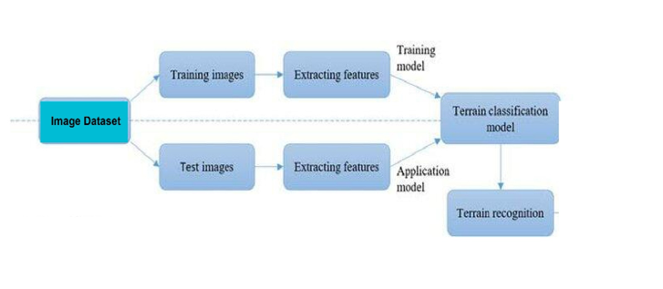

**5.2 Algorithm Proposed**

The proposed solution leverages Convolutional Neural Networks (CNNs) for terrain prediction and classification from remote sensing data (e.g., multispectral or hyperspectral satellite images). The CNN architecture is chosen due to its capability to automatically extract hierarchical spatial features from raw images, making it highly suitable for complex terrain classification tasks. Below is the detailed methodology:

* 1. **Data Preprocessing:**
* **Data Collection**: Satellite images will be obtained from publicly available sources such as Landsat and Sentinel-2.
* **Cleaning and Augmentation**: Preprocessing steps such as cloud masking and data augmentation (e.g., flipping, rotation) will be applied to ensure data quality and increase dataset size.
* **Normalization and Labeling**: Pixel values will be normalized, and data will be labeled using available terrain maps or manually annotated through GIS tools.
  1. **CNN Architecture Design:**
* **Convolutional Layers**: Multiple convolutional layers will be used to automatically learn features from the satellite images.
* **Activation Functions**: ReLU activation will be employed after each convolutional layer to introduce non-linearity into the model.
* **Pooling Layers**: Max-pooling layers will reduce spatial dimensions and retain important features, making the model more computationally efficient.
* **Fully Connected Layer and Classification**: A fully connected layer will process the extracted features and classify the terrain using a softmax activation for multi-class output.
  1. **Model Training and Optimization:**
* **Loss Function**: Categorical cross-entropy will be used to measure the difference between predicted and true terrain classes.
* **Optimizer**: The Adam optimizer will be utilized to adjust weights and minimize loss during training.

**(b)TECHNOLOGY USED**

This segment outlines the key technologies employed in developing the terrain prediction and classification system. These technologies enable efficient processing, model training, and user interaction through a web application.

* 1. **Programming Language: Python**

Python is the primary language due to its simplicity and extensive libraries for machine learning and data processing. Its versatility facilitates the integration of various components in the system.

* 1. **Deep Learning Frameworks: TensorFlow and PyTorch**

**TensorFlow**: Used for building and training the Convolutional Neural Network

(CNN). It supports large-scale training and GPU acceleration.

**PyTorch**: Utilized for research purposes due to its dynamic computational

graph, allowing for easier experimentation and debugging.

* 1. **Data Processing Libraries**

**NumPy**: Handles numerical operations and large datasets efficiently.

**Pandas**: Simplifies data manipulation and analysis, particularly for cleaning and

organizing data.

**OpenCV**: Used for image processing tasks, such as resizing and augmenting

satellite images.

* 1. **Hardware: GPUs**

GPUs are employed to accelerate the training of deep learning models, significantly reducing training time by enabling parallel processing of data.

* 1. **Version Control: Git and GitHub**

Git manages code versions, while GitHub facilitates collaboration among team members. This setup allows for tracking changes and ensuring code integrity.

* 1. **Web Application Technologies**

**Frontend**: Built using HTML, CSS, and JavaScript to create an interactive and user-friendly interface.

**Backend**: Flask serves as the backend framework, handling requests and processing input data.

**Bootstrap**: Used for responsive design, ensuring the web application is mobile-friendly.

* 1. **Visualization Tools**

**Matplotlib**: For visualizing training metrics like accuracy and loss.

**Plotly**: Provides interactive visualizations for displaying classification results on the web interface.

**ER Diagram**

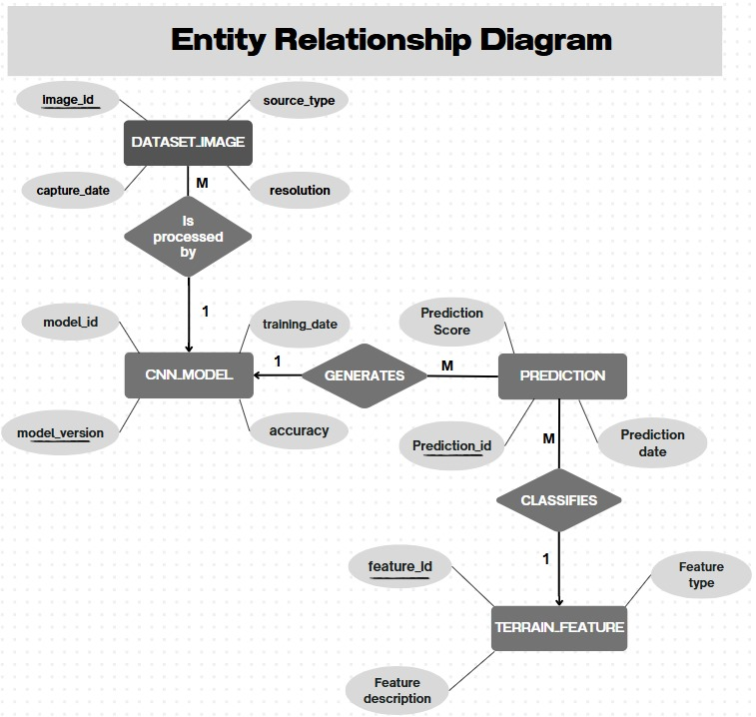

**CHAPTER 6 EXPECTED OUTCOMES**

The expected outcomes of this project are focused on achieving a high level of

accuracy, efficiency, and scalability in the terrain prediction system using

Convolutional Neural Networks (CNNs). The following outcomes are anticipated:

1. Accurate Terrain Classification: The model is expected to classify various terrain types (such as mountains, forests, rivers, and deserts) from satellite or aerial imagery with high accuracy. The system will effectively distinguish between different terrain features, even in complex and variable environments, by leveraging CNN’s ability to learn spatial hierarchies and patterns.
2. Improved Generalization: The trained model will be capable of generalizing well to new, unseen data. It is expected to maintain robust performance across different regions and varying image resolutions, making it adaptable to a wide range of real-world terrain data.
3. Real-time Processing: The project aims to demonstrate the ability to process satellite images in near-real-time, enabling practical applications like autonomous vehicle navigation and real-time disaster management. This outcome will address the scalability limitations of traditional methods and provide a framework suitable for large-scale deployment.
4. Data Preprocessing Pipeline: A comprehensive data preprocessing pipeline will be developed, ensuring that the data used to train the model is clean, augmented, and normalized. This step will increase the diversity and quality of the dataset, enhancing the model's ability to make accurate predictions.
5. User-Friendly Interface: The project will include the development of a web application or user interface that allows users to upload images and receive predictions. The interface will be intuitive, enabling users to interact with the system easily, even if they lack technical expertise.
6. Evaluation Metrics: The model will be evaluated using standard metrics such as accuracy, precision, recall, and F1-score. These metrics will assess how well the model performs in terms of correct classifications and its ability to minimize false positives and negatives.
7. Visualization of Results: The model’s output will be visualized using heatmaps, overlays, or color-coded maps, providing clear and actionable insights into the terrain classification process. This visualization will be useful for both academic analysis and practical applications in fields such as environmental monitoring and urban planning.
8. Scalable Solution: The proposed system is expected to be scalable, capable of handling large datasets and integrating seamlessly into real-time systems. The use of GPUs and optimized algorithms will ensure that the system can be deployed in environments where large-scale, high-resolution data is processed continuously.
9. Impact on Key Industries: The successful implementation of the terrain prediction system will have significant impacts on industries that rely on terrain data, such as autonomous driving, environmental monitoring, agriculture, and disaster response. By providing accurate, real-time terrain information, the system will enhance decision-making and contribute to safer and more efficient operations.

**CHAPTER 7 CONCLUSION**

In this project, we developed a robust terrain prediction and classification system utilizing deep learning techniques, specifically Convolutional Neural Networks (CNNs). The integration of advanced algorithms with cutting-edge technologies has enabled us to achieve significant improvements in the accuracy and efficiency of terrain classification tasks.

The key findings of this project demonstrate that CNNs outperform traditional machine learning methods in identifying complex terrain patterns from satellite and aerial imagery. By leveraging high-dimensional data through effective preprocessing techniques, our model effectively captures the intricate spatial structures that characterize various terrains.

Additionally, the implementation of a web application provides an intuitive interface for users to upload images and obtain real-time predictions. This user-friendly approach not only facilitates accessibility but also enhances the practical utility of the system in fields such as environmental monitoring, urban planning, and disaster response.

Despite the advancements made, several challenges were encountered during the project, including data availability, generalization across different terrain types, and the computational demands of training deep learning models. Future work should focus on addressing these challenges by exploring techniques such as transfer learning, data augmentation, and hybrid models that combine CNNs with other machine learning algorithms.

In conclusion, this project not only demonstrates the potential of deep learning in terrain prediction but also sets the foundation for further research and development in this area. The insights gained through this study contribute to the broader field of geospatial analysis, highlighting the transformative impact of machine learning on understanding and interpreting complex environmental data.

**REFERENCES**

1. J. Cheng, P. Zhou, and J. Han, "Learning rotation-invariant convolutional neural networks for object detection in VHR optical remote sensing images," *IEEE Transactions on Geoscience and Remote Sensing*, vol. 54, no. 12, pp. 7405–7415, Dec. 2016.
2. X. Zhang, Y. Li, Z. Wang, and C. Shen, "Land-use classification of very high-resolution remote sensing images using a deep convolutional neural network," *IEEE Journal of Selected Topics in Applied Earth Observations and Remote Sensing*, vol. 11, no. 10, pp. 3701–3712, Oct. 2018.
3. X. Xu, L. Wang, G. Wu, and S. Ma, "Multi-scale convolutional neural network for terrain classification based on high-resolution remote sensing images," *Remote Sensing*, vol. 11, no. 10, pp. 1–15, May 2019.
4. S. Sumbul, H. Lefèvre, L. F. Díaz, and M. Pelcat, "CNN-based hyperspectral image classification using 3D convolutional neural networks," in *Proc. IEEE Int. Conf. on Image Processing (ICIP)*, Taipei, Taiwan, 2019, pp. 1964-1968.
5. X. Li, Q. Guo, M. Gong, and X. Sun, "Multi-scale CNN for terrain classification using high-resolution remote sensing imagery," *IEEE Transactions on Image Processing*, vol. 29, pp. 3036–3050, Mar. 2020.