FLAPPY BIRD GAME
PROJECT REPORT

Sumbitted By-;
Ankit Kumar 11907132
Akshat Jain 11911838
Himanshu Mishra 11907174
A project submitted in partial fulfillment of the requirement for the semester of B-Tech CSE.


LOVELY PROFESSIONAL UNIVERSITY

SUMBITTED TO-;
Dr. Rahul
5 Nov 2020

ACKNOWLEDGEMENT
In accomplishment of this project, we would like to add a few words of appreciation for the people who have guided and assisted us in getting this outcome. We owe our profound gratitude to our project guide Dr Rahul sir, who took keen interest on our project work and guided us all along, till the completion of our project work by providing all the necessary information for development of this application.
His constant suggestions for improvements made our work easier and proficient.
Lastly, we are thankful and fortunate to get support and remarks from our colleagues and everyone else who directly or indirectly helped us through its completion.

ABSTRACT
The Project exacty follows rules like that of the original game known as flappy bird.
The rules and regulation of the game are very basic and easy to understand. The game scenario puts the player in control of a hovering dot in the screen with moving obstacles of pipelines.
The goal of the game is to get through the opening in the obstacles without colliding into them.
The game is implemented in Python language. The case study discusses the use of simpler motion and modification to build the abstraction.
In addition, this report will also discuss the strategies used to stimulate the crowd pattern in the leisure environment. The game is in single player mode.
The user can interact with the game using keyboard. The position of the obstacles will also be discussed. The game is a 2D game with the purpose to keep the dot moving forward.

TABLE OF CONTENTS

ACKNOWLEDGEMENT...............................................................................I

ABSTRACT................................................................................................II

Introduction...........................................................................................III

Results....................................................................................................IV

Conclusion................................................................................................V

Introduction
History of Flappy Dot-;
It is an abstraction of the original game Flappy Bird. Flappy Bird is a 2013, developed by - Nguy n He Đông (Dong Nguyen) and published by. GEARS Studios, a small, independent game developer also based in Vietnam.
The game is where the player controls a bird, attempting to fly between rows of green pipes without hitting them.
Flappy Bird was removed from both and by its creator on February 10, 2014, due to guilt over what he considered to be its addictive nature and overuse.
The game's popularity and sudden removal caused phones with it preinstalled to be put up for sale for high prices over the Internet. Games like Flappy Bird became popular on the iTunes App Store in the wake of its removal, and both Apple and Google have removed games from their app stores for being too like to the original. The game has also been distributed through unofficial channels on multiple platforms.
Release Flappy Bird was originally released on May 24, 2013, The game was subsequently updated for in September 2013.
In January 2014, it topped the Free Apps chart in the US and Chinese, and later that month topped the same section of the UK App Store where it was touted as "the new ". It ended January as the most downloaded App on the App Store.
The Android version of Flappy Bird was released to the Google Play store on January 30, 2014. In early 2014, Nguyen claimed in an interview with that the game was earning around $50,000 a day in revenue through it.
On February 8, 2014, due to its discontinuation Nguyen announced on that the game was to be removed from both Android and app store and, writing: "I am sorry 'Flappy Bird' users, 22 hours from now, I will take 'Flappy Bird' down. I cannot take this anymore." He went on to say that taking down the game has "nothing to do with legal issues."
The game was removed from both Apple's App Store and Google Play exactly on time, much to the dismay of many fans. Today The removal has spawned remakes and parodies of the game such as 's Flappy Bert and 's Fall Out Bird.
Flappy Bird became one of the most cloned games in Apple's App Store. At the peak of its popularity, over 60 clones per day Document shared on were appearing on the App Store, prompting both Google and Apple to begin rejecting games with the word "Flappy" in the name. reviewed seven "Flappy copycats" for two days after the original game's removal, describing the options as "pretty bleak", but singling out the underwater as the closest approximation of Flappy Bird.
Shortly after the game's removal, security researchers warned that some versions of Flappy Bird and its imitators available on alternative Android app stores have been found to contain that can lead to unauthorized charges to a user's phone bills.
The number matching game has been compared to Flappy Bird because of the similarities between how people react to them and by the chain of clones that they are both respectively part of.
Flappy Dot is a modified and simpler version of the original game. The objective of the game is to pass through the pipelines without running into them. The addictive nature of the game makes it more interesting to play. It is comparatively, an easy game and can be played without network connectivity.

This project is the replica of flappy bird with some changes.
And some of the features of this project are:
• GUI Interface
• Single player game
• Less graphics
We made this game or project so that we could give our best in possible ways and show what we learned. The objectives of this project are:
• To play the famous game flappy bird in computer.
• To make it user friendly.
• To provide an easy interface.
• To entertain people in their leisure time.

System Study of our Project-;
Existing System For the game to feel like Flappy Bird, the focus is given on the game play.
The two essential elements that the game needs to get right are the Bird and the pipes.
Specifically, the bird must move like Flappy Bird, and our pipes must generate and move exactly as do their Green counterparts. It makes use of just seven colors. The bird is scaled accordingly to fit the device width.
The bird also comes in three different color schemes, alternating randomly. Bird Physics -;
• The bird accelerates due to gravity, i.e., vertical velocity is always increasing downwards.
• But there's a cap. You can't go faster than this velocity cap.
• No matter the current velocity, the bird will gain the same amount of height when the screen is tapped.
• The rotation of the bird is correlated to its vertical velocity.
Animation (flapping) only occurs when moving upwards. Collision Detection When should the bird die? From the way it seems the implementation was done with the idea of pixel-perfect collision.
A hit box is created for the bird, will be used to check for collisions with the pipes.
If the hit box is too small the game is too easy to play so the hit box is proportioned accordingly.
Pipes are a large part of the appeal of this game is its difficulty.
If the difficulty somehow changes, by our miscalculating the speed or generating the pipes inconsistently, the game does not feel right. It won't have that frustration reward addiction system.
Pipes are generated so that there are never more than 6 pipes at once. The pipes seem to come at the same time interval every time, so the distance between each set of pipes will be constant.
As soon as one set of pipes becomes invisible (moves beyond the left edge of the screen), the new pipe’s height will be determined and move the set to appropriate location beyond the right edge of the screen.
The height of the opening varies, but the size of the opening does not. This can be implemented by moving the column vertically to a random Y position when X position is reset (within parameters).
The proposed system is designed to give a minimalistic and simplistic look and feel to the GUI for Flappy Dot.
The control of the system is done with a simple ↑ keystroke or any other key. The other keys can also be used to function for the upward motion of the character back to the beginning and must stay there until you roll another 6 to begin your journey again. The player may join or leave the game at any time. Due to the nature of the game, it is easy in game level and fun to play. Main Menu Window
• Start Game Option by tapping on screen
• Exit option Game play by ESC key.
The player must move the character (Dot) through the pipelines without colliding. If the dot collides with the pipelines the game will come to an end. If the dot lands on the base of the Document shared on game, it will also come to an end.
The basic idea for the player is to keep the dot untouched from any obstacles.

DESIGN
For player or user interaction the input design is designed with the ease of using any button to make the movement.
1. Exit / Stop Game:
The game can be stopped or exit by pressing the ESC button.
2. New Game:
New game can be started from the main menu window by pressing Up key or spacebar.
The output design was created with the game play screen appearing with the moving pipelines (from right to left) on the screen.
The dot (character) will obey the laws of physics and fall the ground with every movement on the screen.
The display of obstacles will have no more than 4-5 obstacles at a time.

Results -;
This is Main Menu window of the game.
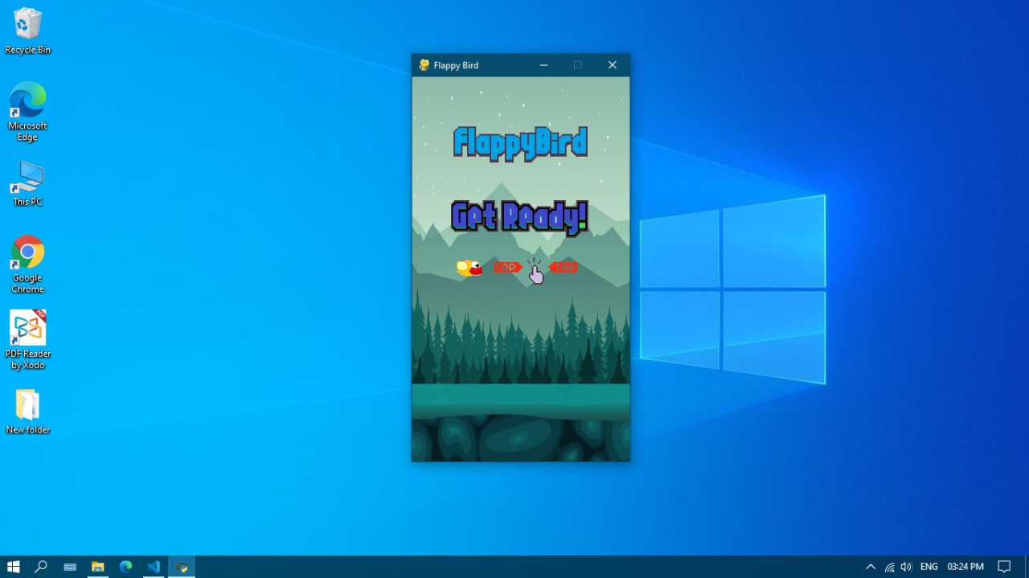

2. This is the game play interface of our Proect-;
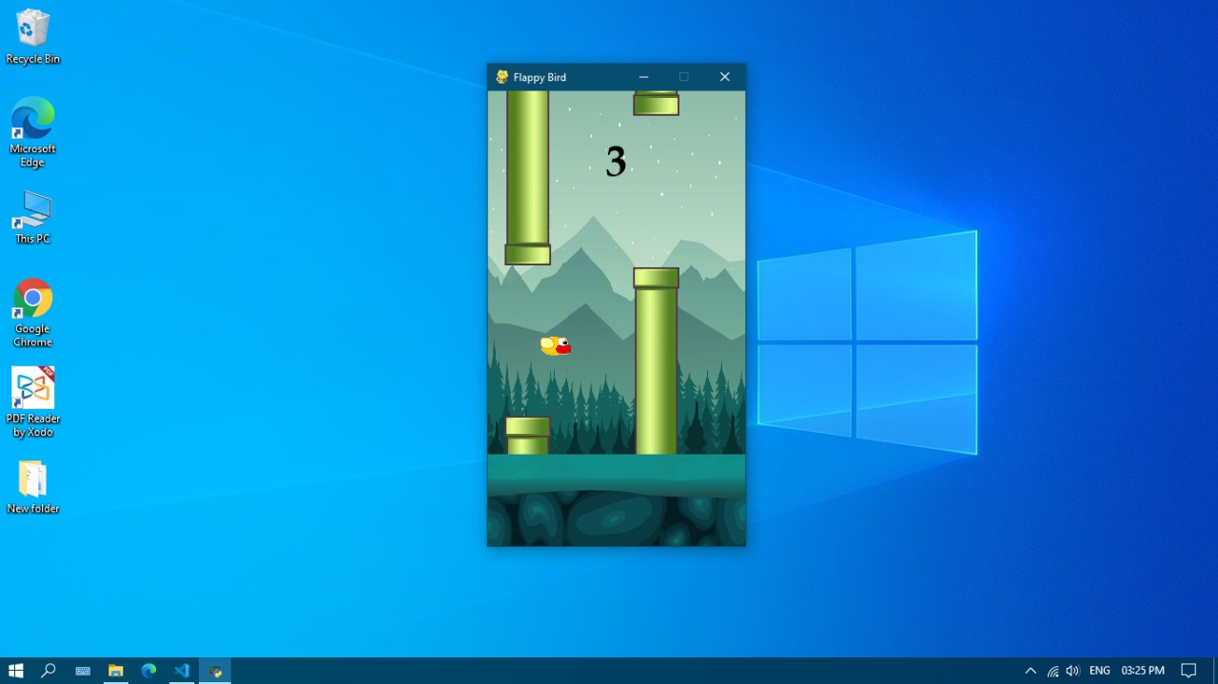

Throughout this project our aim was to develop a flappy bird game that allows user to interact with the game using keyboard with no use of any graphics library.
The game has no graphics library but has a graphical interface for the ease in interaction.
The player must go through all the pipes in order to win or obtain a high score. The concept is to create a flappy bird game with a graphical interface in the computer using Python.

Future Ideas:

If we get the chance to continue our project, then we would like to add some more features to this game:
• Use graphics library for better graphical interface.
• Leaderboard
• Stage levels or game levels.
• New obstacles.
• Difficulty level

