Sqoop安装需要具备java和hadoop的运行环境

**1.Sqoop安装**

将安装包上传至目录

cd /export/software/

put "E:\L\export\software\sqoop-1.4.6.bin__hadoop-2.0.4-alpha.tar.gz"

解压至/export/servers/

tar -zxvf sqoop-1.4.6.bin__hadoop-2.0.4-alpha.tar.gz -C /export/servers/

重命名

cd /export/servers/

ls

mv sqoop-1.4.6.bin__hadoop-2.0.4-alpha/ sqoop-1.4.6

**2.Sqoop配置**

cd sqoop-1.4.6/conf/

ls

拷贝文件：cp sqoop-env-template.sh sqoop-env.sh

编辑文件：vim sqoop-env.sh

export HADOOP_COMMON_HOME=/export/servers/hadoop-2.7.4

export HADOOP_MAPRED_HOME=/export/servers/hadoop-2.7.4

export HIVE_HOME=/export/servers/apache-hive-1.2.1-bin

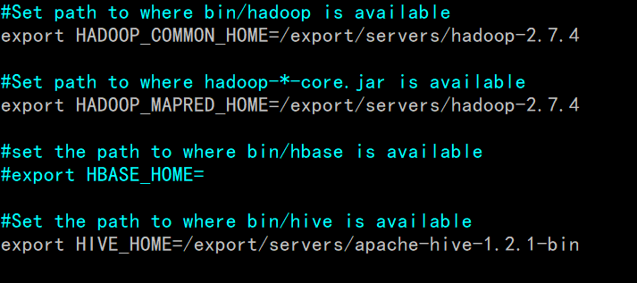

配置Sqoop的系统环境变量

vim /etc/profile

最后添加：

export SQOOP_HOME=/export/servers/sqoop-1.4.6

export PATH=$PATH:$SQOOP_HOME/bin:

source /etc/profile

需要根据所操作的关系型数据库添加对应的JDBC驱动包，用于数据库

cd ..

cd lib/

ls

拷贝mysql的安装包

cp /export/servers/apache-hive-1.2.1-bin/lib/mysql-connector-java-5.1.46.jar ./

3.Sqoop测试

cd ..

sqoop list-databases \

-connect jdbc:mysql://localhost:3306/ \

--username root --password 123456

sqoop list-databases \

-connect jdbc:mysql://localhost:3309/ \

--username root --password lq010705

sqoop list-databases \

-connect jdbc:mysql://localhost:3306/ \

--username root --password lq010705