# 创建表dw_pvs_everyday

create table dw_pvs_everyday(pvs bigint,month string,day string);

#提取“day”字段

insert into table dw_pvs_everyday

select count(*) as pvs,owd.month as month,owd.day as day

from ods_weblog_detail owd

group by owd.month,owd.day;

#查看表dw_pvs_everyday中的数据

select * from dw_pvs_everyday;

#实现人均浏览量

#创建维度表dw_avgpv_user_everyday

create table dw_avgpv_user_everyday( day string,avgpv string);

向表dw_avgpv_user_everyday中插入数据

insert into table dw_avgpv_user_everyday

select '2013-09-18',sum(b.pvs)/count(b.remote_addr) from

(select remote_addr,count(1) as pvs from ods_weblog_detail where

datestr='2013-09-18' group by remote_addr) b;

查看表dw_avgpv_user_everyday中的数据

select * from dw_avgpv_user_everyday;

#在mysql中操作

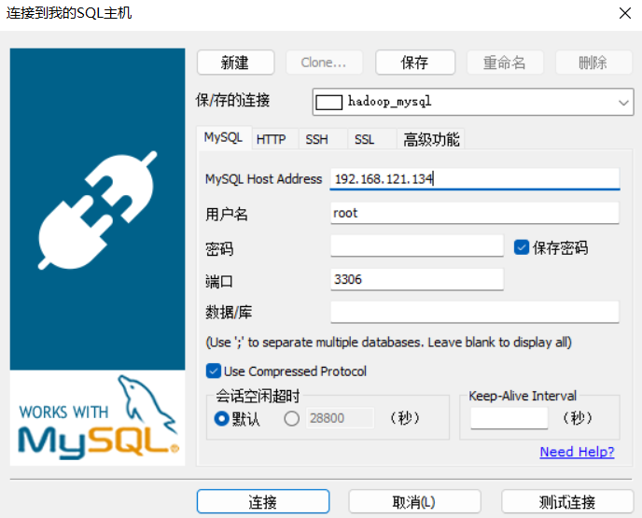

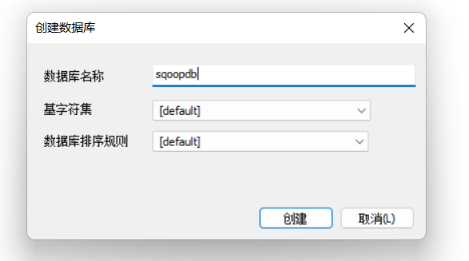

#数据导出

bin/sqoop export \

--connect jdbc:mysql://Hadoop001:3309/sqoopdb \

--username root\

--password lq010705\

--table t_avgpv_num \

--columns "dateStr,avgPvNum" \

--fields-terminated-by '\001' \

--export-dir /user/hive/warehouse/weblog.db/dw_avgpv_user_everyday;