✔ ACHIEVO
S M A R T T O - D O L I S T A P P L I C A T I O N
INTERNSHIP PROJECT SUBMISSION REPORT
JavaScript Mini Project
Submitted by
Hima Agarwal
B.Tech in Computer Science and Engineering
Vellore Institute of Technology, Bhopal
CGPA: 8.9 / 10 | Academic Year: 2024 – 2028

Detail | Information
Date of Submission | July 2, 2026
Project Type | JavaScript Mini Project
GitHub Repository | https://github.com/hima-agarwal-11/achievo
Live Website | https://achievo-nu.vercel.app
Technologies | HTML5, CSS3, Vanilla JavaScript, Local Storage API

CERTIFICATE OF PROJECT COMPLETION
This is to certify that the project detailed in this report has been
independently designed, developed, and deployed by
Hima Agarwal
B.Tech Computer Science and Engineering
Vellore Institute of Technology, Bhopal
Project Title: Achievo — Smart To-Do List Application
Category: Front-End Web Development / JavaScript Mini Project
Academic Year: 2024 – 2028 | CGPA: 8.9 / 10
Date of Submission: July 2, 2026

Table of Contents
1. Project Overview 4
2. Objectives 4
3. Technologies Used 5
4. Project Features 5
5. Project Structure 8
6. Application Workflow 9
7. JavaScript Concepts Used 9
8. Source Code Explanation 10
9. UI Design 12
10. Screenshots 13
11. GitHub & Deployment 15
12. Challenges Faced 16
13. Learning Outcomes 16
14. Future Enhancements 17
15. Conclusion 17

1. Project Overview
Achievo is a modern, productivity-focused task management web application designed to help users plan, organise, and track their daily activities through a clean, distraction-free interface. Built entirely with vanilla HTML5, CSS3, and JavaScript, Achievo demonstrates a complete, self-contained front-end implementation of a real-world productivity tool — without relying on any external framework or backend server.
The application greets users with a personalised, time-aware welcome message and presents an at-a-glance dashboard summarising total, pending, and completed tasks alongside a live completion-percentage indicator. From this dashboard, users can add new tasks with an assigned priority level, mark tasks complete or incomplete, edit task details through a modal dialog, delete tasks, search across their task list in real time, and filter tasks by status — all without a single page reload.
All task data is persisted directly in the browser using the Web Storage API's localStorage, meaning a user's task list, priorities, and completion states remain intact across page refreshes and browser sessions with no external database required. The interface is fully responsive and finished with a polished dark theme, glassmorphism-inspired card surfaces, an indigo-and-violet accent palette, and subtle micro-animations that give the application a modern, production-quality feel.

2. Objectives
Achievo was built with the following core learning and engineering objectives in mind:
- DOM Manipulation — dynamically render, update, and remove task elements in response to user actions without reloading the page.
- Interactive UI — provide immediate visual feedback for every user action, including task creation, editing, completion, and deletion.
- Task Management — implement a complete task lifecycle covering creation, editing, prioritisation, completion, and removal.
- Responsive Design — ensure the interface adapts cleanly across desktop, tablet, and mobile screen sizes.
- Local Storage — persist all task data client-side using the Local Storage API so information survives page refreshes.
- JavaScript Event Handling — use event listeners to drive every interactive element, from buttons and inputs to dropdowns and modals.
- Modern User Experience — deliver a visually refined dark-themed interface with smooth transitions, clear typography, and intuitive controls.

3. Technologies Used
The table below summarises the technologies and tools used to build and deploy Achievo.
Technology | Purpose
HTML5 | Semantic structuring of the dashboard, task list, and modal dialogs.
CSS3 | Styling, dark-theme colour system, glassmorphism card effects, responsive layout, and animations.
Vanilla JavaScript | Core application logic — task CRUD operations, filtering, searching, and state management.
DOM Manipulation | Dynamically creating, updating, and removing task elements as the underlying data changes.
Local Storage API | Client-side persistence of the task list, ensuring data survives page reloads and browser restarts.
Git | Local version control and commit history tracking throughout development.
GitHub | Remote repository hosting and source code management for the project.
Vercel | Continuous deployment and public hosting of the live Achievo application.

4. Project Features

Dashboard
A summary panel at the top of the application displays four live-updating cards: Total Tasks, Pending, Completed, and a circular Completion percentage indicator, giving users an instant overview of their productivity status.

Add Task
A dedicated input field labelled “Plan a new task...” paired with a priority dropdown and a violet “Add Task” button allows users to quickly create a new task, which is immediately appended to the task list and reflected in the dashboard counters.

Edit Task
Clicking the pencil icon on any task opens an “Edit Task” modal pre-filled with the task's current title and priority. Users can update either field and confirm changes via a “Save Task” button, or dismiss the dialog without saving using “Cancel” or the close icon.

Delete Task
A trash-can icon on each task row permanently removes that task from the list and from Local Storage, with the dashboard counters updating instantly to reflect the change.

Complete Task
Clicking the circular checkbox beside a task marks it complete: the checkbox fills with a green check mark, the task title receives a strikethrough style, and the Completed counter increments accordingly.

Undo Task
Completed tasks can be reverted to a pending state by clicking the same checkbox again, restoring the task title's normal styling and adjusting the Pending and Completed counters.

Task Counter
The “Total Tasks” dashboard card tracks and displays the overall number of tasks currently in the list in real time.

Pending Counter
The “Pending” dashboard card displays the live count of tasks that have not yet been marked complete.

Completed Counter
The “Completed” dashboard card displays the live count of tasks the user has marked as done.

Progress Indicator
A circular ring chart labelled “Completion” visualises the percentage of completed tasks out of the total, updating dynamically — for example, showing 50% once one of two tasks is completed.

Search Tasks
A dedicated search input allows users to filter the visible task list in real time by matching characters against task titles as they type.

Filter Tasks
Three filter tabs — All, Active, and Completed — let users narrow the task list view to only pending or only completed items, in addition to the default unfiltered view.

Priority Selection
Every task is assigned a priority level — Low, Medium, or High — chosen from a styled dropdown at task-creation or edit time, and displayed as a colour-coded badge (e.g., red for High, amber for Medium) on each task row.

Dark Mode
Achievo defaults to a refined dark theme using deep navy and near-black backgrounds with high-contrast white text and violet accents; a toggle icon in the header allows users to switch themes.

Responsive Design
The dashboard cards, input controls, and task list reflow gracefully across desktop, tablet, and mobile breakpoints, preserving usability and visual balance at every screen size.

Floating Action Button
A circular violet “+” button fixed to the bottom-right corner of the viewport offers a persistent, always-accessible shortcut for adding a new task.

Animations
Subtle transition and hover animations are applied to buttons, cards, dropdowns, and modal dialogs, giving interactions a smooth, polished feel.

Local Storage
All task data — including titles, priorities, and completion states — is serialised to JSON and saved in the browser's Local Storage, then reloaded automatically when the application is reopened.

Keyboard Shortcut
The task input field supports keyboard-driven submission (Enter key) for quickly adding tasks without needing to click the Add Task button.

5. Project Structure
Achievo follows a simple, conventional front-end file structure that keeps content, styling, and behaviour cleanly separated:
- index.html — Contains the complete semantic markup for the dashboard, task input controls, task list container, and the Edit Task modal.
- style.css — Defines the dark-theme colour palette, glassmorphism card styling, Flexbox/Grid layout rules, responsive media queries, and all transition/animation effects.
- script.js — Implements the application's core logic, including task creation, editing, deletion, completion toggling, search, filtering, counter updates, and Local Storage persistence.
- README.md — Documents the project overview, feature list, technology stack, and setup instructions for anyone viewing the repository.
- assets folder — Stores icon and image assets, such as the clipboard logo mark and any illustrative graphics used across the interface.

6. Application Workflow
When a user first opens Achievo, the application checks Local Storage for any previously saved tasks and renders them to the task list; if none exist, an empty-state illustration is shown alongside the dashboard, which displays all counters at zero. The header greets the user with a time-aware message (for example, “Good evening, Productive Day Ahead!”) generated from the current system time.
To add a task, the user types a title into the “Plan a new task...” input, optionally selects a priority level from the dropdown, and either presses Enter or clicks “Add Task.” The new task object is pushed into the in-memory task array, immediately rendered as a new row in the task list, saved to Local Storage, and reflected in the Total Tasks and Pending counters.
From the task list, the user can mark a task complete by clicking its checkbox, which updates the task's status property, re-renders its styling with a strikethrough, and recalculates the Completed count and completion percentage. Clicking the pencil icon opens the Edit Task modal pre-filled with the task's current data; saving changes updates the corresponding task object and re-renders the list, while clicking the trash icon removes the task entirely after updating storage and counters.
The Search bar filters the rendered task list in real time by matching the query string against task titles, while the All / Active / Completed tabs apply an additional status-based filter. At every stage — creation, editing, completion, and deletion — the updated task array is immediately re-serialised to Local Storage, ensuring the application state is durable across page refreshes and browser restarts.

7. JavaScript Concepts Used
Concept | Application in Achievo
Variables (let / const) | Used throughout script.js to store the task array, DOM references, and UI state such as the active filter and current search query.
Functions | Discrete functions handle each responsibility — rendering the task list, adding a task, deleting a task, toggling completion, and updating counters — keeping the codebase modular and readable.
Arrow Functions | Used extensively for concise callback handlers passed to event listeners, array methods, and inline logic.
Objects | Each task is represented as a JavaScript object with properties such as id, title, priority, completed, and a creation timestamp.
Arrays | The full task list is stored as an array of task objects, manipulated using methods such as push, filter, map, and find.
DOM Manipulation | createElement, innerHTML, classList, and related DOM APIs are used to dynamically build and update task rows and dashboard counters.
Event Listeners | addEventListener handlers respond to clicks on Add Task, checkboxes, edit/delete icons, filter tabs, and the theme toggle, as well as input/change events on the search and priority fields.
Local Storage | localStorage.setItem and localStorage.getItem persist and retrieve the task array as a serialised string on every state change and on page load.
JSON | JSON.stringify and JSON.parse convert the task array to and from a string representation for storage and retrieval.
querySelector / querySelectorAll | Used to reference and manipulate specific DOM elements such as counter displays, the task list container, and modal fields.
addEventListener | The primary mechanism binding user interactions — clicks, key presses, and form submissions — to their corresponding handler functions.
Template Literals | Used to construct the HTML markup for each task row dynamically, interpolating task properties such as title, priority, and date directly into the rendered string.

8. Source Code Explanation
This section explains the logic and purpose behind Achievo's key functional areas, based on the application's observed behaviour, without reproducing the full source code.

8.1 Task Creation
When the Add Task control is triggered, the entered title (and selected priority, defaulting to Medium) is used to construct a new task object with a unique identifier and a creation timestamp. This object is appended to the in-memory task array, the list is re-rendered, the dashboard counters are recalculated, and the updated array is written back to Local Storage.

8.2 Task Editing
Clicking a task's edit icon opens the Edit Task modal and populates its Task Title field and Priority dropdown with that task's current values. On “Save Task,” the corresponding task object in the array is located (typically by its unique id) and updated in place; the modal closes, the list re-renders with the new details, and Local Storage is updated to reflect the change.

8.3 Task Deletion
The delete icon removes a task by filtering it out of the task array based on its unique identifier. The list is then re-rendered without that entry, the Total Tasks and Pending/Completed counters are recalculated, and the pruned array is saved back to Local Storage.

8.4 Task Completion
Clicking a task's checkbox toggles a boolean completed property on that task object. The UI reflects this immediately: the checkbox fills with a green check icon, the task title is styled with a strikethrough, and the Completed and Pending counters — along with the circular completion-percentage indicator — are recalculated from the updated array.

8.5 Theme Toggle
A toggle icon in the header switches the interface between its dark theme and an alternate colour scheme by adding or removing a class on the document's root element (for example, a data-theme or class-based attribute). CSS rules scoped to this attribute redefine the colour variables used throughout the interface, instantly re-theming the entire application.

8.6 Task Filtering
The All / Active / Completed tabs set a currentFilter variable that is applied whenever the task list is rendered: Active shows only tasks where completed is false, Completed shows only tasks where completed is true, and All bypasses this condition entirely, displaying every task.

8.7 Search Functionality
As the user types into the search field, an input event listener captures the current query string, converts it to lower case, and filters the task array to only those tasks whose title includes the query as a substring, re-rendering the list on every keystroke for a responsive live-search experience.

8.8 Local Storage Persistence
A dedicated save function serialises the current task array to a JSON string via JSON.stringify and stores it under a defined key using localStorage.setItem. On application load, a corresponding load function retrieves this string via localStorage.getItem, parses it back into an array with JSON.parse, and uses it to populate the initial task list — ensuring no data is lost between sessions.

8.9 Counter Updates
A single recalculation function runs after every task mutation (add, edit, delete, or completion toggle). It derives the total task count from the array's length, counts entries where completed is true or false for the Completed and Pending cards respectively, computes the completion percentage as (completed / total) * 100, and writes these values into the corresponding dashboard elements, including updating the circular progress ring's fill.

9. UI Design
Design Aspect | Description
Typography | A clean, modern sans-serif typeface is used throughout, with a bold, larger weight for the Achievo logo and section headings, and a lighter weight for body text and metadata such as task dates.
Colour Palette | The interface uses a deep navy-to-black dark background paired with a vivid indigo/violet accent (used for the logo, primary buttons, and active states), a green accent for completed states, and amber/red badges for Medium and High priority indicators respectively.
Glassmorphism | Dashboard cards, the task input bar, and modal dialogs use softly rounded corners, subtle background transparency, and light borders to create a layered, frosted-glass visual effect against the dark backdrop.
Cards | Each dashboard metric (Total Tasks, Pending, Completed, Completion) is presented in its own rounded card with an icon, label, and prominent numeric value for quick scanning.
Buttons | Primary actions such as Add Task and Save Task use a solid violet fill with white bold text, while secondary actions such as Cancel use a muted outlined style, clearly distinguishing primary from secondary actions.
Icons | Minimal line-style icons represent each dashboard metric (list, clock, check), as well as task-row actions (pencil for edit, trash can for delete) and the theme toggle (sun/moon).
Responsive Layout | A fluid Flexbox/Grid-based layout allows dashboard cards and controls to reflow from a multi-column arrangement on desktop to a stacked, single-column arrangement on smaller viewports.
Spacing | Generous internal padding within cards and consistent vertical rhythm between sections give the interface an uncluttered, breathable feel consistent with modern productivity tools.
Animations | Hover states on buttons and task rows, smooth modal fade/scale transitions, and an animated circular progress ring add a refined sense of interactivity without being distracting.

10. Screenshots
The following screenshots document the completed Achievo application across its major states and interactions.

10.1 Homepage — Empty Dashboard
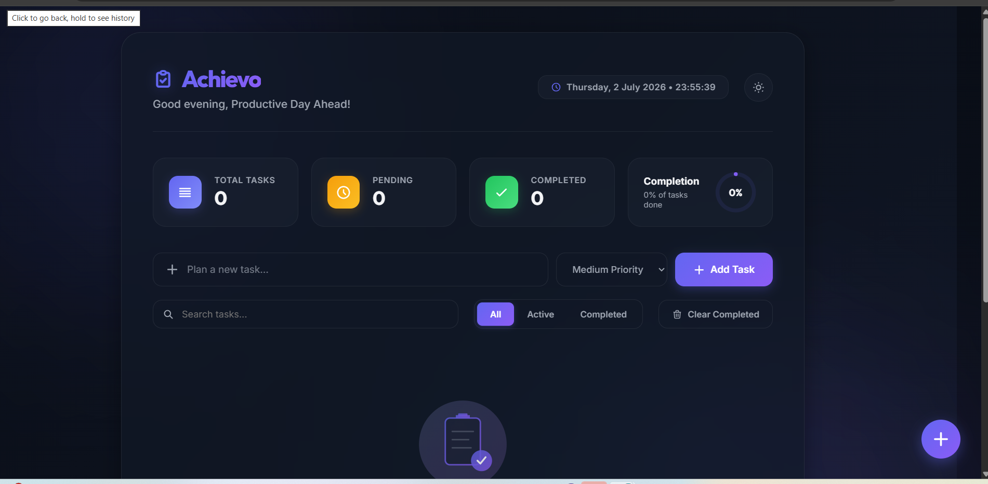
Figure 1: Initial dashboard state with zero tasks, showing the header greeting, empty-state illustration, and the Add Task and Search controls.

10.2 Adding a Task with Priority Selection
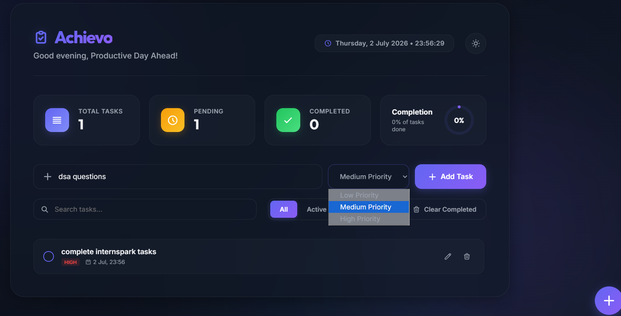
Figure 2: A task titled “dsa questions” being created, with the Priority dropdown open showing Low, Medium, and High options.

10.3 Task List View
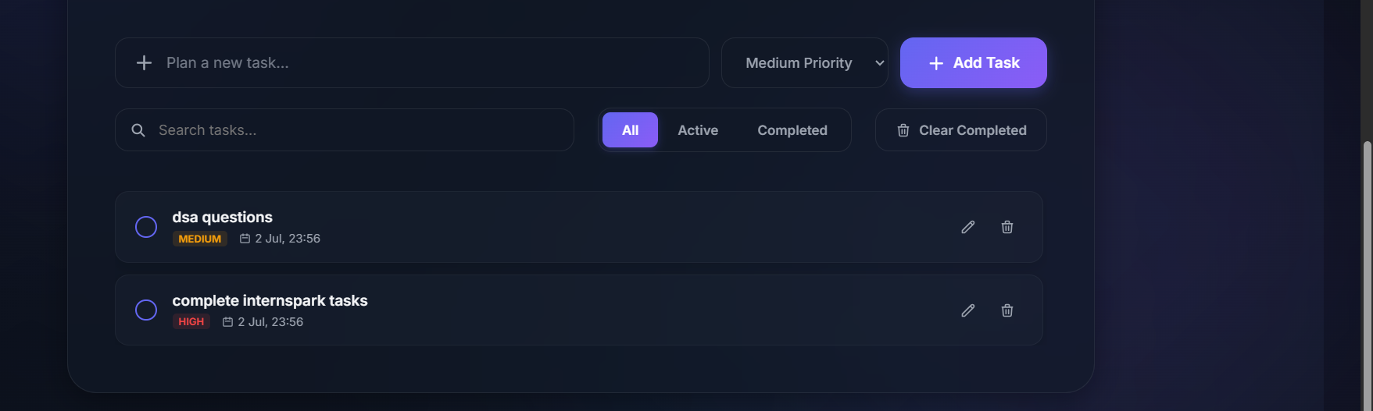
Figure 3: The task list displaying two tasks with colour-coded priority badges (Medium and High) and their creation dates.

10.4 Editing a Task
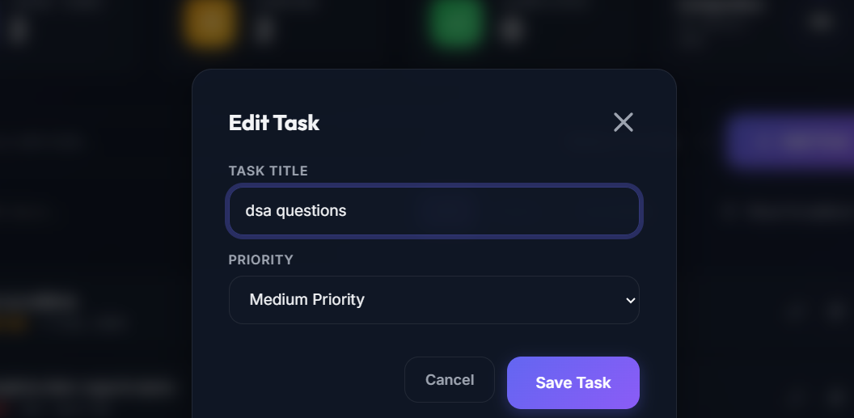
Figure 4: The Edit Task modal dialog, pre-filled with the selected task's title and priority, with Cancel and Save Task actions.

10.5 Completed Tasks
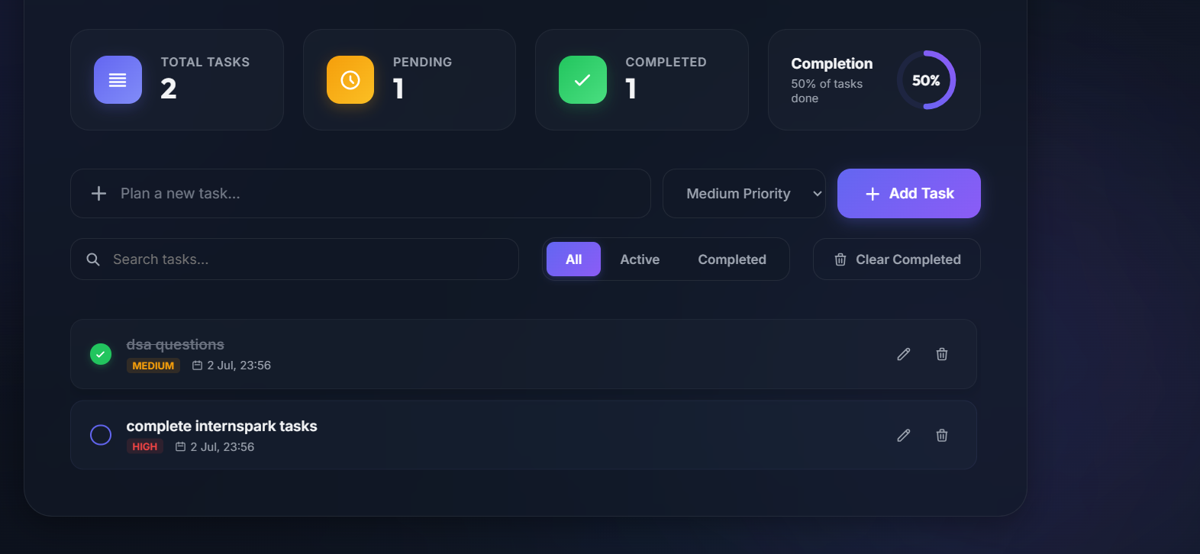
Figure 5: Dashboard and task list after completing one of two tasks — the Completed counter and completion ring both update to reflect 50% progress, and the completed task is shown with a strikethrough.

11. GitHub & Deployment
Achievo was version-controlled and deployed to a public production environment following standard front-end deployment practices:
- Repository Creation — A public GitHub repository named achievo was created under the account hima-agarwal-11 to host the project's source code.
- Git Version Control — All project files were committed locally using Git, with incremental, descriptive commit messages tracking the application's development from initial scaffold through to feature completion.
- Deployment using Vercel — The GitHub repository was connected to Vercel, which automatically builds and redeploys the static site whenever changes are pushed to the main branch.
- Live Website — Following deployment, the application became publicly accessible at a Vercel-generated URL, allowing anyone to use Achievo directly in their browser without any local setup.
Live Website: https://achievo-nu.vercel.app
GitHub Repository: https://github.com/hima-agarwal-11/achievo

12. Challenges Faced
Challenge | Solution
Keeping dashboard counters in sync with task actions | Centralised all counter and progress-ring calculations into a single update function called after every add, edit, delete, or completion toggle, ensuring the UI never drifts out of sync with the underlying data.
Persisting complex task data reliably | Standardised on JSON.stringify / JSON.parse for all Local Storage reads and writes, with a consistent task-object schema to avoid data corruption between sessions.
Smooth modal open/close behaviour | Applied CSS opacity and transform transitions triggered by toggling a visibility class, rather than abrupt display switching, for a polished Edit Task modal experience.
Maintaining readable priority indicators | Introduced a consistent colour-coded badge system (red/amber/grey-blue) mapped directly to each task's priority value for instant visual scanning.
Live search without performance lag | Filtered the in-memory task array directly on each input event rather than querying the DOM repeatedly, keeping the search responsive even as the task list grows.
Responsive dashboard card layout | Used a CSS Grid with auto-fit/minmax sizing for the summary cards so they reflow naturally from a four-column desktop layout to a stacked mobile layout without fixed breakpoints.

13. Learning Outcomes
- Gained hands-on experience designing and implementing a complete CRUD (Create, Read, Update, Delete) workflow using vanilla JavaScript.
- Strengthened understanding of the Local Storage API as a lightweight, serverless client-side persistence mechanism.
- Developed proficiency in structuring JavaScript logic into modular, single-responsibility functions for maintainability.
- Learned to keep multiple dependent UI elements (counters, progress ring, task list) reliably synchronised with a single source of truth.
- Improved skills in DOM manipulation and dynamic HTML generation using template literals.
- Gained practical experience implementing real-time search and multi-state filtering over an in-memory data set.
- Deepened understanding of event-driven programming through extensive use of addEventListener across diverse UI controls.
- Practised building an accessible, theme-aware interface with a toggleable dark mode driven by CSS custom properties.
- Strengthened responsive design skills using CSS Grid and Flexbox for adaptable, multi-breakpoint layouts.
- Gained hands-on experience with the full Git and GitHub workflow, alongside continuous deployment using Vercel.
- Built confidence in independently planning, designing, and shipping a complete, polished front-end product end-to-end.

14. Future Enhancements
While Achievo is fully functional as a client-side task manager, several enhancements could extend its capability and reach in future iterations:
- Task Categories — group tasks under custom categories or projects for better organisation.
- Due Dates — allow users to assign and be reminded of specific deadlines for each task.
- Cloud Sync — replace or supplement Local Storage with a cloud database to sync tasks across multiple devices.
- Notifications — implement browser push notifications or reminders for upcoming or overdue tasks.
- Calendar Integration — visualise tasks on a calendar view and integrate with external calendar services.
- Authentication — add user accounts and secure login so task data can be tied to an individual profile.
- Data Export — allow users to export their task list as CSV, JSON, or PDF for backup or reporting purposes.
- AI Task Suggestions — leverage AI to suggest task priorities, groupings, or optimal scheduling based on user habits.

15. Conclusion
Achievo — Smart To-Do List Application has been successfully designed, developed, and deployed as a fully functional, publicly accessible productivity tool. Built entirely with HTML5, CSS3, and vanilla JavaScript, the project delivers a complete task-management workflow — creation, editing, completion, deletion, search, and filtering — backed by reliable client-side persistence through the Local Storage API.
Beyond satisfying its core functional requirements, Achievo demonstrates careful attention to user experience through its live dashboard metrics, animated circular progress indicator, colour-coded priority system, and polished dark-themed, glassmorphism-inspired visual design. These touches reflect a genuine effort toward production-quality craftsmanship rather than a minimal, purely functional build.
The development process reinforced foundational and intermediate JavaScript skills — including DOM manipulation, event-driven programming, JSON-based data persistence, and state synchronisation across multiple UI elements — while also providing practical experience with Git version control and live deployment via Vercel. Achievo stands as a strong demonstration of front-end development capability and a valuable addition to a growing professional portfolio.

Hima Agarwal
B.Tech Computer Science and Engineering — VIT Bhopal
GitHub: github.com/hima-agarwal-11

