Check /hana/shared path :
This path utilization should not exceed 90%, as daily log files are stored in this directory.
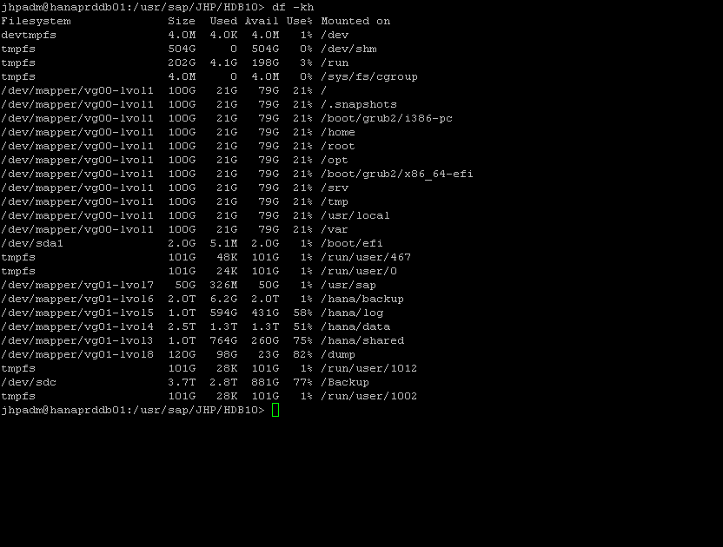

Stop commands :
First you need to Stop application server first and then Database.
Application: 192.168.32.209
Sapcontrol –nr 00 –function GetProcessList
Sapcontrol –nr 01 –function GetProcessList
If application is running
To StopApplication
stopsap R3
Or
Sapcontrol –nr 00 –function StopSystem
Sapcontrol –nr 01 –function StopSystem
Then Check Status of system :
Sapcontrol –nr 00 –function GetProcessList
Sapcontrol –nr 01 –function GetProcessList

(Check until it gets gray)

Database : 192.168.32.207
Sapcontrol –nr 10 –function GetProcessList
If Database is running (in Gray: its stopped, yellow: Running state (stopping or starting),
Green: running)
To Stop Database:
HDB stop
sapcontrol -nr 10 -function GetProcessList
(Check until it gets gray)

Start commands :

Database : 192.168.32.207
Sapcontrol –nr 10 –function GetProcessList
If Database is not running (in Gray: its stopped, yellow: Running state (stopping or starting),
Green: running)
To Start Database:
HDB start
sapcontrol -nr 10 -function GetProcessList
(Check until it gets green)

Application: 192.168.32.209
Sapcontrol –nr 00 –function GetProcessList
Sapcontrol –nr 01 –function GetProcessList
If application is nor running
To Start Application
startsap R3
Or
Sapcontrol –nr 00 –function StartSystem
Sapcontrol –nr 01 –function StartSystem

You need to start Database First Then Application server.

System Replication Status
Login to server 192.168.32.207
With user: jhpadm
Commands:
cdpy
python systemReplicationStatus.py

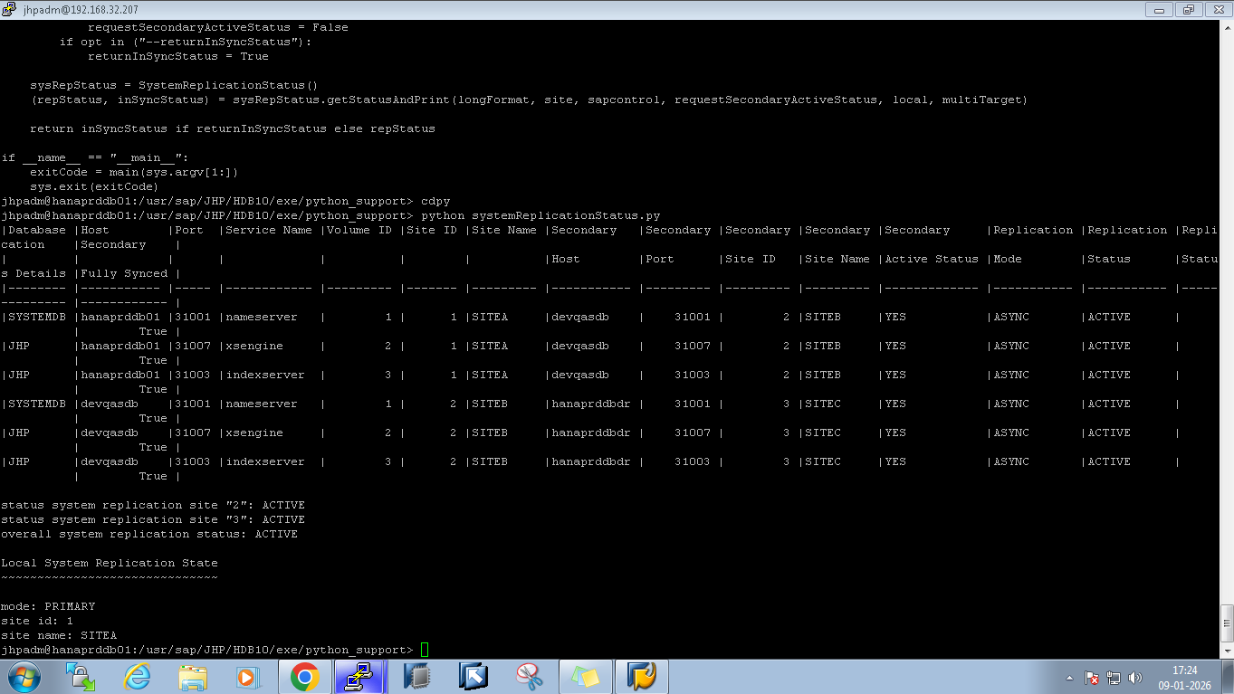

HANA Database Server
- OS: SUSE Linux Enterprise Server for SAP Applications 15 SP4
- Package Directory: /usr/sap/JHP/HDB10
- Plugin/Application: SAP HANA Database
- Execution User: jhpadm
Application Server
- OS: SUSE Linux Enterprise Server for SAP Applications 15 SP5
- Package Directory: /usr/sap/JEP
- Plugin/Application: SAP S/4HANA ABAP Application Server
- Execution User: jepadm

