ASSIGNMENT 13.2
T.HimaBindhu
2303A52050
Batch -38

Task Description -1 (Refactoring – Eliminating Repetitive Logic)
• Task: Use AI-assisted coding techniques to restructure a Python
program that performs repeated calculations, transforming it into
a reusable and maintainable design.
Instructions:
• Ask AI to locate repeated computations within the program.
• Encapsulate repeated logic into reusable functions.
• Verify that program output remains unchanged after refactoring.
• Add proper docstrings to all defined functions.
Sample Code:
length = 8
width = 4
print("Area:", length * width)
print("Perimeter:", 2 * (length + width))
length = 12
width = 6
print("Area:", length * width)
print("Perimeter:", 2 * (length + width))
Expected Output:
A refactored Python script that uses a single reusable function to
compute area and perimeter without repeating code.

Prompt:
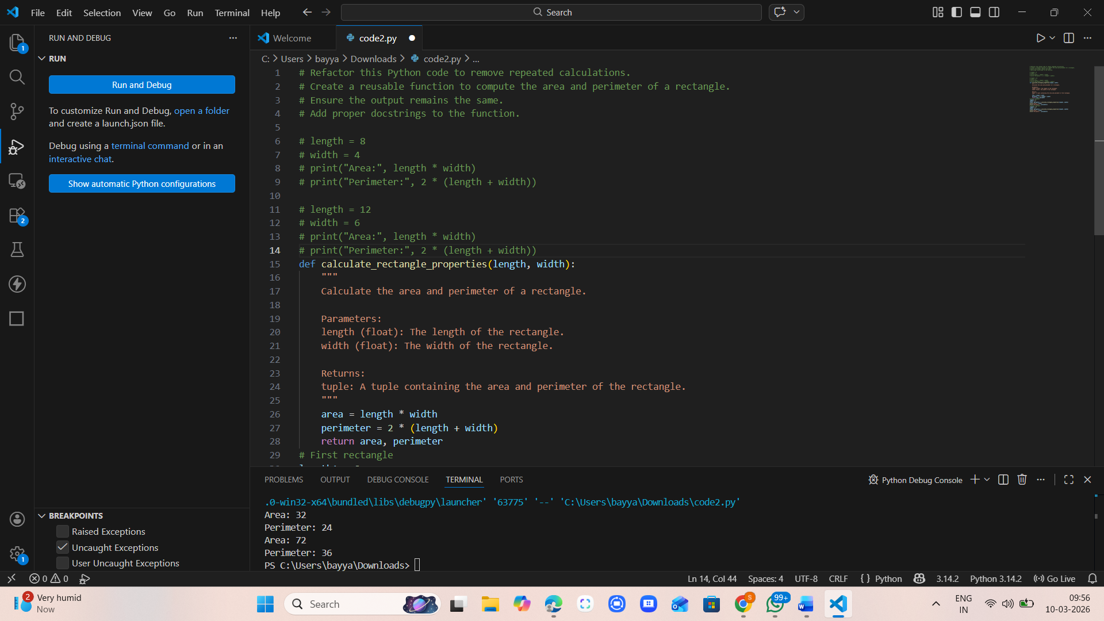

Code :
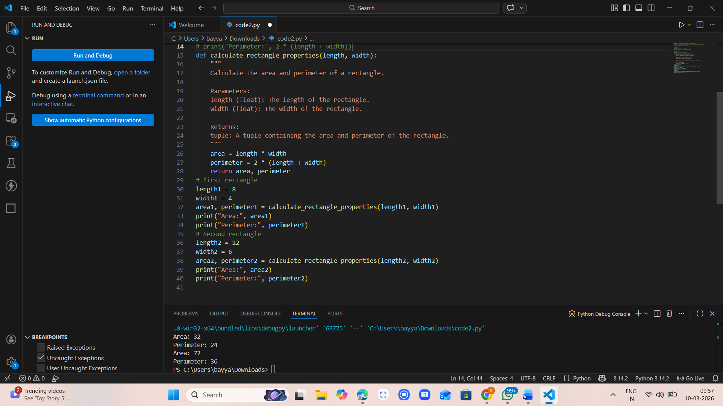

Output:
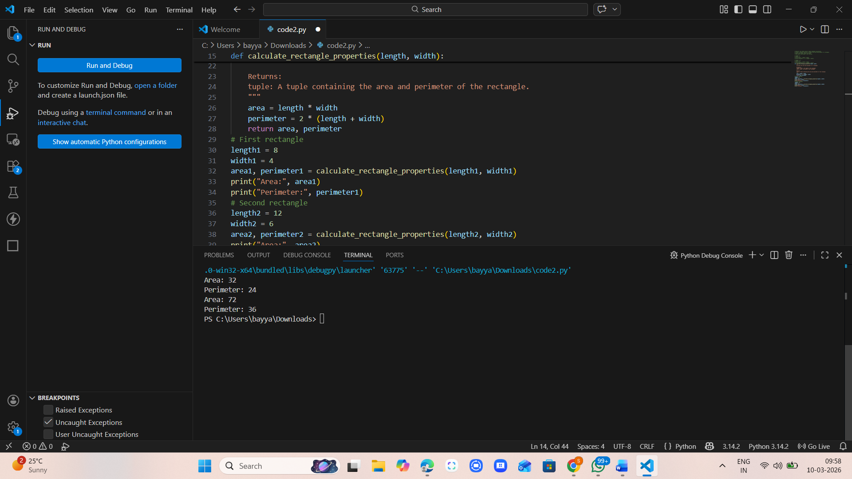

Task Description -2 (Refactoring – Modularizing Inline
Calculations)
• Task: Use AI to refactor a Python script by extracting repeated
inline calculations into reusable and well-documented functions.
Instructions:
• Identify repeated calculation patterns in the code.
• Convert them into reusable functions.
• Ensure readability and proper documentation.
Sample Code:
amount = 1000
discount = amount * 0.10
final_amount = amount - discount
print("Final Amount:", final_amount)
amount = 2000
discount = amount * 0.10
final_amount = amount - discount
print("Final Amount:", final_amount)
Expected Output:
A modular Python program that uses a reusable function to compute
final amounts for different inputs.

Prompt:
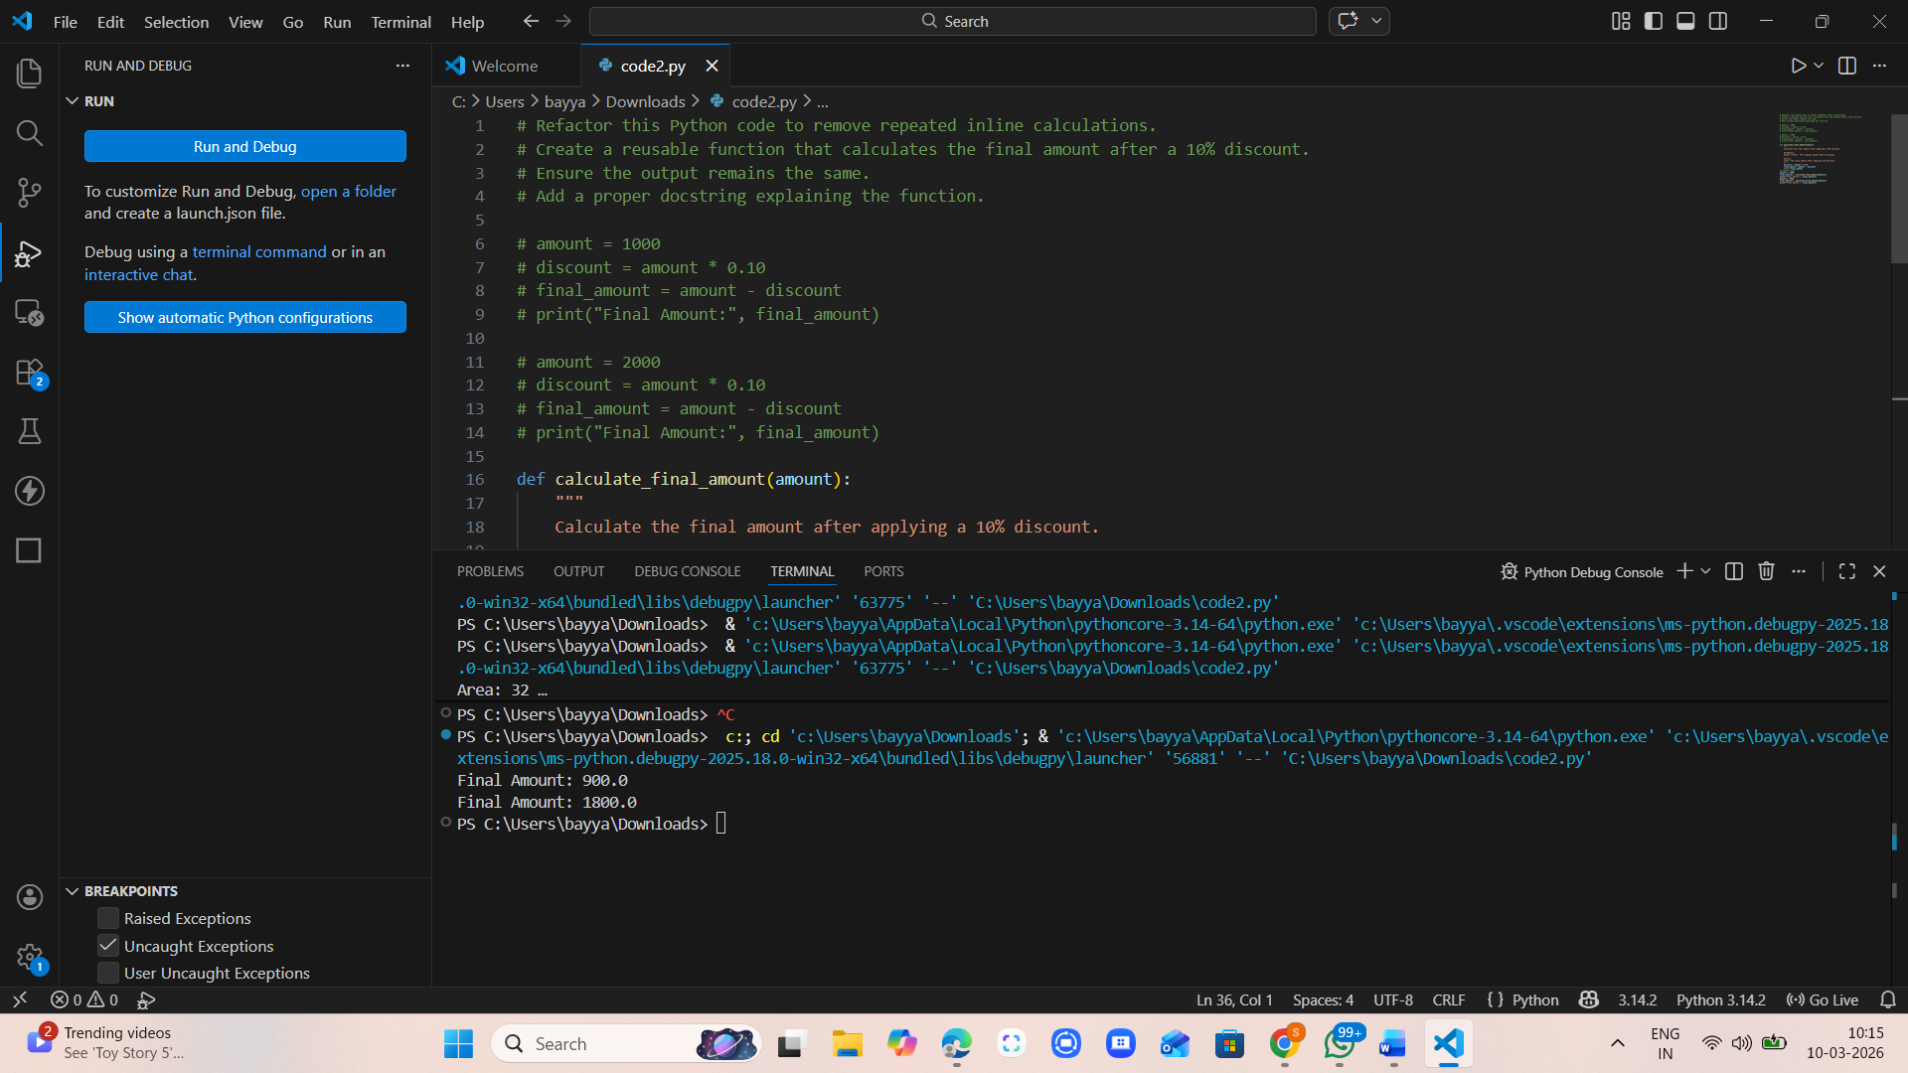

Code:
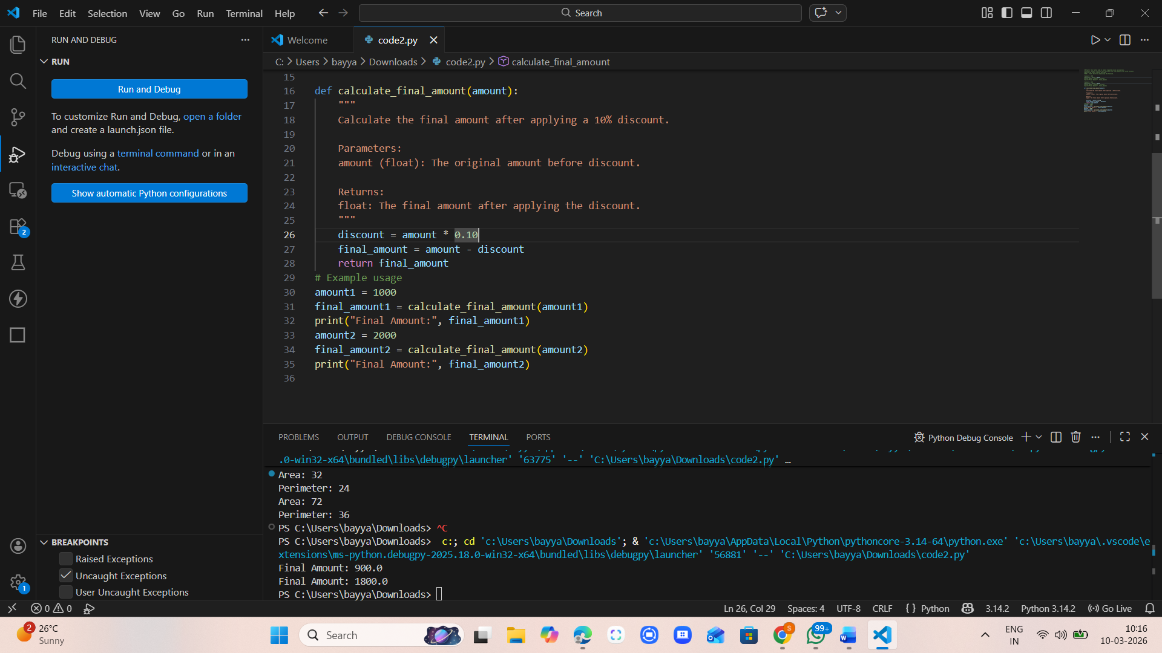

Output:
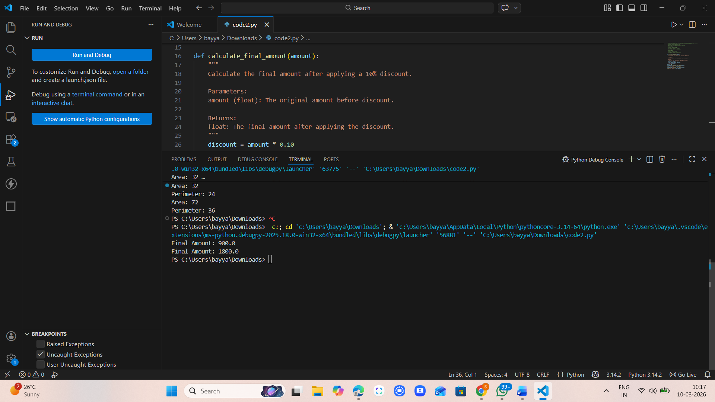

Task Description -3 (Refactoring – Improving Loop and
Conditional Performance)
• Task: Apply AI-based suggestions to enhance the performance of
Python code that relies on nested loops and repeated conditional
checks.
Instructions:
• Use AI to recommend more efficient data structures or logic
simplifications.
• Replace inefficient constructs while preserving program behavior.
• Compare execution efficiency before and after refactoring.
Sample Code:
students = ["Anil", "Bhavya", "Charan", "Divya"]
check_list = ["Charan", "Esha", "Bhavya"]
for name in check_list:
exists = False
for student in students:
if name == student:
exists = True
if exists:
print(name, "found")
else:
print(name, "not found")
Expected Output:
An optimized Python program that performs faster lookups using
efficient logic, along with execution performance comparison.

Prompt:
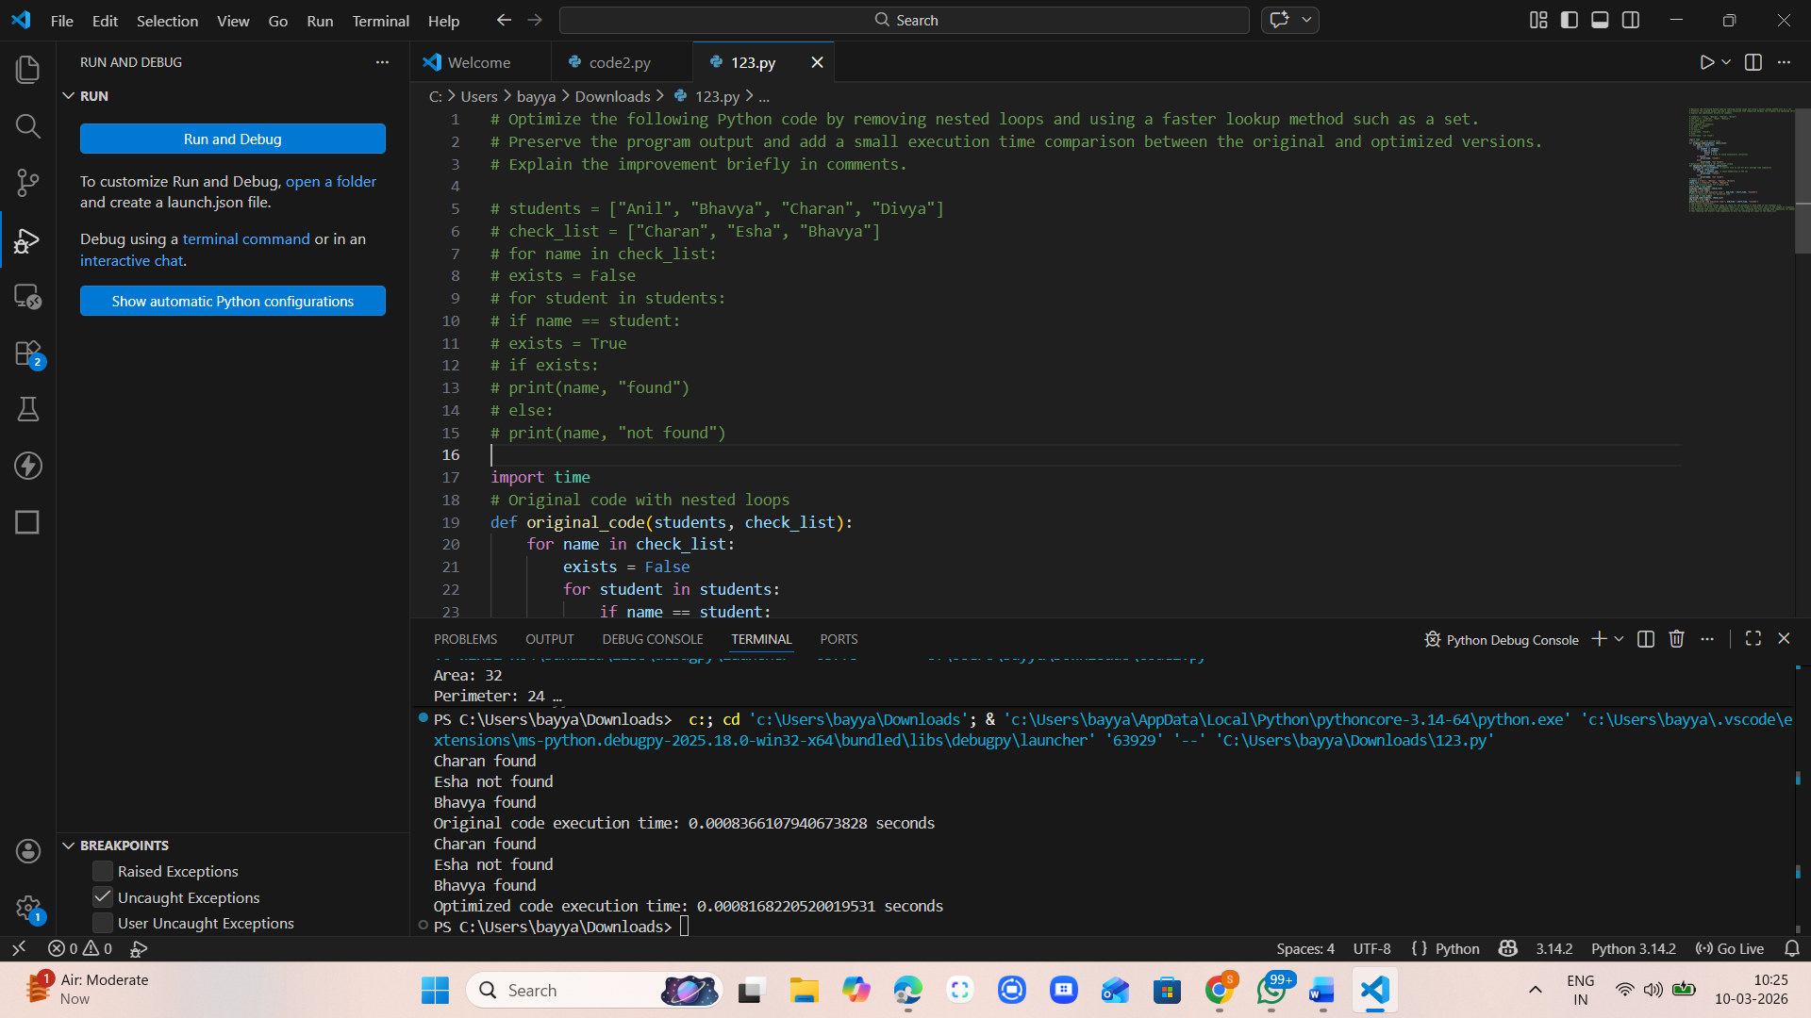

Code:

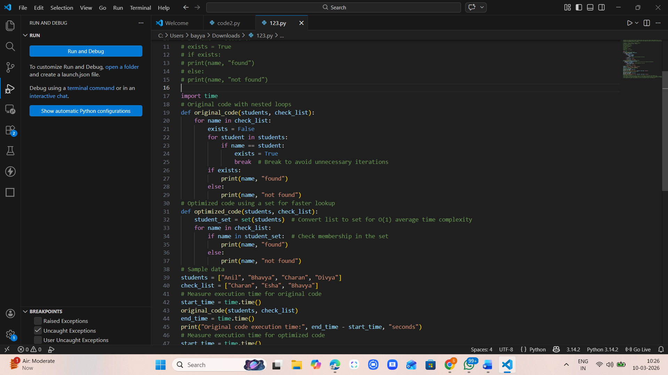

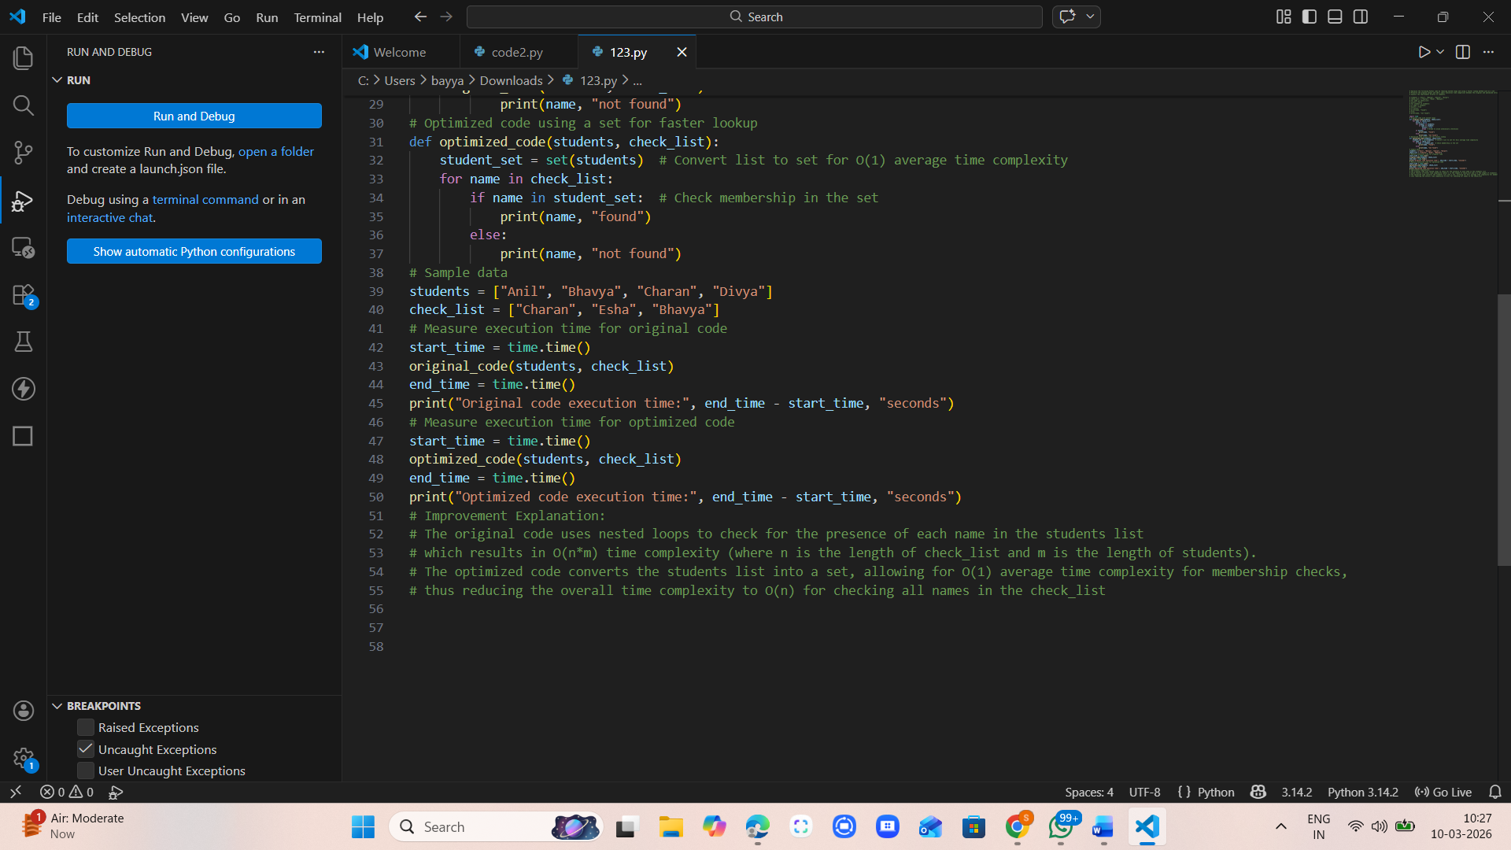

Output:
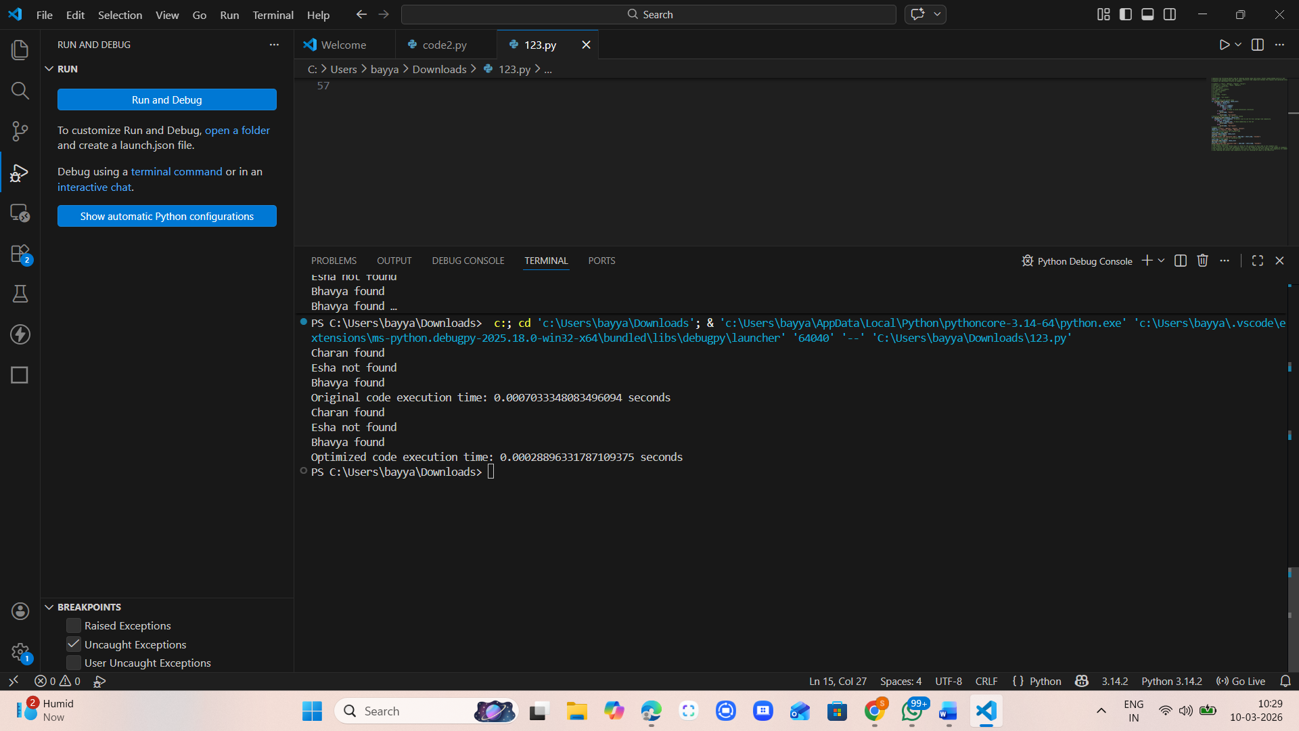

Task Description -4 (Refactoring – Replacing Hardcoded Values
with Constants)
• Task: Utilize AI assistance to improve maintainability by
replacing hardcoded numerical values with named constants.
Instructions:
• Detect hardcoded numeric values used directly in expressions.
• Define descriptive constants at the beginning of the program.
• Update calculations to use these constants without changing
results.
Sample Code:
print("Simple Interest:", (1000 * 2 * 5) / 100)
print("Simple Interest:", (2000 * 2 * 5) / 100)
Expected Output:
A revised Python program using constants such as RATE and TIME for
clearer and maintainable calculations..

Prompt:
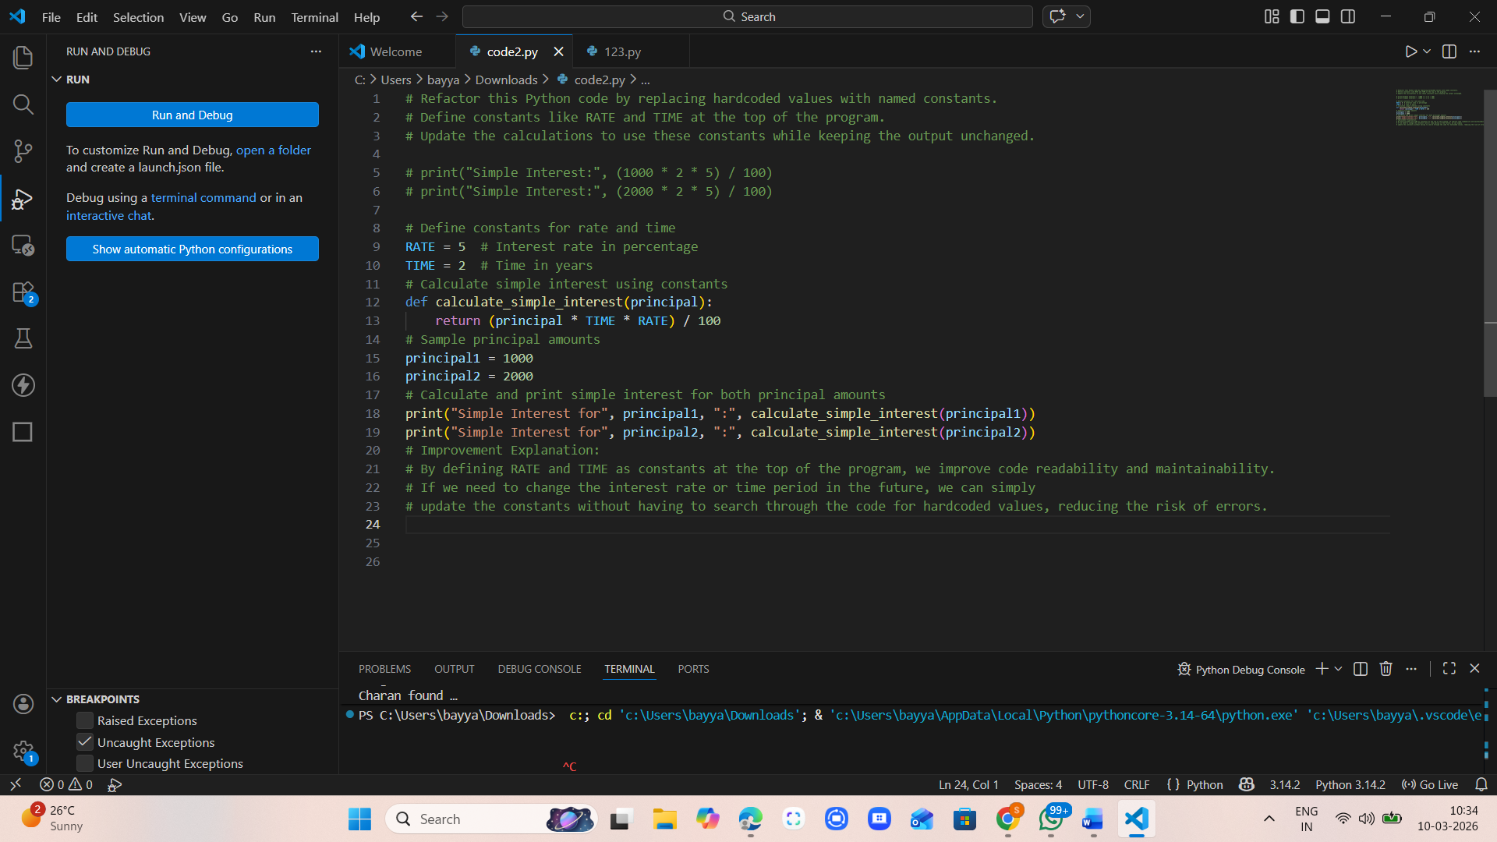

Code:


Output:
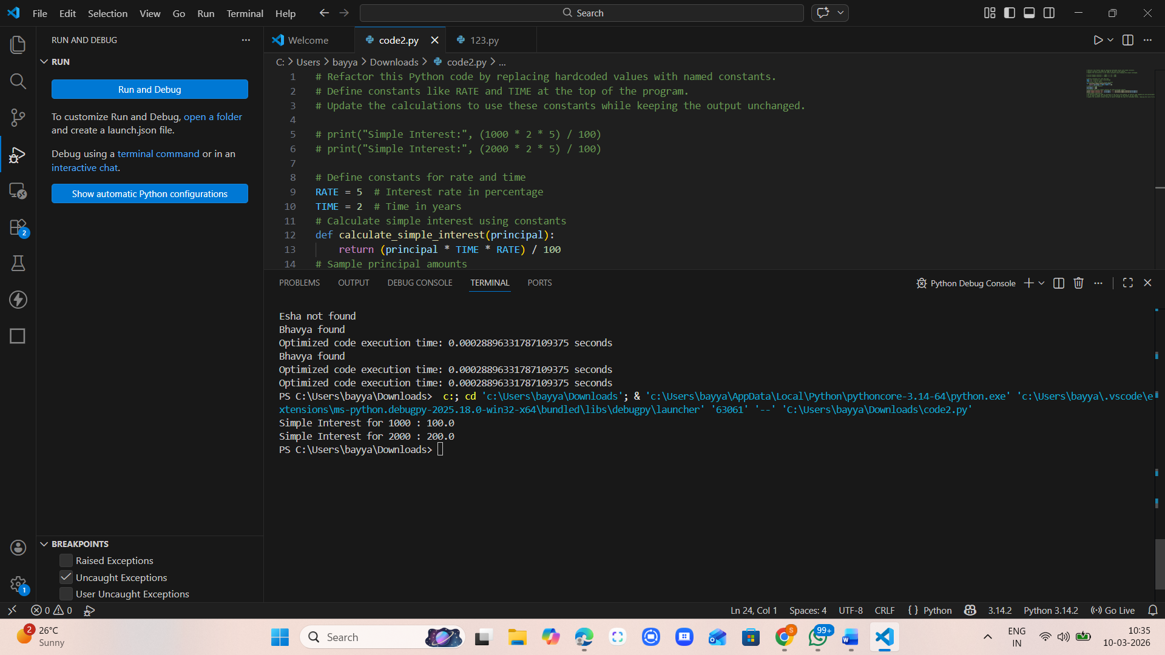

Task Description -5 (Re factoring – Enhancing Variable Naming
and Code Clarity)
• Task: Apply AI tools to improve code readability by renaming
unclear variables and adding meaningful comments..
Instructions:
• Replace non-descriptive variable names with meaningful
identifiers.
• Add inline comments where the logic may be unclear.
• Ensure program output remains the same.
Sample Code:
x = 50
y = 30
z = x + y
print(z)
Expected Output:
A Python program with clear variable names and explanatory comments
that improve readability without altering functionality.

Prompt:

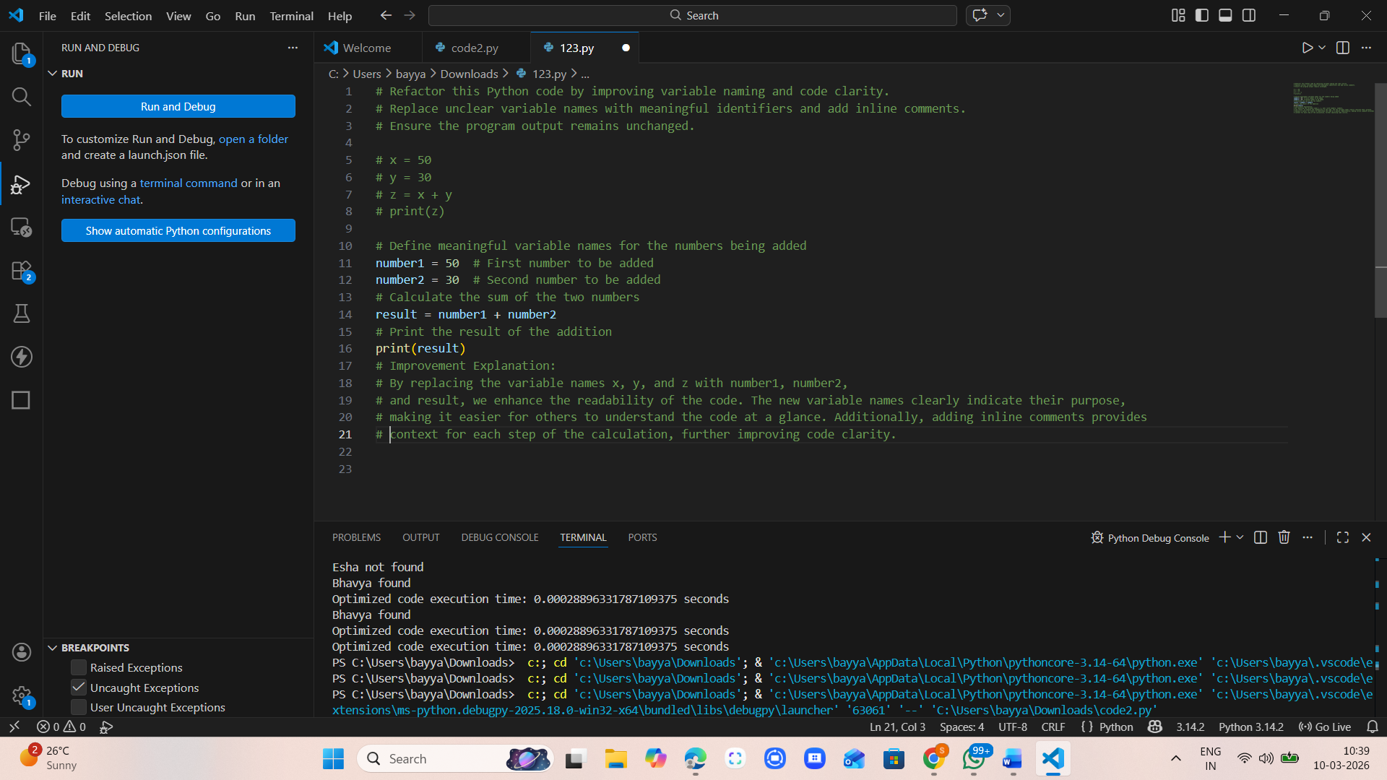

Code:


Output:
