LAB ASSIGNMENT – 11
T.Hima Bindhu
2303A52050
Batch- 38

Task Description -1 – (Stack Using AI Guidance)
- Task: With the help of AI, design and implement a Stack data structure supporting basic stack operations.

Expected Output:
- A Python Stack class supporting push, pop, peek, and empty- check operations with proper documentation.
PROMPT:
Design and implement a Stack class in Python. The stack should support push, pop, peek, and is_empty operations. Use a list to store elements internally. Include proper documentation and example usage.
CODE:
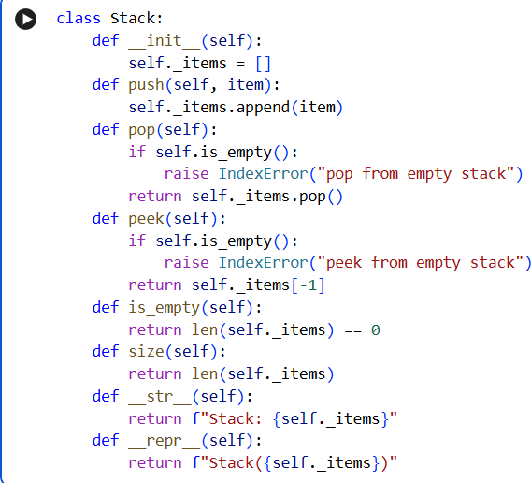

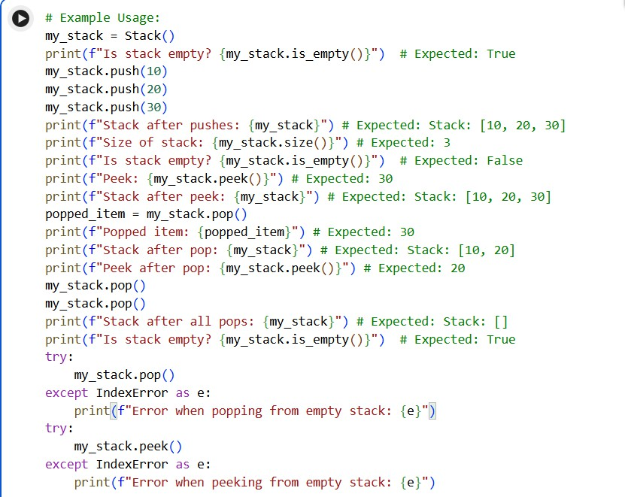
OUTPUT:
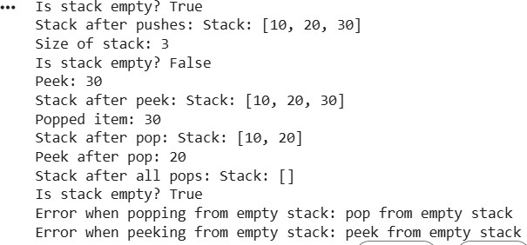
EXPLANATION:
This code creates a simple Stack using a Python list. A stack follows the Last In, First Out (LIFO) rule, which means the last item added is removed first. The push() method adds an item to the stack,
and the pop() method removes the top item. The peek() method shows the top item without removing it. The is_empty() method checks if the stack has no elements, and size() tells how many items are in the stack. The example part shows how items are added, removed, checked, and how errors are
handled when trying to remove or view items from an empty stack.

Task Description -2 – (Queue Design)
- Task:Use AI assistance to create a Queue data structure following FIFO principles

Expected Output:
- A complete Queue implementation including enqueue, dequeue, front element access, and size calculation

PROMPT:
Design and implement a Queue class in Python. The queue should follow FIFO (First In, First Out) principle. Include methods: enqueue, dequeue, front, and size. Use a list to store elements and show example usage.
CODE:
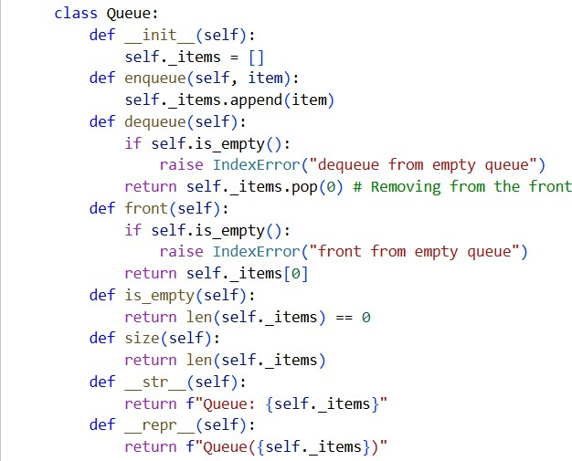
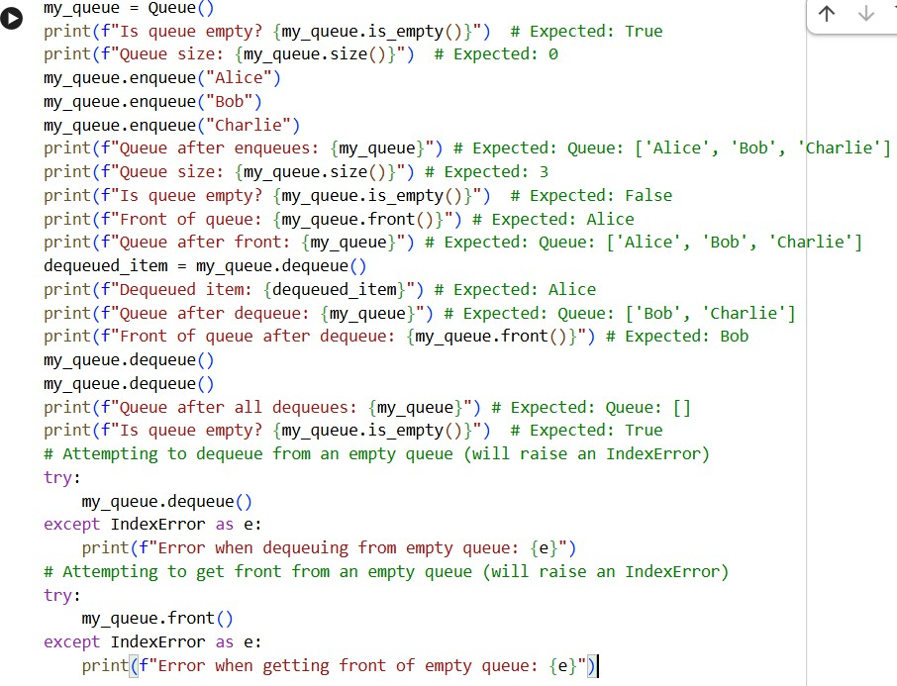

OUTPUT:
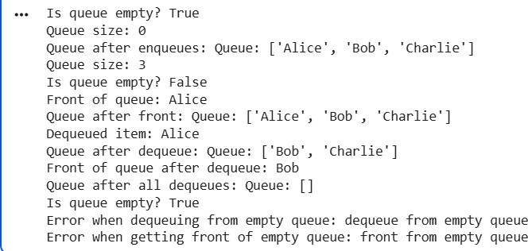
EXPLANATION:
This code creates a simple Queue using a Python list. A queue works on the First In, First Out (FIFO) rule, which means the first item added will be removed first. The enqueue() method adds an item to the end of the queue. The dequeue() method removes the first item from the queue. The front()
method shows the first item without removing it. The is_empty() method checks if the queue is empty, and size() tells how many items are in the queue. The example shows how items are added, removed inorder, and how errors are handled when the queue is empty.

Task Description -3 –(Singly Linked List Construction)
- Task: Utilize AI to build a singly linked list supporting insertion and traversal.

Expected Output:
- Correctly functioning linked list with node creation, insertion logic, and display functionality.
PROMPT:
Design and implement a Stack class in Python. The stack should support push, pop, peek, and is_empty operations. Use a list to store elements internally. Include proper documentation and example usage
CODE:

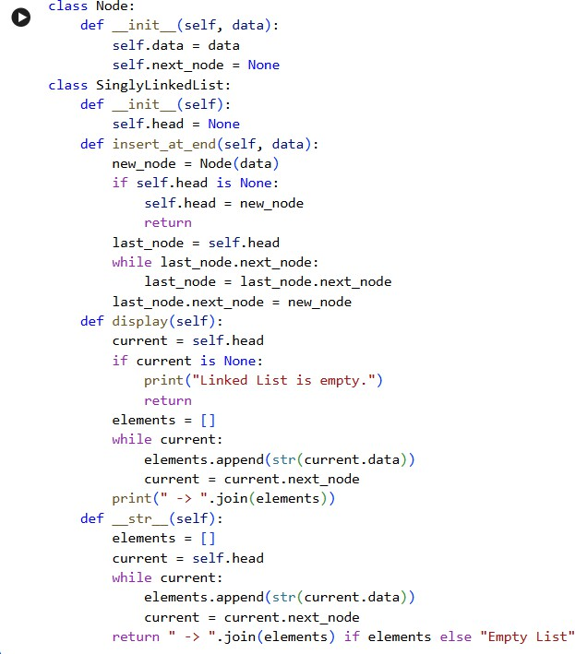
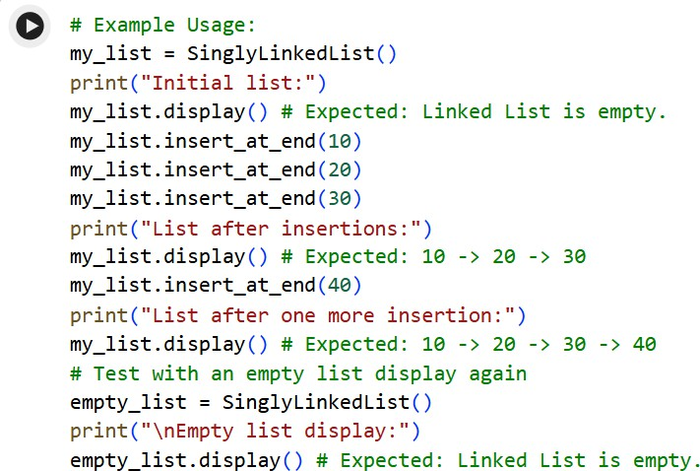

OUTPUT:
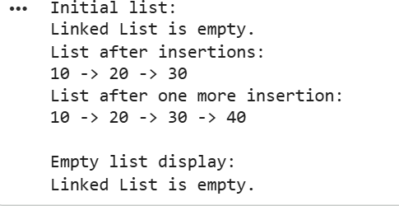
EXPLANATION:
This code creates a simple Singly Linked List. The Node class stores the data and a link to the next
node. The SinglyLinkedList class keeps track of the first node using head. The insert_at_end() method adds new elements to the end of the list. The display() method prints all elements in order. The
example shows inserting numbers and displaying them, and it also shows what happens when the list is empty.

Task Description -4 – (Binary Search Tree Operations)
- Task: Implement a Binary Search Tree with AI support focusing on insertion and traversal.

Expected Output:
- BST program with correct node insertion and in-order traversal output.
PROMPT:
Design and implement a Binary Search Tree (BST) in Python. Include node creation, insertion method, and in-order traversal function. The tree should follow BST rules for inserting elements. Provide example usage with traversal output.
CODE:

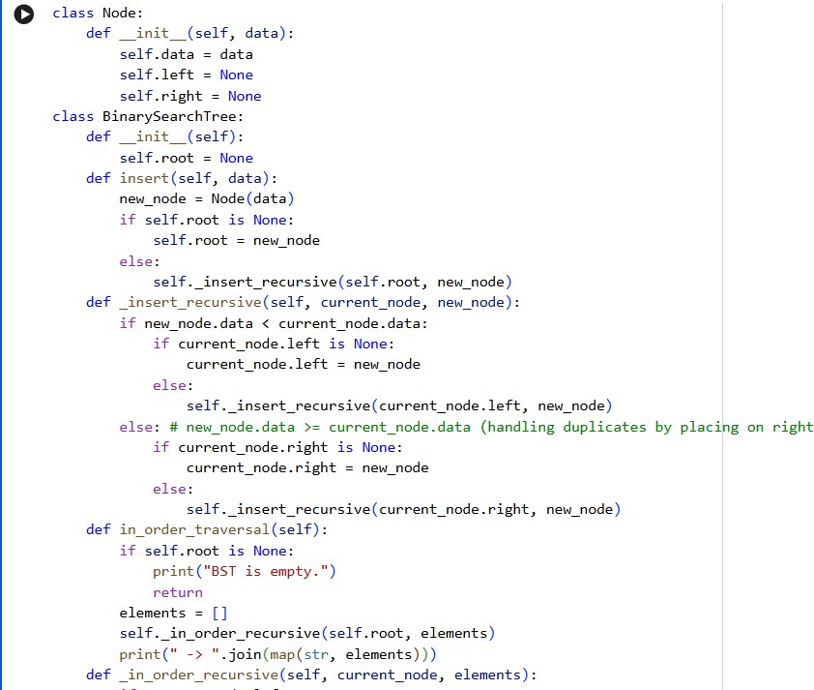
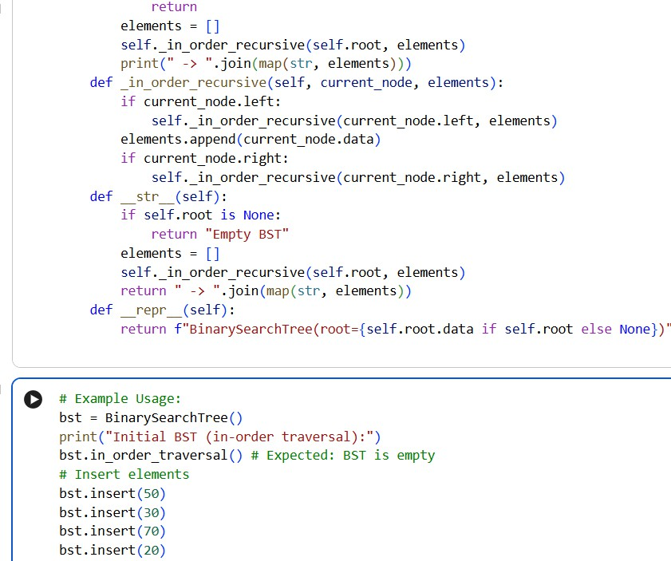

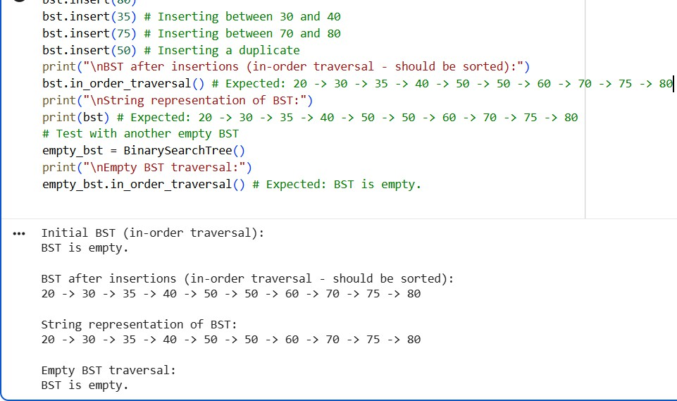
EXPLANATION:
This code creates a simple Binary Search Tree (BST). The Node class stores a value and has two links: left and right. The BinarySearchTree class keeps track of the first node called the root. The insert() method adds numbers to the tree following the rule: smaller numbers go to the left, and bigger numbers go to the right. The tree uses recursion to find the correct place for each new value. The in_order_traversal() method prints the elements in sorted order. If the tree is empty, it shows a
message saying the BST is empty.

Task Description -5 – (Hash Table Implementation)
- Task: Create a hash table using AI with collision handling

Expected Output:
- Hash table supporting insert, search, and delete using chaining or open
PROMPT:

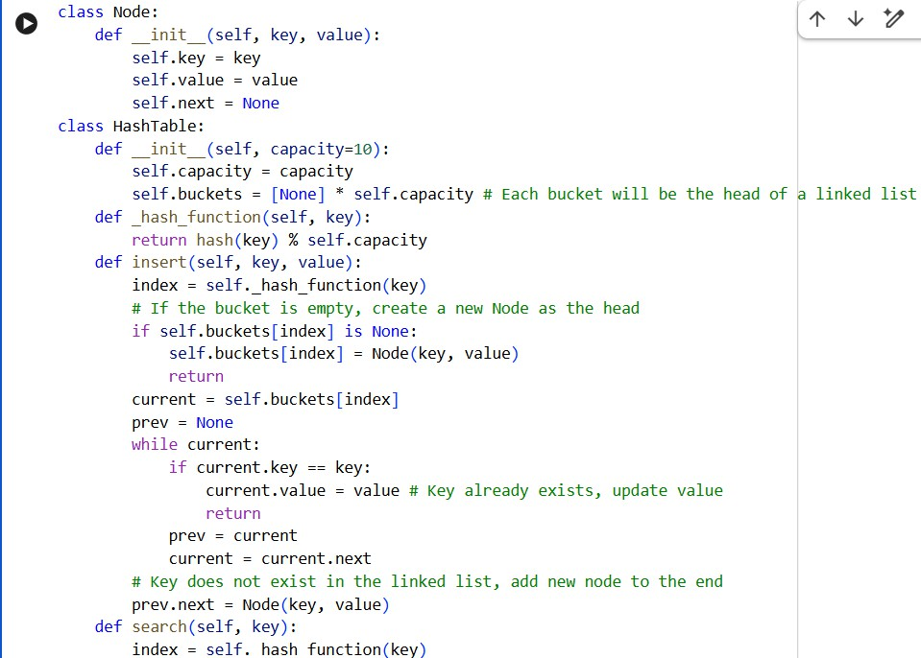
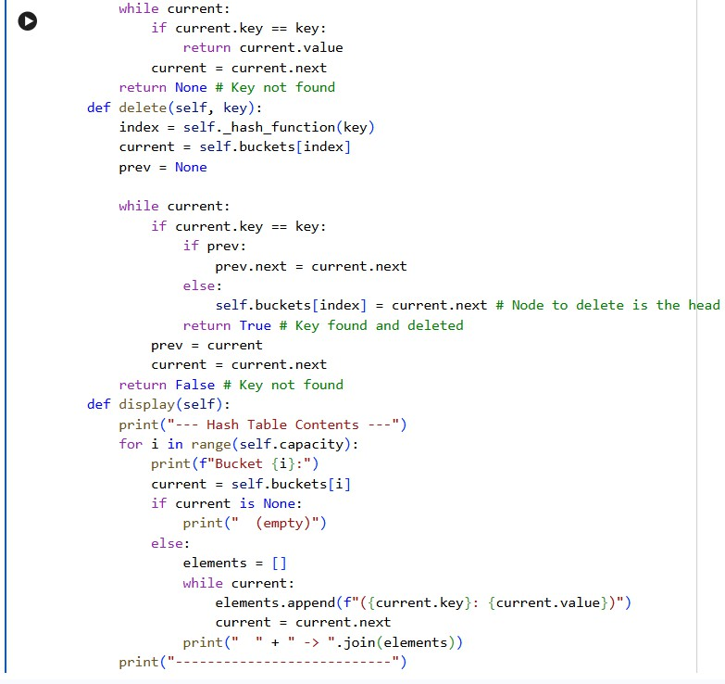

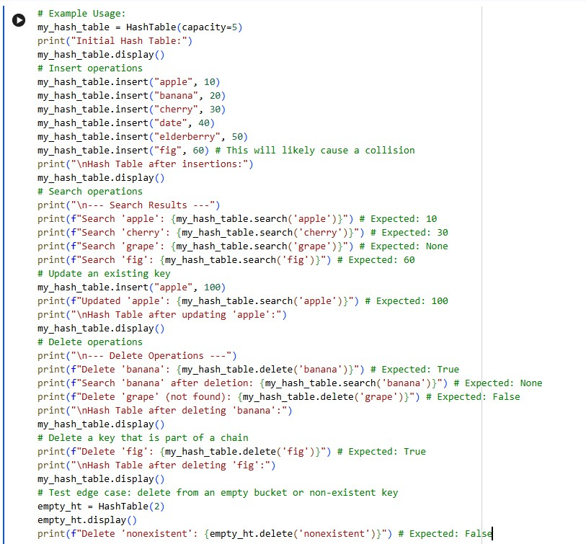
OUTPUT:
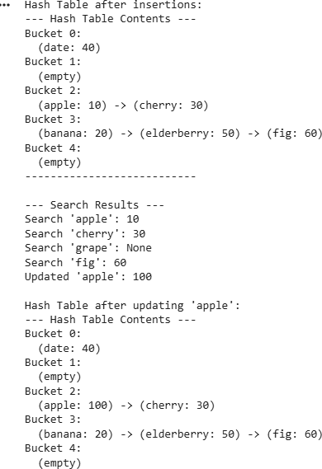

EXPLANATION:
This code creates a simple Hash Table to store key–value pairs. It uses a hash function to decide which bucket (index) each key should go into. If two keys go to the same bucket, it handles the
collision using a linked list (chaining). The insert() method adds a key and value to the table, and if the key already exists, it updates the value. The search() method finds and returns the value for a
given key. The delete() method removes a key from the table. The display() method shows all the buckets and their stored data. The example shows inserting, searching, updating, deleting, and handling cases where a key is not found.

