Basics

1. How can you retrieve all the information from the cd.facilities table?

select * from cd.facilities

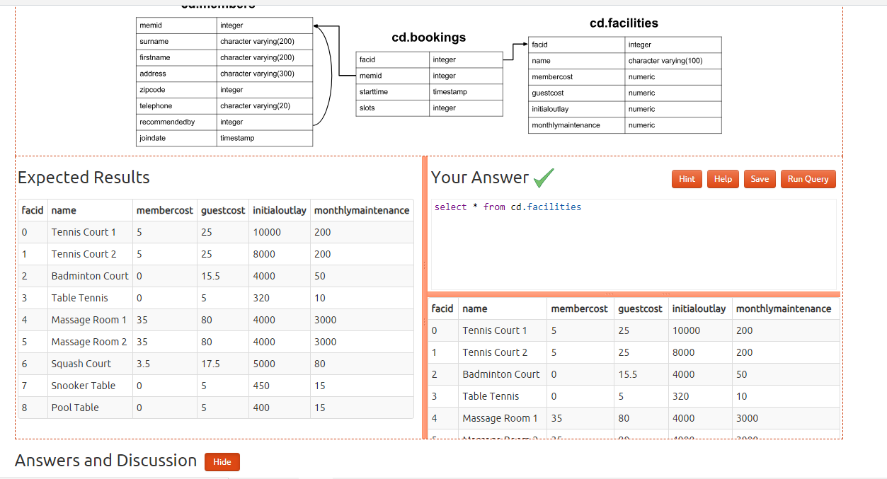

1. You want to print out a list of all of the facilities and their cost to members. How would you retrieve a list of only facility names and costs?

select name,membercost from cd.facilities

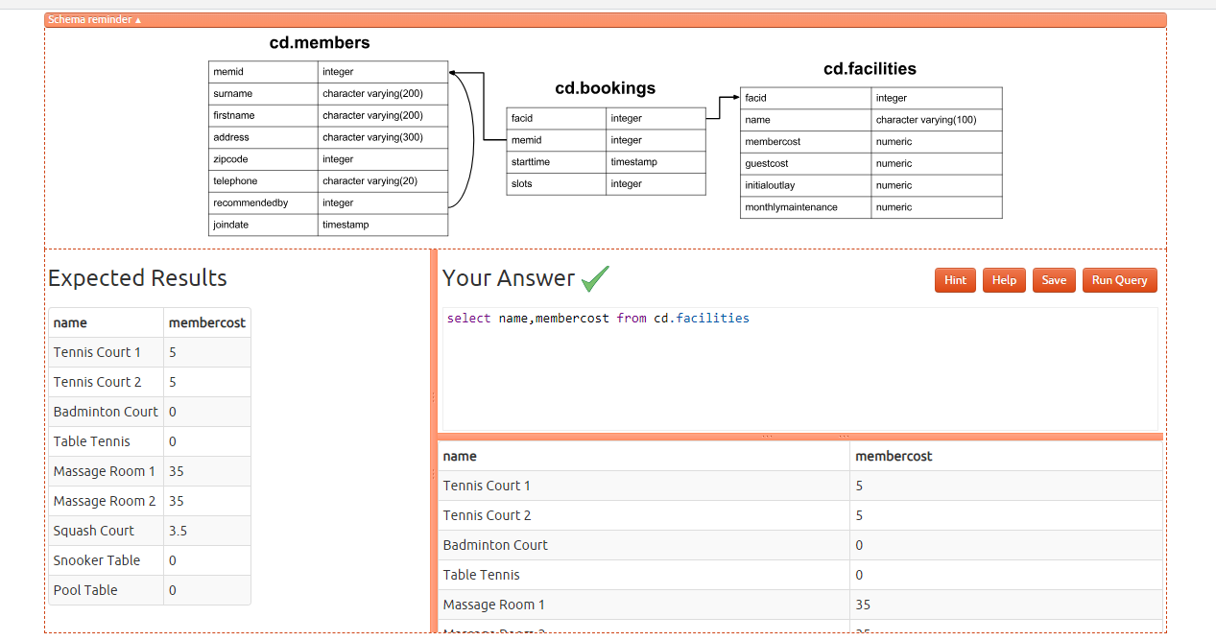

3) How can you produce a list of facilities that charge a fee to members?

select * from cd.facilities where membercost>0

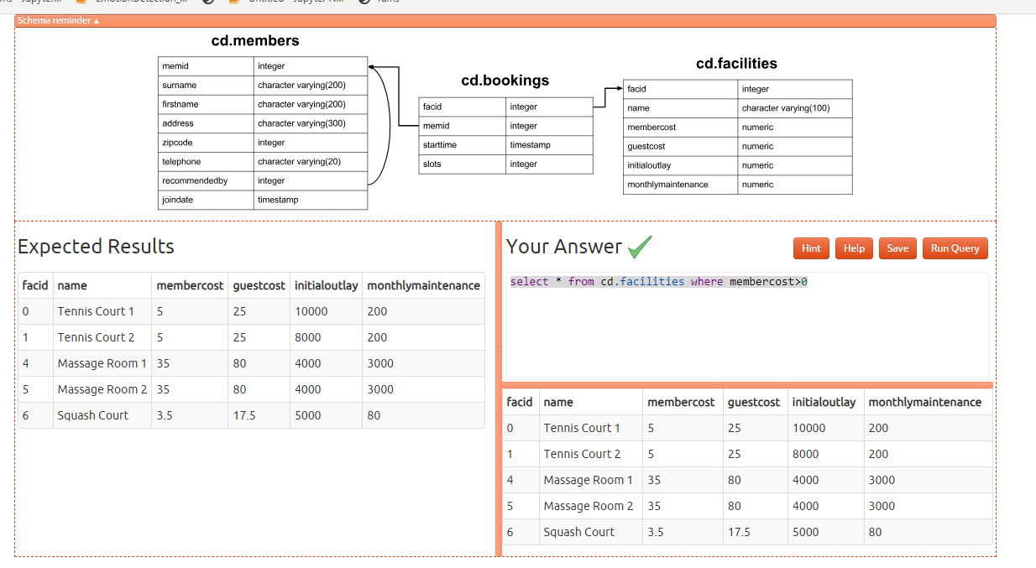

4)How can you produce a list of facilities that charge a fee to members, and that fee is less than 1/50th of the monthly maintenance cost? Return the facid, facility name, member cost, and monthly maintenance of the facilities in question.

select facid,name,membercost,monthlymaintenance from cd.facilities

where membercost>0 and membercost<monthlymaintenance/50

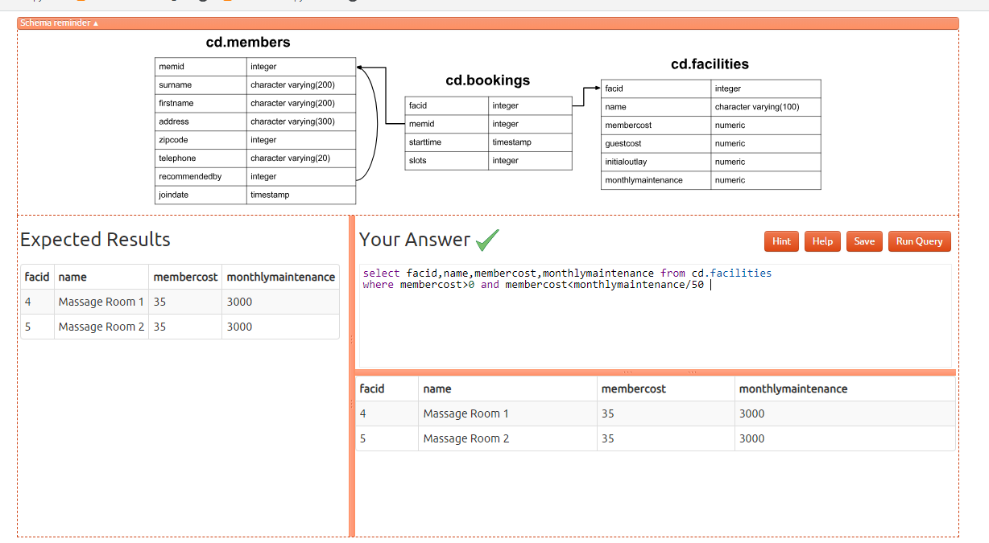

5) How can you produce a list of all facilities with the word 'Tennis' in their name?

select * from cd.facilities where name like '%Tennis%'

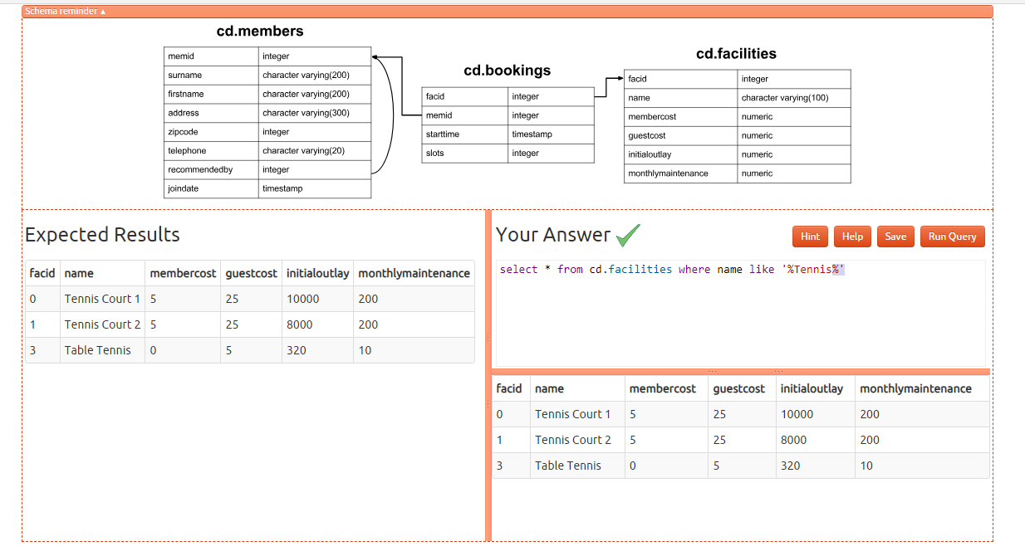

6) How can you retrieve the details of facilities with ID 1 and 5? Try to do it without using the OR operator.

select * from cd.facilities where facid in (1,5)

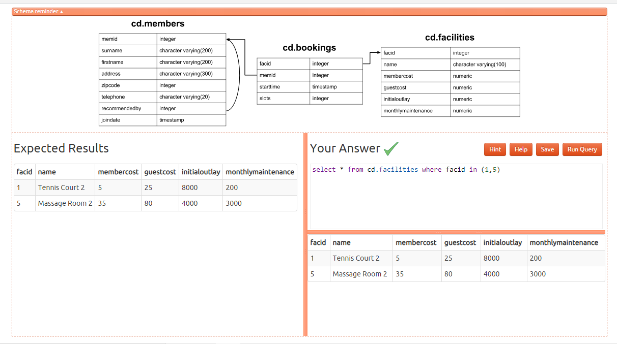

7) How can you produce a list of facilities, with each labelled as 'cheap' or 'expensive' depending on if their monthly maintenance cost is more than $100? Return the name and monthly maintenance of the facilities in question.

select name,

case when monthlymaintenance>100 then 'expensive'

else 'cheap'

end as cost from cd.facilities;

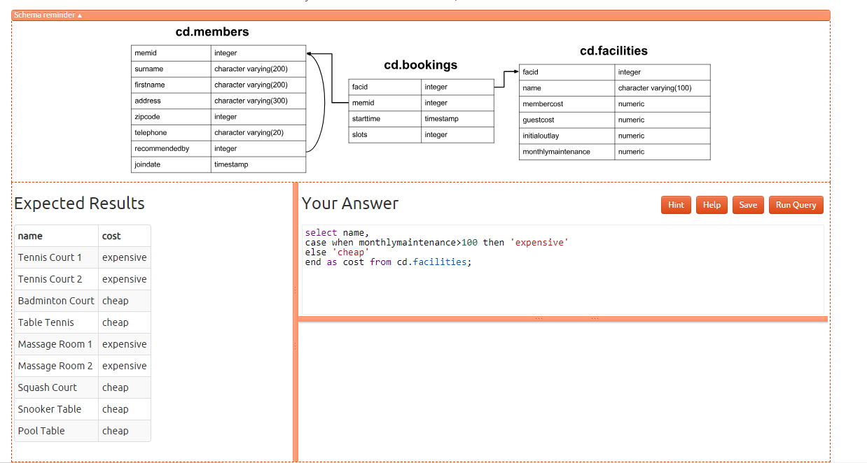

8) How can you produce a list of members who joined after the start of September 2012? Return the memid, surname, firstname, and joindate of the members in question.

select memid,surname,firstname,joindate from cd.members

where joindate>'2012-09-01'

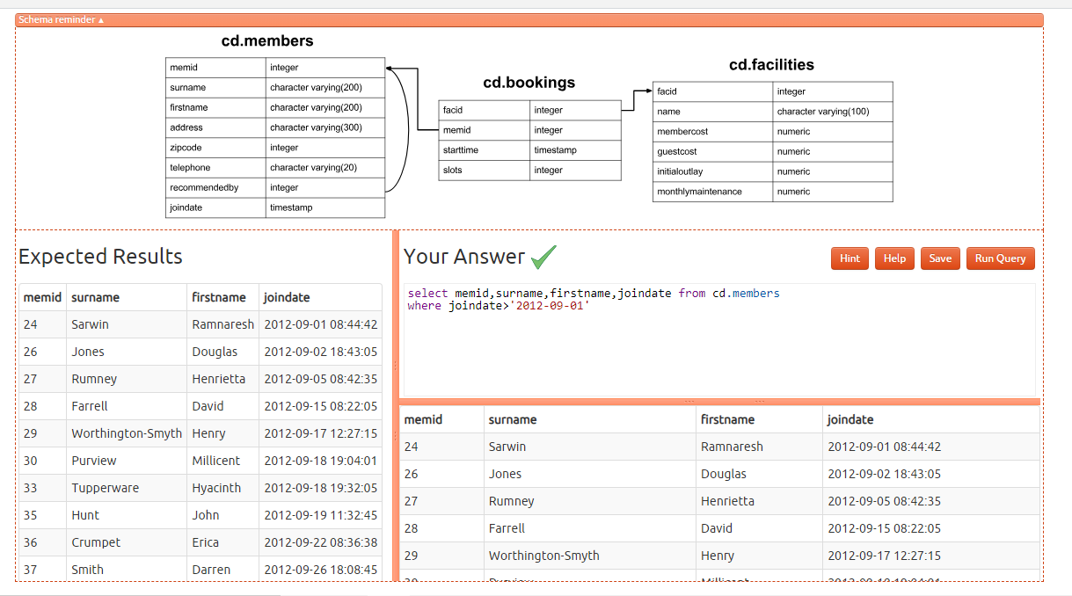

9) How can you produce an ordered list of the first 10 surnames in the members table? The list must not contain duplicates.

select distinct surname from cd.members order by surname asc limit 10

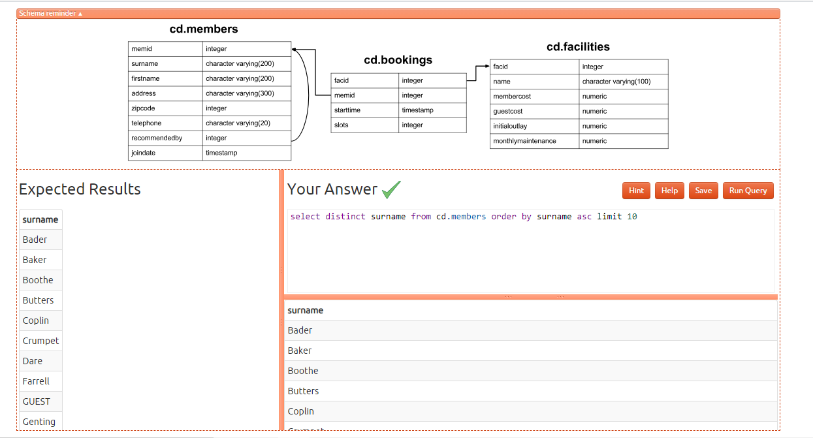

10) You, for some reason, want a combined list of all surnames and all facility names. Yes, this is a contrived example :-). Produce that list!

select surname from cd.members

union

select name from cd.facilities;

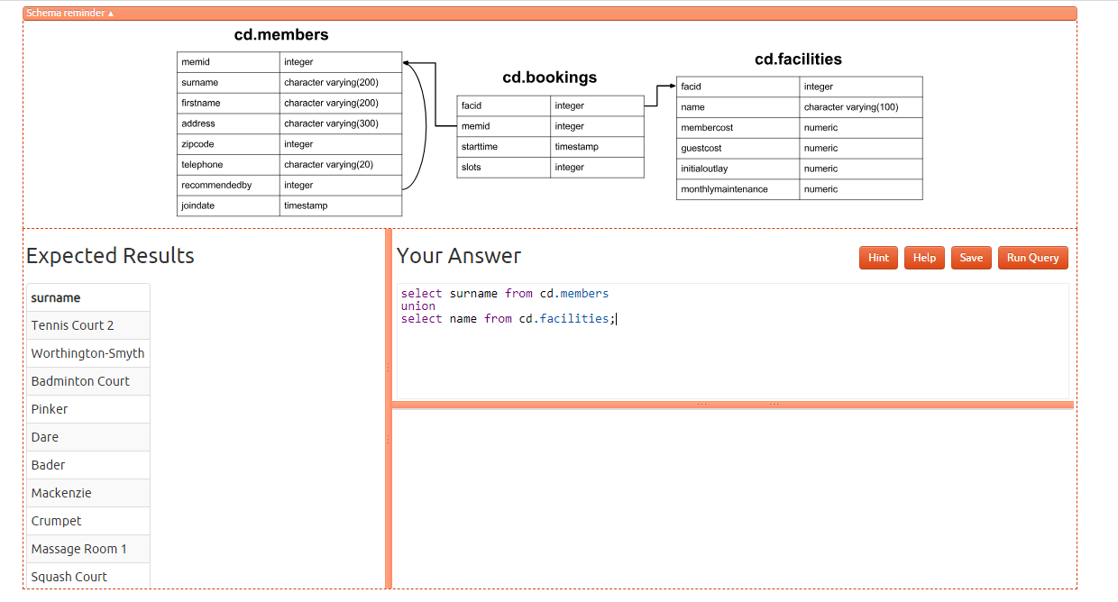

11) You'd like to get the signup date of your last member. How can you retrieve this information?

select max(joindate) as latest from cd.members

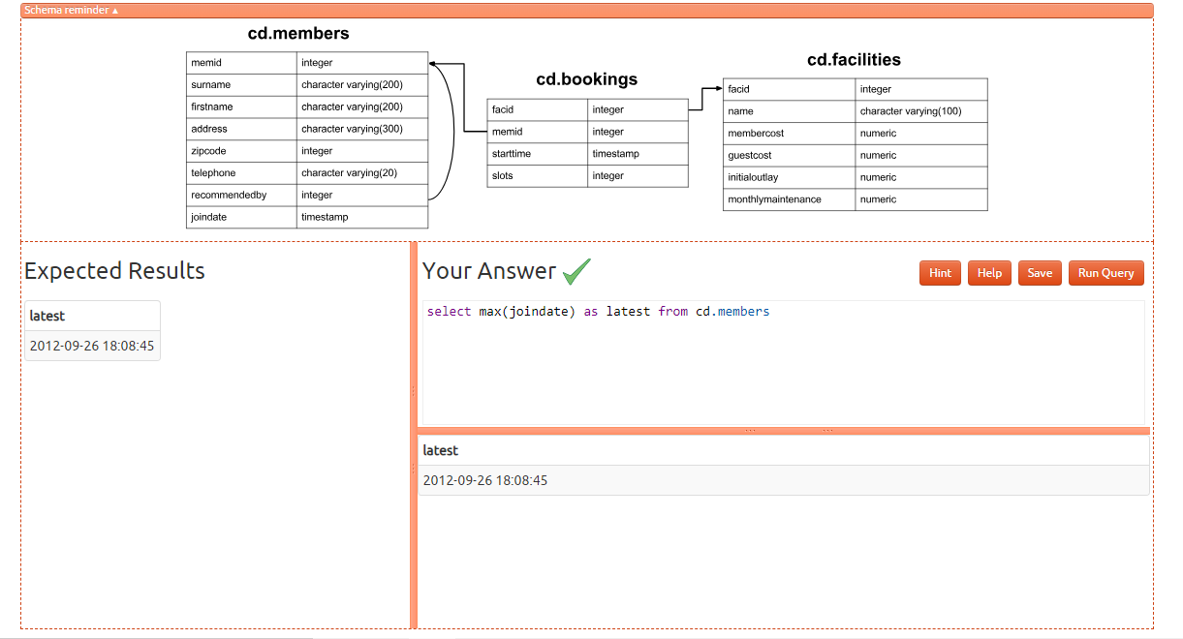

12) You'd like to get the first and last name of the last member(s) who signed up - not just the date. How can you do that?

select firstname,surname,joindate from cd.members

where joindate=(select max(joindate) from cd.members);

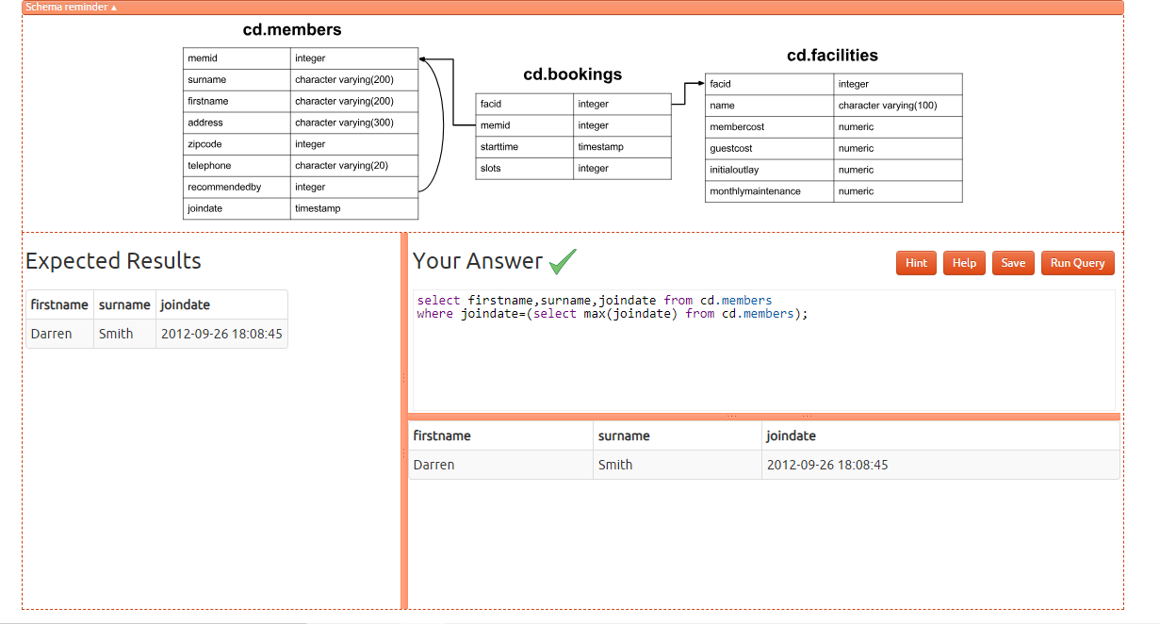

Joins and Subqueries

1. How can you produce a list of the start times for bookings by members named 'David Farrell'?

select b.starttime

from

cd.bookings b

inner join cd.members m

on m.memid = b.memid

where

m.firstname='David'

and m.surname='Farrell';

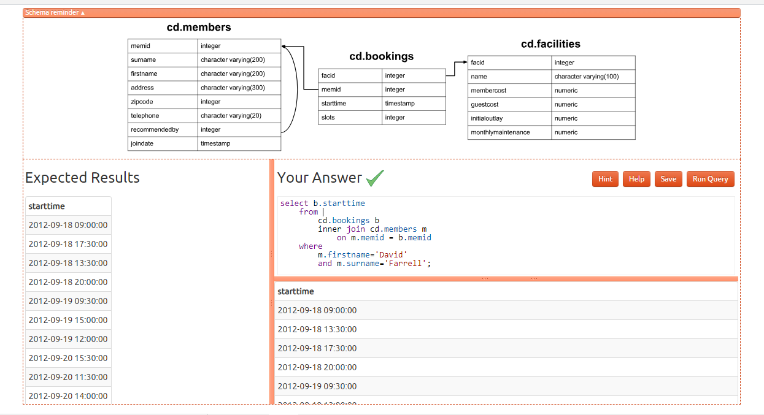

1. How can you produce a list of the start times for bookings for tennis courts, for the date '2012-09-21'? Return a list of start time and facility name pairings, ordered by the time.

select b.starttime as start, f.name as name

from

cd.facilities f

inner join cd.bookings b

on f.facid = b.facid

where

f.name in ('Tennis Court 2','Tennis Court 1') and

b.starttime >= '2012-09-21' and

b.starttime < '2012-09-22'

order by b.starttime;

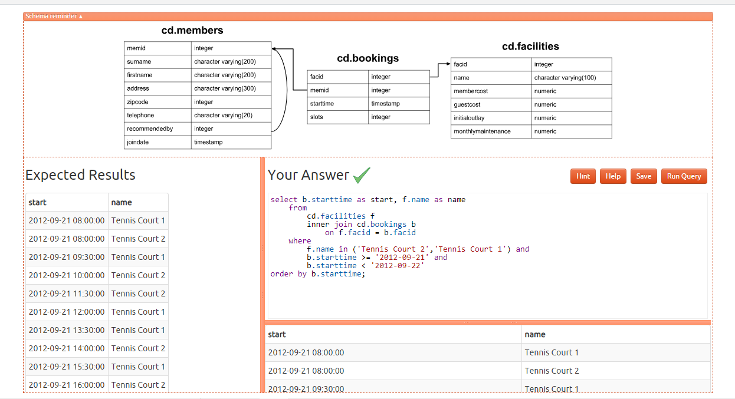

1. How can you output a list of all members who have recommended another member? Ensure that there are no duplicates in the list, and that results are ordered by (surname, firstname).

select distinct r.firstname as firstname, r.surname as surname

from

cd.members m

inner join cd.members r

on r.memid = m.recommendedby

order by surname, firstname;

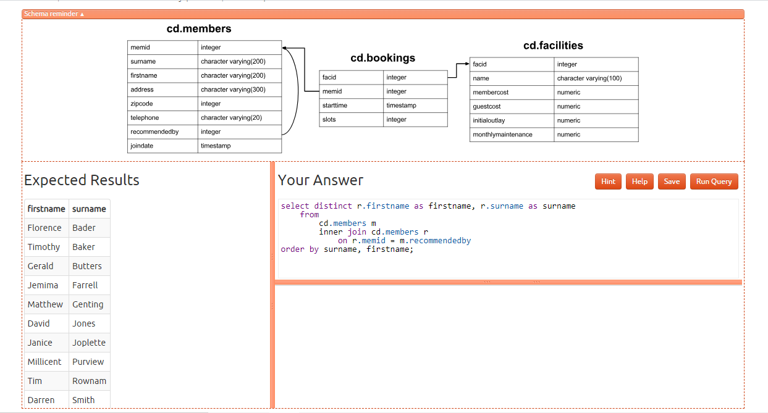

1. How can you output a list of all members, including the individual who recommended them (if any)? Ensure that results are ordered by (surname, firstname).

select m.firstname as memfname, m.surname as memsname, r.firstname as recfname, r.surname as recsname

from

cd.members m

left outer join cd.members r

on r.memid = m.recommendedby

order by memsname, memfname;

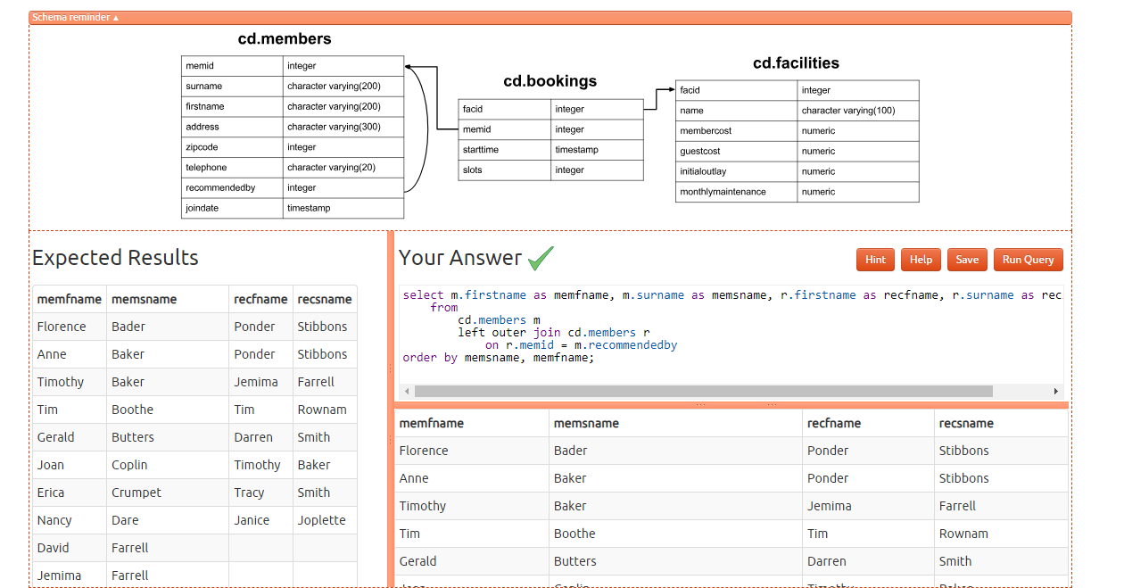

1. How can you produce a list of all members who have used a tennis court? Include in your output the name of the court, and the name of the member formatted as a single column. Ensure no duplicate data, and order by the member name followed by the facility name.

select distinct m.firstname || ' ' || m.surname as member, f.name as facility

from

cd.members m

inner join cd.bookings b

on m.memid = b.memid

inner join cd.facilities f

on b.facid = f.facid

where

f.name in ('Tennis Court 2','Tennis Court 1')

order by member, facility

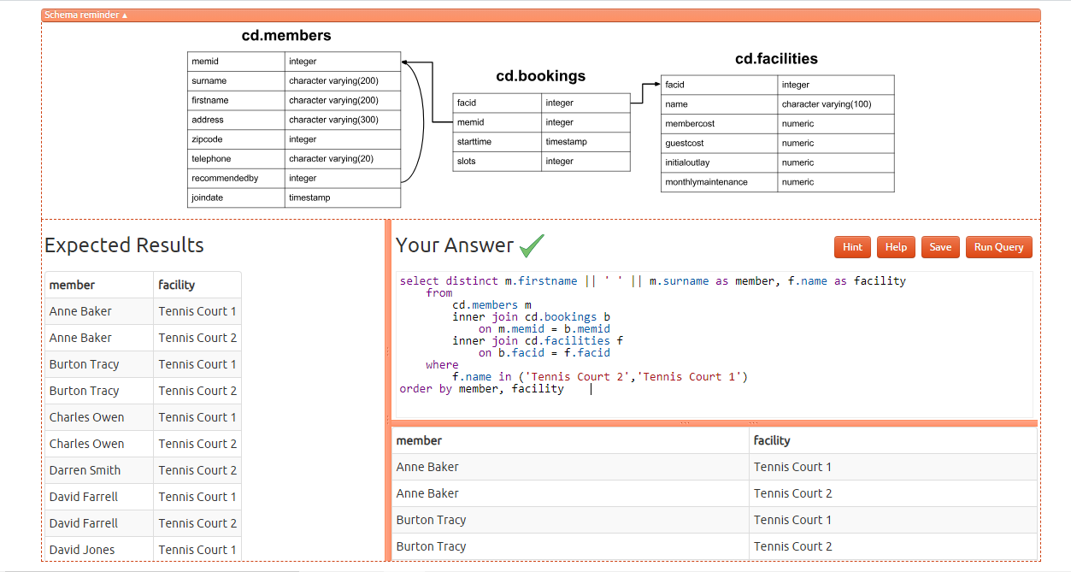

1. How can you produce a list of bookings on the day of 2012-09-14 which will cost the member (or guest) more than $30? Remember that guests have different costs to members (the listed costs are per half-hour 'slot'), and the guest user is always ID 0. Include in your output the name of the facility, the name of the member formatted as a single column, and the cost. Order by descending cost, and do not use any subqueries.

select m.firstname || ' ' || m.surname as member,

f.name as facility,

case

when m.memid = 0 then

b.slots*f.guestcost

else

b.slots*f.membercost

end as cost

from

cd.members m

inner join cd.bookings b

on m.memid = b.memid

inner join cd.facilities f

on b.facid = f.facid

where

b.starttime >= '2012-09-14' and

b.starttime < '2012-09-15' and (

(m.memid = 0 and b.slots*f.guestcost > 30) or

(m.memid != 0 and b.slots*f.membercost > 30)

)

order by cost desc;

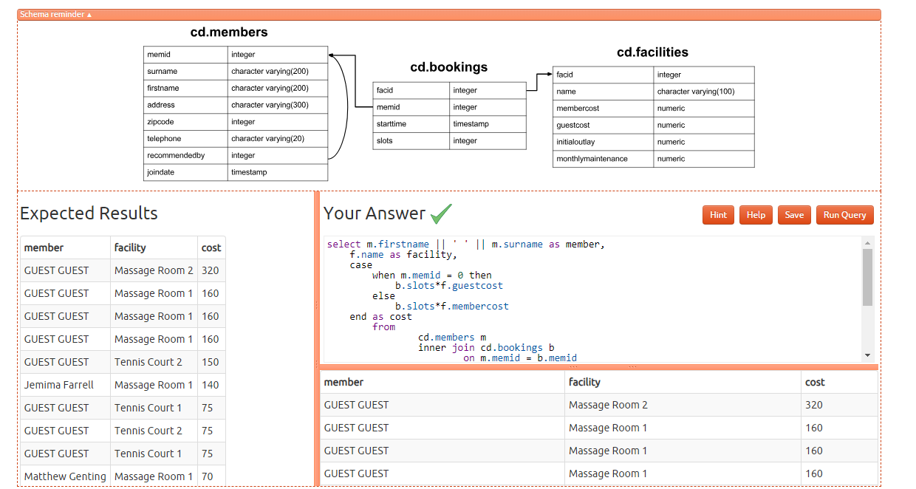

1. How can you output a list of all members, including the individual who recommended them (if any), without using any joins? Ensure that there are no duplicates in the list, and that each firstname + surname pairing is formatted as a column and ordered.

select distinct m.firstname || ' ' || m.surname as member,

(select r.firstname || ' ' || r.surname as recommender

from cd.members r

where r.memid = m.recommendedby

)

from

cd.members m

order by member;

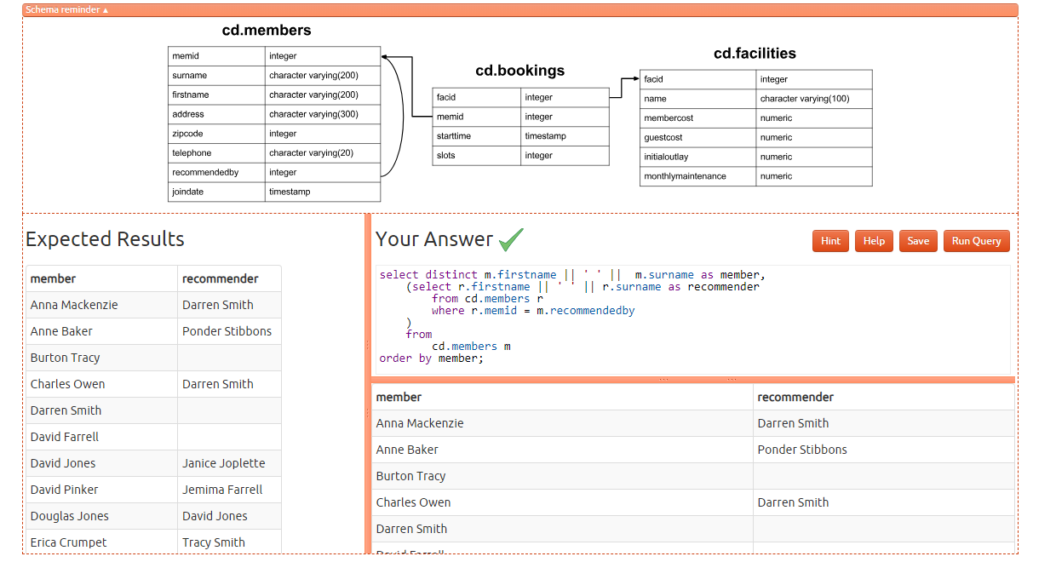

8) The [Produce a list of costly bookings](https://pgexercises.com/questions/joins/threejoin2.html) exercise contained some messy logic: we had to calculate the booking cost in both the WHERE clause and the CASE statement. Try to simplify this calculation using subqueries. For reference, the question was:

*How can you produce a list of bookings on the day of 2012-09-14 which will cost the member (or guest) more than $30? Remember that guests have different costs to members (the listed costs are per half-hour 'slot'), and the guest user is always ID 0. Include in your output the name of the facility, the name of the member formatted as a single column, and the cost. Order by descending cost.*

select member, facility, cost from (

select

m.firstname || ' ' || m.surname as member,

f.name as facility,

case

when m.memid = 0 then

b.slots*f.guestcost

else

b.slots*f.membercost

end as cost

from

cd.members m

inner join cd.bookings b

on m.memid = b.memid

inner join cd.facilities f

on b.facid = f.facid

where

b.starttime >= '2012-09-14' and

b.starttime < '2012-09-15'

) as bookings

where cost > 30

order by cost desc;

