Documentation for Translator web app

Submitted by: Himadri Goswami

Employee ID:46159312

**1.Introduction**

The Translation Application aims to provide a context-aware and domain-specific translation service with an active frontend, API-based connection, and backend processing. The application will primarily focus on translating text from English to German and Italian, with a domain emphasis on Technology. This document outlines the basic functionalities and requirements for developing this small-scale web-based service.

**2. Functional Requirements**

**2.1 Frontend Features:**

**Language Selection:**

From Language: English (default)

To Language: German, Italian

**Domain Selection:**

Generic and Technology domain

**Input Format:**

Supports input in word or digital PDF format

**User Interface:**

Simple and user-friendly design

**Submit Button:**

Initiates the translation process

**2.2 Backend Processing:**

**Translation Process:**

Utilizes API-based connection to perform translations

**Post Processing:**

Automatically downloads the translated document

Provides an option for the user to download the translated document

**3. Technology Stack**

**Frontend:**

Streamlit python

**Backend:**

Programming Language: Python

**API:**

Google Translate API

4. **Frontend code:**

import streamlit as st

import os

from googletrans import Translator

from PyPDF2 import PdfReader

from docx import Document

def translate_text(text, target_language):

    translator = Translator()

    translated_text = translator.translate(text, dest=target_language)

    return translated_text.text

def translate_file(input_file_path, output_file_paths, target_language):

    # Read text from input file

    if input_file_path.endswith('.docx'):

        doc = Document(input_file_path)

        text = '\n'.join([paragraph.text for paragraph in doc.paragraphs])

    elif input_file_path.endswith('.pdf'):

        with open(input_file_path, 'rb') as file:

            pdf_reader = PdfReader(file)

            text = ''

            for page in pdf_reader.pages:

                text += page.extract_text()

    else:

        raise ValueError("Unsupported file format")

    # Translate text to target language

    translated_text = translate_text(text, target_language)

    # Write translated text to output file

    with open(output_file_paths, 'w', encoding='utf-8') as file:

        file.write(translated_text)

    return output_file_paths

def main():

    st.title("Document Translator")

    # Language selection

    from_language = "English"  # Fixed as English for now

    to_language = st.selectbox("To Language", ['German', 'Italian'])

    # Display dropdown menu for domain selection (not used in translation)

    domain = st.selectbox("Domain", ['Generic', 'Technology'])

    # Mapping of language names to language codes

    language_codes = {

        'German': 'de',

        'Italian': 'it'

    }

    # File upload

    uploaded_file = st.file_uploader("Upload a Word or PDF file", type=['docx', 'pdf'])

    # Translate file on submit

    if st.button("Translate"):

        if uploaded_file is not None:

            output_file_paths = f"translated_output_{language_codes[to_language]}.txt"

            translated_file_path = translate_file(uploaded_file.name, output_file_paths, language_codes[to_language])

            st.success(f"Translation to {to_language} completed.")

            with open(translated_file_path, "rb") as file:

                file_contents = file.read()

            st.download_button(label="Download Translated File", data=file_contents, file_name=output_file_paths)

        else:

            st.error("Please upload a file first.")

if __name__ == "__main__":

    main()

**5.Output Snapshot:**

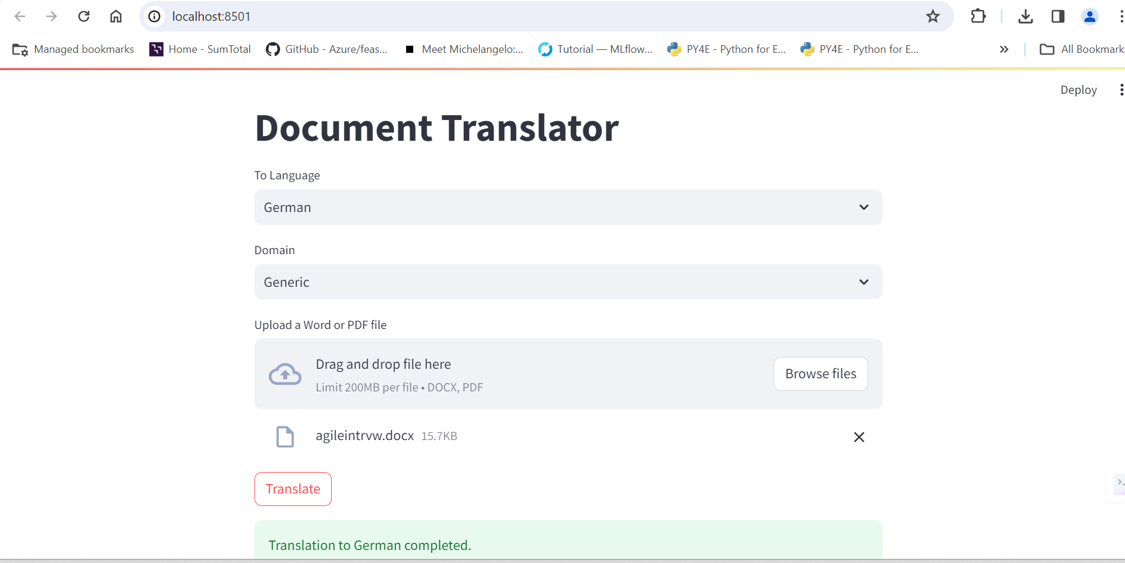

**6. References:**

1. <https://lokalise.com/blog/how-to-translate-languages-in-python-with-google-translate-and-deepl-plus-more/>

2. https://stackabuse.com/text-translation-with-google-translate-api-in-python/