Project 1: The Mystery Binary
Himadri Saha
EECE.5821 Computer Architecture
10/7/2026

Part C
C.1
This program reads the integer n and prints the sum of the squares.
n = read_int()
for i = 1..n: arr[i-1] = mult(i, i) # arr at 0x10010840
sum = arr[0] + ... + arr[n-1]
print "=> ", sum, '\n' then exit
mult(a, b) multiplies by repeated addition (b loops)

C.2
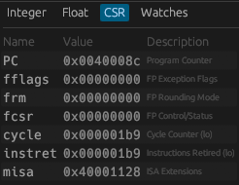
ic_n10 = 441

C.3
IC(n) = Σ sᵢ · kᵢ(n):
IC(n) = 6(1) + 1(n+1) + 3n + 5n + 2(1) + 1(n+1) + 6n + 11(1) + 1n + 1[n(n+1)/2 + n] + 3[n(n+1)/2] + 2n
(B9 and B10):
(1 + 3) · n(n+1)/2 = 4 · n(n+1)/2 = 2n(n+1) = 2n² + 2n
remaining n terms:
n (B1) + 3n (B2) + 5n (B3) + n (B5) + 6n (B6) + n (B8) + n (B9) + 2n (B11) = 20n
Collect the constants:
6 (B0) + 1 (B1) + 2 (B4) + 1 (B5) + 11 (B7) = 21
Solve:
IC(n) = (2n² + 2n) + 20n + 21
IC(n) = 2n² + 22n + 21
a = 2, b = 22, c = 21

C.6
- ALU contributes to the most cycles, it’s the most common class and has the highest CPI amongst the common classes (4 compared with 3 for branches and jumps)
- f = 72 100 / 78 206 = 0.922 ->92.2%
- Speedup = 1 / [(1 − f) + f/s]
As s → ∞, the f/s term goes to 0:
Speedup_max = 1 / (1 − f) = total cycles / (cycles not in mult)
Numbers:
Speedup_max = 78 206 / (78 206 − 72 100) = 78 206 / 6 106 = 12.81×

Part D
# | Optimization | IC Changes | CPI Changes | Why it helps
1 | Closed-form sum: Σi² = n(n+1)(2n+1)/6 replaces both loops | Large drop: O(n²) → constant | Rises (uses 30-cycle mul/div) | Removes all the repeated work. This is an algorithm change, not a small tweak.
2 | No array: squares are never stored and reloaded | Drops by 2n (n sw + n lw) | Removes 4-CPI stores and 5-CPI loads | The array was only temporary storage, and memory operations are the most expensive non-MulDiv class.
3 | No subroutine call: mult is gone entirely | Drops by 4n (jal, jalr, setup, return move) | — | Removes call overhead along with the loop inside it.
4 | Strength reduction: ÷2 done with srli instead of div | — (still 1 instruction) | Drops: 4 cycles instead of 30 | n(n+1) is always even, so a shift gives the exact result. Saves 26 cycles.
5 | 2n + 1 computed as add t2, a0, t0, i.e. n + (n+1) | Drops by 1 (instead of slli + addi) | — | Reuses the n+1 already computed. Saves 4 cycles.
6 | Removed the redundant addi a0, a0, 0 after lui | Drops by 1 | — | The string is at 0x10010000, so its low 12 bits are 0 and lui alone builds the full address. Saves 4 cycles.
7 | Reordered to compute the result straight into a0 | Drops by 1 (no mv before print-int) | — | The work starts while a0 still holds n, so the final divu writes the value to print directly into a0. Saves 4 cycles.
8 | Negative-input guard (bge) | Rises by 1 | — | Costs 3 cycles. Kept for correctness: the original prints 0 for n < 1, but the formula alone would print nonzero values for some negative n (for example, n = −2 gives −1).
RV32M is worth it for any meaningful n. Each 30-cycle instruction replaces work that grows with n, so its fixed cost pays for itself quickly. For very small inputs, though, a pure RV32I version would be faster.
When mul costs 30 cycles:
i Repeated addition (14i + 14) mul (30) Winner
1 28 30 repeated addition
2 42 30 mul
10 154 30 mul (5×)
100 1 414 30 mul (47×)

Without RV32M, the best approach is an O(n) loop that builds each square from the previous one with no multiply:
(i+1)² = i² + (2i + 1)
Total ≈ 85 + 19n cycles.

For which n is the optimized version not much faster?
n | Original cycles (7n² + 81n + 106) | Optimized | Speedup
0 | 106 | 177 | 0.60× (slower)
1 | 194 | 177 | 1.10×
2 | 296 | 177 | 1.67×
5 | 686 | 177 | 3.88×
10 | 1 616 | 177 | 9.13×
20 | 4 526 | 177 | 25.6×
100 | 78 206 | 177 | 441.8×

At n <= 2, optimized version is faster. At n = 0, the version is slower. This is because the original version cost grows with n, but the optimized cost is fixed. At smaller values for n, the original n² is ~0, meaning it costs a little more than setup and printing instructions.

Graduate component
G3.
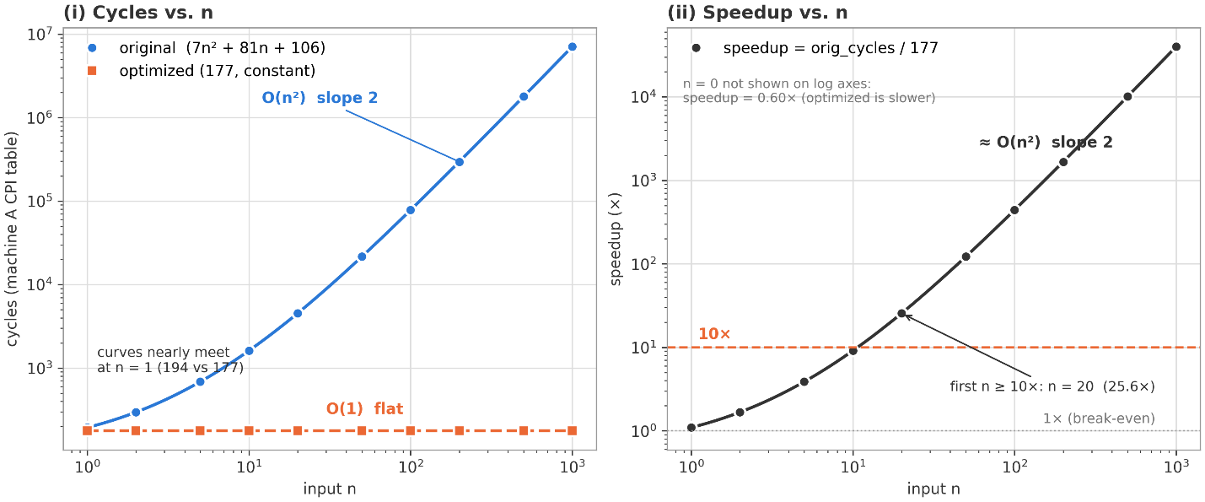
The optimization lowers IC but raises CPI. The optimized code runs only 19 instructions, but 3 of them are mul/mul/divu at 30 cycles each. Those 3 take 90 of its 177 cycles. The optimized program is slower at n = 0. At n = 0 the original takes 106 cycles and the optimized takes 177.

G2.
No, machine B is faster on the original program but slower on the optimized program. Which machine wins depends on the instructions used.
Instruction mix of each program:
Class | Original: count (% of IC) | Optimized: count (% of IC)
ALU | 11 215 (50.5%) | 11 (57.9%)
Branch + Jump | 10 802 (48.6%) | 1 (5.3%)
Load + Store | 200 (0.9%) | 0
MulDiv | 0 | 3 (15.8%)
System | 4 (0.02%) | 4 (21.1%)
Total | 22 221 | 19

Original Program - B is faster: B's large ALU advantage outweighs the rest of the instructions, and B finishes in 110.7 µs against A's 156.4 µs
Optimized Program – A is faster: B still saves time on ALU and MulDiv instructions, but there are only 14 of those. This can't make up for the system calls plus B's slower clock.
A speedup is the property of a machine AND workload together (not the machine alone)

