Problems section of the report:

In this lab we started by separating our work into different sections of the lab. Our initial idea was to have each group member do a section of the code and someone work on the assembly. This division of labor works well but had a few issues. The first issue came when some parts of the code were made before the others, which led to temporary pseudo code and mistakes. This had to be almost completely rewritten to fit the assembly and digital display portions of the lab. This issue was easily fixed since the framework was made prior, but the actual code needed improvements, so our group put the code together and fixed all the issues with the code including how to call the assembly that turns the LEDs on and off. The next challenge we had during this lab was with the Digital display. Initially we were confused that the 7-segment display had only one shift register. We began troubleshooting with the driver, but our main problem persisted. We got one digit to display properly with interrupts but needed double digits for the assignment. In the end our solution stemmed from the elegoo instructions using all the same pins. The code part was solved by using interrupts and the built in timer. The timer was used to trigger an interrupt every second and decrement another variable used to count the seconds down to then display on the 7 segment digital display. The other major issue we had was during our brainstorming process earlier into the project, we initially made the entire project minus the digital display without interruptions integrated into the code. The LEDs all worked properly with the correct timing, however there was no code for interrupts between the traffic lights for when they switch. Instead, it was made purely from timing commands. This definitely helped showcase that the general system was working properly, however the interrupts are a bit part of the lab and led to a lot recoding and changing the general set up of the whole system. We fixed the timing issue by adding some initial interrupts using the “*” key to poll for the keypad inputs. The final issue we had to overcome was our keypad wasn’t reading in the data properly. We created the keypad using a 2D array set up like the keypad in real life. The original design had an function for reading in the data, this function as the crux of the data reading issue. The original function called a character variable to get the input from the keypad, then checks an if statement to see if the variable is assigned a value. If that’s true, the function checked if the first character was “#” indicating the start of the keypad sequence. The flaw in this code was that the whole function had to loop to get the full command, rather than have a loop within the function. Without the loop it only found the first character and checked if it was the start, this would be checked each time the function was called, which made it so the only time the code would go through was for the “#” symbol rather than the whole sequence. However, in the new code we initialize the character variable, and set up a infinite while loop. In the loop it sets the variable to the read value from the keypad, then returns the character as a string. This works now because the code isn’t looking for the first character in the read function, instead it looks for it later in the code when it needs to take that data and convert it to different states of the lights.

Personal Contribution:

I originally was given the task of making the keypad, however our jobs got mixed up so someone else took that job. After that confusion I was tasked with making the main function. Since this was early in the project, I had no idea how to implement some of the code, and some of the other parts weren’t finished yet. So instead, I made my best attempt at the code. It didn’t include interrupts but rather based off time and input data. When I didn’t know how to call things properly, I added pseudo code so it could be used as a template for how the process would go. The code I made essentially took the data from the keypad in pseudo code, the puts it into a while loop to take all the key presses and put it into one big command sting. Then I took that string and made a case statement for each color in the command based on the letter in the command. Then taking the rest of the command I converted the numbers from the command string to be integers to make the time frame for the lights. Within each of the “if” statements I had the set time frame for each of the LEDs to light up. My code didn’t call the assembly or the 7-segment digital display since those weren’t coded yet. Overall, my code was very flawed, but I provided a skeleton for the future code renditions. I was also in charge of writing the problems and solutions section of the report along with the lessons learnt section.

Lessons Learnt:

In this lab we learned a multitude of new software and hardware applications. For the hardware applications, we learned how to use the 7-segment display, keypad, and how to use the Arduino microcontroller. Specifically, we learned how to properly wire up the 7-segment display to the Arduino and how to properly hook up a driver to make the display work. The keypad was pretty straight forward, but we learned how to wire up the keypad to the Arduino’s I/O pins. We also learned the locations and applications of the Arduino I/O and pwm pins of the microcontroller. The software applications we learned mainly had to do three main sections. The first being the keypad. We learned how to set up the keypad arrays to take input characters and how to use them in our code to act as commands. The second software we learned how to use was how to set up the 7-segment digital display. We were able to set up hexadecimal values to set up a hex map for the display, along with setting up a time, prescaler, and interrupts all combined in order to make the display work. The next software problem we overcame and learned from was implementing interrupts with the other newly learned skills in this lab. The interrupts were very similar to other times we have used them, but we still learned how to implement them into our keypad, and digital display. The final software application we learned was how to combine assembly and Arduino IDE code. It was relatively simple the way we implemented it. We made one assembly file in charge of turning the red LED on and then called the function to use it for the initial situation where no button is pressed and both red lights have to be on.

Result:

In this lab we successfully created the traffic lights functioning according to the assignment’s requirements. We successfully made the LEDs react in cahoots with keypad and the 7-segment digital display. The only issue we didn’t figure out was how to add a second digit to the digital display. It still returns the correct time and keeps it up to date, but it only displays the last 8 seconds of the timer, since there is only one shift register. Other than that, the traffic lights work properly. The LEDs are connected to each other, changing from red to green, green to yellow, then back to red using either their respective times determined by the keypad, or the three seconds for the yellow lights. The process has the proper interrupts to make the keypad, LEDs, and digital display work properly. Overall the lab was a success and the traffic lights work as intended with only one small issue.

*Figure 1. 7-segment Digital Display Wiring reference*

This is the image we used to figure out how to properly wire the digital display. This image comes from Lesson 28 of the four digit digital display. Found on this URL: <https://parsippany.vidyalaya.org/fut102-7segment.pdf>

[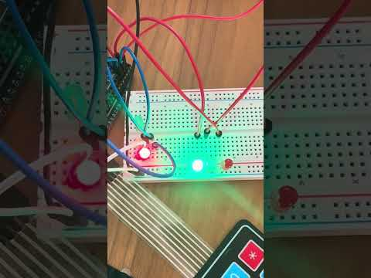](https://www.youtube.com/embed/KhIwH64PW10?feature=oembed)

*Video 1: First working prototype of the Traffic Light System*

This video is a demonstration of one our first tests of the basic traffic light system. This model has no interrupts or digital displays. The code used in this video is purely time based with the keypad inputs.

[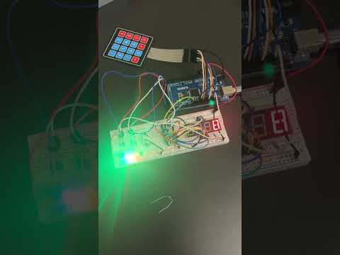](https://www.youtube.com/embed/GyIDsukMH8w?feature=oembed)

*Video 1: Final working Traffic Light Circuit*

This video is the final showing of our working circuit with interrupts and the digital display included. The code also includes the working assembly code.

Software Design:

**Source Code:** <https://github.com/himadri553/Microprocessors-2/tree/main/Lab1/Main_Code_Lab1>

The software design started out as a basic idea of different important functions that need to be addressed. The brainstormed functions we talked about was, the initial state where everything is waiting for an input value and the lights are all red. The next step being the polling state where there are inputs from the keypa

*Figure 2. State Machine for the Traffic Lights*

This image is a basic state machine for the entire lab, it goes through all the big processes in the lab. This state machine is used as a skeleton for our code, each state is essentially a function in the program that needs to be addressed.