Project Phase 4: Go-Back-N protocol over an unreliable UDP channel
EECE 4830 - Network Design
Nour Fahmy, Himadri Saha

Introduction
This project implements the Go-Back-N protocol on a UDP channel. The implementation includes the sliding windows, cumulative acknowledgments retransmission timers and packet buffering. The GBN sender will transmit a BMP image to the GBN receiver, which are designed to handle out of order delivery, packet corruption and intentional loss.

Flowchart

Code Description
GBN_Sender Class is the sender in this implementation. It is responsible for splitting up the file into fixed-sized chunks, assigning them with sequence numbers and transmitting the packets using a sliding window. Changes to the window are made when the sender receives ACKs. The class also manages the retransmission timer which resends the full window when a timeout is triggered. Based on the user’s prompt on which scenario to run, the sender class will also inject scenario-based behavior like ACK corruption or loss.
For the GBN_Receiver, the receiver will listen on a UDP port or incoming data packets. It maintains the expected sequence number and only accepts packets that match this number to keep them in order. The receiver will deliver packets to a file buffer and send ACKs when it receives data in the correct order for the sender to see. When packets are received out of order or the packet is corrupted, the receiver will resend the last correct ACK. The final file is then outputted by the receiver.

Execution Screenshots
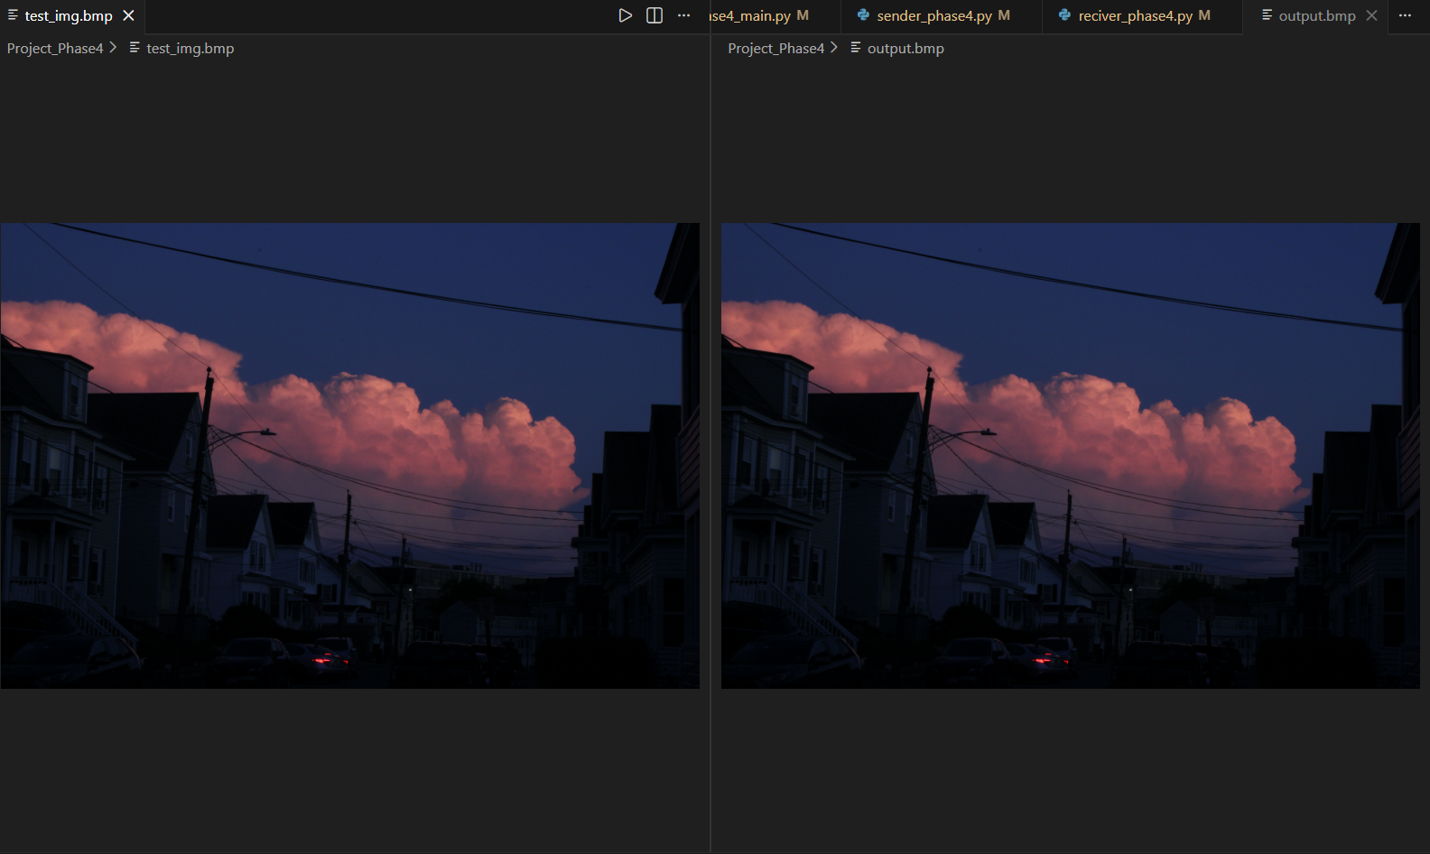
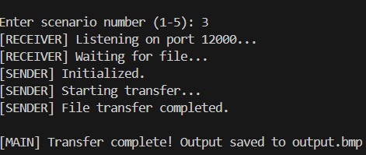

Performance Plots
