**Section 1: Data Cleaning & Preparation**

**1. Dispatch Date Format**

I changed the format of the Dispatch Date column to look like YYYY-MM-DD (year-month-day).  
This makes all the dates easier to read and keeps them in the same format.  
I used a simple Excel formula to do this.

**2. Checking Load Weight Values**

I looked through the Load Weight (Tonnes) column to find any values that were Less than 0, Equal to 0 or More than 50 tonnes. But there were no such records all the weights were valid and within a reasonable range.

**3. Filling Missing Ratings**

There were some missing values in the Rating column.  
To fill them in, I first grouped the data based on Vendor Region and Vendor Type and calculated the average rating for each group.  
Then I merged this average back to the main table on the basis of Vendor Region and Vendor type and filled in only the blank rating values. If a rating was already present, I left it as is.

**4. Duplicate Delivery IDs**

I checked the Delivery ID column for duplicates.  
There were no duplicates all 1,000 Delivery IDs are unique.

**Section 2: Data Analysis & Insights (Excel & Google Sheets)**

1.Calculate the average delivery delay (Actual Arrival – Expected Arrival) and the delivery success rate per Route Code. Identify the top five performing routes.

=here Delivery success flag means if Actual delivery time>Expected delivery time than 0 else 1. Form this pivot table we got that every delivery is late (Actual delivery time>Expected delivery time)

=and every route has **avarage delay time(hr)** of **2 hours.**

2.Calculate a new metric called Revenue Efficiency = Revenue / (Distance × Delivery Duration in hours). Use Dispatch Date and Actual Arrival for the duration.

=here I have used simple excel formula.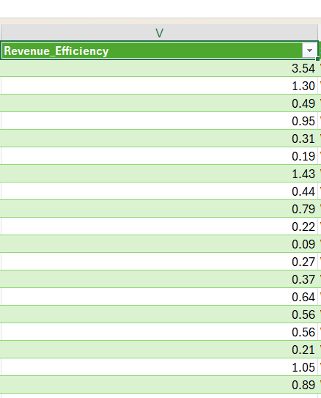

3.Build a pivot table showing the average delay (in hours) grouped by Priority Level. Interpret the results.

4.Categorize Dispatch Dates into Winter (Dec–Feb) and Monsoon (Jul–Sep) periods. Compare Fuel Cost, Revenue, and number of delayed deliveries between the two periods.

=Thise dataset include only Winter season and below are my observations.

**Section 4: Problem-Solving & Decision Making**

**13. Delay Analysis for Regions & Fleet Types**

In the data, the delay is the same for every delivery which is exactly **2 hours**. This means no specific **region** or **fleet type** is causing more delays than others. The issue seems to be happening across the board.

**Three ways to reduce delays:**

1. **Fix expected arrival times**  
   The current expected times might be too strict so we can make it flexible little bit. Updating them based on actual delivery times can reduce reported delays.
2. **Track deliveries in real time**  
   Use live tracking to quickly handle delays and make better decisions while the delivery is on the way. For this use more Advanced AI/ML tech.
3. **Use the right type of vehicle**  
   Assign faster or more suitable vehicles for certain areas (e.g., two-wheelers for big cities so that reduce traffics times).

**14. Improve Revenue Efficiency by 15%**

Revenue Efficiency = Revenue ÷ (Distance × Delivery Duration)

To make this number 15% better, the company can either **cut costs** or **earn more per delivery**.

**Two simple methods:**

1. **Lower fuel and time costs**  
   Look at routes where time or fuel use is high and try to improve them by Delivering multiple orders together or avoiding long routes can help.
2. **Adjust pricing according to different factors**  
   Some long or slow deliveries may not be priced well. Charging a bit more for difficult deliveries could increase revenue without losing customers.

**15. Transit Time vs Rating**

We looked at whether longer deliveries get lower ratings. But in our case according to our dataset, **every delivery takes 12 hours**, so we can’t compare different transit times.

Even though the time is the same, the **ratings are different**, which shows that other things matter more like how the driver behaves, the condition of the package, or communication with the customer.

**Observation:** Transit time doesn’t explain the ratings. We should focus on other areas to improve customer satisfaction. ex-driver behaviours, packaging or the state in which package received etc.