Report
Of
Miku AI Assistant: An LLM-Based Offline Multilingual AI Voice Assistant
Submitted
To
School of Computer Science and Engineering
IILM University, Greater Noida, U.P.
In partial fulfilment of the requirement of degree of
B.Tech CSE

By
Roll Number of Student: 2410030898
Name of Student: HIMADRI SINHA
Batch: 2026-27

Chapter No. | Chapter Name | Page Nos.
 | Cover Page | ---
1. | Candidate's Declaration | ii
2. | Acknowledgement | iii
3. | Internship / Project Completion Certificate | iv
4. | Project Description | 1
 | Introduction | 2
 | Organization Profile | 3
 | Problem Statement | 4
 | Project Objectives | 5
 | Scope of the Project | 6
 | Technologies and Tools Used | 7
 | System Architecture | 8
 | Methodology | 9-11
 | Expected Outcomes | 12
 | Certificates of Completion and Communication Proof | 13
5. | Bibliography / References | 14

TABLE OF CONTENTS

CANDIDATE'S DECLARATION
I, Himadri Sinha, hereby declare that the project report titled “Miku AI Assistant: An LLM-Based Offline Multilingual AI Voice Assistant” has been prepared by me as part of my internship work at the Centre for Development of Advanced Computing (C-DAC), Patna, and in fulfilment of the academic requirements for the degree of Bachelor of Technology in Computer Science and Engineering.
I declare that the work presented in this report is based on my learning, development, implementation, and testing carried out during the internship period. All sources and references used in the preparation of this report have been appropriately acknowledged.
I further declare that this report has not been submitted to any other institution for the award of any degree or diploma. I shall be responsible for any copyright or academic issues arising from the contents of this report

Signature: Himadri sinha
Student Name: Himadri sinha
Roll No:2410030898

ACKNOWLEDGEMENT
I would like to express my sincere gratitude to the Centre for Development of Advanced Computing (C-DAC), Patna, for providing me with the opportunity to undertake this internship and gain practical exposure to Artificial Intelligence, Machine Learning, Large Language Models, and related technologies.
During the initial phase of my internship, I studied important concepts related to AI/ML, Large Language Models (LLMs), and Retrieval-Augmented Generation (RAG). These learning activities helped me build a better understanding of modern AI systems and prepared me for the practical project work carried out later during the internship.
I am thankful to my mentors and the team at C-DAC for their guidance, suggestions, and support throughout the internship. Their feedback helped me understand the practical aspects of developing and integrating different AI components.
I would also like to thank my faculty members for their guidance and encouragement during the preparation of this project report.
Finally, I am grateful to my parents, friends, and everyone who supported and encouraged me throughout the internship and project development.

Signature: Himadri sinha
Student Name: Himadri sinha
Roll No:2410030898

INTERNSHIP COMPLETION CERTIFICATE
Internship Organization: Centre for Development of Advanced Computing (C-DAC), Patna
Internship Duration: 1 June 2026 to 6 August 2026
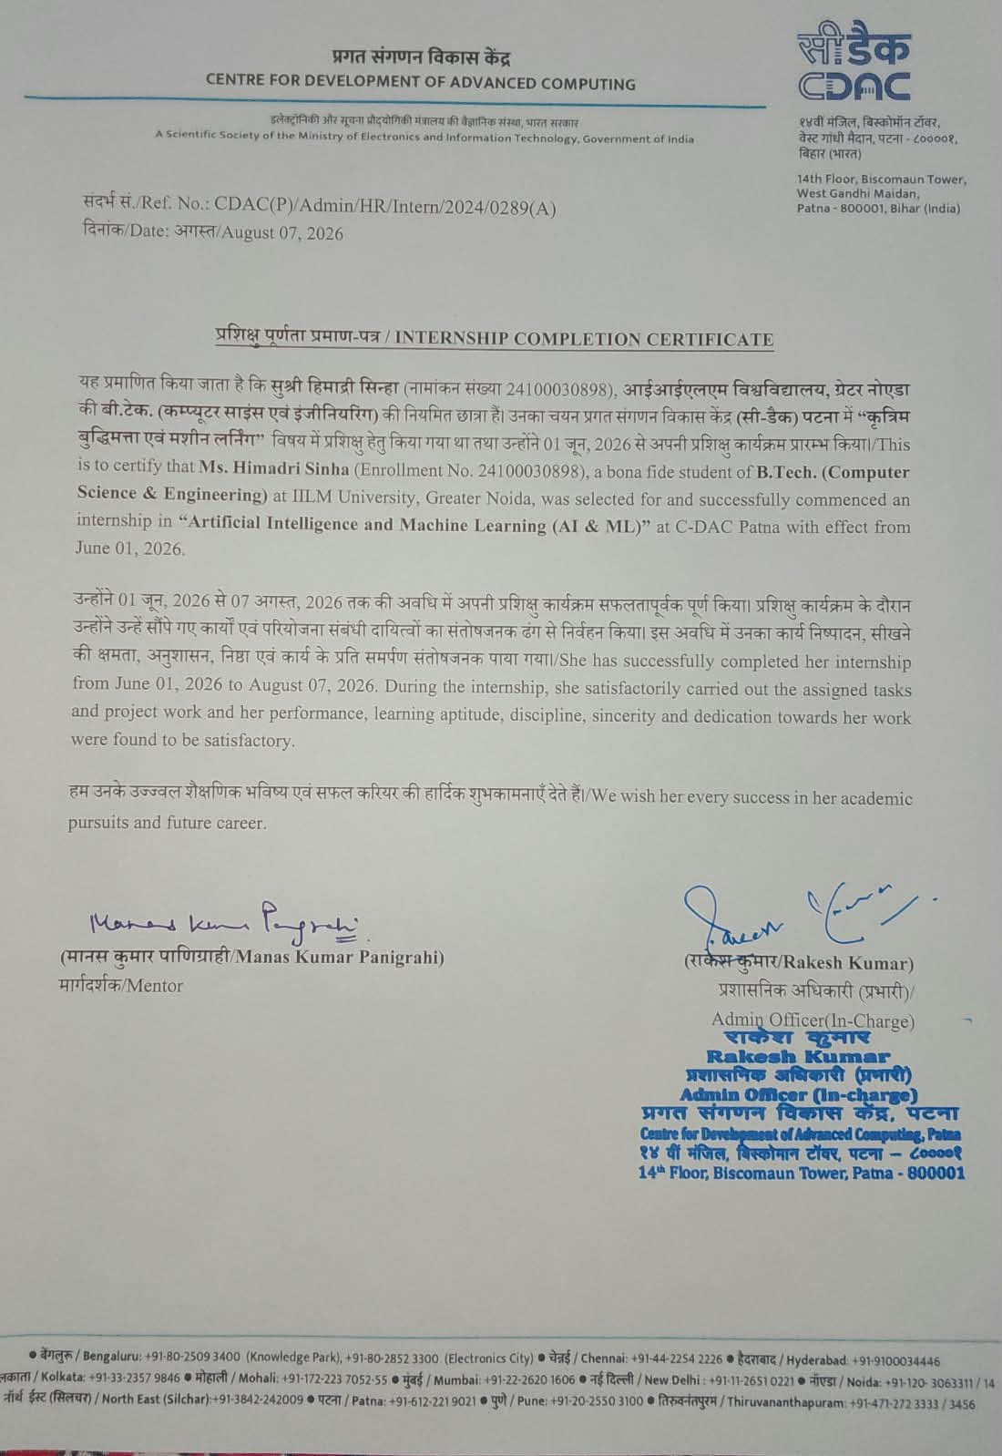

Project Description

4.1Introduction
Voice-based interaction has become an important method of communication between users and computer systems. Modern voice assistants allow users to interact with technology using natural speech instead of traditional keyboard and mouse inputs. However, many commonly used voice assistants depend on cloud-based services for speech recognition, language processing, and speech synthesis. This creates concerns related to privacy, internet dependency, and response delays in poor network conditions.

Miku AI Assistant is an offline, local Large Language Model (LLM)-based multilingual voice assistant developed during the internship at C-DAC, Patna. The main purpose of the project is to demonstrate how a voice assistant can perform its core processing locally without depending on cloud-based AI services.

The system uses a local LLM served through llama.cpp to generate responses. User speech is converted into text using faster-whisper, after which the text is processed by the local language model. The generated response is then converted into speech using Piper TTS. A Flask-based backend manages communication between the browser interface and the local AI services.

The assistant is designed to support English, Hindi, and Hinglish interactions. For Hindi text written in Roman script, the indic_transliteration library is used to convert Roman Hindi into Devanagari where required. This helps make the interaction more natural for users who commonly mix Hindi and English while communicating.

The complete processing pipeline is designed to remain on the local machine, reducing the need to send user voice or text data to external servers.

Organization Profile

The Centre for Development of Advanced Computing (C-DAC) is a research and development organization working under the Ministry of Electronics and Information Technology (MeitY), Government of India. It works in areas related to advanced computing, electronics, information technology, artificial intelligence, high-performance computing, software technologies, and other emerging areas of technology.

The internship for this project was carried out at the C-DAC Patna centre from 1 June 2026 to 6 August 2026.

The initial phase of the internship focused on studying concepts related to Artificial Intelligence and Machine Learning, Large Language Models (LLMs), and Retrieval-Augmented Generation (RAG). After completing the initial learning and presentation/viva activities, project development work was started in July 2026.

The practical project work focused on designing and developing Miku AI Assistant, an offline multilingual voice assistant using a locally hosted LLM and locally running speech-processing components.

Problem Statement
Many mainstream voice assistants rely on cloud infrastructure for speech recognition, language processing, and response generation. Although this approach provides access to powerful computing resources, it also introduces several limitations.
The major problems addressed by this project are:
- Dependence on an active internet connection for cloud-based processing.
- Privacy concerns when voice and text data are transmitted to external servers.
- Possible delays caused by network communication.
- Limited control over the processing and storage of user conversations.
- Difficulty in providing natural interaction for users who frequently mix Hindi and English.
- Requirement for a lightweight AI assistant that can run on locally available computing hardware.
Therefore, there is a need for a voice assistant that can perform its core processing locally while supporting multilingual and code-mixed interaction.

Project Objectives

To design and develop an offline voice assistant capable of processing user input locally.

To integrate a locally hosted Large Language Model using llama.cpp for response generation.

To implement Speech-to-Text functionality using faster-whisper for converting spoken input into text.

To support conversational interaction in English, Hindi, and Hinglish.

To use indic_transliteration for converting Roman Hindi text into Devanagari where required.

To integrate Piper TTS for converting generated text responses into spoken output.

To develop a lightweight Flask backend for handling API requests and communication between the user interface and local AI services.

To implement streaming-based interaction so that generated responses can be displayed progressively.

To maintain the complete core AI processing pipeline locally and reduce dependence on external cloud services.

To develop a simple browser-based interface using HTML, CSS, and JavaScript for text and voice interaction.

Scope of the Project

The scope of Miku AI Assistant is focused on developing a functional prototype of an offline, multilingual AI voice assistant.

The project covers the complete interaction pipeline, beginning with user input and ending with a spoken response. The system supports both text chat and voice chat through a browser-based interface.

The voice interaction pipeline includes:

User Speech → Audio Processing → faster-whisper → Text → Local LLM → Response → Piper TTS → Voice Output

The system uses llama.cpp to run the local LLM and Flask to manage communication between the frontend and backend services.

The project also includes multilingual handling for Hindi, English, and Hinglish. Roman Hindi can be processed and converted into Devanagari using the indic_transliteration library.

The project is intended as a prototype and does not focus on commercial-scale deployment, large-scale distributed computing, or integration with external cloud AI services. Real-time internet-based information retrieval and external IoT integrations are also outside the current scope.

Technologies and Tools Used

The following technologies and tools were used in the development of Miku AI Assistant:

1. Python

Python was used as the primary programming language for implementing the application logic and integrating the different components of the voice assistant pipeline.

2. Flask

Flask was used as the backend web framework. It provides the API layer and handles communication between the browser-based interface and the locally running AI services.

The backend includes endpoints such as:

/chat-stream

/speak

/transcribe

/history

3. llama.cpp

llama.cpp was used to run the Large Language Model locally. It provides an efficient method for running open-weight language models on local hardware.

The project used the following model:

Gemma 4 E2B IT Q4_K_M GGUF

The local LLM server provides an OpenAI-compatible interface and generates responses that are sent back to the application.

4. faster-whisper

faster-whisper was used for Speech-to-Text processing. It converts the user's spoken input into text locally.

The voice input is processed as audio and converted into text before being passed to the language model.

5. Piper TTS

Piper TTS was used for Text-to-Speech conversion. It converts the generated text response from the LLM into spoken audio.

The project supports voice synthesis for Hindi and English interaction.

6. indic_transliteration

The indic_transliteration library was used to convert Roman Hindi text into Devanagari script when required. This helps in handling common Hinglish interaction patterns.

7. HTML, CSS and JavaScript

HTML, CSS, and JavaScript were used to create the browser-based user interface.

The frontend provides features for:

Text chat

Voice recording

Displaying generated responses

Streaming responses

Communication with the Flask backend

System Architecture

The Miku AI Assistant follows a locally hosted architecture in which the main AI processing components run on the user's local machine.

The high-level architecture can be represented as:

Browser Frontend
↓
HTML + CSS + JavaScript
↓
Flask Backend
↓
Local On-Device Services
↓
llama.cpp + faster-whisper + Piper TTS

The major components of the architecture are:

Browser Frontend

The browser provides the user interface for text and voice interaction. HTML, CSS, and JavaScript are used to implement the chat interface, recording controls, response display, and streaming behaviour.

Flask Backend

The Flask backend acts as the central communication layer. It receives requests from the frontend and communicates with the local AI services.

llama.cpp

The local LLM server handles language understanding and response generation. The selected Gemma model runs locally through llama.cpp.

faster-whisper

The Speech-to-Text component processes recorded audio and converts the user's speech into text.

Piper TTS

Piper converts the generated response into speech so that the assistant can respond through voice.

The overall system architecture is designed so that the core processing remains on the local machine.

Methodology

The development of Miku AI Assistant was carried out in several stages.

Phase 1: AI/ML and LLM Study

During the initial phase of the internship, fundamental concepts related to Artificial Intelligence, Machine Learning, Large Language Models, and Retrieval-Augmented Generation (RAG) were studied.

The purpose of this phase was to understand the basic concepts behind modern AI systems and their practical applications.

A presentation and viva were also conducted during the learning phase to evaluate the understanding of the studied topics.

Phase 2: Speech-to-Text Integration

After the initial learning phase, development of the voice assistant was started.

The faster-whisper library was integrated to convert recorded user speech into text. Audio input from the microphone is processed and transcribed locally.

This component forms the first major stage of the voice interaction pipeline.

Phase 3: Local LLM Integration

A local Large Language Model was integrated using llama.cpp.

The Gemma 4 E2B IT Q4_K_M GGUF model was used for generating conversational responses.

The local server provides an OpenAI-compatible API interface, allowing the Flask application to send user prompts and receive generated responses.

Phase 4: Flask Backend Development

A Flask-based backend was developed to connect the browser interface with the local AI services.

The backend manages different operations such as:

Sending user messages to the LLM.

Streaming generated responses.

Processing speech-to-text requests.

Handling text-to-speech requests.

Maintaining conversation history.

This makes Flask the central bridge between the frontend and the local AI components.

Phase 5: Text-to-Speech Integration

Piper TTS was integrated to convert the generated text responses into spoken audio.

After the local LLM generates a response, the response is passed to the TTS component, which produces an audio output that can be played to the user.

Phase 6: Multilingual and Hinglish Handling

The system was designed to handle English, Hindi, and Hinglish.

Since Hinglish is often written using Roman characters, indic_transliteration was integrated to convert Roman Hindi into Devanagari when required.

This helped improve the handling and presentation of Hindi-language responses.

Phase 7: Frontend and Streaming Integration

A browser-based interface was developed using HTML, CSS, and JavaScript.

The interface supports both text and voice interaction. Streaming was incorporated so that the user interface can display generated responses progressively instead of waiting for the complete response before displaying it.

Phase 8: End-to-End Integration and Testing

Finally, all components were connected into a single pipeline.

For text chat, the flow is:

User Types → LLM Generates Response → Response Streams to Interface → Piper TTS Speaks Response

For voice chat, the flow is:

User Speaks → Audio Processing → faster-whisper Transcription → Text Chat Flow → Local LLM → Piper TTS → Voice Response

The integrated system was tested with Hindi, English, and Hinglish queries to check the behaviour of the complete pipeline.

[Figure 4.2: End-to-End Flow of Miku AI Assistant]

Insert your End-to-End Flow screenshot here.

[Figure 4.3: Miku AI Assistant Application Interface]

Insert your application interface screenshot here.

Expected Outcomes

The expected outcome of the project is a functional prototype of an offline multilingual AI voice assistant.

The system is expected to:

Accept text and voice input from the user.

Convert spoken input into text using faster-whisper.

Process user queries using a locally hosted Gemma LLM through llama.cpp.

Generate responses without requiring a cloud-based LLM API.

Support English, Hindi, and Hinglish interaction.

Convert Roman Hindi into Devanagari where required.

Convert generated text responses into speech using Piper TTS.

Provide a browser-based interface for text and voice interaction.

Display streamed responses progressively.

Keep the core AI processing on the local machine.

The project demonstrates how different open-source and locally deployable technologies can be integrated to create a privacy-focused conversational AI system without depending on cloud-based language-model services for its core response generation

Certificates of Completion and Other Communication Mail Proof

BIBLIOGRAPHY / REFERENCES

C-DAC, Centre for Development of Advanced Computing. Official Website and Information Resources.

llama.cpp, Official Repository and Documentation.
https://github.com/ggerganov/llama.cpp

faster-whisper, Speech Recognition Implementation based on Whisper.
https://github.com/SYSTRAN/faster-whisper

Piper, Fast and Local Neural Text-to-Speech System.
https://github.com/rhasspy/piper

Flask, Official Documentation.
https://flask.palletsprojects.com/

Python Software Foundation, Python Documentation.
https://docs.python.org/

indic-transliteration, Indic Language Transliteration Library.
https://github.com/indic-transliteration/indic_transliteration_py

