EXP-7:Implement ARP Protocol using CISCO PACKET TRACER

ARP (Address Resolution Protocol) is a protocol used in networking to map an IP address to a physical MAC (Media Access Control) address within a local network.(TO KNOW MAC ADDRESS WHEN WE KNOW IP ADDRESS)

It enables devices on the same network to find the hardware address of other devices by broadcasting a request.

Here’s how it works in simple terms:

1. A device sends an ARP request (a broadcast message) to all devices in the local network, asking, "Who has this IP address?"

2. The device with the matching IP address responds with its MAC address.

3. The requesting device stores the MAC address in its ARP cache for future communication.

**STEP:1**

**SELECT 4 PC’S AND CONNECT TO A SWITCH AND ASSIGN IP ADDRESSES TO PCS**

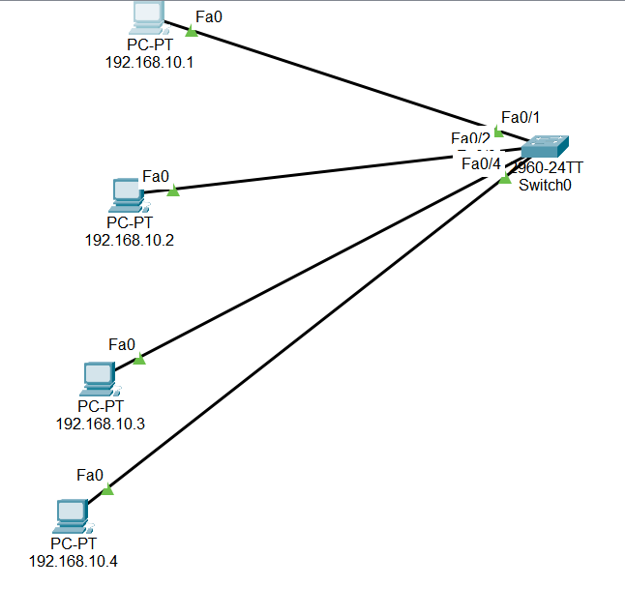

STEP:2

**In PC1 i.e 192.168.10.1 ------>Go Tocommand prompt ----> Type command arp-a------>no ARP entries found msg will appear**

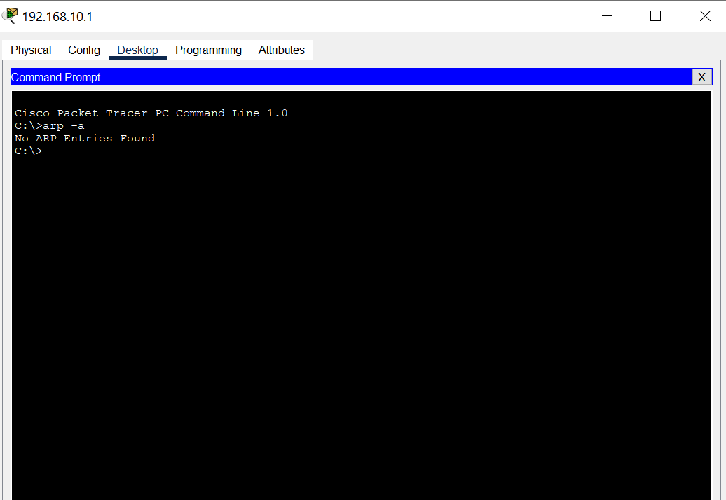

STEP-3:Go to **Simulation Mode** then click icon inspect(maginifier icon)---> then click on PC1 --->**ARP Table** and PC4 ---> **ARP TABLE**

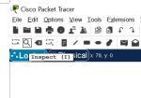

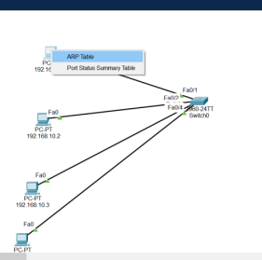

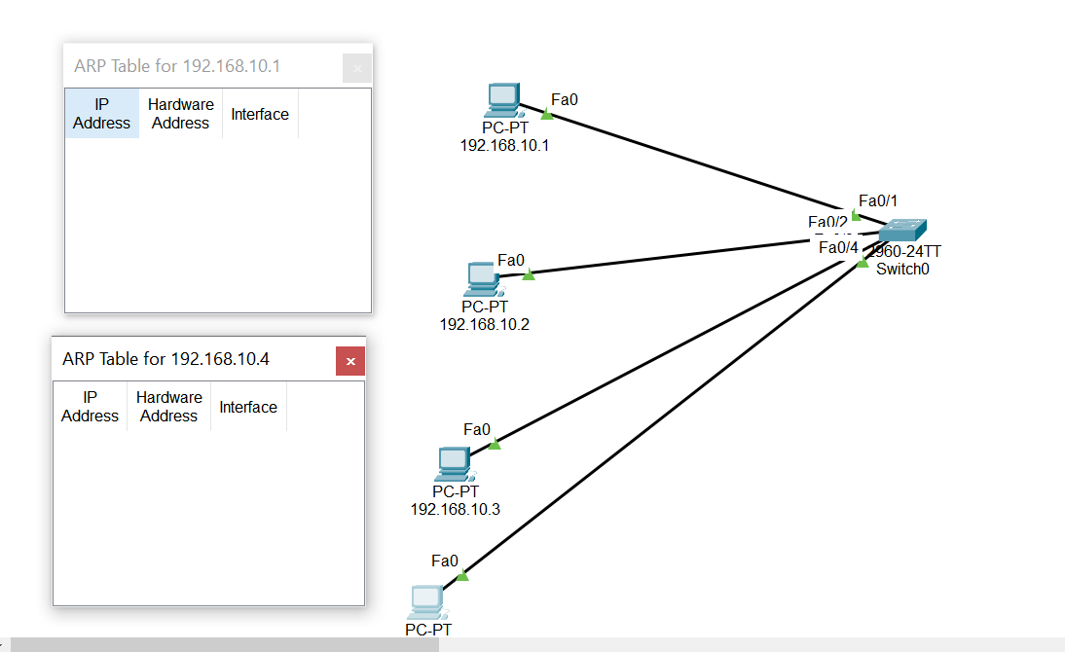

**STEP:4 PRESS ESCAPE FROM INSPECT MODE-------> AGAIN FROM SIMULATION MODE --->GO TO PC1----->COMMAND PROMPT--->PING 192.168.10.4**

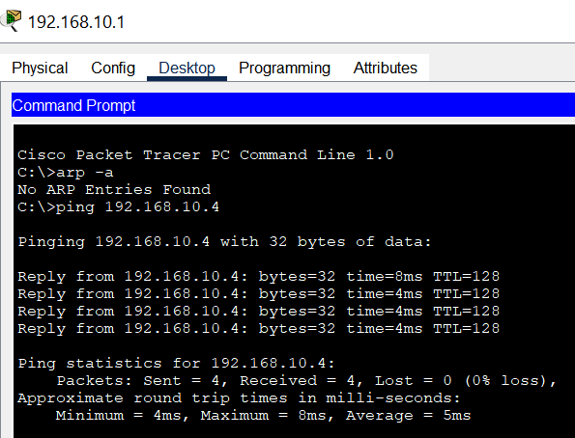

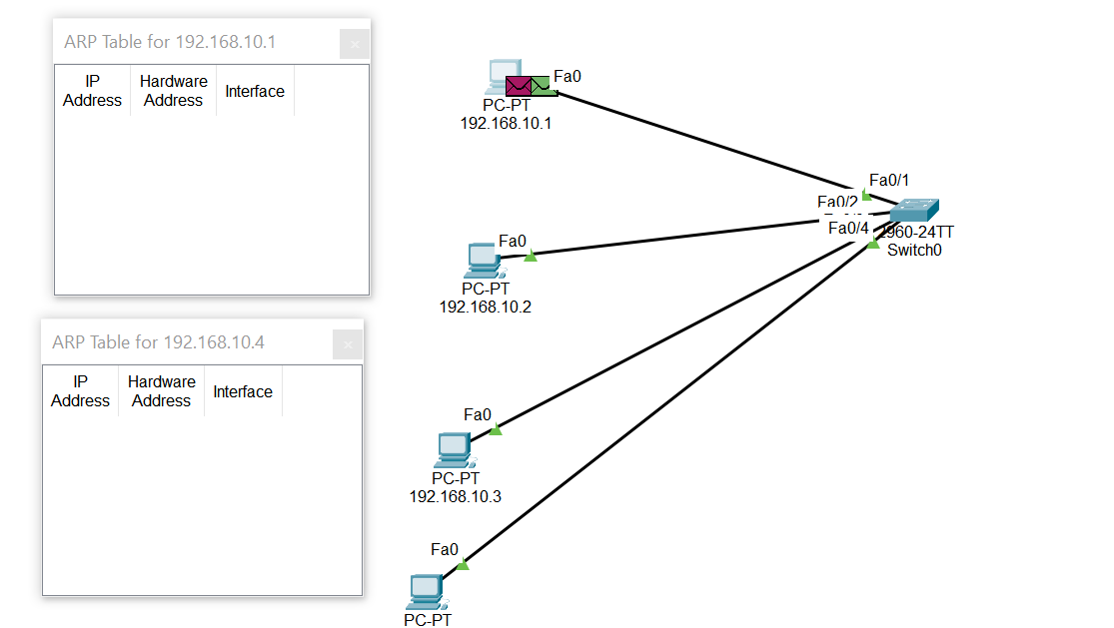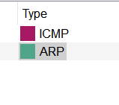

**STEP-5:CLICK ON (GREEN PACKET) ARP ICON--->OUTBOUND DETAILS-- WE CAN SEE TARGETMAC--0000.0000.0000.0000**

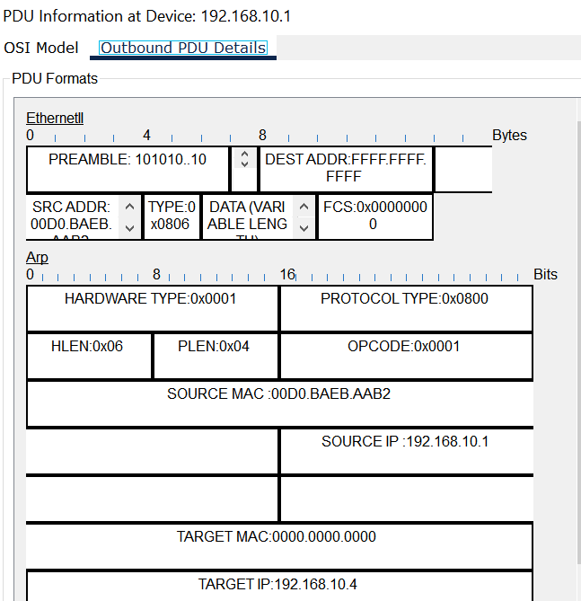

**STEP-6:TO FIND MAC ADDRESS PC4 ---->CLICK START BUTTON IN SIMULATION PANEL**

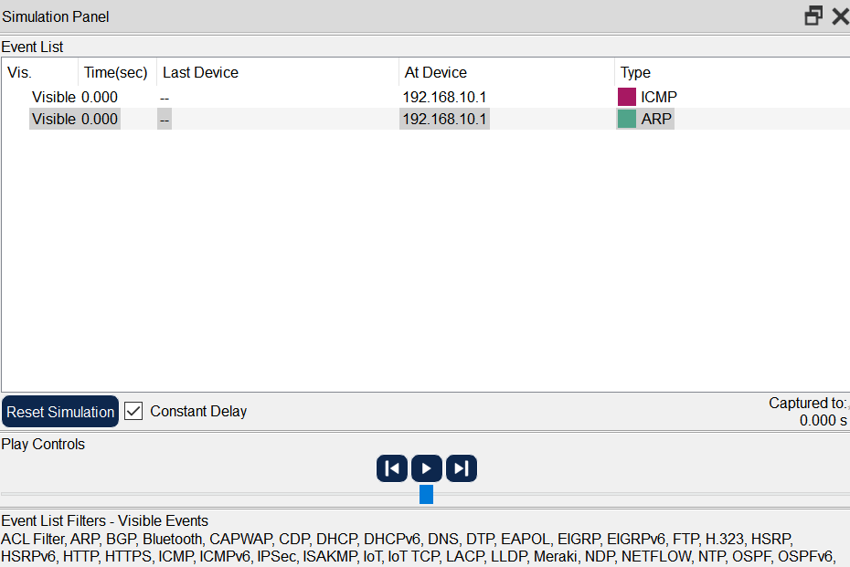

**STEP-7:ONCE PC1 MSG SENDS TO PC4 ---->PC4 MAC ADDRESS RESOLUTION TABLE IS FILLED**

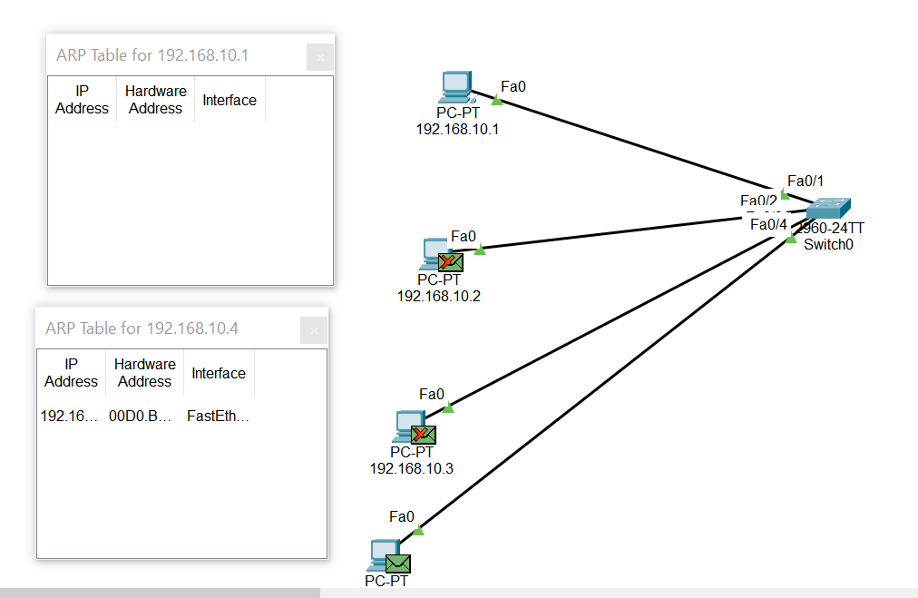

**STEP-8-:ONCE ACK MSG TO PC4 TO PC1 -----> MAC ADDRESS OF PC1 WILL BE-FILLED**

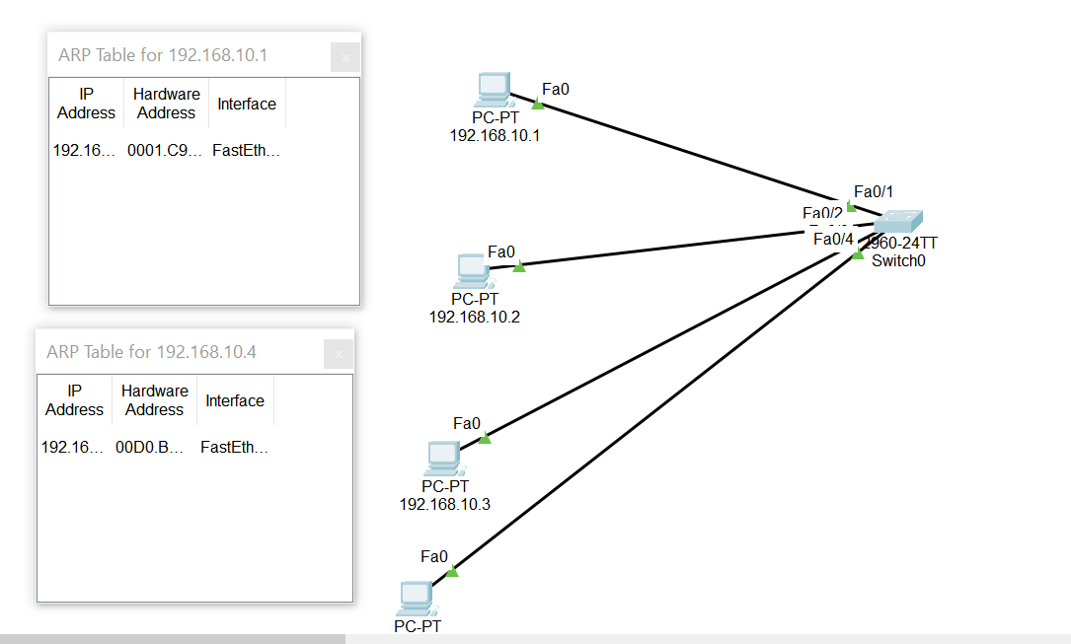

**STEP-9:Again use command arp -a from PC1(192.168.10.1)**

