FOREX Pair Trading Strategy

1. Investing.com is one of the data source where one can easily obtain data of FROEX rates to perform analytics on it.

## A good pair which is cointegrated

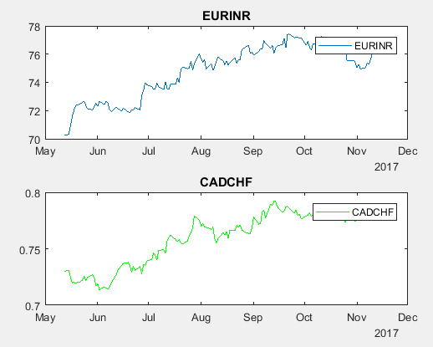

## A cointegrated series which is stationary

