ICAI–SEPC Strategic Collaboration & Key Initiatives
- The Institute of Chartered Accountants of India, through its Global Trade & Services Committee, has maintained a strategic partnership with the Services Export Promotion Council since signing the MoU on 30 June 2020.
- The MoU was renewed on 1 July 2025 for a further five years, valid until 30 June 2030, to strengthen collaboration in promoting services exports.
- The partnership focuses on enhancing India’s professional services exports and expanding global opportunities, including in the GCC region.
Key Initiative:
- Dr. Abhay Sinha has participated as a distinguished speaker at ICAI GCC Summit events in Ahmedabad sharing insights on Global Capability Centers.
- Chintan Shivir on Professional Services held on 23 December 2025 in collaboration with the Ministry of Commerce & Industry and SEPC.
- Theme: “Expanding Global Horizons: Opportunities for Indian Professionals.”
- Participation of 100+ delegates.
- Focus areas included:
  - Global readiness of professionals
  - Mutual Recognition Agreements (MRAs) & international MoUs
  - Expansion of overseas professional chapters
  - Leveraging FTAs for export of professional services
- Overall, the ICAI–SEPC collaboration continues to promote global readiness, international mobility, and sustained growth in services exports.
Glimpses from ICAI–SEPC Collaborative Initiatives
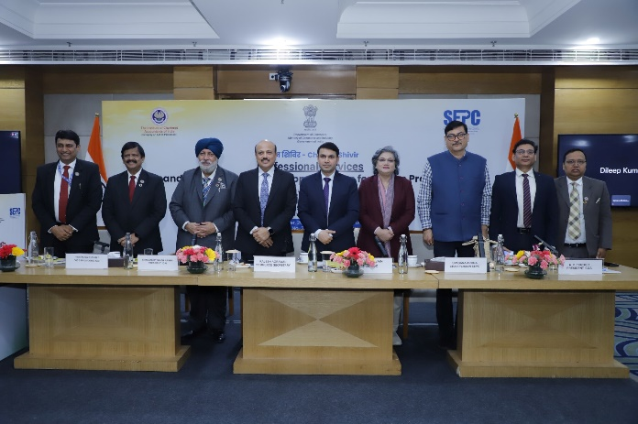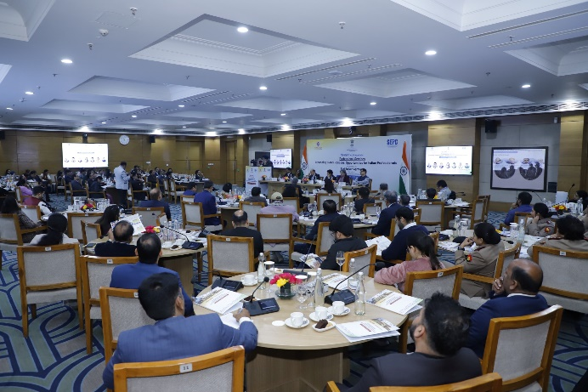

Chintan Shivir 2025 on Professional Services with the Ministry of Commerce & Industry and SEPC

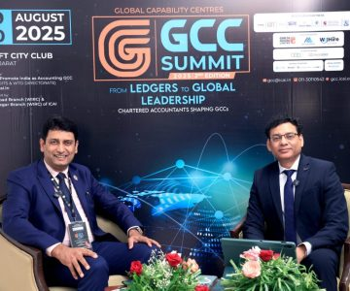
ICAI GCC Summit events in Ahmedabad

