**Add file to your iPhone**

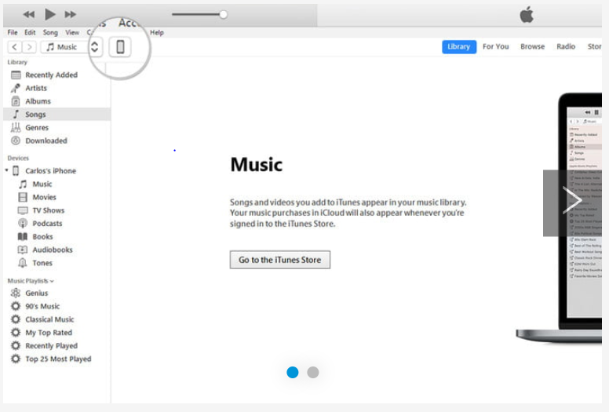

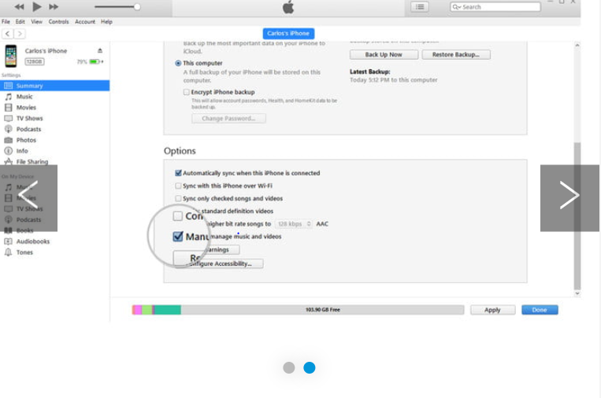

To add the .m4r ringtone file to your iPhone, connect your device to your computer using a [lightning-to-USB cable](https://www.digitaltrends.com/mobile/best-lightning-cables/). Then, select the iPhone icon in the upper-left corner. Go to the Summary section and scroll down to Options. Check the box beside Manually manage music and videos and click Apply. Now, drag the .m4r file into the Tones tab located under On My Device, which will automatically sync the ringtone with your iPhone.

If you’re using MacOS Catalina and don’t have iTunes, then open the Finder, and click your iPhone in the sidebar. If it’s the first time you’ve done this since updating, you may need to click the Trust button and go through the process to open your iPhone to your Mac. From there the steps are similar. Select the General tab, check the box beside Manually manage music and videos and click Apply. But this time, there’s no Tones tab, so just drag your ringtone file to the name of your iPhone above the General tab. That will sync your ringtone to your phone.

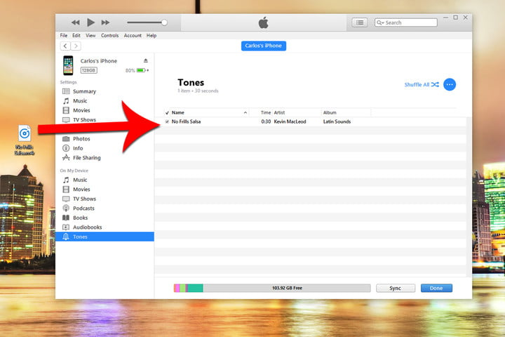

Note: If you’re having issues dragging the .m4r file to the Tones tab after you apply the changes, disconnect your iPhone and restart iTunes. Then, connect your iPhone and try dragging the file into the window again.