Linux_Training

pwd : to print working directory
ls : to list contents of the current directory
mkdir : command to make a new directory
cd : command to change into a directory
rmdir : command to remove a directory

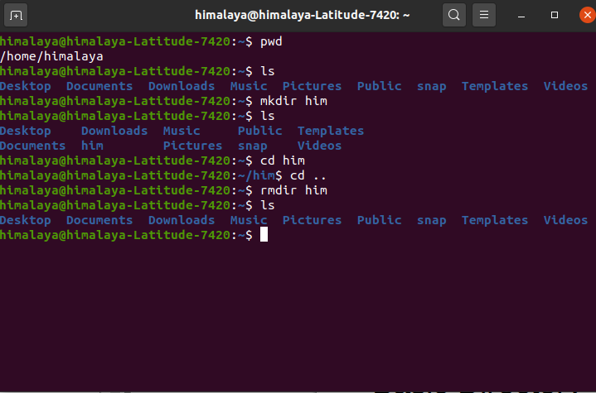

touch : creates an empty file.
echo : prints to standard output.
cat : It reads data from the file and gives it’s content as output.
wc : counts number of lines, words, and characters in a text file.
cp : command to make a copy of a file or directory (for directory use cp -R file_name copy_file_name)

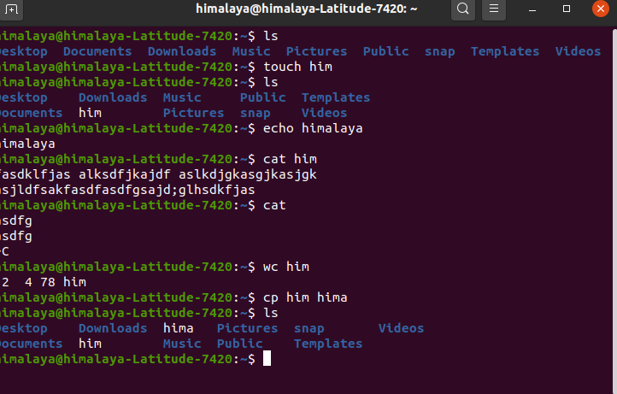

mv : to make a copy of the source file and directory into the destination and remove the source at the end. Also be used to rename the file.
rm : to remove file and directory permanently.
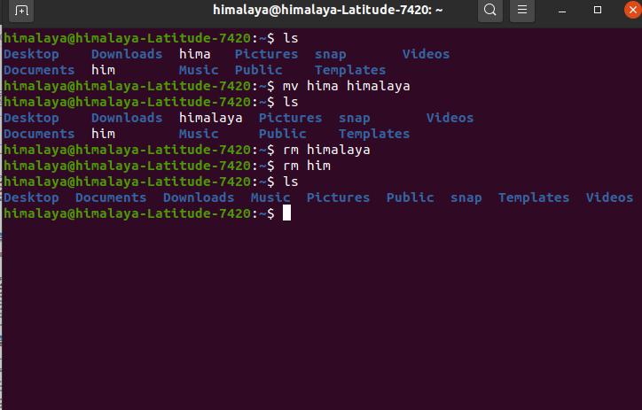

man : to search and open the manual page of a Linux command.

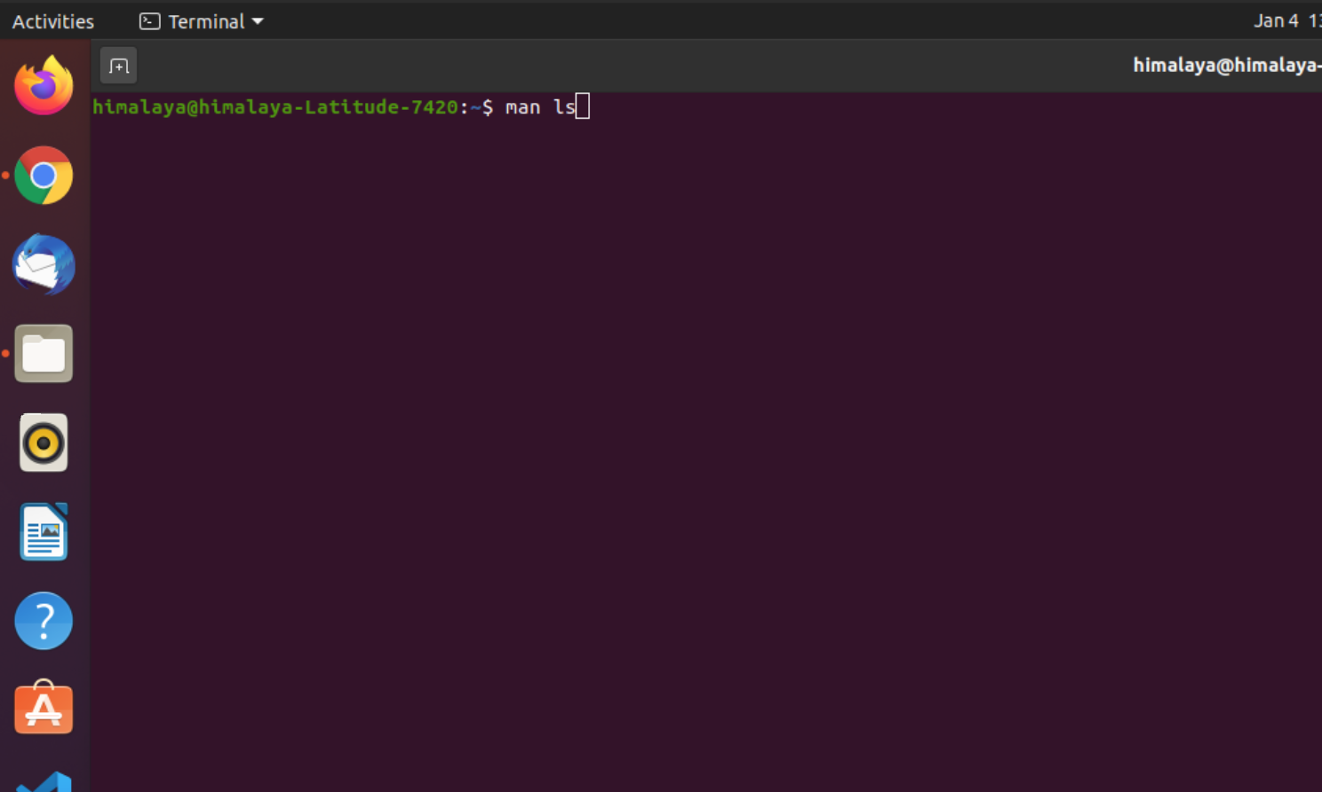
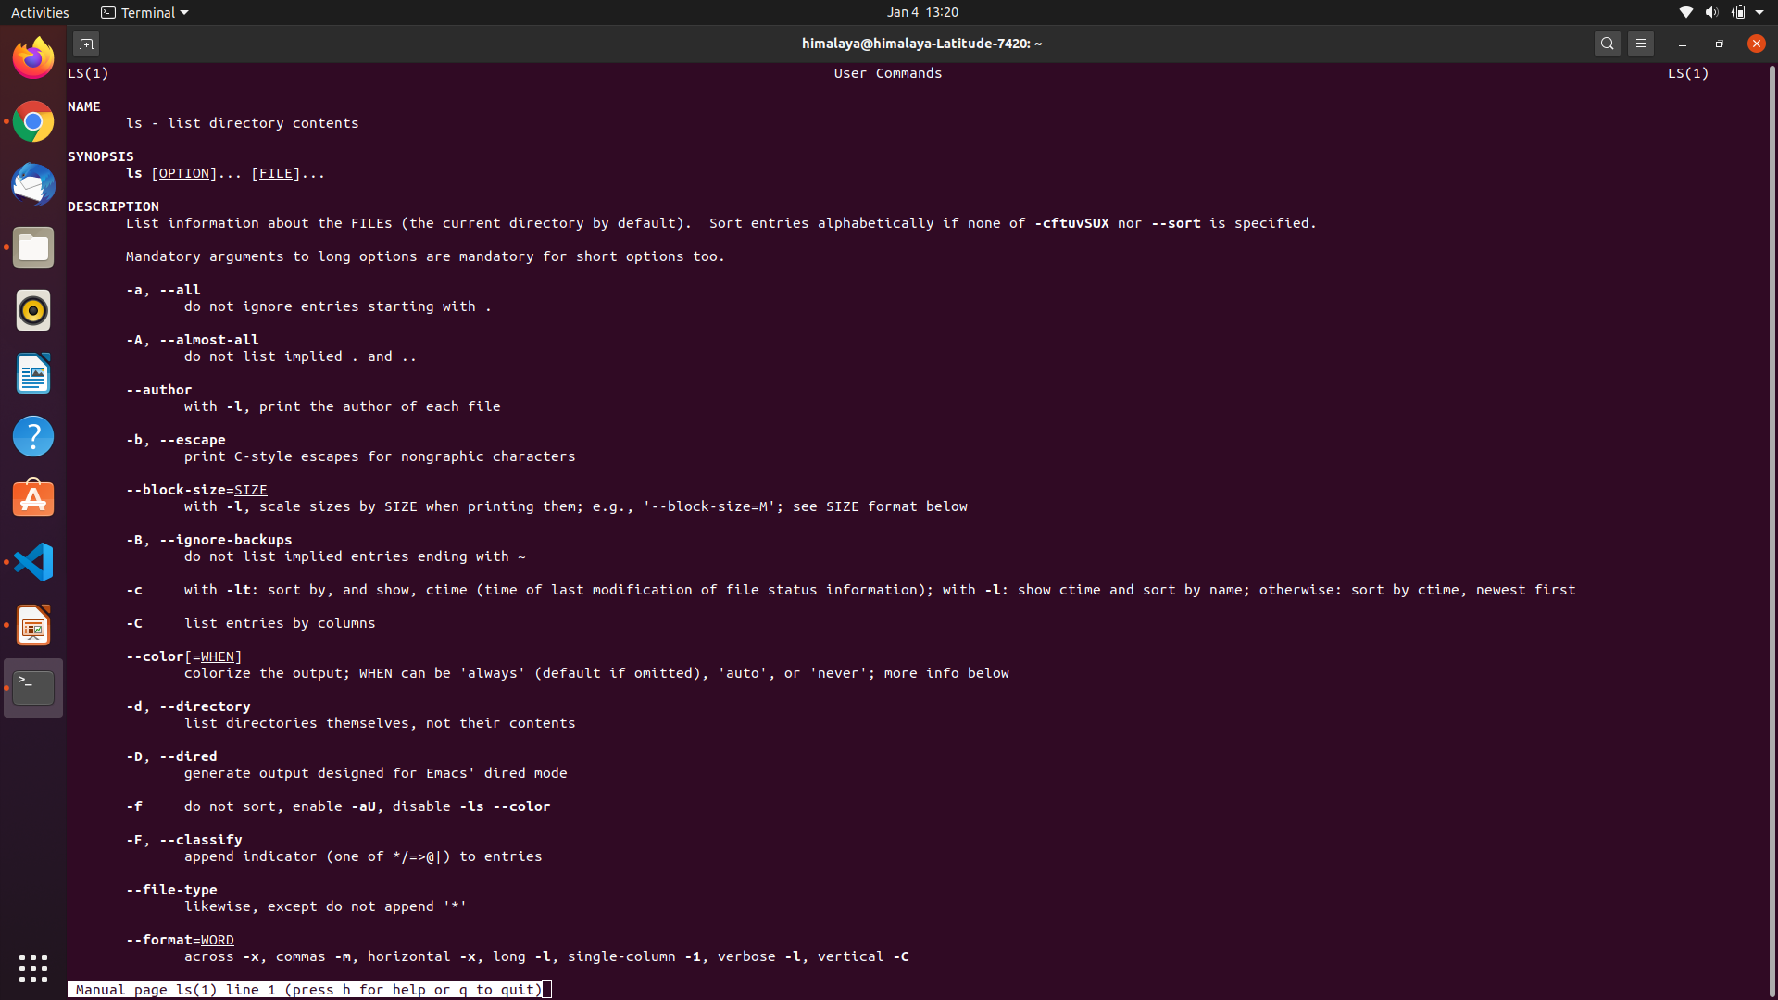

More : for paging through text one screenful at a time
Less : is an improved version of more command which allows backward movement in the file as well as forward movement.

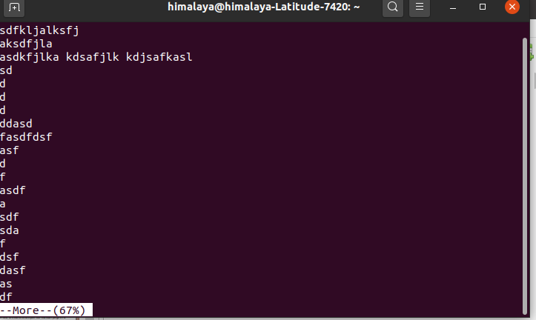
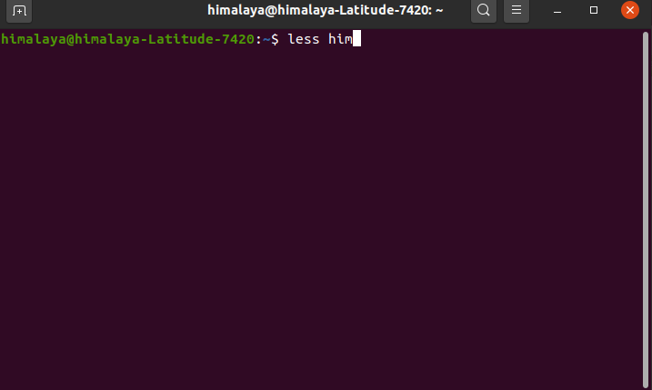

head : to see first lines of a file (default – 10 lines) (head -n 20 file1.txt)
tail : to see last lines of a file (10 lined by default tail -n 20 file1.txt)

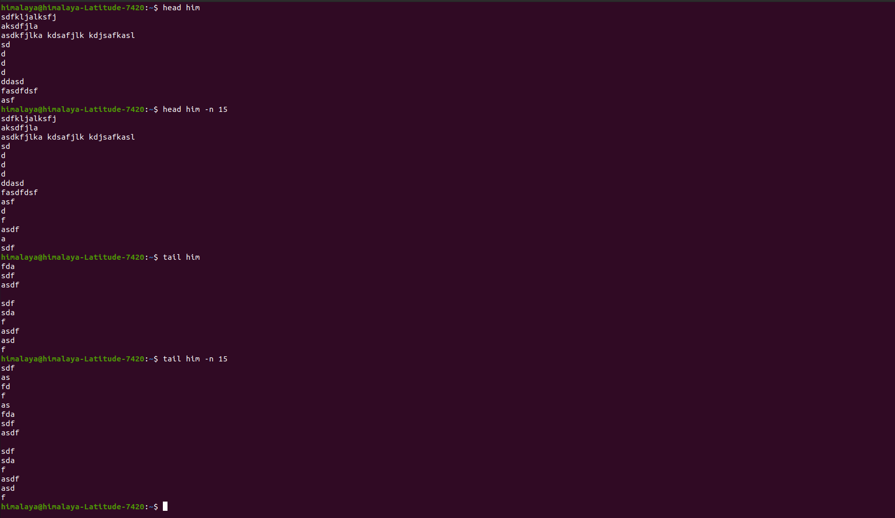

grep : to print lines in a file matching a pattern grep “pattern” file_name.
history : to see the commands you have typed so far.
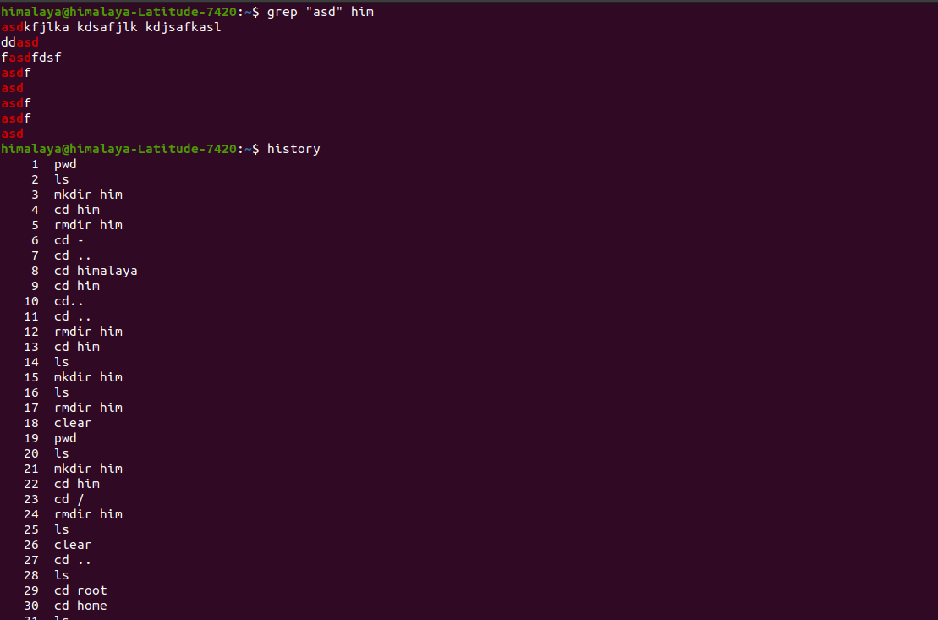

ps : output a list of currently active processes (top can be used)
df : is used to get disk usage information.
kill : can send a variety of signals to a program (default TERM).
which : will return the path to the command specified
whoami : to print the user name currently logged in to the terminal session
who : displays the users logged in to the system

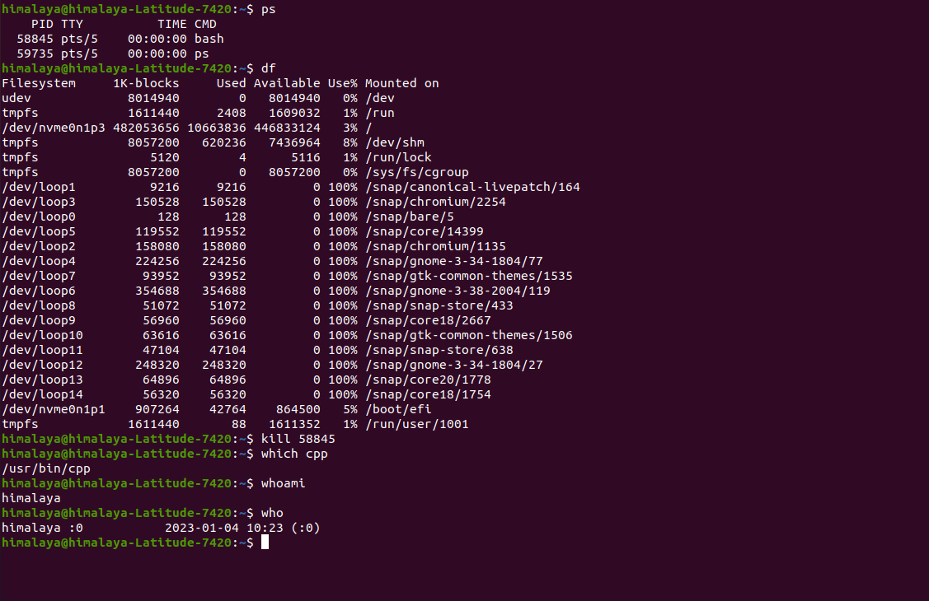

< : redirects to the standard input

> : redirects the standard output

>> : appends the standard output

2> : redirects the standard error

&> : redirects the standard output and standard error

2>&1 : redirects standard error to where the standard output is set

1>&2 : redirects the standard output to where the standard error is set

| : (pipe) pass the output of one command to another

