

**Networking CC217N**

Lecturer: Nischal Shakya

Assignment: Group Assignment

Semester: Extended Semester

Date: 2021/03/28th

|  |  |  |
| --- | --- | --- |
| **Name of Students** | **University ID** | **Email** |
| Hemanta Bhandari | 1001849575 | Hemantabhandari97@gmail.com |
| Himal Bogati | 1001849576 | himalbogati77@gmail.com |

# Acknowledgement

First of all, we would like to thank our parents, whom we are greatly indebted for us brought up with love and encouragement to this stage. With a grateful heart we would like remember the person who helped us during this report. Mr. Nischal Shakya sir deserves special thanks for providing the opportunity, as well as stimulating suggestions and encouragement, which aided us in coordinating our study, especially in writing this report on "School Management System. "We owe a heartfelt thanks to the Institute of Management Science (IIMS) at UCSI University for granting us permission to submit this research proposal on "School Management Method." We have no meaningful words to express our appreciation, but our hearts are always filled with gratitude for the kindness shown to us by all.

Thank you.

# Assignment Brief

Teamwork is described as a group of people from different backgrounds working together to divide workload while pursuing a common goal of completing a mission. This project is often broken down into many tasks, including designing the Class Diagram, Use Case Diagram, Flow chart, and ER Diagram, designing the system, and implementing the system, with each task being assigned to both participants. Both have put forth equal effort in achieving this mission. The team consists of two people (Hemanta Bhandari and himal bogati). The mission that we divided and completed is detailed below.

Himal bogati completed the code using the MVC pattern for the user member CRUD activity portion. He also went over the corresponding diagram for the CRUD user.

The login and logout sections, as well as the other pages, were covered by a Hemanta Bhandari. He also went over the related diagram for the segment.

Contents

Title

...............................................................................................................................................................0

Background...................................................................................................................................................

1. Problem

Statement.......................................................................................................................................1

Objective.......................................................................................................................................................

1. Proposed System

..........................................................................................................................................2 i. System User

..........................................................................................................................................2 ii. System Functional requirement........................................................................................................3 iii. System Design...................................................................................................................................6 iv.

User manual......................................................................................................................................7

Conclusion

..................................................................................................................................................11 Future

Work................................................................................................................................................12

References..................................................................................................................................................1

3

Java Web Programming

[Type here] CC305n

# Title

## School Management System

| P a g e

Java Web Programming (CC305n)

1

# Background

This article on the School Management System was written by us. In general, this program is a school management framework that utilizes online terminologies and applications. It involves both front end and back end design (HTML, CSS, and JAVASCRIPT) (java, servlets, JSP). The user has easy access to the system since it contains student information records.

The home page, as well as sign up, login, connect, remove, and edit, are all technical aspects of the system. The framework is designed to have a simple UI and UX, while the backend responds to user requests with the desired data.

This application will provide users with school-related knowledge. Users should sign up or login as they navigate through the application framework. This site is very useful to the clients as they can see the information of their schools.

# Problem Statement

* The problem description for designing the system is to preserve school data, make it easy to monitor staff, control access to the school, and use technology for accurate and timely processing while preserving maximum privacy and authority access.
* A consumer must go through a lot of trouble in order to register and obtain the requested information.

# Objective

The main goal of this project is to create a successful web application in Java that incorporates both the front end and back end. However, the following are some of our system's goals:

* To develop a web application by successfully incorporating established java web concepts and knowledge.
* To make it easier for users to access information about students' data.
* To ensure that the application's records are well-managed and organized.

# Proposed System

# We've already clarified why our system is designed, but in this session, we'll show you how and why it's proposed. All supporting diagrams, such as the Use Case diagram, Flow map, Machine design, ER Diagram, and Class Diagram, are shown below. These diagrams are more akin to a schematic, since they display all of the system's functions.

## i. System User

System user includes admin and the visitors. The various action and users of the system are listed below:

Admin:

Here the admin will be allowed to perform the following functions

* Add new student with their information to the system database
* Delete their information

Edit information

* Student

⮚ Create user

⮚ Add information

⮚ Delete P a g e 2

Java Web Programming (CC305n)

## ii. System Functional requirement

## Fig I: Use Case Diagram

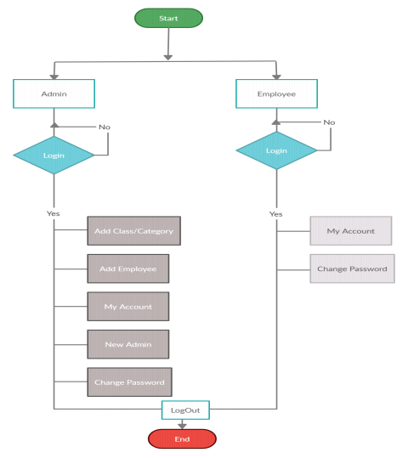

Fig II: Flow Chart

1. | P a g e Java Web Programming (CC305n)

## iii. System Design

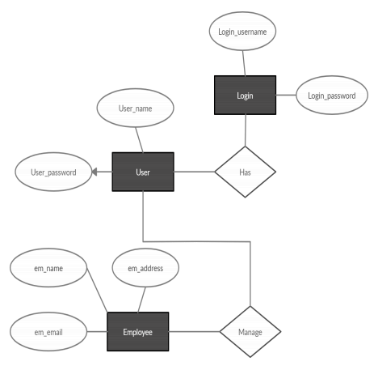

Fig III: ER Diagram

6 | P a g e Java Web Programmin

g (CC305n)

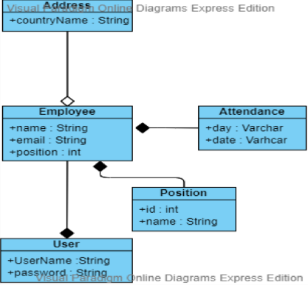

Fig IV: Class Diagram

## iv. User manual

Some screenshots of designed and developed system is shown below:

1. | P a g e

Java Web Programming (CC305n)

Fig V: Login page

In fig V, the homepage of login form is shown. User can find a login button also create new admin button you can either login or if you don’t have created and admin user then you can create a new admin user.

Fig VI: Creating admin user page

In figure VI, the creating admin user page is shown where you can create a new admin user from where you can login through username and password.

1. | P a g e Java Web Programming (CC305n)

## Fig VII: Add New Employee page

In figure VII, add new employee page is shown where user can add new employee with their information of email, country and student role.

9 | P a g e

Java Web Programming (CC305n)

## Fig VIII: Employee CRUD page

In figure VIII, school managing page is shown where members can be added, modified as well as deleted. Here, list of members is also retrieved from the database.

10 | P a g e

Java Web Programming (CC305n)

# Conclusion

School Management System is a program designed to keep track of employee information for the benefit of the school. It has a basic interface that is simple to understand and use. So, this is a report on a web-based system called School Management System. The framework was able to be built in such a way thanks to a well-designed class diagram, use case diagram, ER diagram, and flow map.. Our course also cleared us in the concept of the development phase of the system.

11 | P a g e

Java Web Programming (CC305n)

# Future Work

When it comes to the future of the School Management System, a mobile-based program for students that allows them to access their information might be feasible. The backend is written in Java, a powerful programming language. So, backend may not be giving any problem. However, the database will be moved from MySQL to Oracle Database, maintaining high security for staff and member data and looking for the best future for the School Management System.

12 | P a g e

Java Web Programming (CC305n)

# References

1. "NIC standard templates," [Online]. Available: http://intranic.nic.in. [Accessed 1 11 2020].
2. "Ministry of labour website," [Online]. Available: http://labour.nic.in. [Accessed 3 11 2020].
3. A. R. S.Pressman, "Software Engineering Practitioner's approach".
4. J. Scott Mitchell, "Active Server Pages," in *ASP in 21 days*.

13 | P a g e