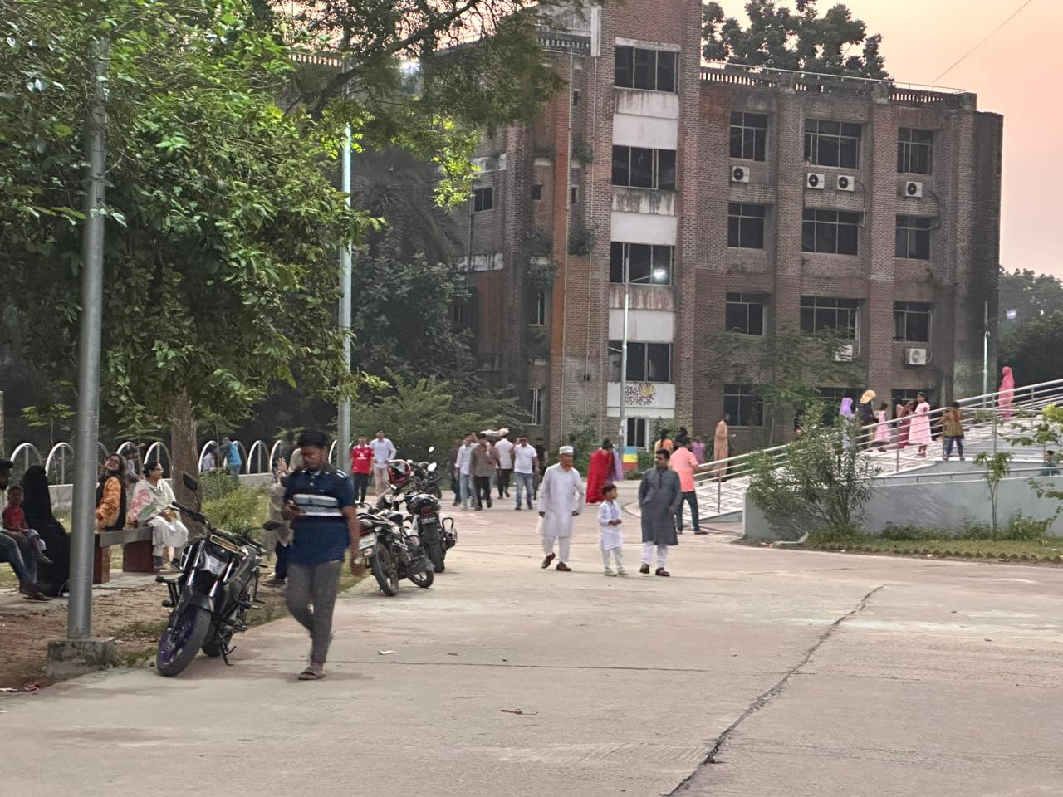

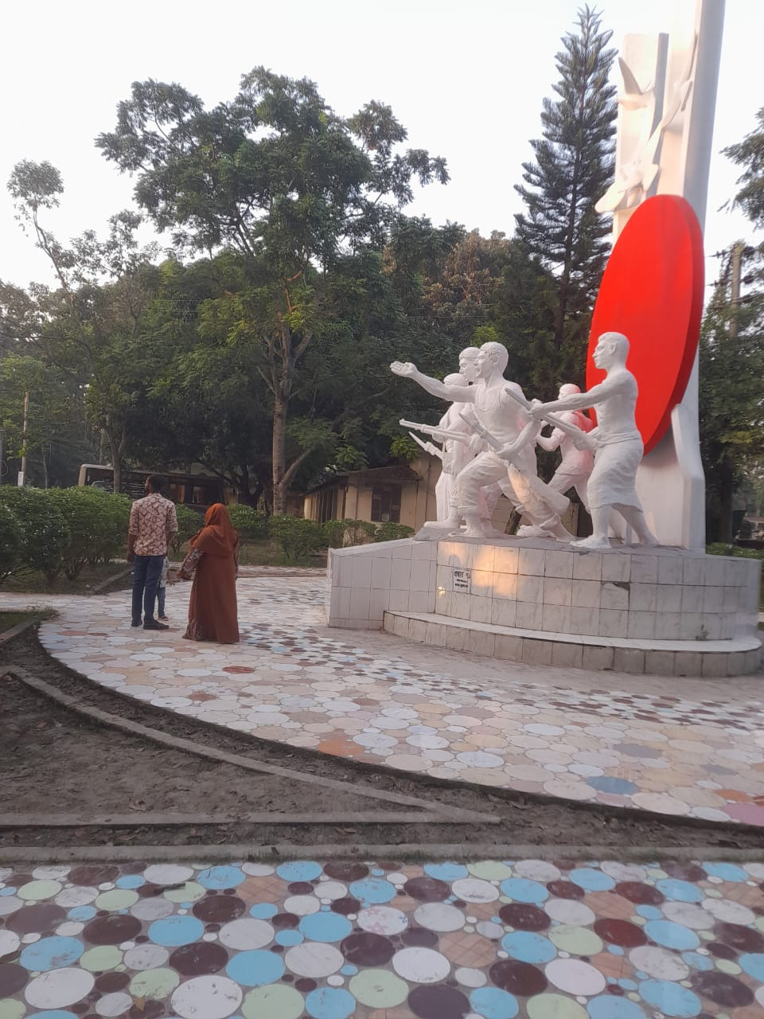

MBSTU provides public access to buildings, monuments and
natural heritage landscapes of cultural significance.

