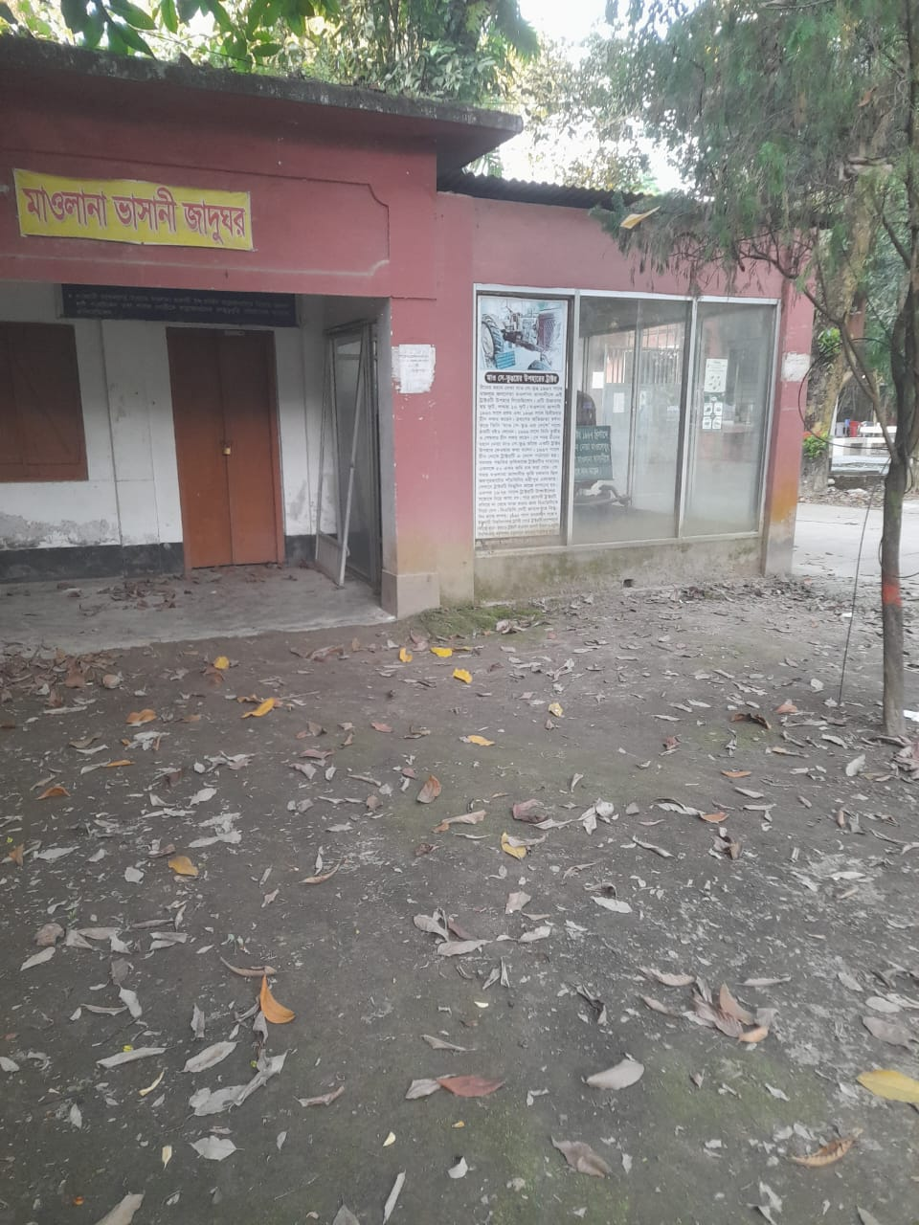
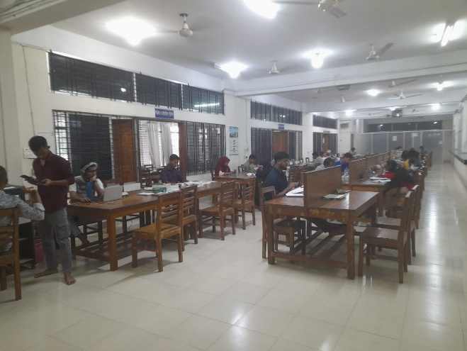

Mawlana Bhashani Science and Technology University (MBSTU)
provides public access to its central library. The Central Library of
MBSTU maintains an open-door policy for researchers, alumni,
and visitors from other institutions who seek academic resources,
subject to the library regulations.
The library houses a rich collection of books, journals, theses, and
digital resources covering science, technology, and humanities disciplines.

