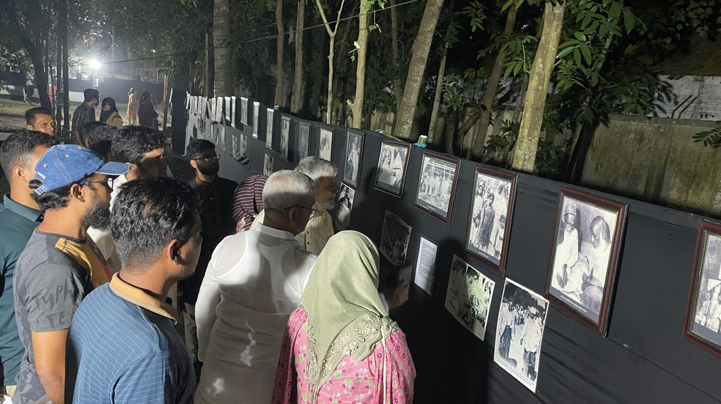

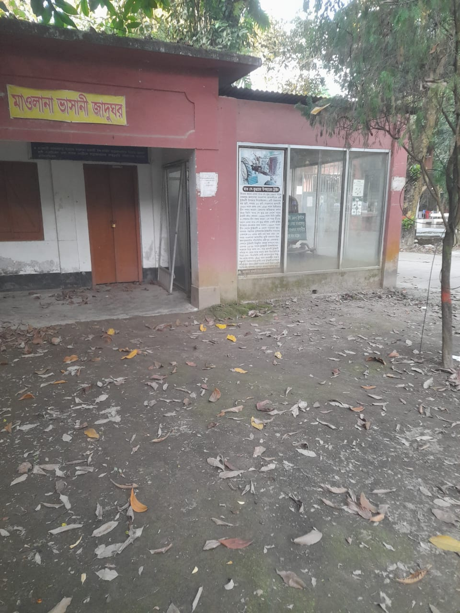

MBSTU provides public access to museums, exhibition spaces,
and works of art and artifacts.

