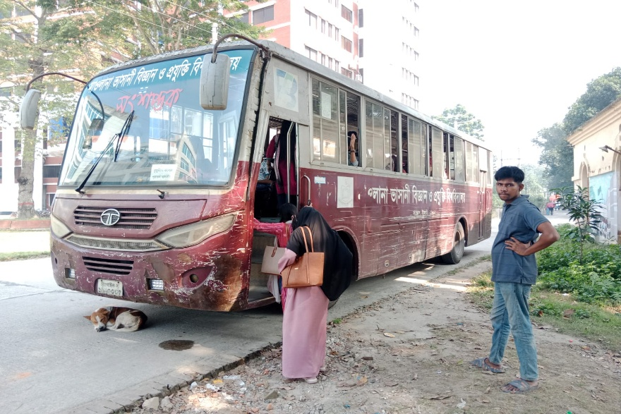

MBSTU uses shuttle bus for the transportation of students, faculties and staff.

