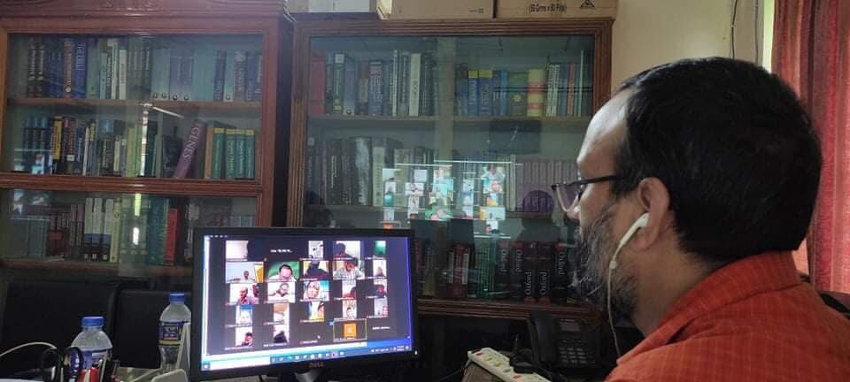

Professor Dr. Mohammad Jahirul Islam of BMB department MBSTU conducting a class from his home.

