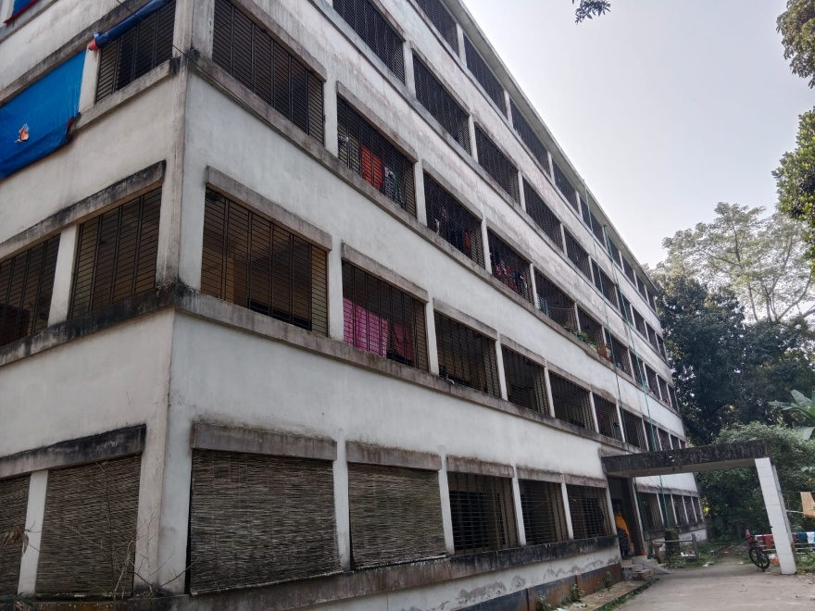

Affordable Housing for the employees of MBSTU

