Digital Awareness Boot-Camp for Females

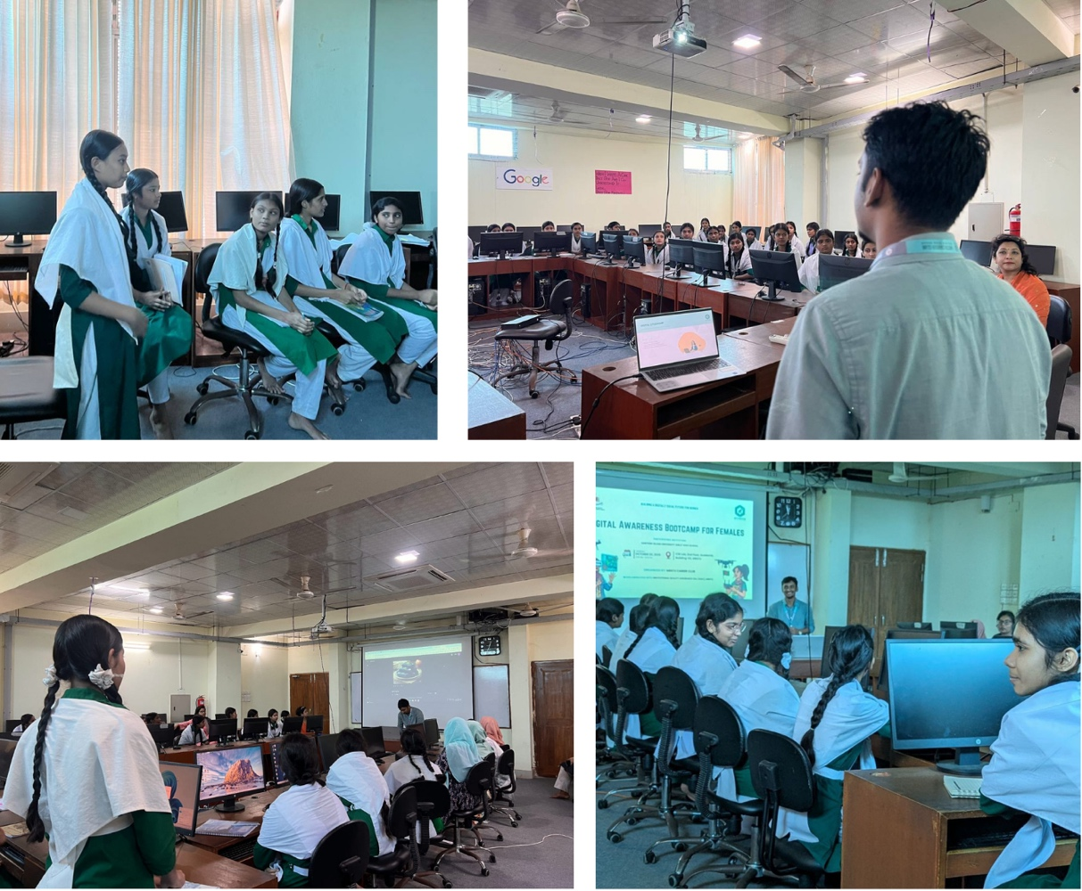

Mawlana Bhashani Science and Technology University (MBSTU), through its Career Club and in collaboration with the Institutional Quality Assurance Cell (IQAC), organized a mentoring and awareness program titled “Digital Awareness Boot-Camp for Females” at the Department of Computer Science and Engineering (CSE) computer lab.
The program was designed to support MBSTU’s Women Mentoring Scheme, focusing on enhancing the digital confidence and leadership capacity of young females both within and beyond the university. Around 40 female students from Santosh Islami University Girls’ High School, many from digitally underprivileged backgrounds, participated in this initiative. MBSTU’s female students and mentors provided them with free, hands-on access to computers, ICT literacy training, cybersecurity awareness sessions, and guidance on using digital learning platforms. Certificates were also provided to participants upon completion of the session.
The session was facilitated by Moneem Ahmed, a senior CSE student and mentor, while Tahamid Alif, President of MBSTU Career Club, presided over the event.
This initiative reflects MBSTU’s institutional commitment to providing free access to digital educational resources and fostering inclusive learning opportunities for non-university students. It directly serves the purpose of SDG Target 4.3.1, demonstrating the university’s sustained effort to ensure equal access to affordable and quality technical, vocational, and higher education for all.

