Higher Studies in Australia and Cybersecurity Research Opportunity

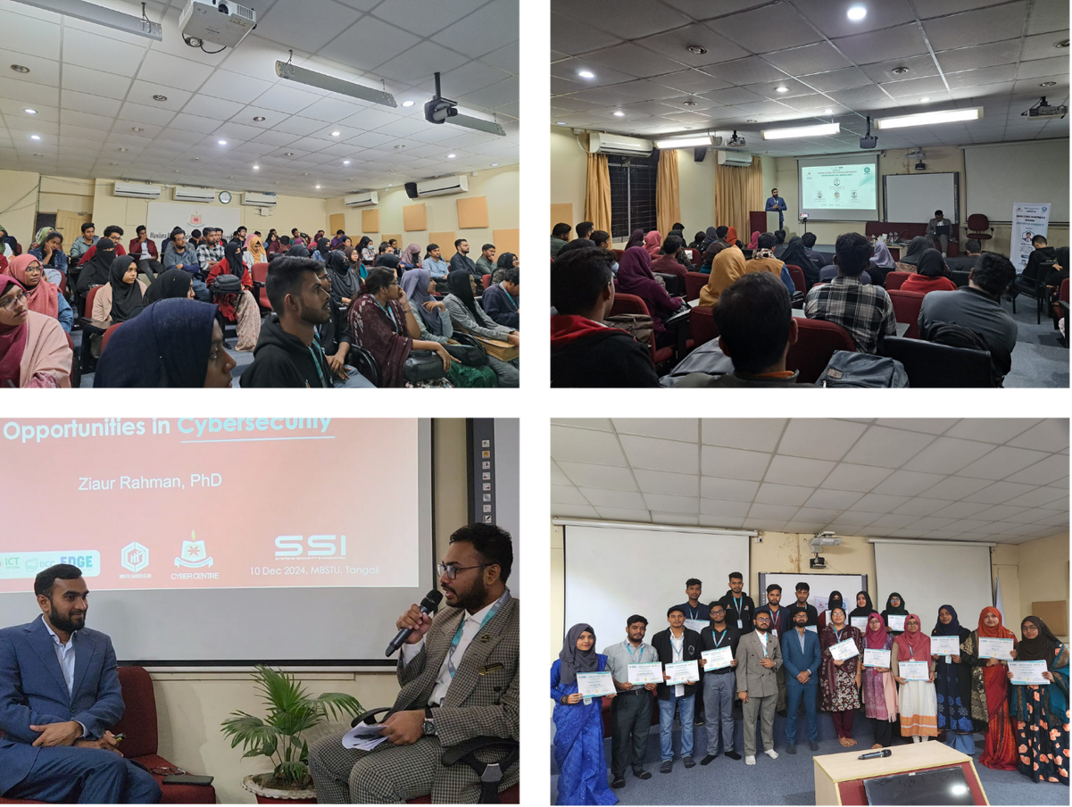

Mawlana Bhashani Science and Technology University (MBSTU), through its Career Club, regularly hosts open educational events that are accessible to the general public, including students, graduates, and professionals from outside the university.
A notable example is the seminar titled “Higher Studies in Australia and Cybersecurity Research Opportunity”, held on 10 December 2024 at MBSTU. The event featured Dr. Ziaur Rahman, PhD in Cybersecurity, RMIT University, Melbourne, Australia, who shared valuable insights on Australian higher education systems, scholarship opportunities, and emerging research areas in cybersecurity. The session included interactive Q&A discussions, informative presentations, and direct guidance on pursuing international academic and research opportunities.
The program was open to external participants, welcoming not only MBSTU students but also graduates and individuals from nearby institutions who are interested in global education and research. All attendees received participation certificates, while quiz winners were rewarded with gifts to encourage engagement.
This seminar exemplifies MBSTU’s commitment to providing open and inclusive educational experiences beyond its enrolled students. By hosting public academic lectures and community learning events, the university actively contributes to SDG Target 4.3.2, ensuring access to quality learning opportunities for the wider community.

