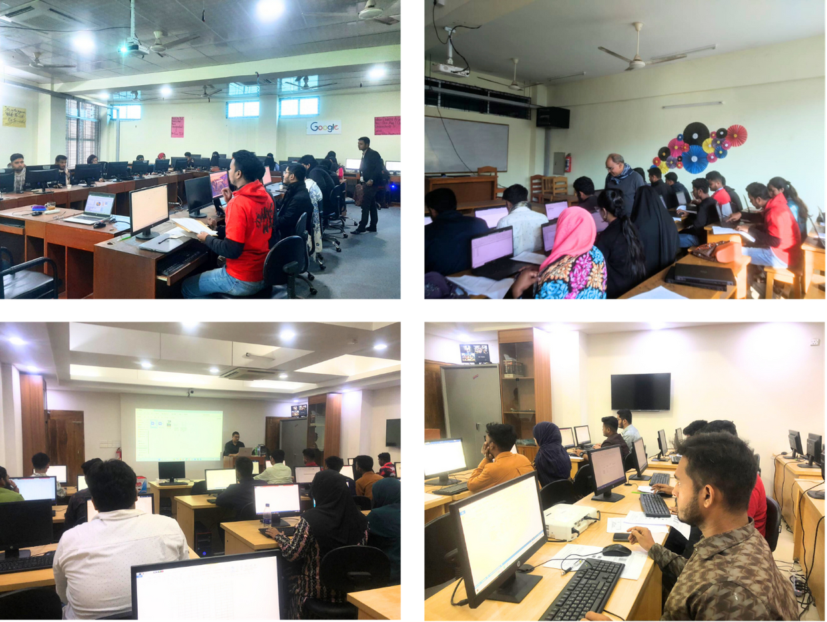
Skill Development Training under EDGE Project at MBSTU
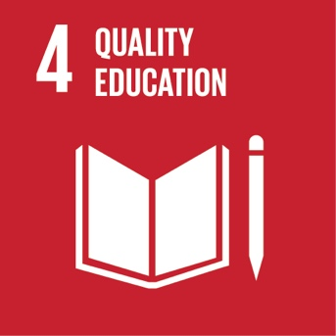

MBSTU, as an educational institution, hosts events and training programs that are open to the general public. Under the EDGE project (Enhancing Digital Government and Economy), the CSE and ICT departments organized short-term skill development classes in areas such as Office Management, Python Programming, Digital Marketing, Web Designing, and Graphics Designing. These programs are designed to enhance practical skills and employability for participants who are not formally enrolled at the university. Refreshments were provided after each session, creating an inclusive and supportive learning environment.
These initiatives qualify as executive education and vocational training, providing accessible, short-duration learning opportunities beyond the regular academic curriculum. In alignment with SDG 4.3.3, MBSTU hosts short-term training programs and skill development classes that are open to the general public.

