Information Technology Awareness Workshop
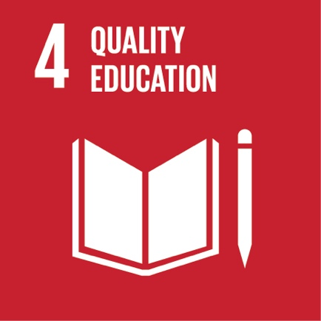
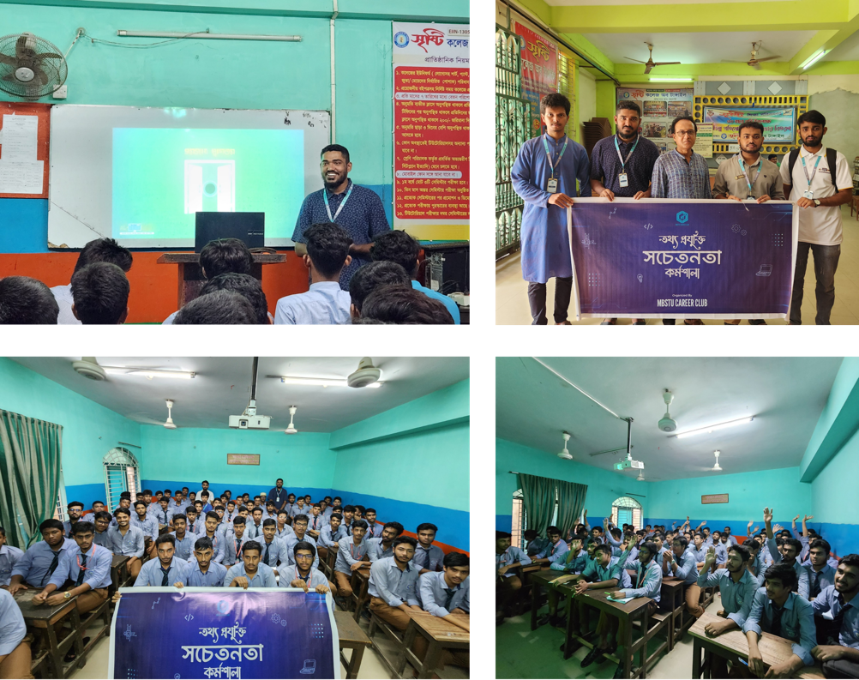

In alignment with SDG Target 4.3.4, Mawlana Bhashani Science and Technology University (MBSTU), in collaboration with the MBSTU Career Club, undertakes educational outreach activities beyond campus, including tailored workshops, lectures, and demonstrations in local schools and communities. For example, the Information Technology Awareness Workshop held at Shristy College, Tangail on 1 October, 2024 provided students with essential IT skills, promoting digital empowerment and expanding access to quality education in the community.

