* Question 01

package Q_01;  
  
import javax.swing.*;  
public class Q_01 {  
 public static void main(String[] args) {  
 JFrame frame = new JFrame("Welcome to Java");  
 frame.setVisible(true);  
 frame.setSize(800, 600);  
 }  
}

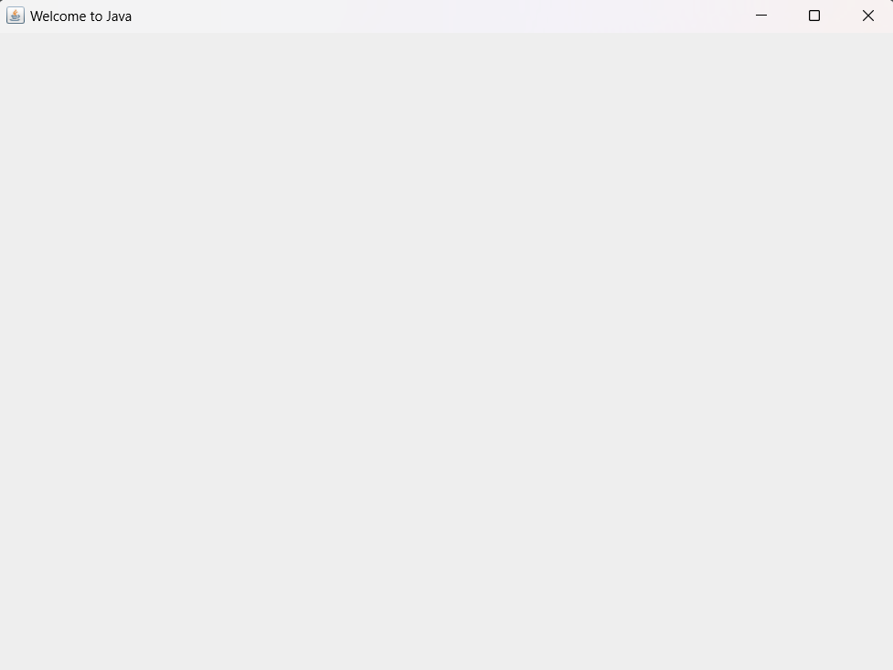

* Question 02

package Q_02;  
  
import javax.swing.*;  
import java.util.*;  
  
  
public class Q_02 {  
 public static void main(String[] args) {  
 Scanner scanner = new Scanner(System.*in*);  
 String fName;  
 String lName;  
 System.*out*.print("Enter your first name :");  
 fName = scanner.next();  
 System.*out*.print("Enter your last name :");  
 lName = scanner.next();  
 JFrame frame = new JFrame();  
 frame.setSize(300,200);  
 frame.setVisible(true);  
 frame.setTitle(fName+" "+lName);  
  
 }  
}

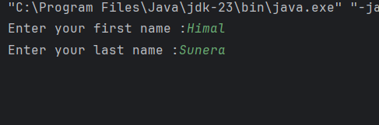

* Question 03

package Q_03;  
  
import java.util.*;  
  
public class Q_03 {  
 public static void main(String[] args) {  
 Scanner scanner = new Scanner(System.*in*);  
 String fName;  
 String mName;  
 String lName;  
 System.*out*.print("Enter your first name : ");  
 fName = scanner.next();  
 System.*out*.print("Enter your middle name : ");  
 mName = scanner.next();  
 System.*out*.print("Enter your last name : ");  
 lName = scanner.next();  
 System.*out*.println(fName+" "+mName.charAt(0)+". "+lName+".");  
 }  
}

* Question 04

package Q_04;  
  
import java.text.SimpleDateFormat;  
import java.util.*;  
  
public class Q_04 {  
 public static void main(String[] args) {  
 Date date = new Date();  
 SimpleDateFormat sdf = new SimpleDateFormat("dd MMM YYYY");  
 System.*out*.println(sdf.format(date));  
 }  
}

* Question 05

package Q_05;  
  
import java.text.SimpleDateFormat;  
import java.util.*;  
  
public class Q_05 {  
 public static void main(String[] args) {  
 Date date = new Date();  
 SimpleDateFormat sdf = new SimpleDateFormat("EEEE, MMM dd YYYY");  
 System.*out*.println(sdf.format(date));  
 }  
}

* Question 06

package Q_06;  
  
import javax.swing.*;  
import java.util.*;  
  
public class Q_06 {  
 public static void main(String[] args) {  
 Scanner scanner = new Scanner(System.*in*);  
 int h;  
 int w;  
 String title;  
 System.*out*.print("Enter the title of the frame: ");  
 title = scanner.nextLine();  
 System.*out*.print("Enter the height of the frame: ");  
 h = scanner.nextInt();  
 System.*out*.print("Enter the width of the frame: ");  
 w = scanner.nextInt();  
  
 JFrame frame = new JFrame(title);  
 frame.setSize(w, h);  
 frame.setVisible(true);  
 }  
}

* Question 07

package Q_07;  
  
import javax.swing.*;  
import java.text.SimpleDateFormat;  
import java.util.Date;  
  
public class Q_07 {  
 public static void main(String[] args) {  
 Date date = new Date();  
 SimpleDateFormat sdf = new SimpleDateFormat("hh:mm:ss a");  
 JFrame frame = new JFrame(sdf.format(date));  
 frame.setVisible(true);  
 frame.setSize(400,300);  
  
  
 }  
}

* Question 08

package Q_08;  
  
import java.util.*;  
  
public class Q_08 {  
 public static void main(String[] args) {  
 Scanner scanner = new Scanner(System.*in*);  
 String text;  
 int exclam;  
 String firstText; // the text before the exclamation mark  
 String secoundText; // the text after the exclamation mark  
 System.*out*.print("Enter a string: ");  
 text = scanner.nextLine();  
 exclam = text.indexOf("!");  
 firstText = text.substring(0,exclam);  
 secoundText = text.substring(exclam+2); // skip the space after the exclamation mark using +2  
 System.*out*.println(firstText+"\n"+secoundText);  
  
 }  
}

* Question 09

package Q_09;  
  
import java.util.*;  
  
public class Q_09 {  
 public static void main(String[] args) {  
 Scanner scanner = new Scanner(System.*in*);  
 String text; //text is the input string  
 System.*out*.print("Enter a string: ");  
 text = scanner.nextLine();  
 System.*out*.print(text.length()+"\n"+text.charAt(0)+"\n"+text.charAt(text.length()-1));  
 }  
}

* Question 10

package Q_10;  
  
import java.util.*;  
  
public class Q_10 {  
 public static void main(String[] args) {  
 Scanner scanner = new Scanner(System.*in*);  
 String text; //text is the input string  
 System.*out*.print("Enter a string: ");  
 text = scanner.nextLine();  
 if (text.length() % 2 == 0) {  
 System.*out*.print("Entered string has even length."); //Prints this if the length of the string is even  
 } else {  
 System.*out*.print(text.charAt(text.length() / 2)); //Prints the middle character if the length of the string is odd  
 }  
 }  
}

* Question 11

package Q_11;  
  
import java.util.*;  
  
public class Q_11 {  
 public static void main(String[] args) {  
 Scanner scanner = new Scanner(System.*in*);  
 String fName; // store first name  
 String mName; // store middle name  
 String lName; // store last name  
 System.*out*.print("Enter your first name: ");  
 fName = scanner.next();  
 System.*out*.print("Enter your middle name: ");  
 mName = scanner.next();  
 System.*out*.print("Enter your last name: ");  
 lName = scanner.next();  
 System.*out*.println(lName +", "+ fName +" "+mName.charAt(0)+".");  
 }  
}

* Question 12

package Q_12;  
  
import javax.swing.*;  
  
public class Q_12 {  
 public static void main(String[] args) {  
 JFrame frame = new JFrame("My First Frame");  
 frame.setSize(300,200);  
 frame.setVisible(true);  
 frame.setLocation(100,50);  
 }  
}

