**Listener**

The listener pulls in real-time stock prices and weather forecasts and publishes to a single Kafka topic for the storm bolt to read from. The Wunderground Weather API was chosen for acquiring real-time forecasts due to the ease of use and adequate documentation. Other weather APIs considered were Yahoo Weather, Weatherbug, and OpenWeathermap however, limitations such as inadequate data fields and maximum API calls dissuaded the group from selecting them. The most compelling reason for choosing the Wunderground API was due to the training weather dataset fields corresponding most with the Wunderground data fields.

The Yahoo Finance API for python was used primarily since it is one of the few remaining finance APIs that is easy to incorporate in python and straightforward to use. The API is used to provide closing prices for each ticker symbol for the previous day and two days before.

**Requirements**

The following libraries must be imported into the listener python file:

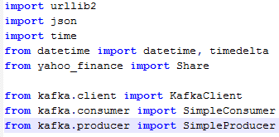

Urllib2 is required to call the Wunderground API and JSON is required to parse and pack the data. Datetime is used to obtain closing ticker for the required dates’ prices using the yahoo_finance library (yahoo_finance must be installed using ‘pip install yahoo-finance’). Kafka client, consumer, and producer are used to publish the data to the ‘weather’ topic.

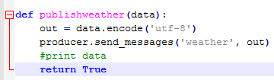

**Wunderground API**

After connecting to the Kafka client the JSON weather data is called every 15 minutes from a URL using an API key and the parsed data is stored in a dictionary.

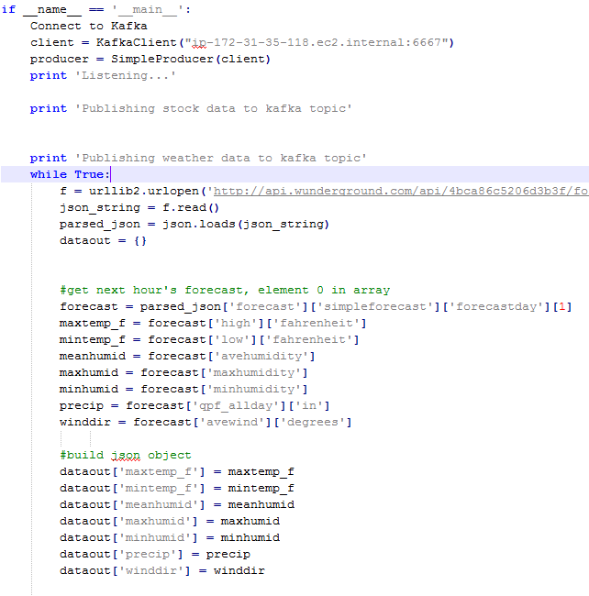

From there, the forecast for the day is obtained using the respective keys yielding the following data for the day: maximum and minimum temperature, maximum and minimum humidity, inches of rain, and wind direction. These fields correspond with the data in the training set. These values are then stored in the dataout dictionary which will be converted to a JSON object after the stock quotes are obtained.



**Yahoo Finance API**

The ticker symbols are stored in an array of strings which is then iterated over in order to obtain the data.



The Share() function obtains the data from yahoo finance and stores it in the tick variable. Yesterday’s closing price is obtained along with the closing price two days ago after the correct date conversions. The difference of the prices is calculated and stored in the dataout dictionary which is then converted to a JSON document and published to the ‘weather’ Kafka topic.

