Sapphire Stays – Hotel & Heritage Stay Booking System
Day 1 – Requirements Document
Date: July 4, 2026

1. Project Links
GitHub Repository: https://github.com/himangimeena/Sapphire-Stays
Kanban / Project Board: https://trello.com/b/N4rAtMOC/sapphire-stays-hotel-management-system
2. Kanban Board & Task Tracking
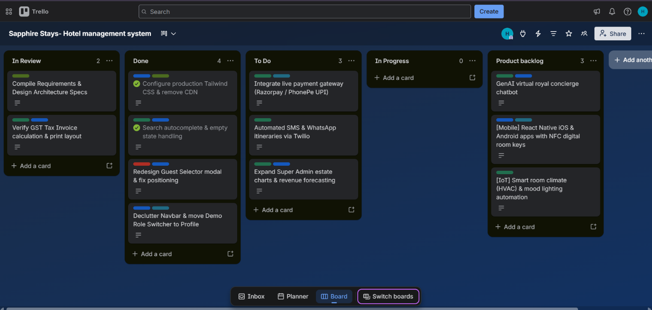
3. Project Overview
3.1 Project Name
Sapphire Stays – India's Premier Luxury Hotel & Sanctuary Management System
3.2 Problem Statement
Traditional hotel management and room reservation systems often suffer from fragmented manual workflows, lack of real-time inventory synchronization, rigid booking interfaces, and poor multi-role access control. Customers face uninspiring, static booking forms, while hotel administrators struggle with booking conflicts, decentralized invoice generation, and inefficient staff coordination across departments (Reception, Housekeeping, Maintenance).
The Sapphire Stays platform provides a centralized, state-of-the-art digital solution tailored for luxury heritage palaces and resorts across India. It seamlessly bridges customer reservation experiences with enterprise-grade multi-role estate management, ensuring real-time inventory accuracy, automated tax invoicing (India GST), and bespoke guest experiences.
3.3 Users
- Customers / Guests: Travelers seeking luxury heritage stays, suites, and palaces across India.
- Super Administrators: Executive estate managers overseeing property-wide analytics, revenue KPIs, and staff governance.
- Branch Administrators: Property managers managing specific palace branches (e.g., Udaipur, Jaipur, Mumbai).
- Receptionists: Front-desk operations staff handling guest check-ins, check-outs, and immediate room assignments.
- Housekeeping Staff: Service staff tracking room cleanliness, turndown schedules, and maintenance reporting.
- Maintenance Engineers: Technical staff resolving facility repairs, HVAC logs, and urgent engineering tickets.
4. Functional Requirements
4.1 Customer / Guest Portal
- Account Registration & Authentication: Secure user signup and login with email and password hashing.
- Dynamic Sanctuary & Palace Search: Real-time location search across Indian destinations with intelligent autocomplete suggestions and error handling for unsupported areas (“We're currently not available in this location”).
- Interactive Guest & Room Selection: Modern stepper modal for configuring Rooms, Adults, and Children (with age validation 0 - 17 Years Old), along with dedicated pet-friendly property filtering (Pets).
- Room & Suite Catalog Filtering: Advanced filtering by location (City/State), luxury tier, price range, and amenities (e.g., Private Pool, Royal Spa, Lake View).
- Reservation & Checkout Flow: Seamless room reservation with automatic coupon code application (e.g., ROYAL20, VIP10), dynamic price calculation, and date-conflict prevention.
- Booking Management: Dedicated customer portal to view active/past reservations, track loyalty point balances (Sapphire Society), and perform stay cancellations.
- Automated Tax Invoicing: Instant generation and downloadable/printable Indian GST Tax Invoices (with CGST 9% and SGST 9% breakdowns).
4.2 Administration & Staff Portals (True RBAC)
- Role-Based Login & Session Control: Secure JWT authentication with strict role verification (SUPER_ADMIN, BRANCH_ADMIN, RECEPTIONIST, HOUSEKEEPING, MAINTENANCE) and interactive demo role switching for testing.
- Estate & Revenue Analytics (Super Admin): Real-time KPI dashboards tracking total revenue, average occupancy percentage, branch comparisons, and system-wide audit logs.
- Branch & Inventory Management (Branch Admin): CRUD operations for room inventory, suite pricing, branch amenities, and local promotional banners.
- Front-Desk Check-In / Check-Out (Receptionist): Live guest arrival verification, instant status updates (CONFIRMED → CHECKED_IN / CHECKED_OUT), and room allocation.
- Room Cleanliness Tracking (Housekeeping): Status board for marking rooms as CLEAN, DIRTY, or IN_PROGRESS, linked directly to guest turnover schedules.
- Engineering Ticket Resolution (Maintenance): Log and resolve facility repair requests, equipment inspections, and room serviceability statuses.
5. Non-Functional Requirements
5.1 Security
- Password Hashing: All user passwords must be securely hashed using cryptographic algorithms (e.g., bcrypt) before database persistence.
- JWT Authentication & Authorization: Stateless, secure JSON Web Tokens (JWT) used for session management, API request signing, and strict Role-Based Access Control (RBAC) route protection.
- Data Input Validation: Protection against SQL injection and XSS through parameterized SQL queries and sanitized React frontend inputs.
5.2 Performance
- Fast Room & Inventory Retrieval: Optimized SQL queries with indexed database columns for sub-100ms room availability searches.
- Efficient Frontend Rendering: Lightweight React production bundles (Vite build < 400KB JS, < 50KB CSS) utilizing code-splitting and asset optimization.
- Real-Time UI Responsiveness: Instantaneous autocomplete dropdowns and glassmorphism UI transitions running smoothly at 60fps across mobile, tablet, and desktop devices.
5.3 Scalability
- Horizontal & Vertical Scalability: Modular 3-tier architecture capable of scaling Express.js backend instances independently from the database and static frontend CDN.
- Multi-Property & Multi-Tenant Architecture: Built to effortlessly support dozens of luxury palace branches and thousands of concurrent guest searches without database contention.
6. Assumptions & Constraints
6.1 Assumptions
- Internet Connectivity: Users and hotel staff have continuous, reliable broadband or 4G/5G internet access.
- Valid User Information: Guests provide authentic identification, email addresses, and contact details during registration and booking check-in.
- Modern Browser Support: Users access the platform via modern web browsers (Chrome, Safari, Edge, Firefox) supporting ES6+ and CSS Flexbox/Grid.
6.2 Constraints
- Regulatory Compliance: Tax calculations and invoicing must adhere strictly to Indian Goods and Services Tax (GST) regulations (18% standard hospitality tax split into 9% CGST and 9% SGST).
- Development Timeframe: Rapid iterative delivery executed within agile sprint milestones.

